Moose PVC Bird Nest Box
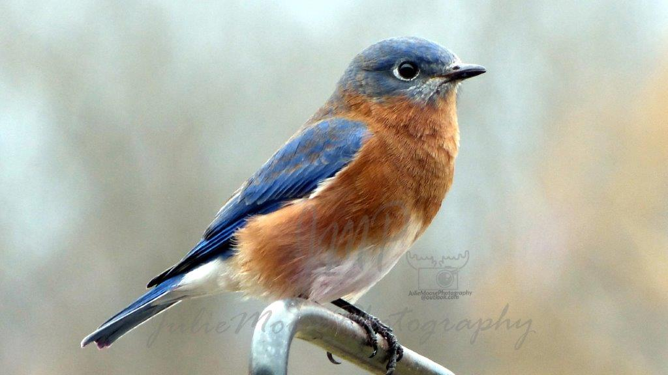

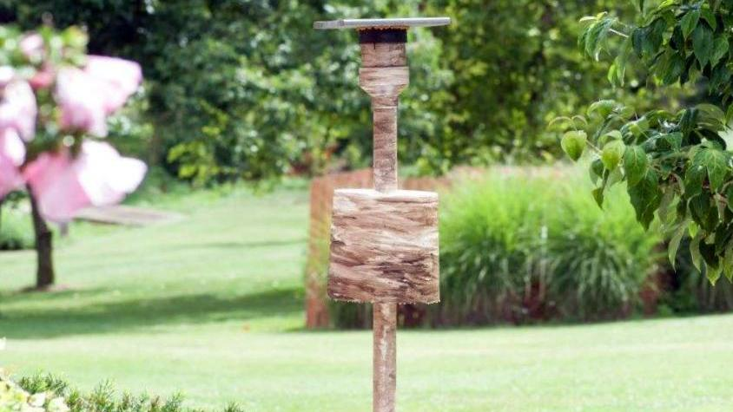

Parts List | Instructions | Cost x1 | Cost x4
3.5”x36” Steel U-Post |  | $2.50 | x4 = $10
2”x5’ PVC pipe Post | 2”x10’ x2 cut to 5’ lengths | $2.50 | x2 = $10
4” to 2” PVC adapter |  | $6.50 | x4 = $26
4”x6” PVC pipe Nest Box | 4”x24” cut to 6” lengths | $1.50 | x1 = $06
4” Qwik Cap |  | $4.50 | x4 = $18
3.75x3.75” hardware “cloth” floor | ¼” single layer or ½” doubled | $1.00 | x4 = $04 or scrap
6” carriage bolt floor anchor | Any 6” bolt with two washers/nuts | $2.00 | x4 = $08 or scrap
.67”x11.25”x12” roof | Composite 8’ cut to 12” lengths | $3.50 | x1 = $28 (x4 left over)
5-gallon bucket predator guard | Support w/ 3 screws ~2.3” apart, 4’ up | $3.00 | x4 = $12 or scrap
Total Cost in 2017 |  | ~$27 | X4 = ~$130

Tool List:
​Table saw and/or Sabre Saw, Xacto Knife, Trauma Sheers or Tin Snips, 2.25” hole saw, Hand Drill and Screwdriver, Post Driver or Sledge Hammer
Pre-assembly instructions (see pictures below):
- Cut 11-12” Square Roof and glue it to rubber Quick Cap (gorilla glue is good but expands when curing)
- Cut two pieces of hardware cloth and assemble with 6-8” centered bolt
Bolt works as center-weight to keep floor from tilting and as plunger to expel spent nests
- Cut 2” PVC post to ~5’ length
- If planning to add predator guard inverted bucket
  - Use hole saw to cut 2.25” hole in bottom of bucket
  - Measure ~11” down from top of post and wrap masking tape around post; make it level
  - Drill 1st hole along upper edge of tape
  - Measure 2.5” to left and right of hole to mark 2nd and 3rd holes for screws
  - Screw in the three short screw so screw-heads project a few mm
- Cut 4” PVC to 6” length; cut 2.5x1.25” entrance slot into Quick Cap with Xacto Knife
- Put Quick Cap onto Nest-Box and trace opening to cut matching entrance to Nest-Box
- Cut two 1.75”, vertical, ventilation slits opposite the entrance slot from upper edge of Nest-Box
(slits will extend ~1/2” below Quick Cap when roof is in place)
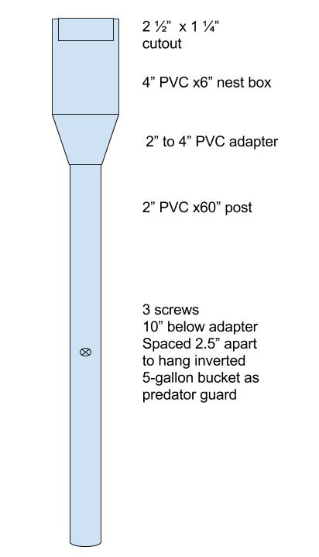
Assembly:
- Choose a location
- Place a post smaller than 2”; U-posts and retired chain-link posts work well
- Cover with 2” PVC post ~5’ tall
- Slide optional inverted bucket guard until suspended by 3 screws in post
- Add 2” to 4” PVC converter
- Add 4” PVC Nest Box
- Add hardware cloth base to Nest Box and cover with pine-needles
- Add 4” Qwik Cap to top of Nest Box with entry slit matching Nest Box slit
- Add 11-12” roof, glued to top of Qwik Cap (glue roof in advance)
- Gelstain post & nest if wanting to blend better with landscape
Stain inside of nestbox if wanting darker interior

Advantages:
PVC post – Entire assembly can be moved inside for winter if desired (may extend product life)
PVC vs Wood Nest Box – Cheaper, fewer parts, easier to make and assemble, longer life
Moose vs Gilbertson – Cheaper, fewer parts, easier to make and assemble, heavier and better insulated
Supported from bottom, so no risk of nest-box falling from a top-suspension design
Slit vs Round opening – No sparrows, easier feeding of older nestlings
Mobile, vented floor – No moisture, fly larvae may fall through, easy to expel spent nest
Removable Roof – Easy viewing and photography of nestlings
Removable Nest Box – Easy viewing and cleaning
Bucket Guard – Cheaper than metal and no seams with exposed screws for climbing snakes

Why my interest?
I inherited an interest in birds from my father, whose family grew up next door to a bird expert. Ruth Thomas studied and banded birds and wrote, “Crip, Come Home” as well as, “Brush Goat, Milk Goat” and a weekly column on birds in the 1940s in the Arkansas Democrat Newspaper. Many of my relatives have fed birds (including hummingbirds) and land-lorded Purple Martins and Bluebirds. I finally upgraded to property that lent itself to land-lording in 1998. My plastic Purple Martin gourds last forever, while my Bluebird houses have been replaced many times over the years. In researching PVC as an option, I ran into the Gilbertson design but thought it was overly complex and had some risk for dropping the nest-box onto the ground, so I designed my own nest-boxes and put them into use in 2016. With only 1.5 acres for 5 nest-boxes, 2017 saw 13 Bluebirds and 20 House Wrens fledged from the new boxes.

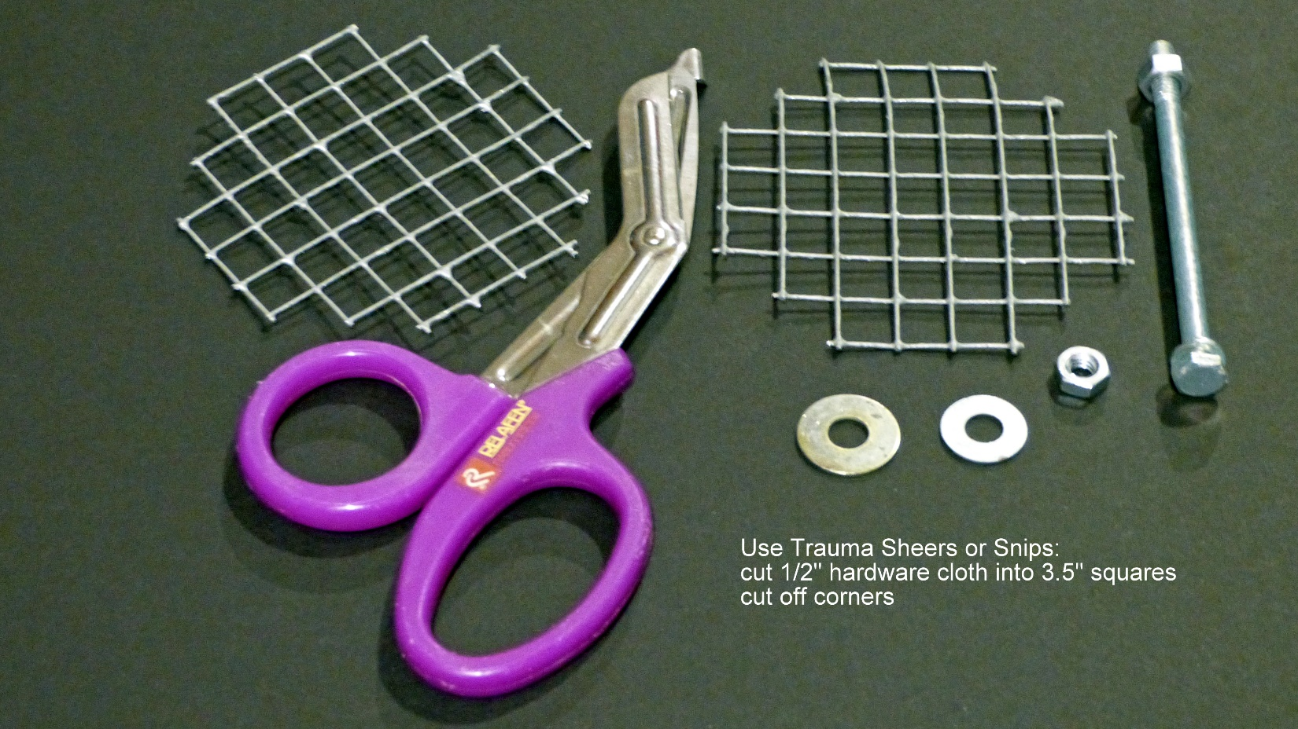

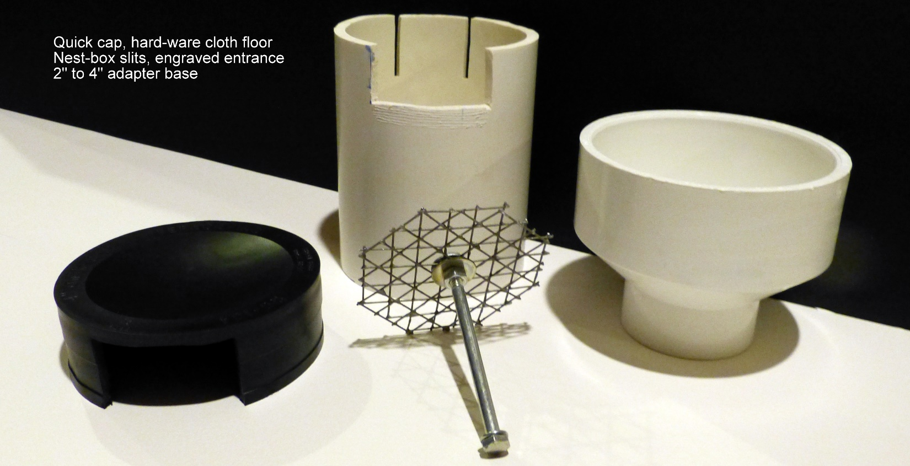

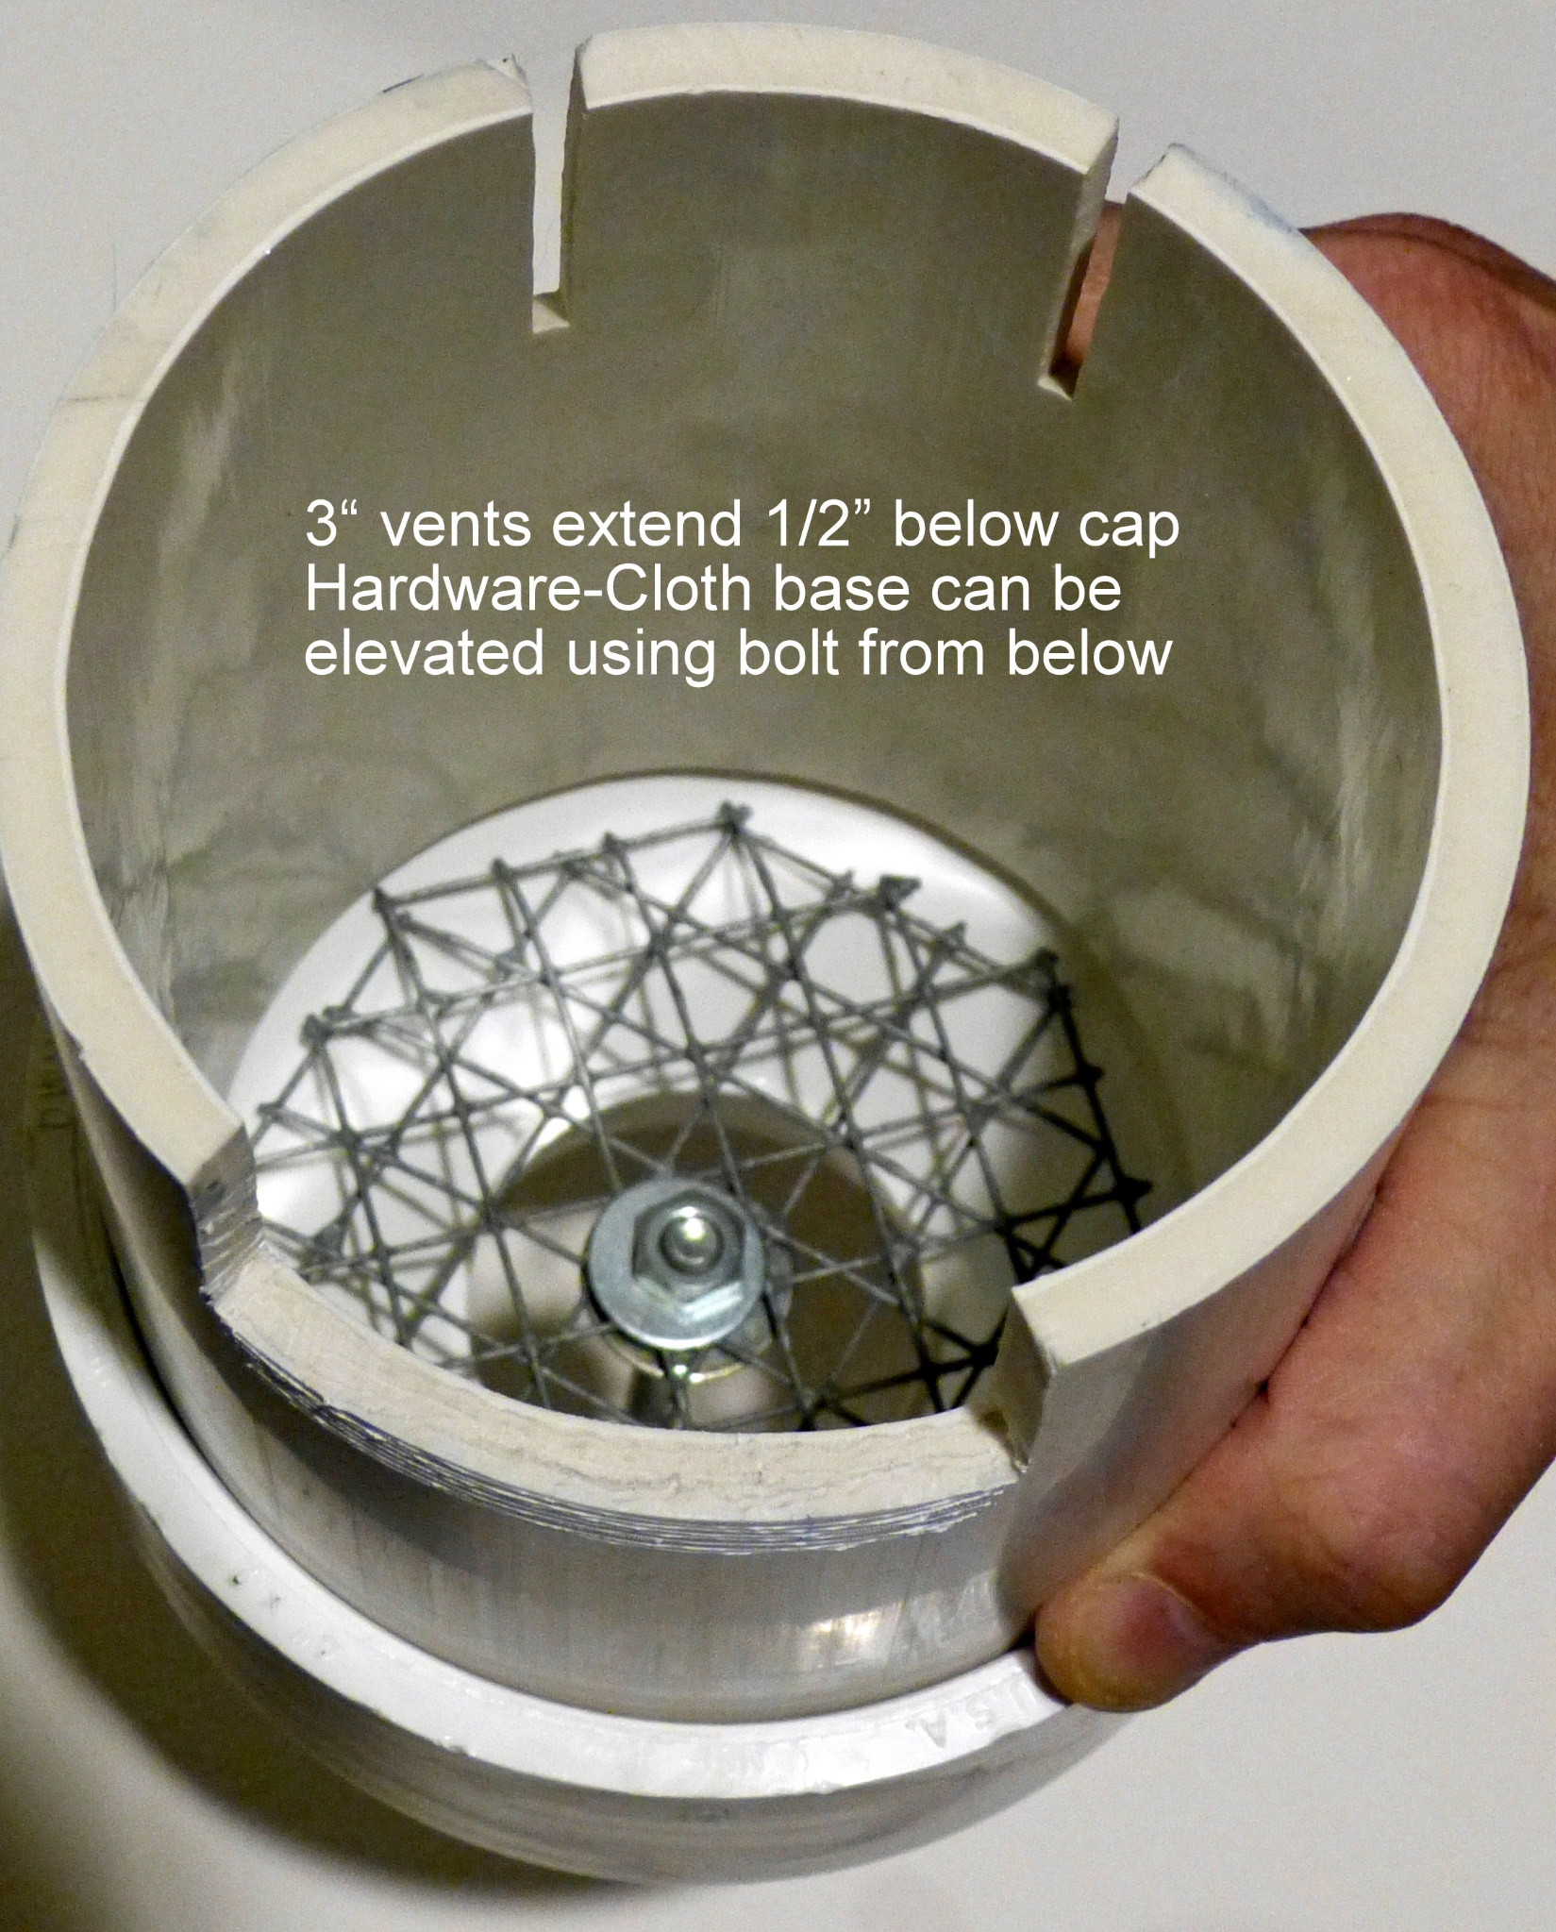

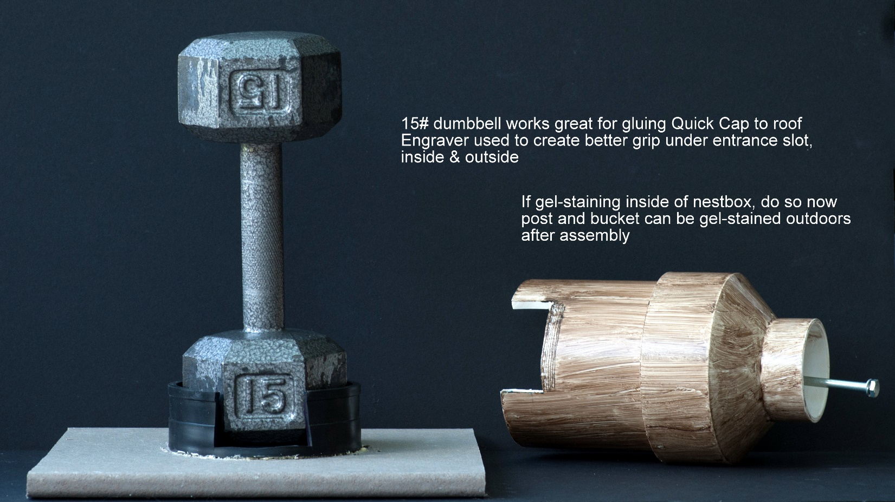

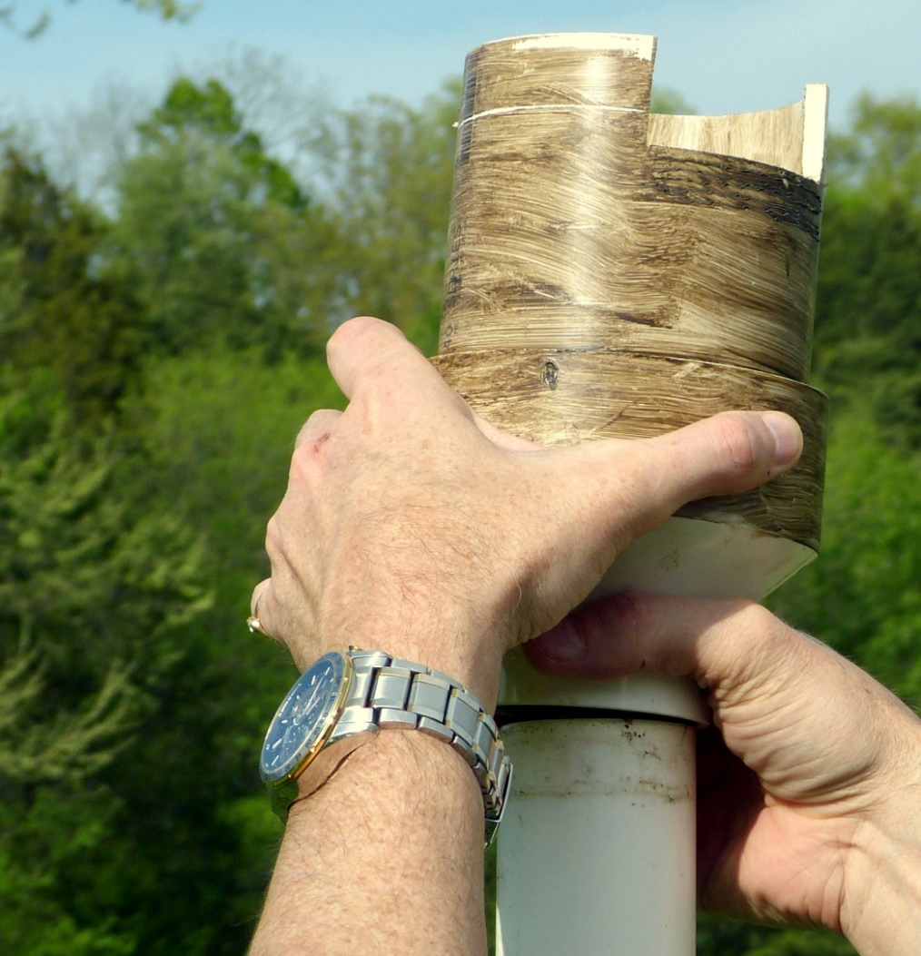
Remove Nest-Box for viewing by lifting adapter off the 2” post
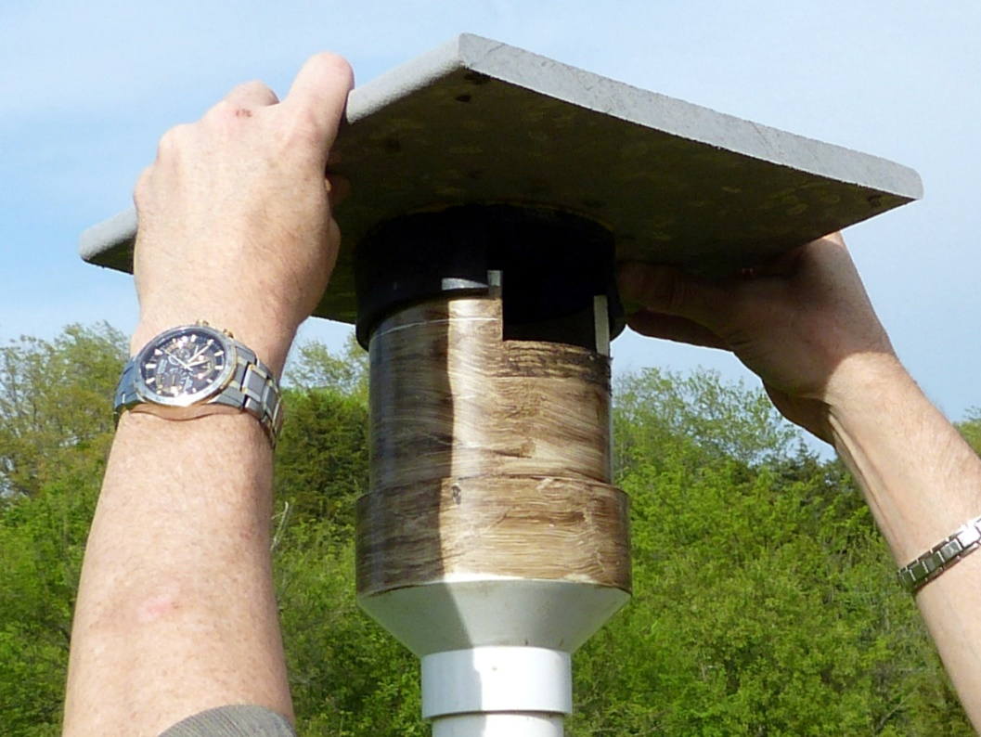
Roof can be removed/replaced before/after lifting nest-box off the 2” post
Removal is most easily done by tipping roof toward the front

