第一步：制作底板
- Step 1: make the base plate
- 选择正方体，调整为长80宽20，高4
1.Select the cube and adjust it to be 80 by 20 and 4 by 4
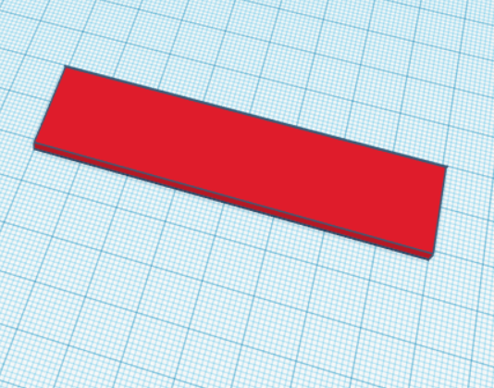
- 选择圆形屋顶，调整为厚度为4
2.Select the dome and adjust the thickness to 4
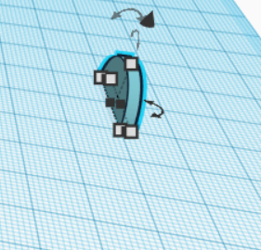
3．旋转90°
3.Rotate 90
4.复制粘贴，并水平旋转90°，两个半圆板对齐底板
4.Copy and paste, and rotate 90° horizontally. Align the bottom plate with the two semicircle plates
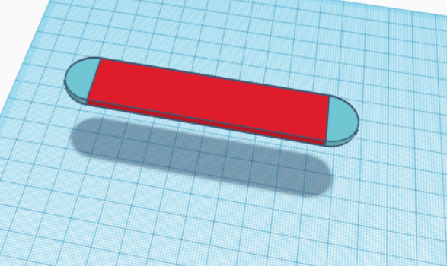

第二步：制作轮子组
- Step 2: make wheels

- 选择轮子调整为直径10，厚度4
1.Select wheels to adjust to 10 in diameter and 4 in thickness
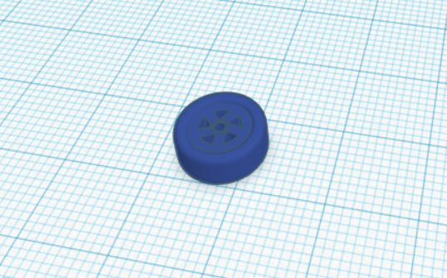
- 旋转90°
2.Rotate 90
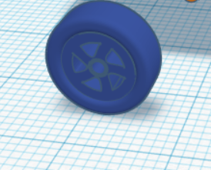
3.复制粘贴3个一样的轮子
3.Let me copy and paste three identical wheels
4.选择一个圆柱，调整为直径2，高20
4.Select a cylinder and adjust it to diameter 2 and height 20
5.旋转90°
5.Rotate 90
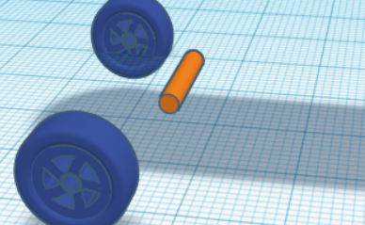
6.轮子与圆柱对齐
6.The wheels are aligned with the cylinder
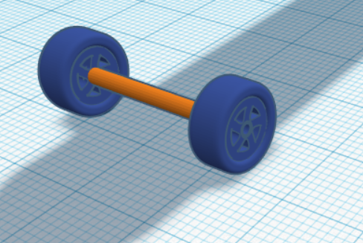
7.选择一个圆柱，调整为直径为3，长为8
7.Select a cylinder and adjust it to diameter 3 and length 8

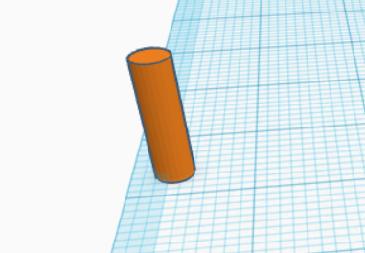
8.旋转45°
8.45 ° rotation
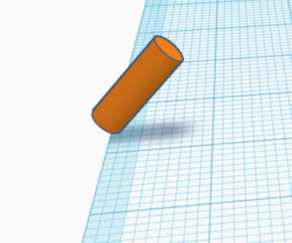
9.拉动圆柱使其与轮子组对齐
9.Pull the cylinder to align with the wheel group

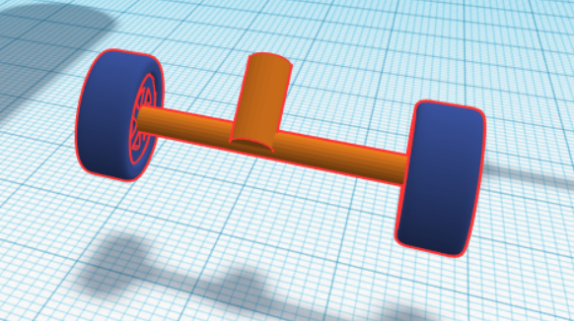
10.复制粘贴轮子组，并水平旋转180°
10.Copy and paste the set of wheels and rotate 180° horizontally

第三步：组合底板和轮组
- Step 3: combine the bottom plate and the wheels

1.使轮组和底板对齐
1.Align the wheels with the bottom plate

2.调整底板颜色
2.Adjust backplate color

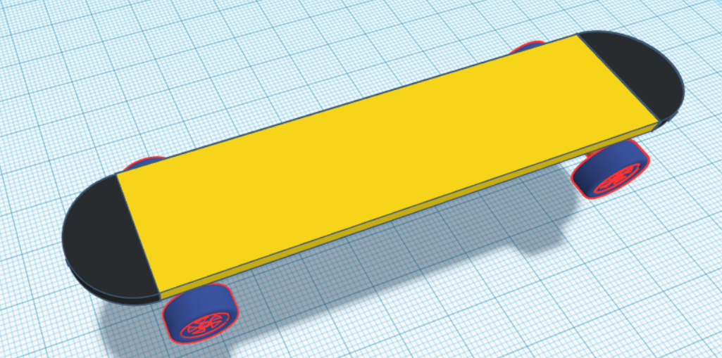
3.制作文本字母，并拉动到底板上
3.Make text letters and pull them onto the base plate
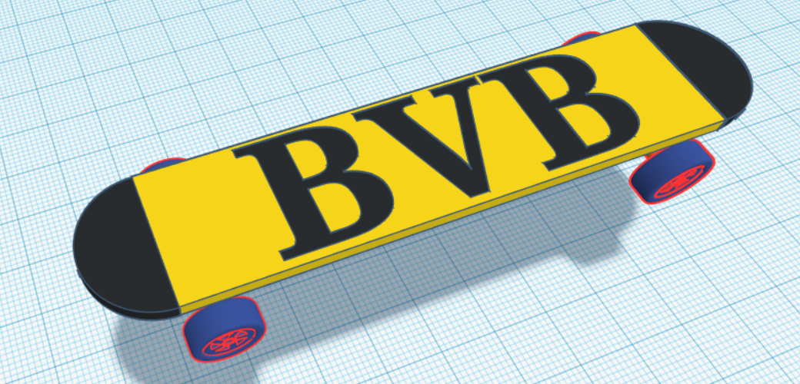
4.使两个半圆柱向上旋转17°
4.Rotate the two semi-cylinders upwards by 17°
