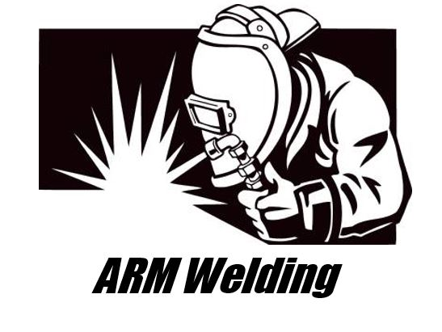

*The Ratchet Filler*

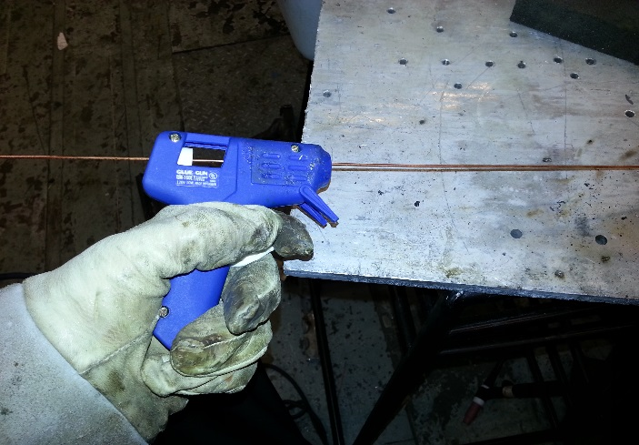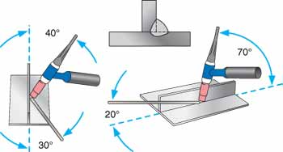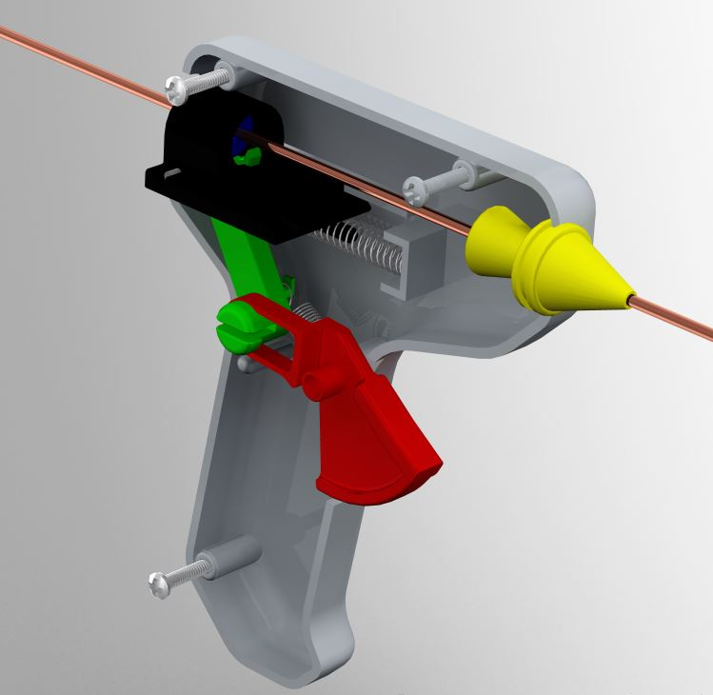

*How to use*

The Ratchet Filler works in a similar manner to a hot glue gun, minus the heating of the glue in the gun.

1. The user will select their specific type of filler rod (1/16th inch to 3/8th inch diameter) and then slide the tip of the filler rod into the back of the gun.
2. There is a collet with a hole the same size of the filler rod in the back of the gun that the user will slide it into.
3. Once inserted, the filler rod should be pushed through so that half of the filler rod length is protruding out the front of the gun, and the other half out the back of the gun. This is for proper distance control from the weld area so the welder’s hand and the gun will not be heated up upon welding to an uncomfortable level.
4. After inserting the filler rod to the correct position the user can position the Ratchet Filler to a comfortable position to begin TIG welding. The Ratchet Filler should be held and placed according to figure below. That is, the angle of the filler compared to the torch and material being welded should be less than or equal to 20 degrees. This is to properly feed the filler into the weld being created.
5. Next the user can begin operating the Ratchet Filler by pulling the trigger on the gun actuating the pulling of the filler rod through the gun. The user must pull the trigger every time he or she would like to dispense more filler into the weld and to keep their hand at a safe distance from the heat.
6. Once the filler rod has been used to where the rod length is under 4 inches, the user must replace the filler rod with a new one.

*The Ratchet Filler*

The Ratchet Gun is a filler rod dispensing gun for TIG welding. The purpose of the ratchet gun is to allow beginners in TIG welding easy control of dispensing the filler rod. This document will inform you the specific use of the product and the different components of the product. The original glue gun will be striped of the electrical cord, the glue gun heat extruder, a hinge, and a hinge pin to convert it into the ratchet gun. Depending on the size of the filler rod use, a 3D printer will build a nozzle with the allowable dimensions for the filler rod to be dispense. The ratchet gun will be wrap in tin foil which will make it heat resistant against the torch. The Ratchet Gun is a new product on the market that will help beginners weld as well as keep them safe from the torch.

**

\***NOTE:** The drawings above are a two phase operation of the product. The left is before pulling the trigger and the right is after depressing the trigger fully. The blue arrows denote the movement of the moving parts.*

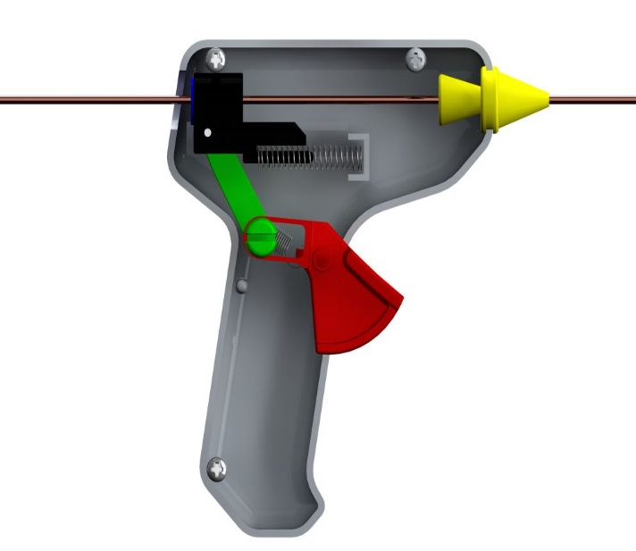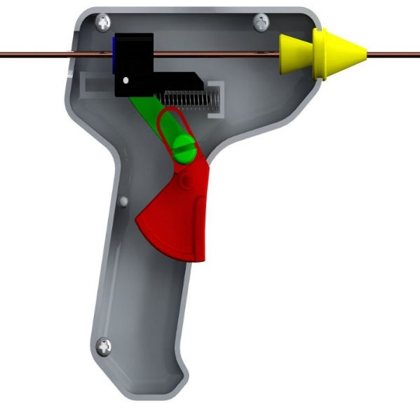

*Components*

Within the Ratchet Filler, the filler rod used for TIG welding is pushed through the gun using several components. The main components used in the Ratchet Filler include: the glue gun frame, a plastic pull trigger, a modified hinge and pin, slider, collet, guide cone, a compression spring, a linear action spring, frame screws, and the filler rod. The completed product with all of its components will look similar to the image to the right of this description. Below, a more in-depth component description and function is shown to better give a description of the product.

1. **Frame:** The frame used for the Ratchet Filler is derived from a standard, open grip hot glue gun. It is made from hard ABS plastic and is resistant to most impacts and higher heats. For the Ratchet Filler, the basic frame is unmodified from the glue gun from which it came. Its primary function is to provide a stable grip for the user as well as house the inner components to move the filler rod.
2. **Trigger:** The trigger is again unmodified from the glue gun the Ratchet Filler is based on. It is made from the same plastic as the frame. The primary function of the trigger is to be pulled by the user to initiate the movement of the filler rod through the gun.
3. **Hinge/Hinge Pin:** The hinge is one of three components changed slightly from the original donor hot glue gun. The hinge is changed in such a way that the small tooth at its end inside the slide component is longer to compensate for the smaller diameter filler rod compared to the glue stick. The hinge is made from ABS 3D printed plastic that the user will need to make prior to using the device. The hinge pin is the pivot point inside the slide component holding the hinge.
4. **Slider:** The slider in the Ratchet Filler is unmodified from the original glue gun. The slide contains the hinge and hinge pin as well as the collet to guide/hold the filler rod in the gun. The slider slides along two rails built into the frame and is returned to its original position via the compression spring connected to it. The slide slides to pull the filler rod through the gun when the trigger is pulled.
5. **Collet:** The collet is a 3D ABS plastic printed component the user must make prior to the use of the product. Its job is to guide and hold the filler rod as it is pulled through the gun. It is placed inside the slider with a slip-fit interface. The collet can be made to accept different diameter filler rods from 1/16th inch to 3/8th inch.
6. **Guide Cone:** The guide cone is also a 3D ABS plastic printed part made by the user. The cone again guides the filler rod through the gun as it’s pulled through. The guide cone can be made to accept different diameter filler rods from 1/16th inch to 3/8th inch. The cone snaps into place where the original heat extruder was located in the glue gun.
7. **Compression Spring:** The compression spring is attached to the slider along a peg built into the slider itself. It comes with the glue gun and does not need to be replaced. It is made from high-strength piano wire.
8. **Linear Action Spring:** The linear action spring is attached to the hinge on a small hook-like boss to return the hinge/trigger back to its rest position after each pull the user completes on the trigger. This spring is also made from high-strength piano wire and is not modified from the original glue gun.
9. **Filler Rod:** This is the main component of the entire design since the filler rod is what the whole product was designed around. The filler rod is fed through the gun through the back into the collet inside the slide. Then the filler rod is pushed through the guide cone and out to the weld area where the welding torch is. The filler rod can vary in size (1/16th inch to 3/8th inch) and can be up to two feet in length. The filler rod should be placed in the gun so that half is out the front of the gun and half out of the back for adequate operation of the device.
10. **Frame Screws:** The frame screws are three small screws that hold the two halves of the frame together, keeping the components inside the gun in working order. They are not changed from the original glue gun.
11. **Tin Foil Heat Shield:** The outside of the frame used for the Ratchet Filler is wrapped in a layer of tin foil to prevent any heat from the welding process melting the plastic components if the user places the device too close to the torch. This shield must be added to the device by the user.

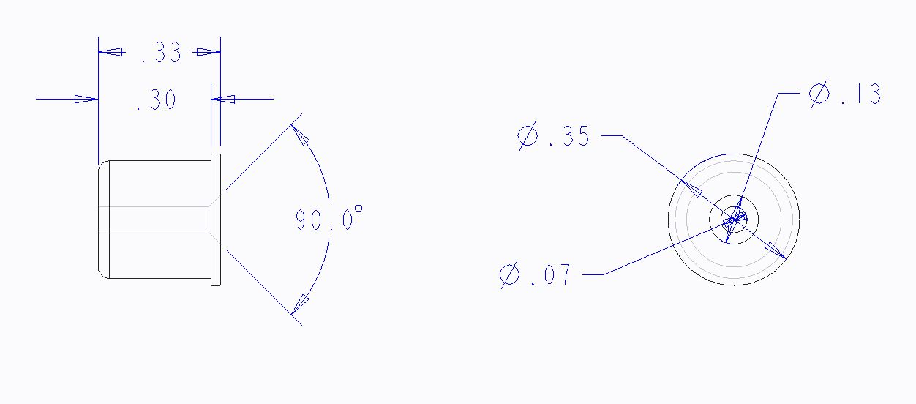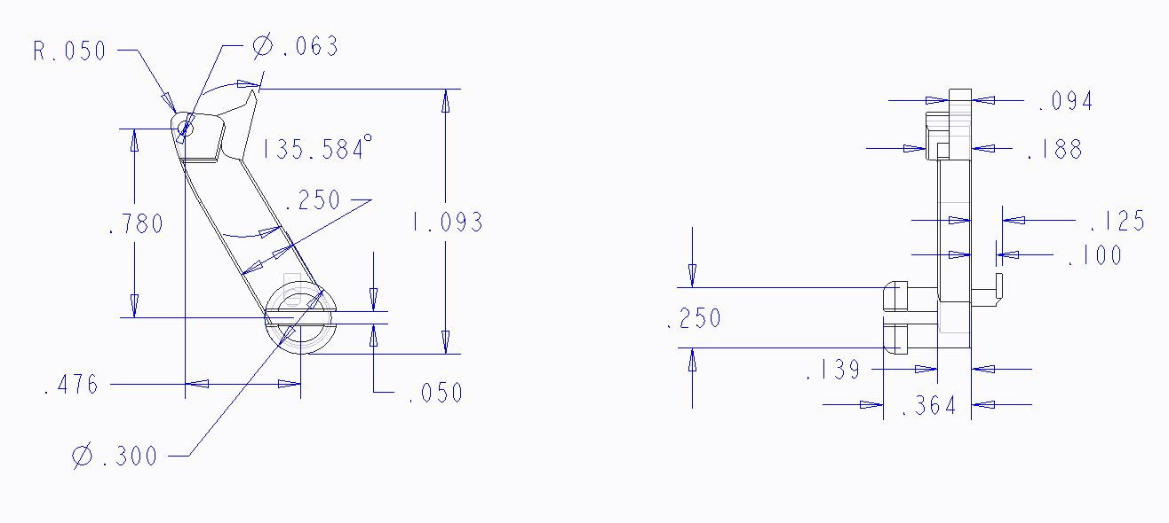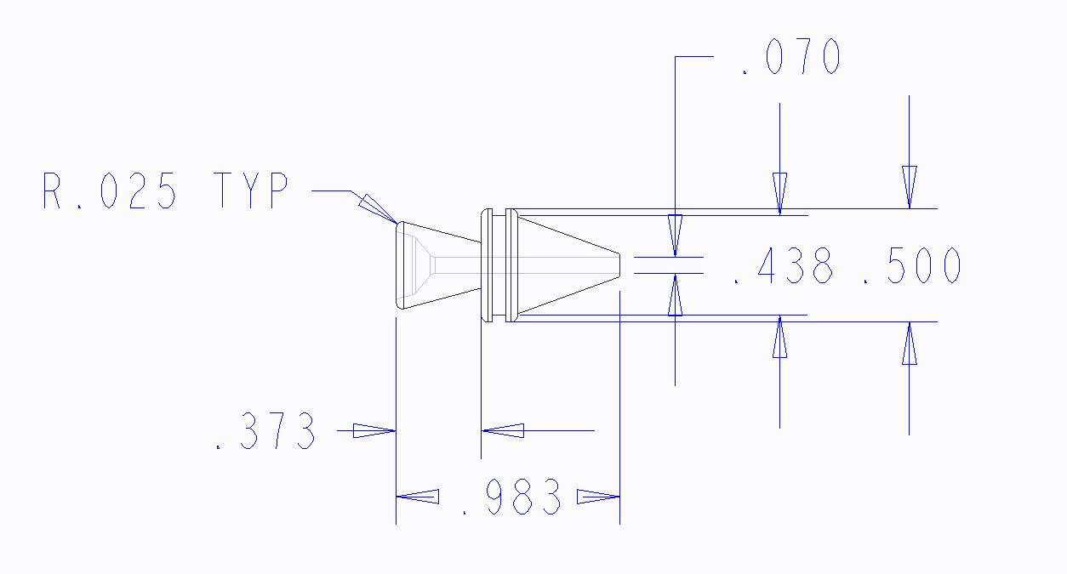

*3D Printed Components-Specifications*

In the Ratchet Filler, there are three components that need to be printed via a 3D printer from ABS or PLA plastic. These parts include:

* Guide cone
* Hinge
* Collet

The technical drawings of each part showing reference dimensions are shown below.

*Collet*

*Hinge*

*Guide Cone*

\***NOTE:** All drawings are not to scale*