**HEY RYMONDA ADD THE VIDEO FIRST AND THEN ADD IN THESE STEPS AND ALSO I LEFT A PLACE WHERE U SHOULD ADD THE DECORATING SHIT VIDEO SO CHECK IT OUT TYILYSM**
Here's a recipe for some super spooky, vanilla, good-witch bad-witch cupcakes! It'll be topped with some buttercream icing!
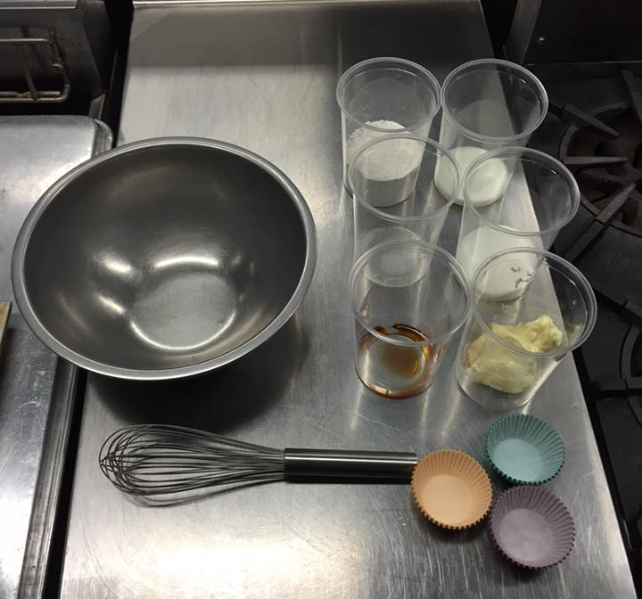
Vanilla Cupcakes
Ingredients:
1/2 cup of butter, room temperature
2/3 cup sugar
3 large eggs
1 teaspoon of vanilla extract
1 & 1/2 cups of flour
1 & 1/2 teaspoons of baking powder
1/4 of teaspoon salt
1/4 cup of milk
Directions:
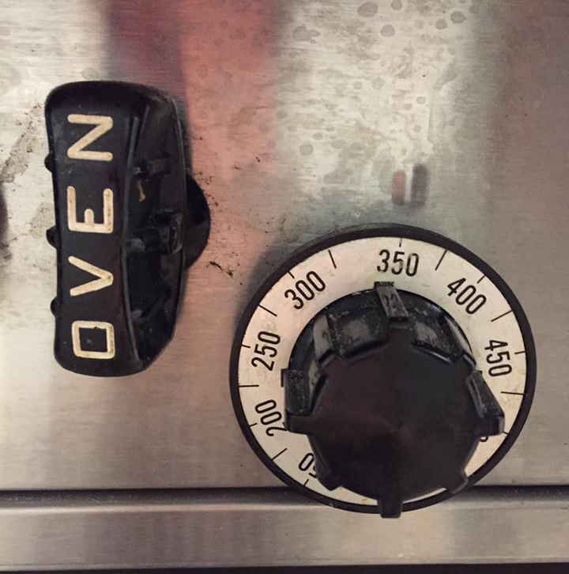
Step 1. Preheat the oven to 350 degrees.

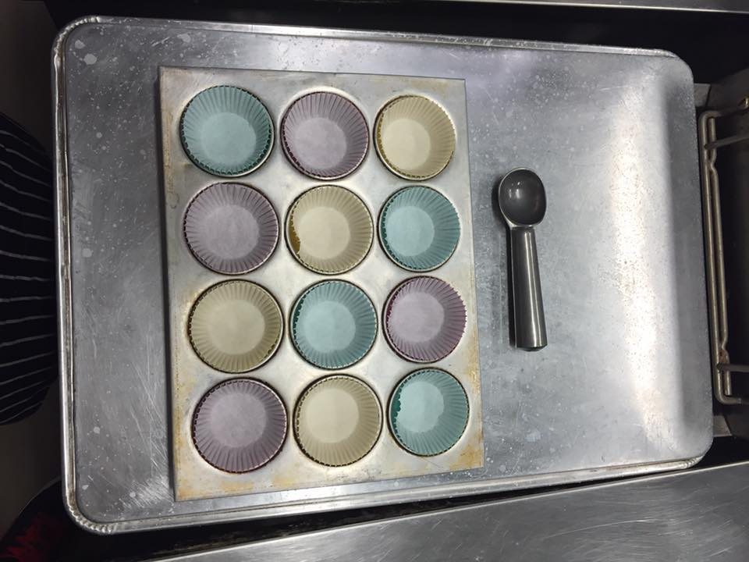
Step 2. Line a muffin tin with paper liners and get something to help scoop the mix into the tin.

Step 3. In a large bowl, beat together the butter and sugar until creamy.
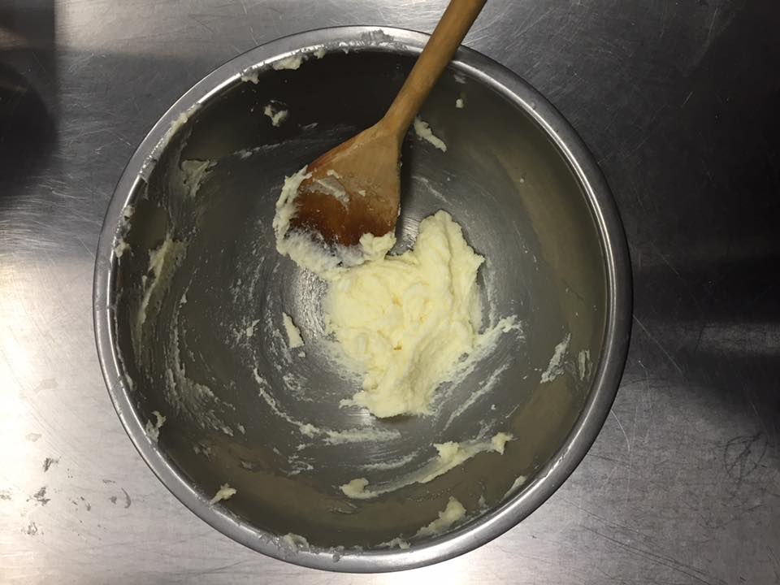

Step 4. Add eggs one at a time, mixing well after each addition. Then mix in the vanilla extract.
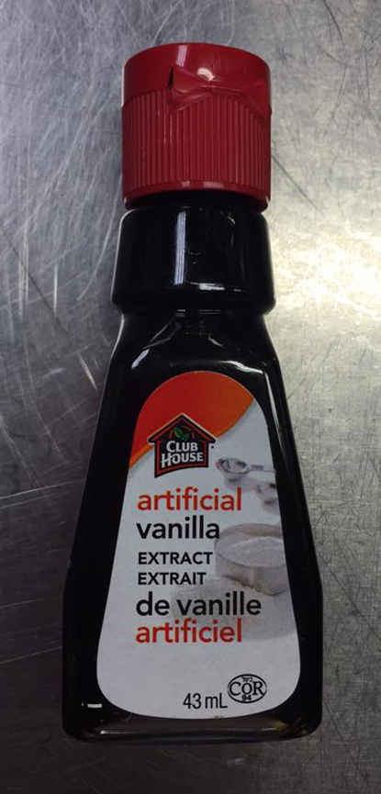
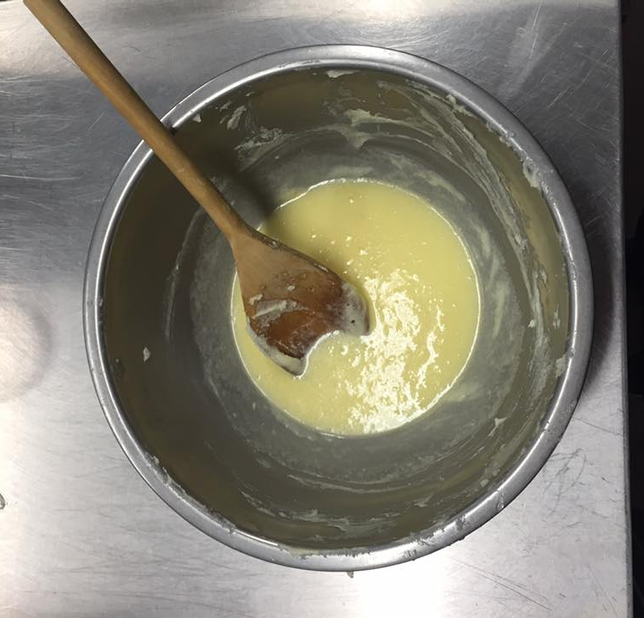

Step 5. In a small bowl, whisk together the flour, baking powder, and salt.
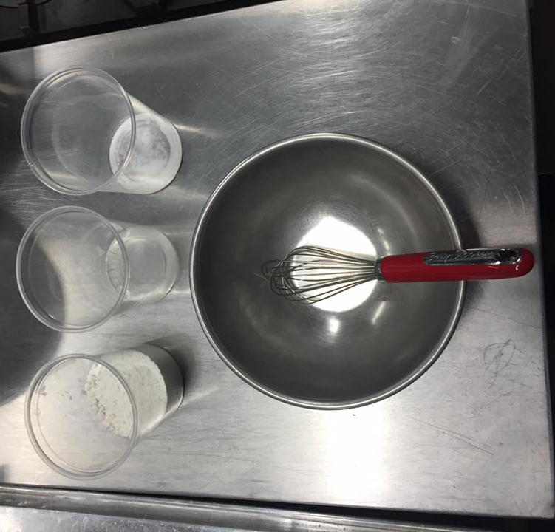
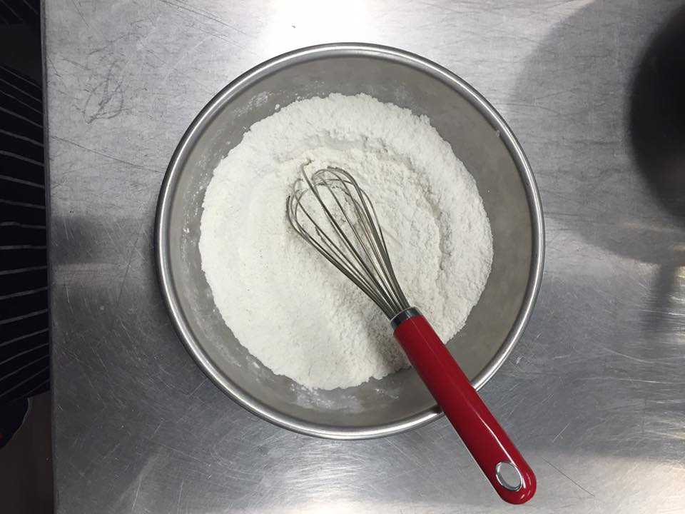

Step 6. Add this to the egg mixture while consistently stirring. Mix until smooth.
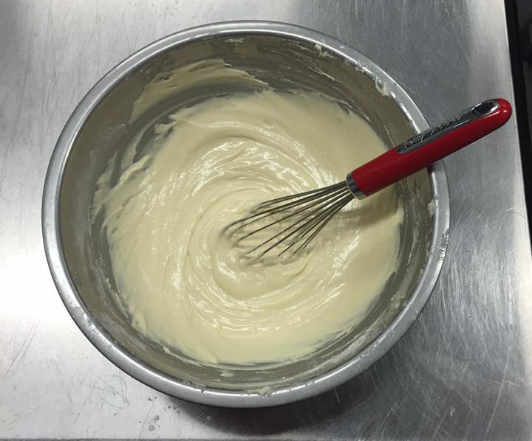

Step 7. Scoop into paper liners, filling them up 2/3 full. Then, bake 18-20 minutes
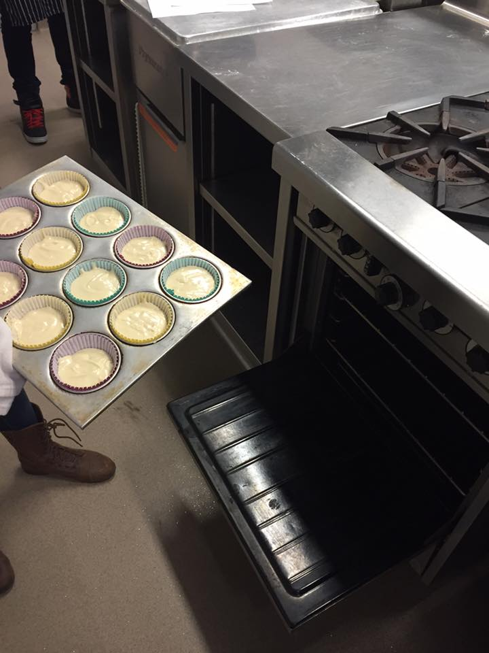
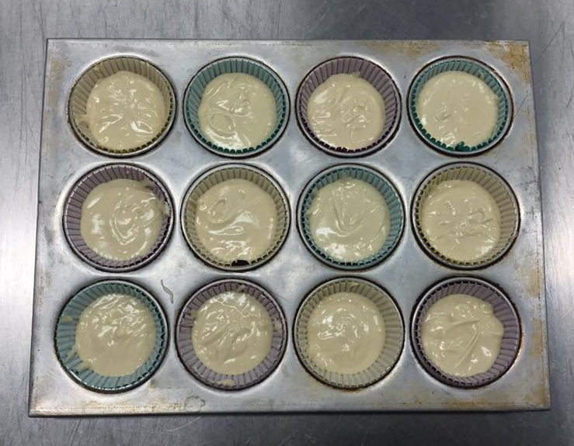

Step. 8 Let it cool in the pan for five minutes, then transfer to a wire rack to cool completely.
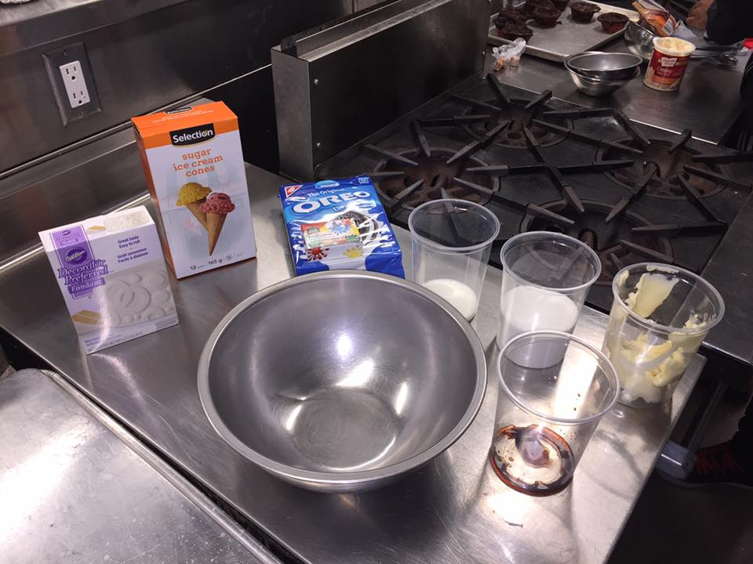
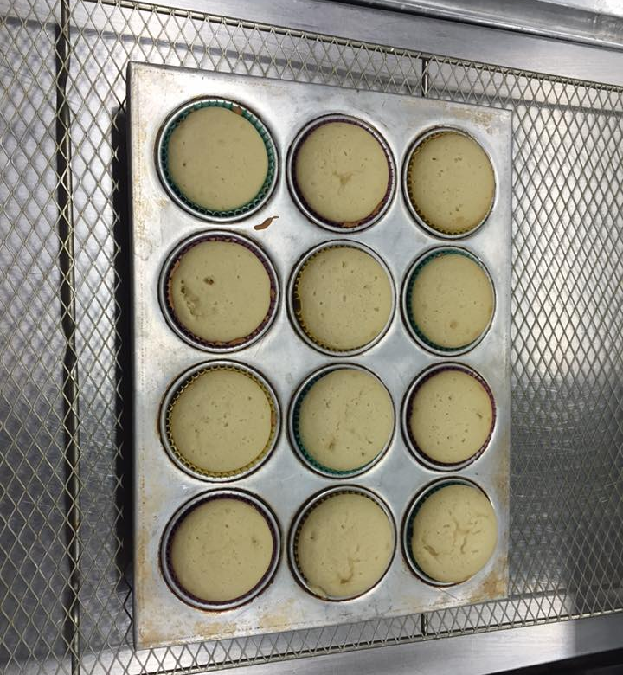
Vanilla Buttercream
Ingredients:
1 cup of softened butter
1-2 cups of powdered sugar
2-4 tablespoons milk
1 & 1/2 teaspoons of vanilla extract
Decorating Supplies:
Sugar/Waffle cone
Oreos
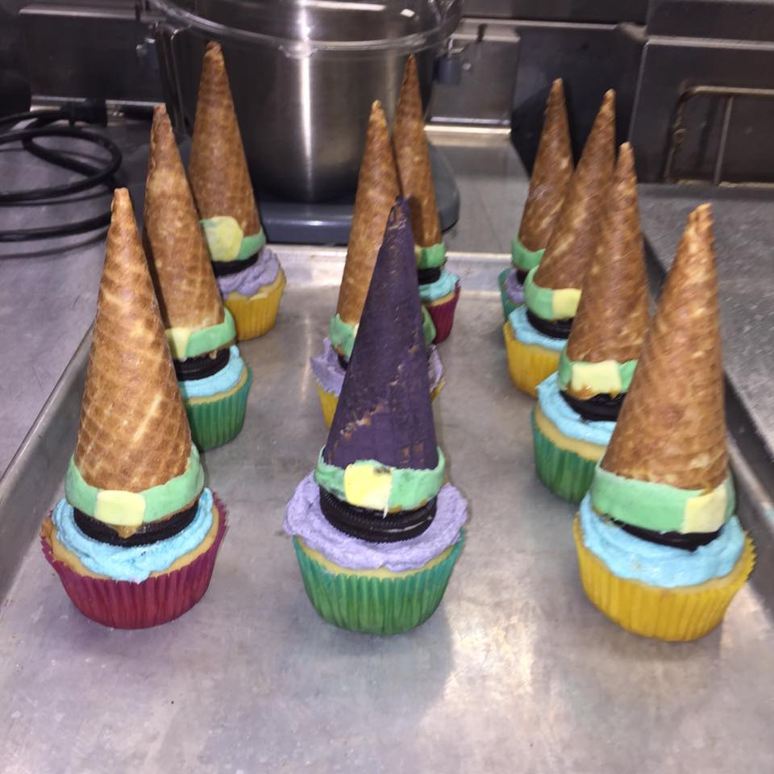
Fondant
Food colouring (Red, Black, Blue, Yellow, Green)

ADD DECORATING VIDEO HERE!!!!!

Final Product!:-)

