Li-Ion Battery Pack to replace 9V Battery for DMM
From time to time I encounter an exhausted battery warning of my DMM and when I have no spare battery it’s pretty bothering to buy it.
Since of it, I have decided to replace the 9V DMM battery with two rechargeable Li-Ion AAA type batteries.
The way how is pretty simple. You just prepare an exhausted 9V battery. I could recommend an Energizer one because their structure is pretty good to perform this project.
I found a readymade Li-Ion battery pack with charger (link below) but I have decided to make it by myself.
http://www.aliexress.com/item/2-pcs-Super-big-capacity-880MAH-Li-Ion-lithium-9V-rechargeable-battery-Universal-9v-AA-AAA/679825343.html?spm=2114.01020208.3.11.idPc4B&ws_ab_test=201526_4,201527_2_71_72_73_74_75,201409_5

Materials:
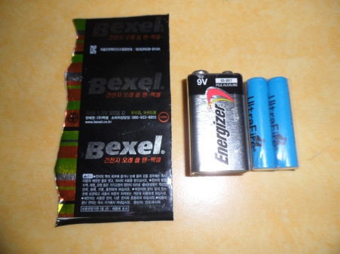
- 1 of exhausted “Energizer” 9V battery (to be used the shell and terminal)
- 2 of AAA type Li-Ion battery. I have purchased 4pcs set from aliexpress (link below).
http://www.aliexpress.com/item/2-x-Rechargeable-10440-AAA-3-7V-Li-ion-Battery/929793475.html?spm=2114.01020208.3.101.NPKFTZ&ws_ab_test=201526_4,201527_2_71_72_73_74_75,201409_5
- Some sheet metal (I upcycled from another dry cell)

Tools:
- Dremel
- Utility Scissors
- Long Nose Plier
- Diagonal Cutting Plier(any size)
- Vernier Caliper(Optional)

Work Steps:
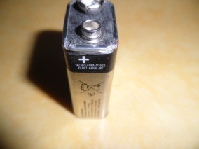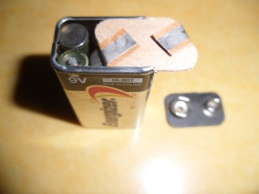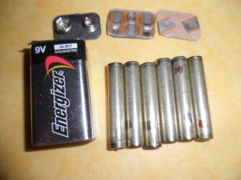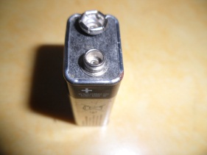
A. Disassembly:
- Try to cut the side (non-seaming side would be better) of 9V battery with dremel. Half of it would be better, not to damage the internal parts. You are going to slide out the terminal sheet without damage and because of it the two round corner shell shall be fully removed.
- Trim the remaining area with diagonal cutting plier.

- Slide out the terminal board and remove all internal parts.
- Discard all internal parts and just keep terminal board. You need the shell also. You can see the 6pcs of cells and bottom and top jumper sheets.
- Make finish trim the cut side for easy slide in the terminal board.
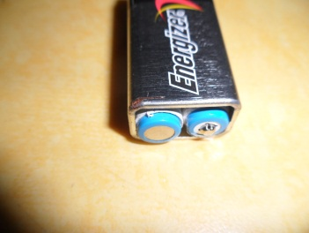
B. Make Bottom
- Because the AAA type Li-Ion battery is slight longer than the existing unit cells, you have to make about 2mm extruded bottom plate.
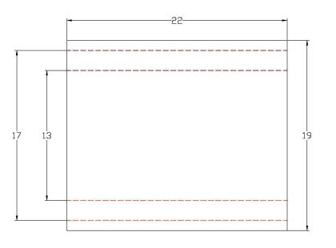
- With upcycled tin plated sheet, you have to provide trimmed and marked sheet for folding as per the drawing.

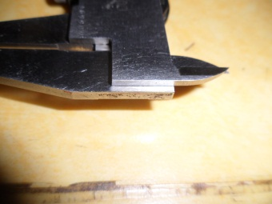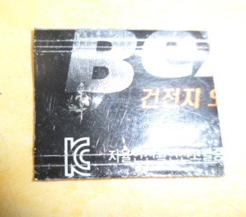

- Through my experience I fund the step measurement of vernier caliper is pretty useful to mark this kind of small sheet. After set the value of the measurement on the caliper, put the sheet to the step measurement and draw line with a knife. It will be better visually if the surface is painted.
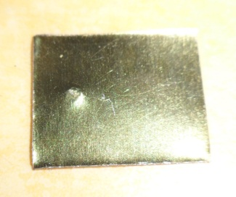
- Before start to fold, make an extruded point for battery negative contact. Push down with a Philips screw driver about 5mm inside of the center line.
- Fold the internal extruded part first. Try to fit the folded sheet at the bottom opening. Adjust the width if it too loose of thght.
- Fold the both edge with minimum length. The edge require just to hold the bottom sheet in position.
- Try to fit in the folded bottom sheet to the bottom opening. It will be required some deformation because of the corner round.
- When you feel good with the bottom sheet, polish the battery contact areas(extruded and the near side) with Dremel or sandpaper for good contact of battery positive and negative.
C. Assembly
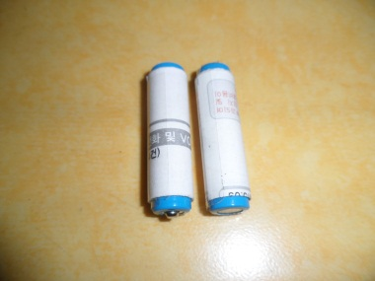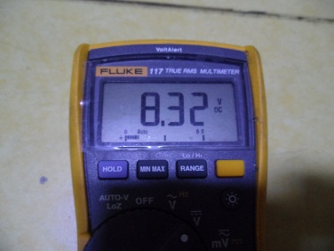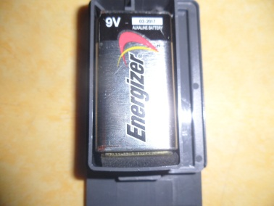
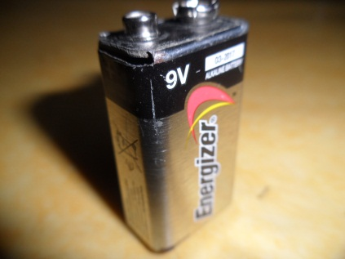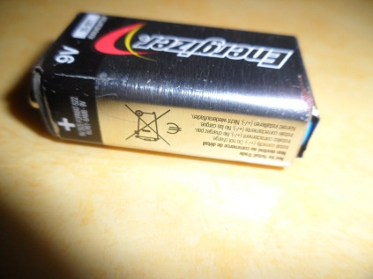
- The AAA type Li-Ion battery is too thin to be fit in the 9V shell. I have rolled a paper sheet(@35*@210mm) to make it bigger.
- Put in the finished bottom sheet in position. The extruded point shall go to positive side.
- Put in the two AAA type Li-Ion battery in position (one up, one down).
- Slide in the terminal board in position. The female terminal shall go in first.
- Check the voltage and polarity of battery pack. My measurement was 8.32V.
D. Application
I had opened the battery compartment of my DMM and applied the new battery pack. The sponge, backing up the battery made enable to accept the new battery pack which is about 2 mm longer than regular one.

E. Finished
With this project, I could save my time to buy new battery and some penny too.
The actual voltage of this new pack shows 8.32V, it works perfectly with my DMM.

