MECHANICAL ARRANGEMENT AND IMPROVEMENT
Mechanical arrangements are meant to be modified according to the surface, application, working operations and surrounding environment. Hence what we have made is a prototype. For example if the application environment is near to poles where icy surfaces are most probably encountered, then drone or base is modified with inclusion of spikes or extra gripping ability. According to application the humanoid is adroitly modified to work for either bomb defusing purpose, future medical applications, in hazardous chemical industry or as a future soldier.
In this prototype, we have made arrangements that could overcome generally faced problems along with few practically helpful modifications.
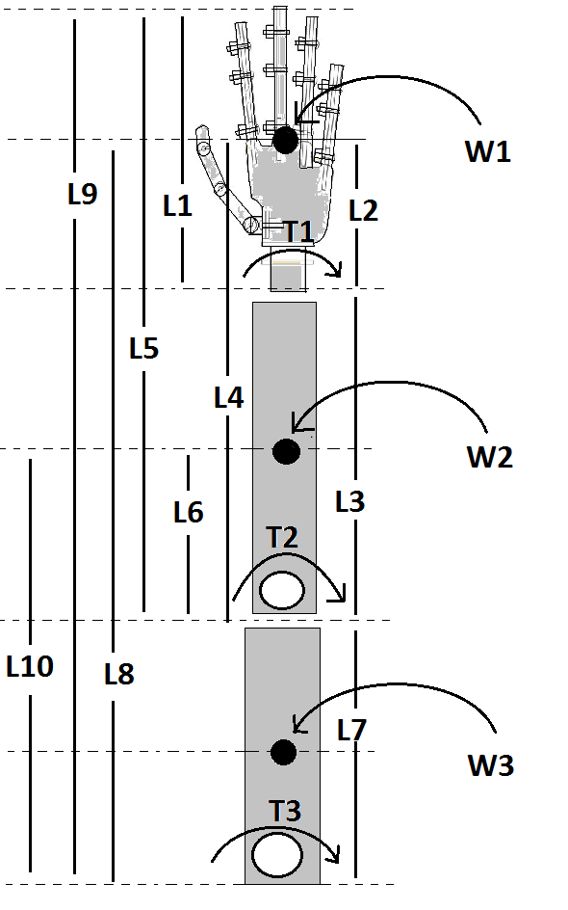
Fig.9 Pictorial representation for understanding calculations

As we have named it as a humanoid, so it’s our obligation to make it as resembling with actual human hand. So we took humanoid body parts ratios exactly equal to actual human body parts.
While considering dimensions, it was necessity to understand market availability of servo motors which could efficiently perform desired tasks. Consequently, we come up with the reading with motor torque requirements.
L1, L2, L3, L4,…L10 are the lengths, T1, T2 and T3 are torques, A1, A2, A3 are weights of respective structures mentioned in the above diagram, their values are as follows:

Table II
Notation | L1 | L2 | L3 | L4 | L5 | L6 | L7 | L8 | L9 | L10
Value(cm) | 10 | 5 | 20 | 25 | 30 | 10 | 16 | 41 | 46 | 26

To obtain torque requirement at wrist,
T1=L1×A1 + 1/2×L1×W1
Where L1= 10 cm, A1= 0.03 kg, W1= 0.13 kg
Hence, T1= 0.9 Kg-cm
Similarly,
T2= (L1+L3) ×A1+(1/2×L1+L3) ×W1 + L3×A2+1/3×L3×W2
Hence, T2= 6.68 Kg-cm

T3=(L1+L3+L7)×A1 + (1/2×L1+L3+L7)×W1 + (L3+L7)×A2+(1/3×L3+L7)×W2 + L7×A3 + 1/4×L7×W3
Hence, T3= 16.27 Kg-cm

From above calculations we come to know that which kind of servo to be employed on particular joint.
Consequently, we employed 15, 7.5, 3.5 Kg-cm torque servos for shoulder, elbow and wrist motion respectively.

FORWARD KINEMATICS
Through forward kinematics we could calculate effective end position or hand position as a function of joint angles.
In this section we are describing graphical forward kinematics method for determining end positions. According to motions capabilities of designed humanoid arm we can differentiate it into two different following parts
Vertical Planar motion from shoulder to wrist
Horizontal Planar motion of wrist

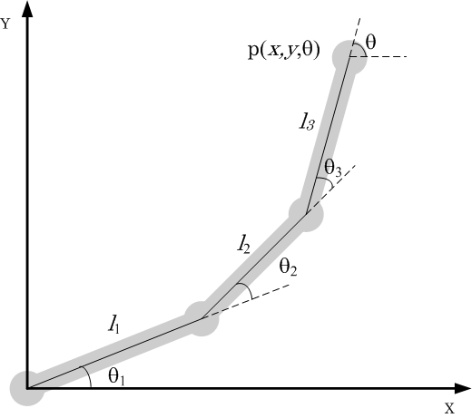

As you can see from above diagram,
Here l₁, l₂, l₃ are representing shoulder, elbow, wrist length respectively
θ₁, θ₂, θ₃ are angles made by shoulder, elbow, wrist respectively with horizontal plane.

Using the vector algebra solution to analyses the graph, the coordinate of the robot end-effector can be solved as follows.

x= l₁cos(θ1)+ l₂cos(θ1+θ2)+ l₃cos(θ₁ + θ₂ + θ₃) ----(1)

y= l₁sin(θ₁)+ l₂sin(θ₁ + θ₂)+ l₃sin(θ₁ + θ₂ + θ₃) ----(2)

θ= θ₁ + θ₂ + θ₃ ----(3)

At each joint we have placed one servo which is solely responsible for variation of angle θ1, θ2, θ₃. In our system servos are meant to move in window 20⁰ to 130⁰. Hence while mapping we have to consider this upper and lower limits in order to achieve desired end position of humanoid hand.

By using above formulas,
For rest position θ₁, θ₂, θ₃ are 20,20,20 respectively by putting this values and respective lengths
(l1= 16, l2= 20, l3= 10) in equation (1, 2, 3) we get X= 35.35, Y=26.98, θ=60.

Since we are imitating human body motions so while considering extreme positions we have to take θ₁, θ₂, θ₃ are 130,20,130 respectively by putting this values and respective lengths
(l1= 16, l2= 20, l3= 10) in equation (1, 2, 3) we get X= -25.86, Y=22.88, θ=280.

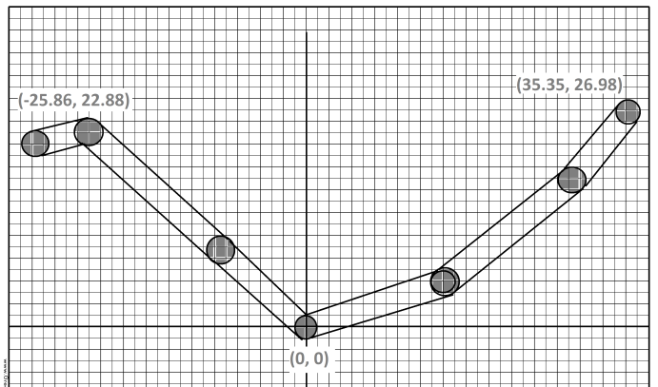

By using minimum and extreme values from above method we have mapped those in servo understandable maxima nad minima by providing window in between necessary values.

