8 channel rs485 commamd

MODBUS command (function code 06 is Control command,03 is Read status command)

Note :
1 MODBUS command must be HEX
2 Slave ID (device address) must be consistent with the DIP switches (A0-A5)
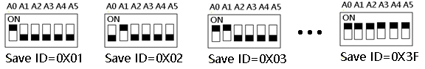
9600 Band ,8 Data bits,None Parity,1 Stop Bit。
MODBUS 06 Command (Control command ,HEX):
Bytes Number | 1 | 2 | 3 | 4 | 5 | 6 | 7 | 8
MODBUS Definitions | Slave ID | Function | Address |  | Data |  | CRC Check
Function | Device Address | Function | Channel number |  | Command | Delay time | CRC Check
Open | 0x00-0x2F | 0x06 | 0x0001-  0x0010 |  | 0x01 | 0x00 | 2Bytes CRC
Close | 0x00-0x2F | 0x06 | 0x0001-  0x0010 |  | 0x02 | 0x00 | 2Bytes CRC
Toggle (Self-locking) | 0x00-0x2F | 0x06 | 0x0001-  0x0010 |  | 0x03 | 0x00 | 2Bytes CRC
Latch Inter-locking) | 0x00-0x2F | 0x06 | 0x0001-  0x0010 |  | 0x04 | 0x00 | 2Bytes CRC
Momentary (Non-locking) | 0x00-0x2F | 0x06 | 0x0001-  0x0010 |  | 0x05 | 0x00 | 2Bytes CRC
Delay | 0x00-0x2F | 0x06 | 0x0001-  0x0010 |  | 0x06 | 0x00-0xff | 2Bytes CRC
Open all relays | 0x00-0x2F | 0x06 | 0x0000 |  | 0x07 | 0x00 | 16 channel version only
Close all relays | 0x00-0x2F | 0x06 | 0x0000 |  | 0x08 | 0x00 | 16 channel version only

Remarks:
1 Momentary mode, delay time is 1 seconds
2 Delay mode, delay time is 1-255 seconds

Return command：
Command is active, return to send commands; instruction is invalid no return.

MODBUS 03 Command (Read status command ,HEX):
Bytes Number | 1 | 2 | 3 | 4 | 5 | 6 | 7 | 8
MODBUS Definitions | Slave ID | Function | Address |  | Data |  | CRC Check
Function | Device Address | Function | Starting register address |  | Register length |  | CRC Check
Read Channel 1 State | 0x00-0x2F | 0x03 | 0x0001 |  | 0x0001
Read Channel 2 State | 0x00-0x2F | 0x03 | 0x0002 |  | 0x0001
Read 2 consecutive channels status | 0x00-0x2F | 0x03 | 0x0001-0x0003 |  | 0x0002
Read 3 consecutive channels status | 0x00-0x2F | 0x03 | 0x0001-0x0002 |  | 0x0003
Read all 16 channels status | 0x00-0x2F | 0x03 | 0x0001 |  | 0x0010

Read status command returns (function code 03, HEX format):
Bytes length | 1 | 1 | 1 |  | 2
MODBUS Definitions | Slave ID | Function | data length | data | CRC16 Check
Function | Device Address | Function | data length | Relay state  0x0001 open  0x0000 close | CRC16 Check
Channel 1  open | 0x00-0x1F | 0x03 | 0x02 | 0x0001
Channel 1  close | 0x00-0x1F | 0x03 | 0x02 | 0x0000
Channel 2  open | 0x00-0x1F | 0x03 | 0x02 | 0x0001
Channel 2  close | 0x00-0x1F | 0x03 | 0x02 | 0x0000
Channel 1 open  Channel 2 open | 0x00-0x1F | 0x03 | 0x04 | 0x0001 0x0001
Channel 1 open  Channel 2 close | 0x00-0x1F | 0x03 | 0x04 | 0x0001 0x0000
Channel 1 close  Channel 2 open | 0x00-0x1F | 0x03 | 0x04 | 0x0000 0x0001
Channel 1 close  Channel 2 close | 0x00-0x1F | 0x03 | 0x04 | 0x0000 0x0000

MODBUS commands you can use "Modbus Poll" input, as shown below
（CRC check generated automatically）
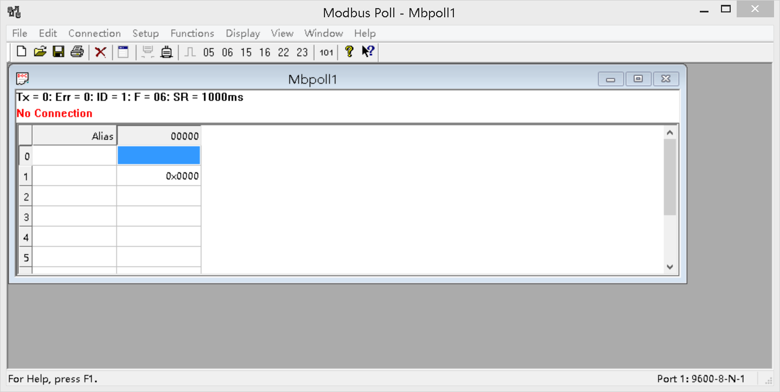
You can also use HyperTerminal serial input, as shown below
（Manually add CRC check）
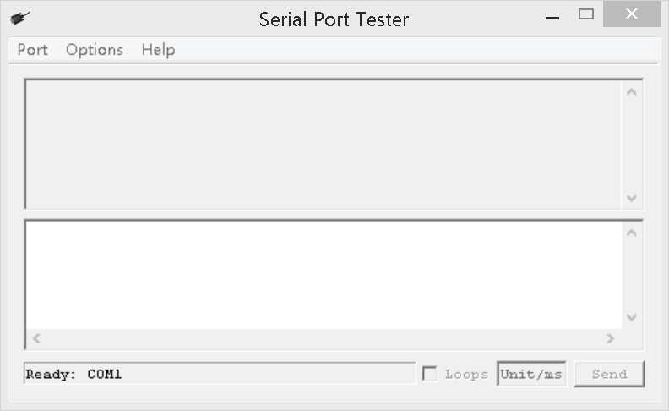

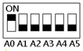
Examples (Slave ID is 1,DIP switch state)
Channel 1 Open ：01 06 00 01 01 00 D9 9A
Channel 1 Close ：01 06 00 01 02 00 D9 6A
Channel 1 Toggle：01 06 00 01 03 00 D8 FA
Channel 1 Latch：01 06 00 01 04 00 DA CA
Channel 1 Momentary: 01 06 00 01 05 00 DB 5A
Channel 1 Delay 10 seconds : 01 06 00 01 06 0A 5B AD
Channel 1 Delay 100 seconds: 01 06 00 01 06 64 DA 41

Channel 2 Open ：01 06 00 02 01 00 29 9A
Channel 2 Close ：01 06 00 02 02 00 29 6A
Channel 2 Toggle ：01 06 00 02 03 00 28 FA
Channel 2 Latch ：01 06 00 02 04 00 2A CA
Channel 2 Momentary : 01 06 00 02 05 00 2B 5A
Channel 2 Delay 10 seconds : 01 06 00 02 06 0A AB AD
Channel 2 Delay 100 seconds : 01 06 00 02 06 64 2A 41

Read state (assuming that the channel 1 is open, the channel 2 is close).
Read channel 1 state ：01 03 00 01 00 01 D5 CA
Return open：01 03 02 00 01 79 84

Read channel 2 state ：01 03 00 02 00 01 25 CA
Return close：01 03 02 00 00 B8 44

Read channel 1 and channel 2 state ：01 03 00 01 00 02 95 CB
Return channel open and channel 2 close ：01 03 04 00 01 00 00 AB F3

CRC check code(C51 MCU)：

const unsigned char code auchCRCHi[256] = {
0x00, 0xC1, 0x81, 0x40, 0x01, 0xC0, 0x80, 0x41, 0x01, 0xC0, 0x80, 0x41, 0x00, 0xC1, 0x81, 0x40,
0x01, 0xC0, 0x80, 0x41, 0x00, 0xC1, 0x81, 0x40, 0x00, 0xC1, 0x81, 0x40, 0x01, 0xC0, 0x80, 0x41,
0x01, 0xC0, 0x80, 0x41, 0x00, 0xC1, 0x81, 0x40, 0x00, 0xC1, 0x81, 0x40, 0x01, 0xC0, 0x80, 0x41,
0x00, 0xC1, 0x81, 0x40, 0x01, 0xC0, 0x80, 0x41, 0x01, 0xC0, 0x80, 0x41, 0x00, 0xC1, 0x81, 0x40,
0x01, 0xC0, 0x80, 0x41, 0x00, 0xC1, 0x81, 0x40, 0x00, 0xC1, 0x81, 0x40, 0x01, 0xC0, 0x80, 0x41,
0x00, 0xC1, 0x81, 0x40, 0x01, 0xC0, 0x80, 0x41, 0x01, 0xC0, 0x80, 0x41, 0x00, 0xC1, 0x81, 0x40,
0x00, 0xC1, 0x81, 0x40, 0x01, 0xC0, 0x80, 0x41, 0x01, 0xC0, 0x80, 0x41, 0x00, 0xC1, 0x81, 0x40,
0x01, 0xC0, 0x80, 0x41, 0x00, 0xC1, 0x81, 0x40, 0x00, 0xC1, 0x81, 0x40, 0x01, 0xC0, 0x80, 0x41,
0x01, 0xC0, 0x80, 0x41, 0x00, 0xC1, 0x81, 0x40, 0x00, 0xC1, 0x81, 0x40, 0x01, 0xC0, 0x80, 0x41,
0x00, 0xC1, 0x81, 0x40, 0x01, 0xC0, 0x80, 0x41, 0x01, 0xC0, 0x80, 0x41, 0x00, 0xC1, 0x81, 0x40,
0x00, 0xC1, 0x81, 0x40, 0x01, 0xC0, 0x80, 0x41, 0x01, 0xC0, 0x80, 0x41, 0x00, 0xC1, 0x81, 0x40,
0x01, 0xC0, 0x80, 0x41, 0x00, 0xC1, 0x81, 0x40, 0x00, 0xC1, 0x81, 0x40, 0x01, 0xC0, 0x80, 0x41,
0x00, 0xC1, 0x81, 0x40, 0x01, 0xC0, 0x80, 0x41, 0x01, 0xC0, 0x80, 0x41, 0x00, 0xC1, 0x81, 0x40,
0x01, 0xC0, 0x80, 0x41, 0x00, 0xC1, 0x81, 0x40, 0x00, 0xC1, 0x81, 0x40, 0x01, 0xC0, 0x80, 0x41,
0x01, 0xC0, 0x80, 0x41, 0x00, 0xC1, 0x81, 0x40, 0x00, 0xC1, 0x81, 0x40, 0x01, 0xC0, 0x80, 0x41,
0x00, 0xC1, 0x81, 0x40, 0x01, 0xC0, 0x80, 0x41, 0x01, 0xC0, 0x80, 0x41, 0x00, 0xC1, 0x81, 0x40
} ;
const unsigned char code auchCRCLo[256] = {
0x00, 0xC0, 0xC1, 0x01, 0xC3, 0x03, 0x02, 0xC2, 0xC6, 0x06, 0x07, 0xC7, 0x05, 0xC5, 0xC4,0x04,
0xCC, 0x0C, 0x0D, 0xCD, 0x0F, 0xCF, 0xCE, 0x0E, 0x0A, 0xCA, 0xCB, 0x0B, 0xC9, 0x09, 0x08, 0xC8,
0xD8, 0x18, 0x19, 0xD9, 0x1B, 0xDB, 0xDA, 0x1A, 0x1E, 0xDE, 0xDF, 0x1F, 0xDD, 0x1D, 0x1C, 0xDC,
0x14, 0xD4, 0xD5, 0x15, 0xD7, 0x17, 0x16, 0xD6, 0xD2, 0x12, 0x13, 0xD3, 0x11, 0xD1, 0xD0, 0x10,
0xF0, 0x30, 0x31, 0xF1, 0x33, 0xF3, 0xF2, 0x32, 0x36, 0xF6, 0xF7, 0x37, 0xF5, 0x35, 0x34, 0xF4,
0x3C, 0xFC, 0xFD, 0x3D, 0xFF, 0x3F, 0x3E, 0xFE, 0xFA, 0x3A, 0x3B, 0xFB, 0x39, 0xF9, 0xF8, 0x38,
0x28, 0xE8, 0xE9, 0x29, 0xEB, 0x2B, 0x2A, 0xEA, 0xEE, 0x2E, 0x2F, 0xEF, 0x2D, 0xED, 0xEC, 0x2C,
0xE4, 0x24, 0x25, 0xE5, 0x27, 0xE7, 0xE6, 0x26, 0x22, 0xE2, 0xE3, 0x23, 0xE1, 0x21, 0x20, 0xE0,
0xA0, 0x60, 0x61, 0xA1, 0x63, 0xA3, 0xA2, 0x62, 0x66, 0xA6, 0xA7, 0x67, 0xA5, 0x65, 0x64, 0xA4,
0x6C, 0xAC, 0xAD, 0x6D, 0xAF, 0x6F, 0x6E, 0xAE, 0xAA, 0x6A, 0x6B, 0xAB, 0x69, 0xA9, 0xA8, 0x68,
0x78, 0xB8, 0xB9, 0x79, 0xBB, 0x7B, 0x7A, 0xBA, 0xBE, 0x7E, 0x7F, 0xBF, 0x7D, 0xBD, 0xBC, 0x7C,
0xB4, 0x74, 0x75, 0xB5, 0x77, 0xB7, 0xB6, 0x76, 0x72, 0xB2, 0xB3, 0x73, 0xB1, 0x71, 0x70, 0xB0,
0x50, 0x90, 0x91, 0x51, 0x93, 0x53, 0x52, 0x92, 0x96, 0x56, 0x57, 0x97, 0x55, 0x95, 0x94, 0x54,
0x9C, 0x5C, 0x5D, 0x9D, 0x5F, 0x9F, 0x9E, 0x5E, 0x5A, 0x9A, 0x9B, 0x5B, 0x99, 0x59, 0x58, 0x98,
0x88, 0x48, 0x49, 0x89, 0x4B, 0x8B, 0x8A, 0x4A, 0x4E, 0x8E, 0x8F, 0x4F, 0x8D, 0x4D, 0x4C, 0x8C,
0x44, 0x84, 0x85, 0x45, 0x87, 0x47, 0x46, 0x86, 0x82, 0x42, 0x43, 0x83, 0x41, 0x81, 0x80,0x40
} ;

unsigned int CRC_16(unsigned char *str,unsigned int usDataLen)
{
unsigned char uchCRCHi = 0xFF ; /* high byte of CRC initialized */
unsigned char uchCRCLo = 0xFF ; /* low byte of CRC initialized */
unsigned uIndex ; /* will index into CRC lookup table */
while (usDataLen--)/* pass through message buffer */
{
uIndex = uchCRCHi ^ *str++ ; /* calculate the CRC */
uchCRCHi = uchCRCLo ^ auchCRCHi[uIndex];
uchCRCLo = auchCRCLo[uIndex] ;
}
return (uchCRCHi << 8 | uchCRCLo) ;
}

