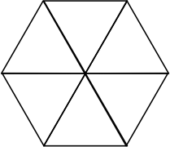

CUT OUT TWO PIECES OF THIS

