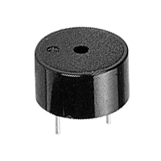See +(positive lead)
Piezo speaker

