INTRODUCTION
Today, most mobile phones are a 'smart phone', which offers more advanced capabilities in connectivity issues than regular cell phones. According to an investigate by ABI Research, at the end of 2013, 1.4 billion smart phones has been in use: 798 million of them run Android, 294 million run Apple’s iOS, and 45 million run Windows Phone . Smart phone usually support one or more short range wireless technologies such as Bluetooth and infrared, making it possible to transfer data via these wireless connections. Smart phone can provide computer mobility, ubiquitous data access, and pervasive intelligence for almost every aspect of business processes and people’s daily lives. One of the smart phone applications that have been developed is smart homes technology. Smart home technology is the technologies that are used in homes with various apparatus converse over a local network. According to the Smart Homes Association the best definition of smart home technology is: the combination of technology and services through home networking for a better value of living. This technology can be used to monitor, alert and execute, according to the desired functions. Smart homes technology makes automatic connection with environment via Internet, telephone or regular fixed phones. Smart homes actually have the ability to make life easier and more proper. Home networking can also offer peace of mind. Whether you're at job or on holiday, the smart home will aware you to what's going on, and security system can be built to offer some help in emergency situations. For example, not only would a house owner be woken with warning of a fire alarm, the smart home would also release doors, call the fire department and light the pathway to safety. The use of Bluetooth technology in a smart phone today is not just for the transfer of data and files only. In recent years, smart home automation is one of the applications of Bluetooth technology. Bluetooth technology operate over unlicensed, its available at 2.4GHz frequency, it also can link digital devices within a range of 10m to 100m at the speed of up to 3Mbps but it depending on the Bluetooth device class . With these qualifications of Bluetooth; we offer a home automation system based on Bluetooth technology.

CIRCUIT DIAGRAM

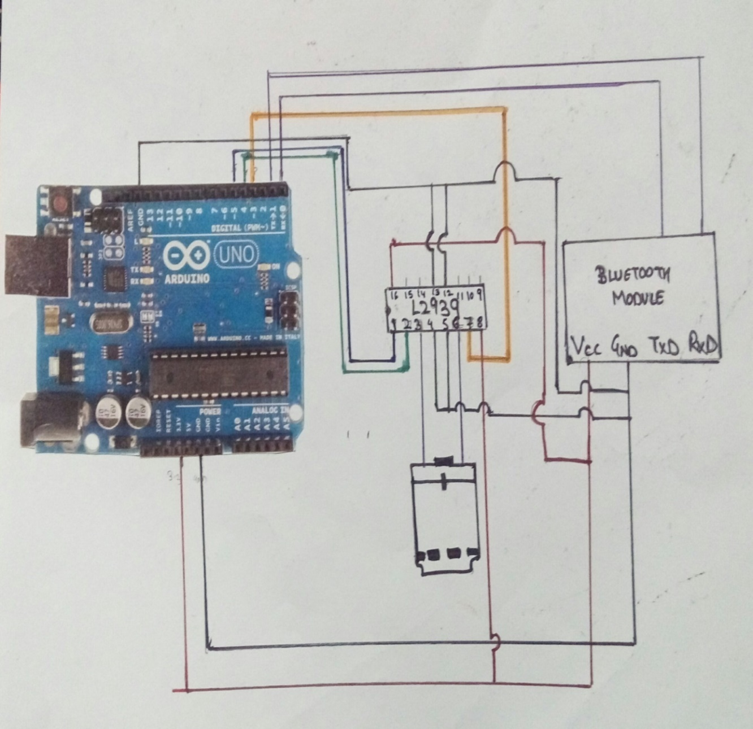

Fig 2.1

COMPONENTS USED
1x Arduino Uno
1x Bluetooth Module (for example: HC-05)
1x Smartphone (any Android will work)
BlueTerm application
1x L293D IC
1x DC motor
1x Breadboard
Jumper Cables

HARDWARE AND SOFTWARE DESCRIPTION

The Bluetooth module HC05:
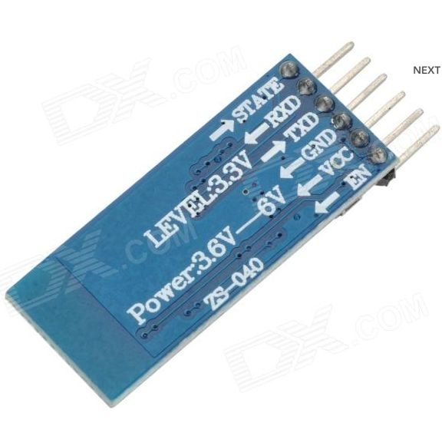
Fig 3.1 HC05
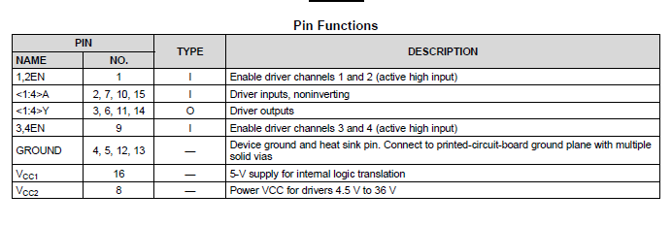
Fig 3.2 Pin out Of HC05
HC-05 module is an easy to use Bluetooth SPP (Serial Port Protocol) module, designed for transparent wireless serial connection setup.
Serial port Bluetooth module is fully qualified Bluetooth V2.0+EDR (Enhanced Data Rate) 3Mbps Modulation with complete 2.4GHz radio transceiver and baseband. It uses CSR Bluecore 04-External single chip Bluetooth system with CMOS technology and with AFH(Adaptive Frequency Hopping Feature). It has the footprint as small as 12.7mmx27mm.
We need to remove the RX and TX cables when you’re uploading the sketch to Arduino.

L293D
L293D is a typical Motor driver or Motor Driver IC which allows DC motor to drive on either direction. L293D is a 16-pin IC which can control a set of two DC motors simultaneously in any direction. It means that you can control two DC motor with a single L293D IC. .
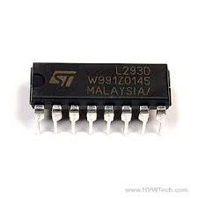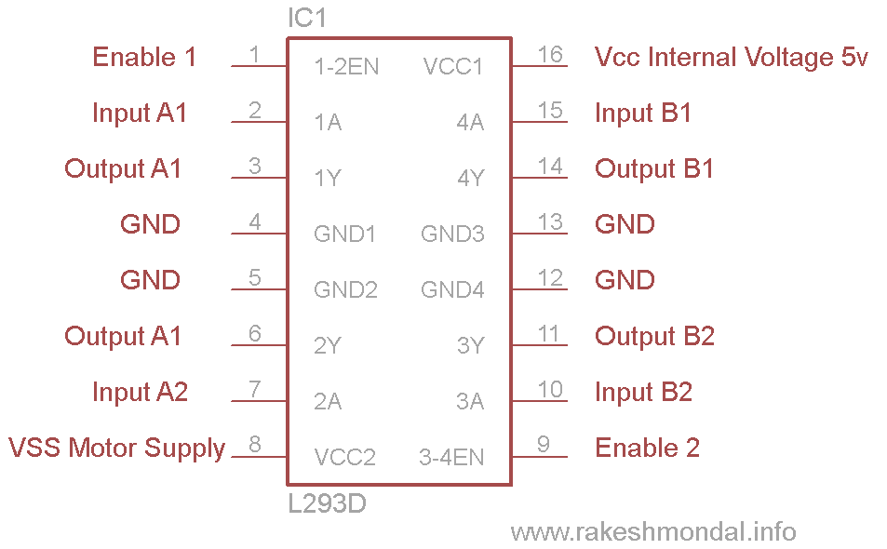
Fig 3.3 L293D Fig 3.4 Pin Out Of L293D

Arduino Uno:

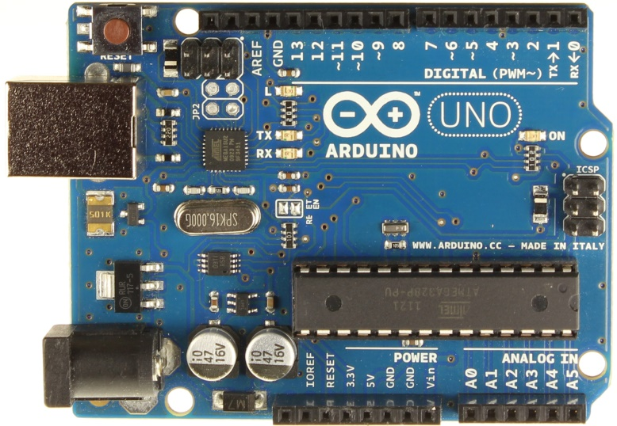
Fig 3.5 Arduino Uno

The Uno is a microController board based on the ATmega328P. It has 14 digital input/output pins (of which 6 can be used as PWM outputs), 6 analog inputs, a 16 MHz quartz crystal, a USB connection, a power jack, an ICSP header and a reset button. It contains everything needed to support the microController; simply connect it to a computer with a USB cable or power it with a AC-to-DC adapter or battery to get started.. You can tinker with your UNO without worrying too much about doing something wrong, worst case scenario you can replace the chip for a few dollars and start over again.
MicroController | ATmega328P
Operating Voltage | 5V
Input Voltage (recommended) | 7-12V
Input Voltage (limit) | 6-20V
Digital I/O Pins | 14 (of which 6 provide PWM output)
PWM Digital I/O Pins | 6
Analog Input Pins | 6
DC Current per I/O Pin | 20 mA
DC Current for 3.3V Pin | 50 mA
Flash Memory | 32 KB (ATmega328P)  of which 0.5 KB used by bootloader
SRAM | 2 KB (ATmega328P)
EEPROM | 1 KB (ATmega328P)
CloCk Speed | 16 MHz
Length | 68.6 mm
Width | 53.4 mm
Weight | 25 g
Fig 3.6 Technical Specification
The Home Automation App:
For the android communication with our bluetooth module we’ve used the BlueTerm app, It’s completely free, so you just need to go to “Play store” and download it. Then you just need to connect your smart phone with the bluetooth module.

Fig 3.7 The App

CONNECTIONS AND WORKING

  - Bluetooth module configuration:
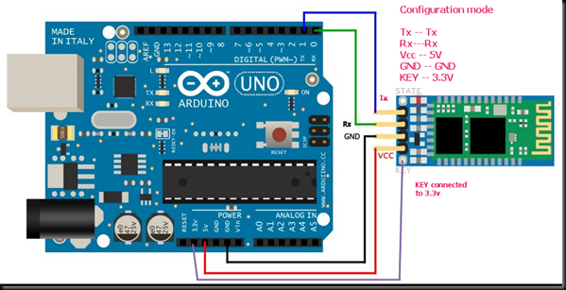
do the following connections with HC05 Slave :
——————————————-
ARDUINO HC05
Rx(pin0 ) —> Rx Remember it is one to one connection here & not cross connection
Tx (pin1) —-> Tx
+5v ——-> VCC
GND ——-> GND
+3.3V ——–> KEY
————————————————-
Command mode:
- Key is now connected to 3.3v,
- Now remove the Vcc pin of Bluetooth and reinsert it.
- Now you can see an orange led glowing slowly which indicates that bluetooth is in command mode.
- Now your HC05 module will respond to all the AT commands.
- Now set the baud rate 38400 and open the terminal. The figure below shows the AT command and their responses.

Data mode:
- Keep the key pin open.
- Now restart the Bluetooth.
- Orange led blinks fast ie the bluetooth is in data mode.
- Now when bluetooth is connected to the app red led blinks.

The Inputs given from the app:
’0′ – Turns off the DC motor
’1′ – DC motor rotates to right
’2′ – DC motor rotates to left

RESULTS
Connection of bluetooth module to app
Motor was moving right, left and stopped after the instruction was given.

CONCLUSION
Thus having implemented this project successfully on a small scale and have inferred that with a proper power driving mechanism the same can be used to control our home appliances thus helping us make things automated. We thus gained knowledge on the how to interface Bluetooth module with Arduino.

FUTURE SCOPE
- To control the fan speed
- To make things automated
- To avoid loss of electricity consumption due to carelessness by interfacing all other home devices.

REFERENCES
- https://www.arduino.cc/en/main/arduinoBoardUno
- https://alselectro.wordpress.com/2014/10/21/bluetooth-hc05-how-to-pair-two-modules/
- http://www.engineersgarage.com/electronic-components/l293d-motor-driver-ic
- R. Piyare, M.Tazil. 2011. Bluetooth Based Home Automation System Using Cell Phone, 2011 IEEE 15th International Symposium on Consumer Electronics.2013. Business Insider Homepage [online], available: http://www.businessinsider.com/15-billion-smartphonesin-the-world-22013-2?IR=T&.
- Pei Zheng, Lionel Ni. 2006. Smart Phone and Next Generation Mobile Computing, Morgan Kaufmann publisher, san Fransisco. R. John Robles and Tai-hoon Kim, 2010.
- Applications, Systems and Methods in Smart Home Technology: A Review, International Journal of Advanced Science and Technology. 15: 37-48. D. Saxena, P. Bisen and S. Bhoyerkar. 2012.
- Development of Intelligent Security and Automation System, International Journal of Advanced Research in Computer Science and Electronics Engineering (IJARCSEE). 1: 139- 143. 2014. How Bluetooth Technology Works, [online]. Available: www.bluetooth.com/bluetooth/technology/works. S. Kumar, 2014.
- Ubiquitous Smart Home System Using Android Application. International Journal of Computer Networks and Communications (IJCNC). 6: 33-43. D. Javale, M. Mohsin, S. Nandanwar, and M. Shingate.2013.
- Home Automation and Security System Using Android ADK. International Journal of Electronics Communication and Computer Technology (IJECCT). 3: 382-385.
- D. Naresh, B.Chakradhar, S.Krishnaveni. 2013. Bluetooth Based Home Automation And Security System Using Arm9, International Journal Of Engineering Trends And Technology (IJETT). 4: 4052-4058. M. Yan and H. Shi.2013.
- Smart Living Using Bluetooth Based Android Smartphone, International Journal of Wireless and Mobile Networks.5: 65-72.

