70mm

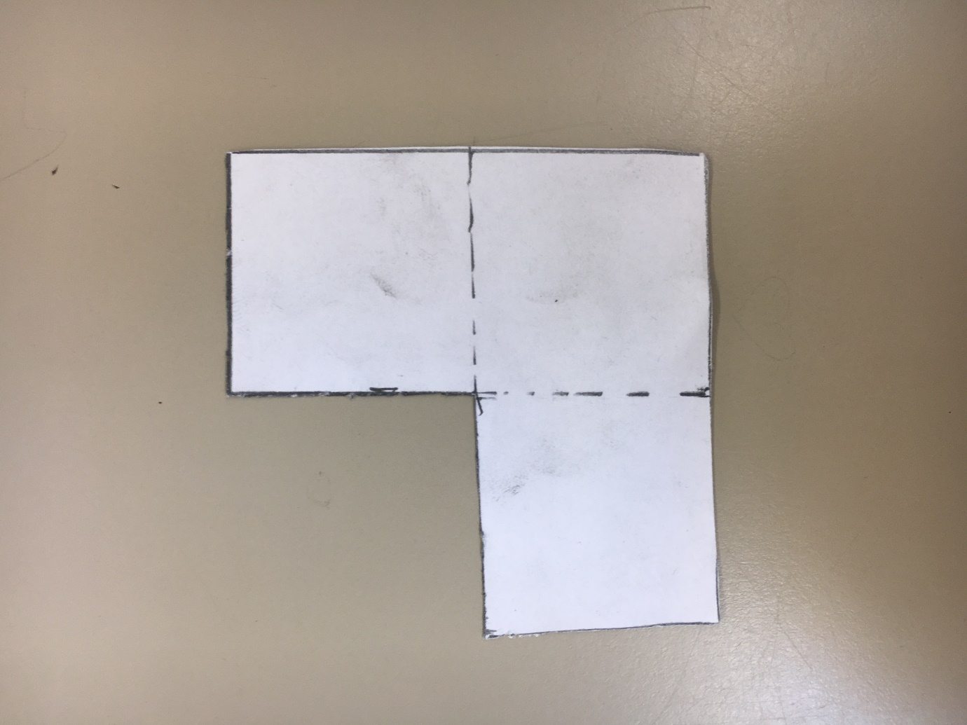

3.5mm

70mm

3.5mm

3.5mm