Seeing potential I made a bra puppet
Materials
- Two recycled padded under wire bras,
- Black embroidery cotton
- needle with a large eye
- beads for eyes
- pieces from an old necklace or jewellery of choice
Method
- Two cup pieces were sewn together along the wire edge to form the head leaving the front open for the mouth
- Sew on hair bead eyes and decorations of choice to give the puppet character
- Shape the bra back for ears
- The body was sewn using another bra the top section used to shape the neck
- Bra straps sewn in place for the arms
- The hands were shaped from the strap that fastens at the back with the hooks and eyes. The same strap was used to shape the nose piece and sewn in place
- The puppet character is up to you just look at the possibilities once you have made the head piece. Perhaps a recycled clothing for a body, another bra or a simple tied rope body

Hysterical laughter from one two year old was the reaction to this puppet
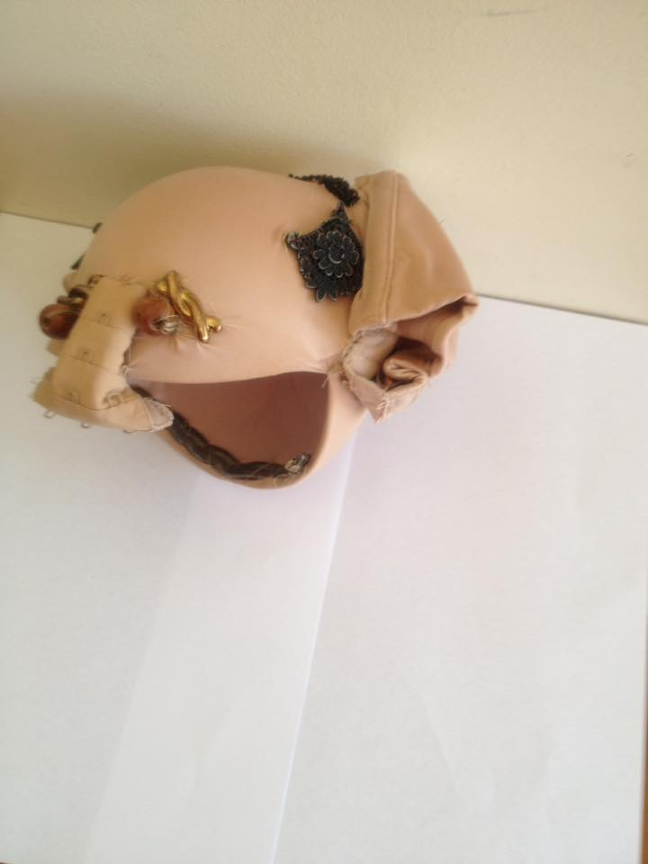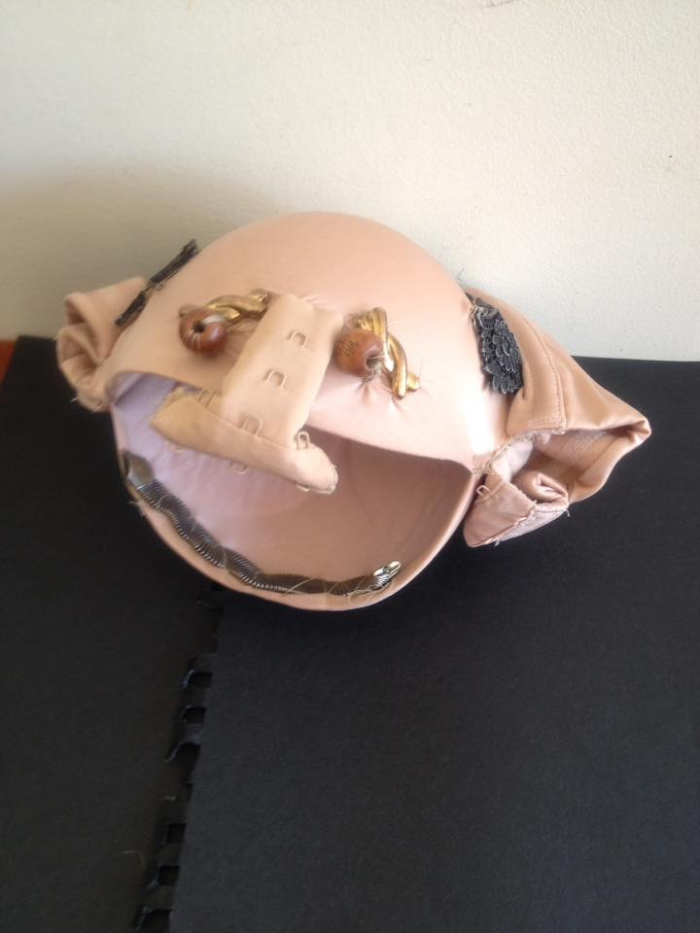

Hysterical laughter from one two year old was the reaction to this puppet

