# 滑板建模介绍

2019级车辆工程2班陈业生

此模型是用tinkercad网页建立的，此网站有操做简易方便、使用免费的多种优

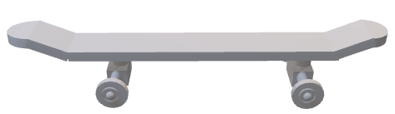

图1是我此次所建立的模型

这个模型虽然看起来有普普通通的感觉，甚至有些别扭。其实不然，它其实运用了包括结构稳定和强度学，流线形、人机关系等众多学科知识，打造而成的高级滑板！

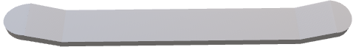

图2是我制作的板底

别看它其貌不扬的样子，其实它的原形是龙舟。你看它两端45度翘起，有利于减少空气阻力，使滑板更快些。中间的平板能与滑板所接触的平面形成，相对水平，能为使用者提供充足的稳定性。

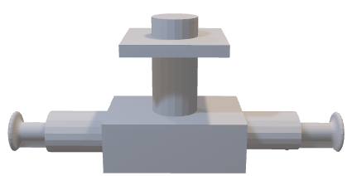

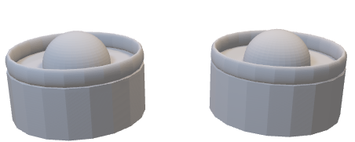

图3是轴承和轮子

轮子共有四个，加上俩个轴承，组成滑板底部结构。四个轮能为滑板提供足够的接触面积，轮子外部的四个小环能有效的防止滑板在高速运动中侧翻！

轴承运用极其稳定的结构方式，其中横向的轴，是用高强度金属打造而成，能使滑板的负载大大提高，也造就了这个轴承具有结构稳定、负载大等特点！

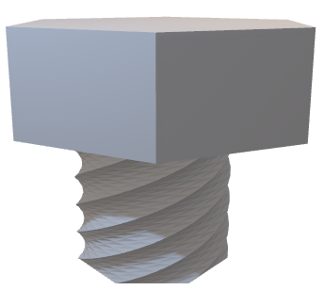

图4是用于连接各部分的螺丝钉

板底、轮子、轴承等各部分的连接都是用螺丝钉，这不仅有利于加强整个滑板的整体性，还方便于保养和维修，这使滑板的使用寿命大大延长！

Intorduction to skateboard modeling

Chen yesheng. class 2 vehicle engineering class2019

This model is built with the tinkersad web page, this site has many advantages of easy to operate and free to use.

10%OKS

Figure 1 is the modell built this time

Although this model looks ordinary feeling, even a ittle awkward. In fact, it is not, including the use of structural stability andstrength of science, flow, man machine relations and many other disciplines of knowledge, built into the advanced skateboard!

Figure 2is the botomo the boadtmade

Despite do appearanceit sectuoly the originolshapeo the dragon boat You can 3c0 theends are45 degreeo up. which helps teduce the airesistance ndmokes the board faster. The middle plate c

Stability of the foct..

Fipura3 thom the bearingn and whrela

Thee are fcur wheela, plus tro bearings. formirgthe boticm structure of the skatcboard. The four whce 5 can provde enoughcontact orca for the skataboard.

The bearing USES an extremely stable structure, in which the transv