How to Fold a Dollar Bill into a Bowtie
James Daniel

Introduction

The purpose of this tutorial is to have a little fun and entertain friends and family.

Materials:

- Dollar Bill

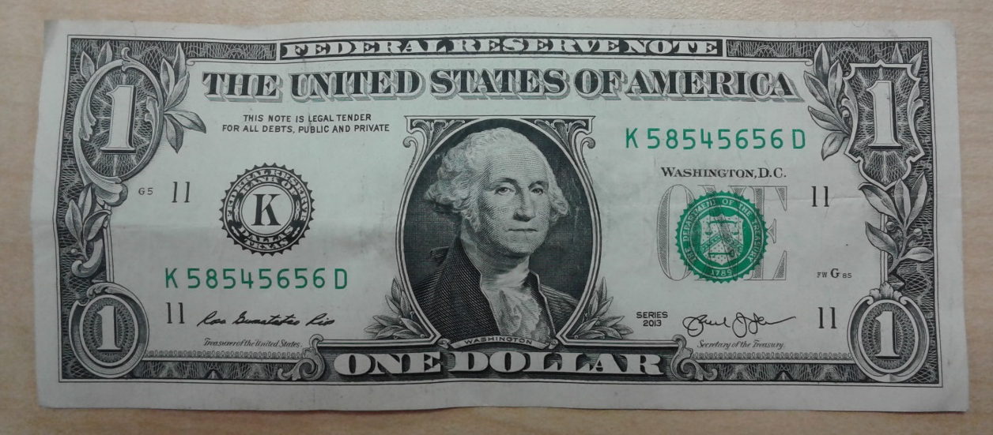

Step 1

- Place the bill with George Washington face down on a hard surface.
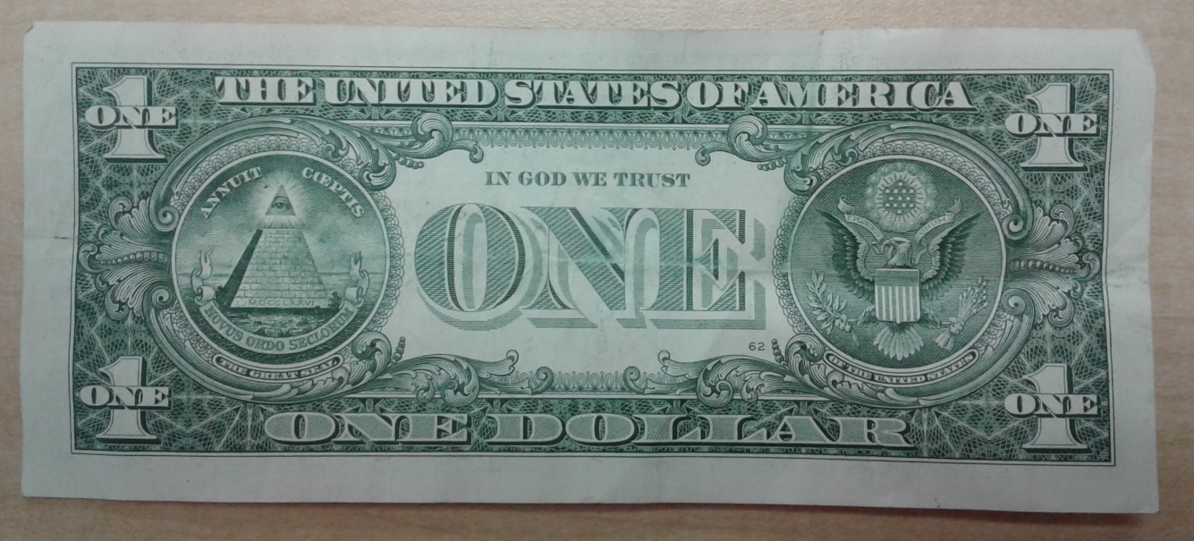

Step 2
Washington Here
- Fold the bill in half from left to right.

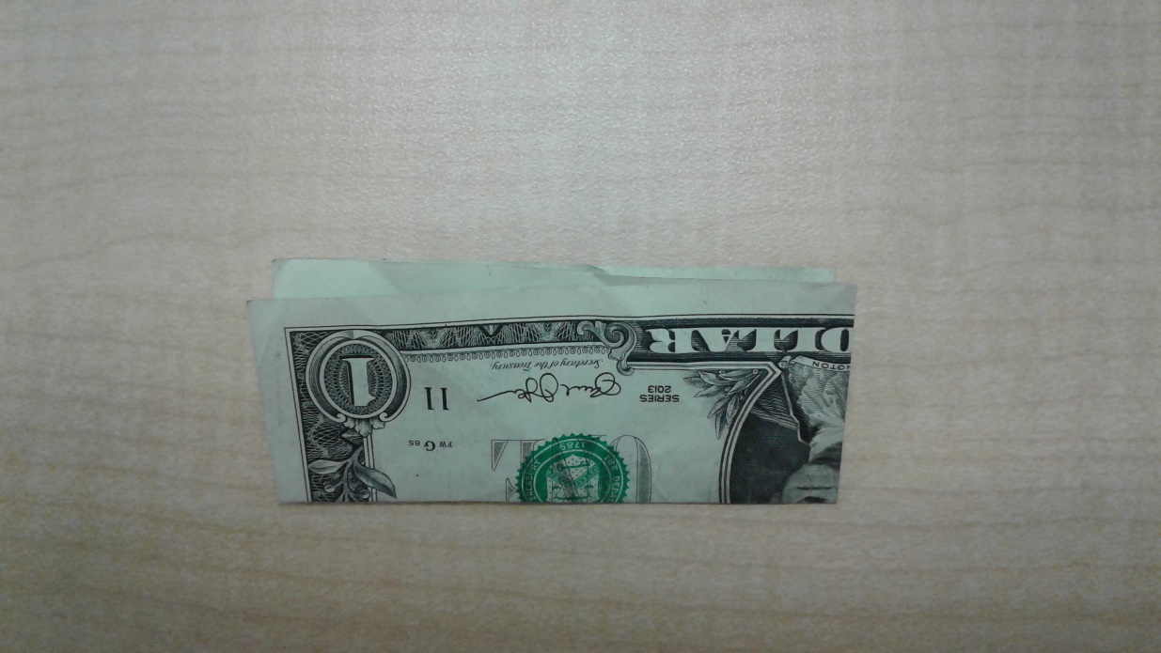
Step 3

- Fold the dollar bill in half from bottom to top.

Step 4
Washington at top
- Rotate the dollar bill so that George Washington’s face is at the top.

- Hold the dollar bill in the bottom left corner.

George Washington

Finger Under Flap

Picture 1
Step 5

- Pull the open flap over to the right. (Picture 1)

Picture 2

- Press down at the top of the dollar bill to make a triangle (Picture 2).

Washington Here
Step 6

- Flip the dollar bill over.

Step 7
- Hold the dollar bill on the left side (Picture 1)

Picture 1

- Fold the right flap over to the left side to make a triangle at the top (Picture 2).

- Flatten creases of triangle.

Picture 2

Step 8:

- Hold the bottom of the dollar bill.

- Open the right flap from right to left.

- Note: This is what the dollar should look like after Step 8.

Step 9

- Flip the dollar bill over.

Note: Triangle should be at the top.

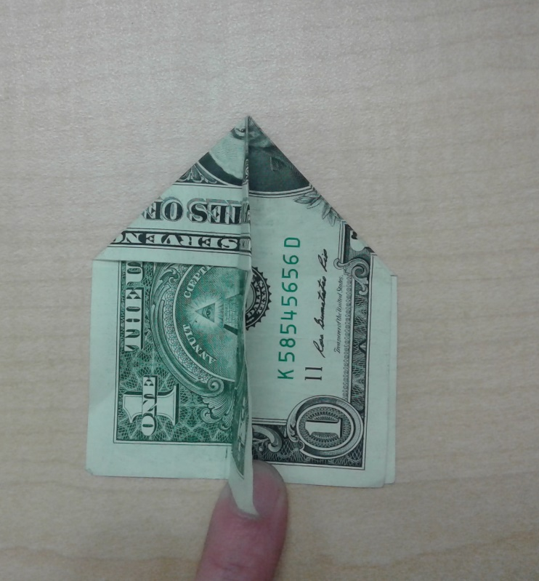
Step 10

- Hold the bottom of the dollar bill.

- Open the right flap from right to left.

Hold Here

- Note: The dollar should look like this after Step 10.

Step 11
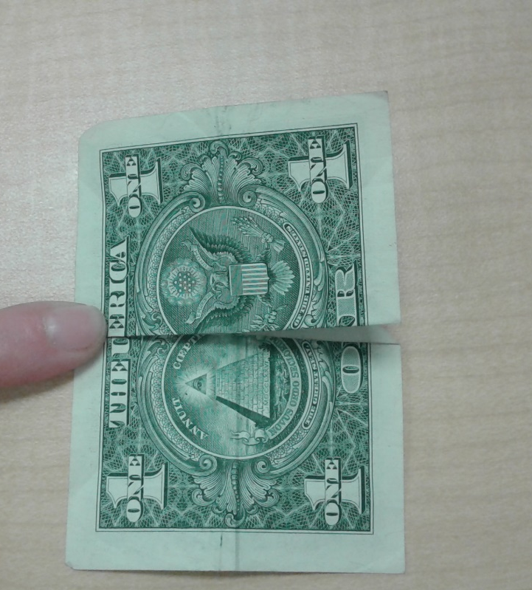
- Fold the bottom corners of the top flap up and over the triangle.

Step 12

- Flip the dollar bill over.

- Fold bottom corners up and over the triangle.

- Note: The dollar should look like this after Step 12.

Step 13

- Fold the bottom right corner to the middle crease of the dollar bill.

- Fold the bottom left corner to the middle crease of the dollar bill.

Step 14

- Flip the dollar bill over.

- Position the bill where the number 1 is in the top right and left corners.

- Fold the bottom right corner to the middle crease of the dollar bill.

- Fold the bottom left corner to the middle crease of the dollar bill
.

Step 15

- Place both thumbs inside the crease

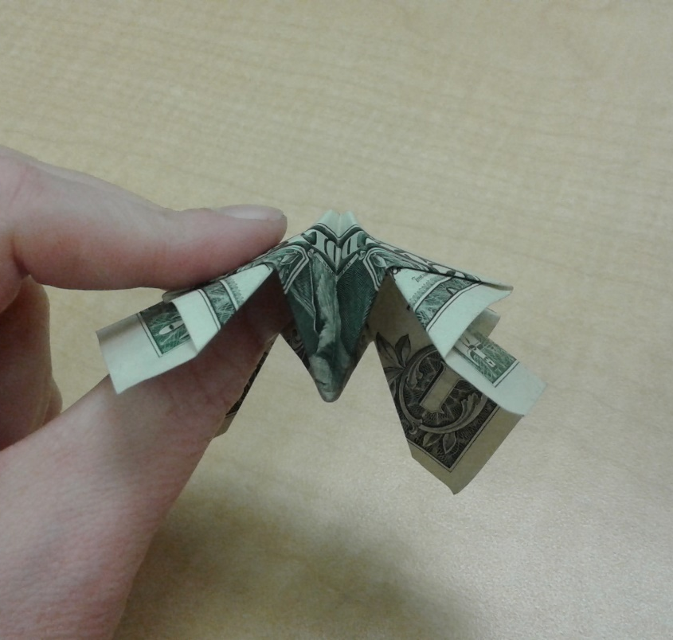
- Hold the back of the bill with both index and middle fingers.

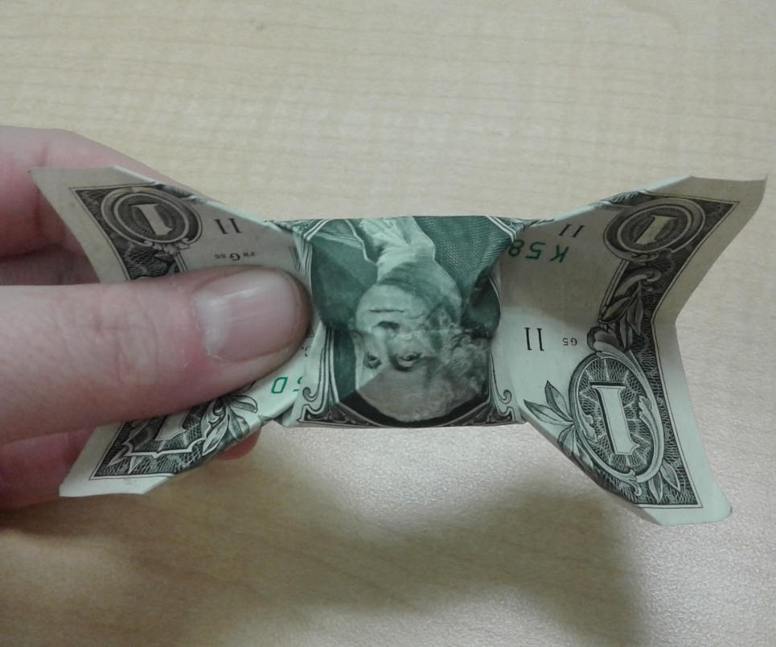
Step 16

- Leave fingers and thumbs in place.
Pop Out Center

- Push fingers inward and thumbs outward to pop out the center of the bowtie.

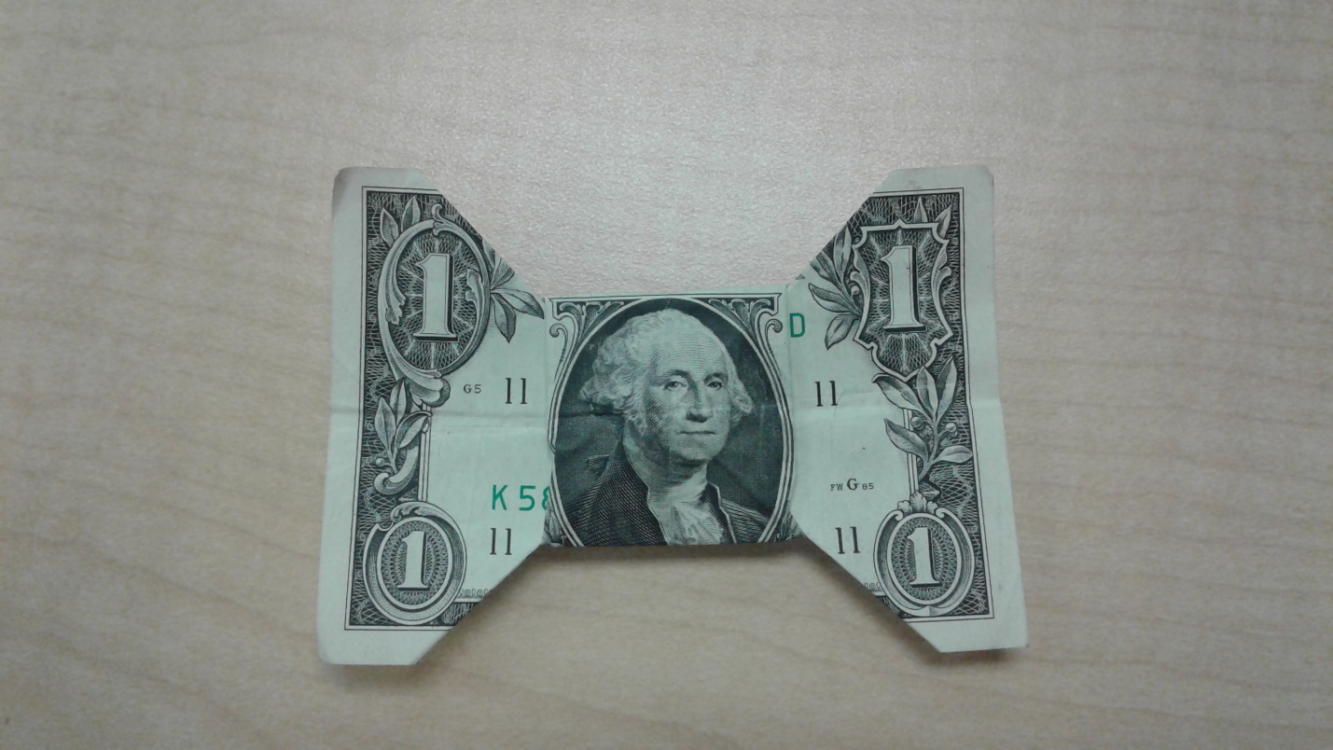
Finished Product

