Supplies
Big Teddy Bear
Bunny
Cardboard box
Stapler and staples
Scissors
Thread
Needle
Conductive Tread
20 Yellow LED
20 Red LED
LilyPad
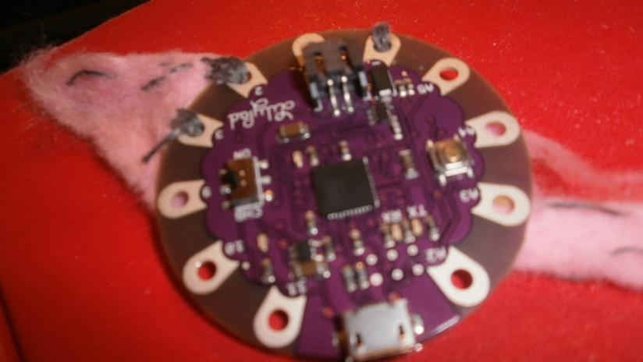
LilyPad Arduino
Speaker (comes with Arduino)
Light Sensor (comes with Arduino)
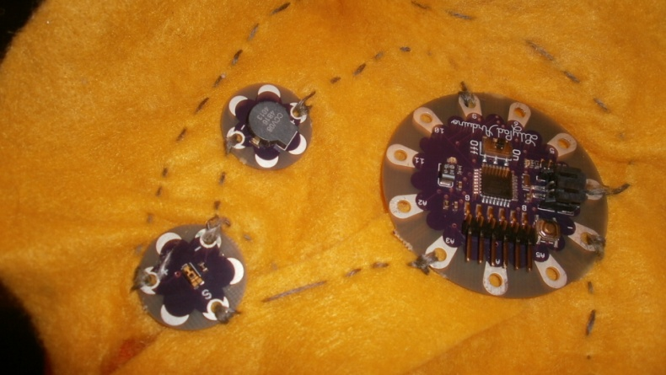

Steps
Making the Case
- Make a mold using the cardboard box
(We placed the box over the robot and arranged the box to fit)
**This step will change depending on your robot’s shape and size.
The following figures are our cardboard mold.
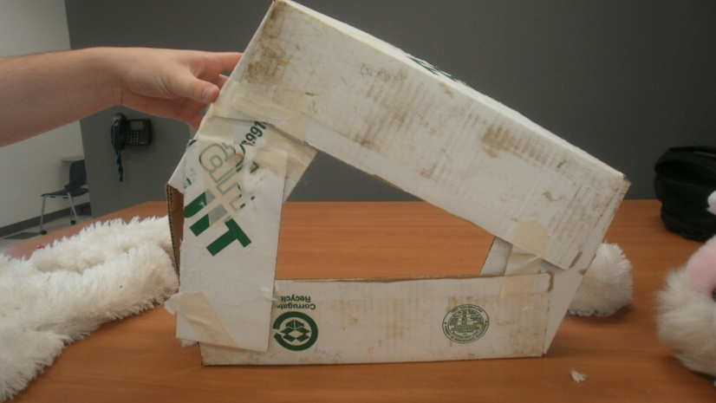

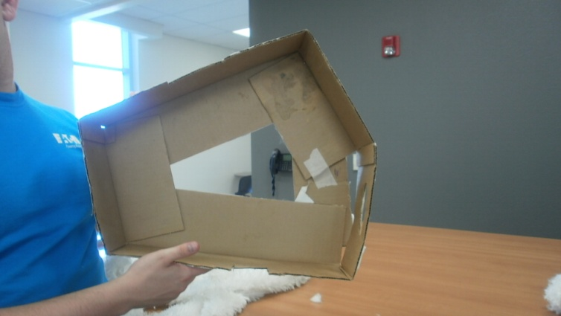
- Buy teddy bear and bunny from Deseret Industries (DI)
- Cut into the bear so that you just have the body and could attach the bunny head
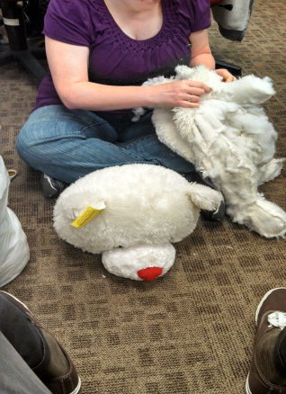
- Staple or glue the body of the bear onto the mold you made
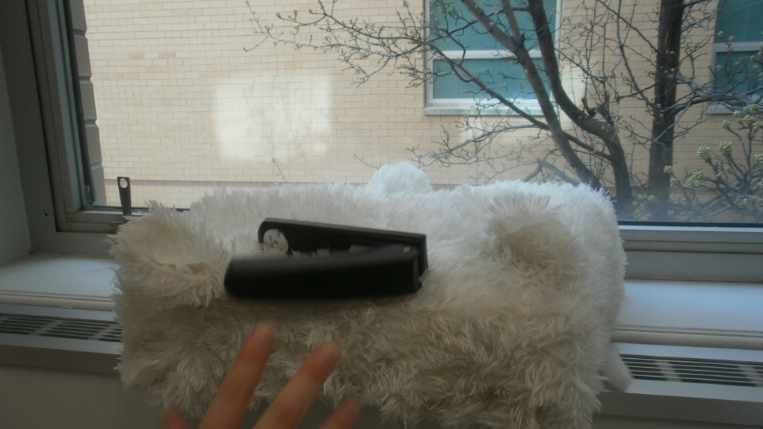
- Cut into the bunny for the head and feet
- Sew the head and feet onto the bear’s body which is on the mold
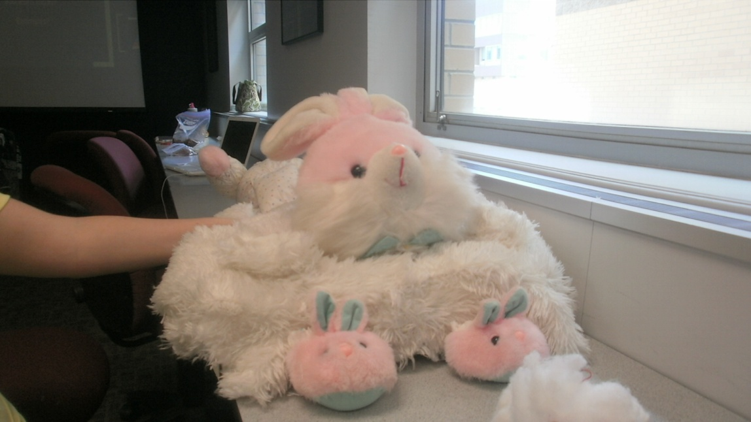
- The tail of the bunny/bear is the leg of the bear cut down to look like a bunny tail.
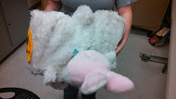
- We added an American flag to the back of the robot, as a type of bumper sticker. Vladimir loves showing off his American pride.
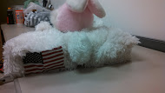

Making the Racing Stripe
- Draw out your circuit diagram! Make sure all the positive sides of the LEDs are connected to only each other and the negative sides of the LEDs are all connected to each other; in other words the LEDs are in series. The negative side of the LED is the side that is shorter and the LED is more flat on that side.
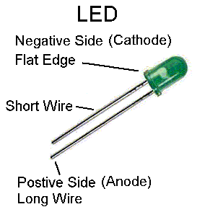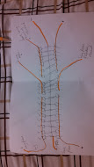

- To get the lights to make a pattern and look cool, we mixed the red and yellow LEDs in the same line and wanted the color lights blink at different times. This is why in the circuit diagram you see that some of the lights are disconnected from the other line of lights. It is important to make sure your wires or in our case conductive thread does not cross. When our threads were going to overlap each other we would put felt down between the threads so that the threads would not touch each other. (that is the yellow in the picture) Each line of negatives is connected to the negative pin on the LilyPad and the positive side of the yellow LEDs are connected to A3 and the positive side of the red LEDs are connected to A4 on the LilyPad.
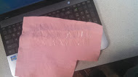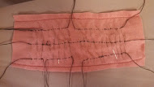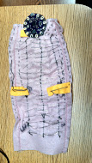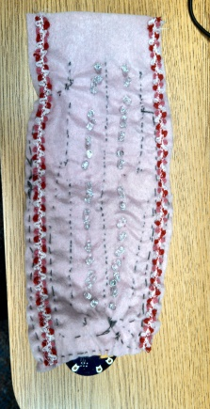
- We printed a racing stripe pattern on some paper and then put Canola oil on the paper to make it transparent like. We then put the lights on the side of the case and the racing stripes on top of the lights.
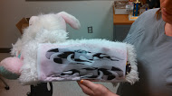

Coding the Lights
Coding was done using a LilyPad and Arduino
//saying what each pins connected to
int redLed=A2;
int yellowLed=A3;
int brightness=0;
int fadeAmount=10;
//setting up the pins as outputs so can output light
void setup(){
pinMode(redLed,OUTPUT);
pinMode(yellowLed,OUTPUT);
}
void loop()
{
//turn on all the lights
digitalWrite(redLed,HIGH);
delay(1000); //must delay so can see the action for at least 1 second
digitalWrite(yellowLed,HIGH);
delay(1000);
//have the yellow LEDs fade out
analogWrite(yellowLed,brightness);
if(brightness==0||brightness==255){
fadeAmount=-fadeAmount;
}
delay(1000);
//turn off the red LED
digitalWrite(redLed,LOW);
delay(1000);
//turn on and then off the yellow LEDs
digitalWrite(yellowLed,HIGH);
delay(1000);
digitalWrite(yellowLed,LOW);
delay(1000);
}

Making the Sensor
We wanted to have the robot play Beyonce’s song To the Left anytime the robot turned left and to play Choose the Right, an LDS Hymn, anytime the robot turned right. However, we had too much trouble with programming a tilt sensor so we choose to make the robot play the songs depending on how much light was exposed to the light sensor.
- Draw your circuit diagram! The light sensor has three different connections that must be connected to the LilyPad Arduino. S is connected to A3 where the negative is connected to a negative pin and the positive is connected to the positive pin of the LilyPad. The speaker positive pin is connected to pin 9 on the LilyPad and the negative pin to the negative on the LilyPad.
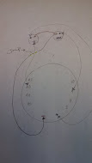
- Sew on the speaker and light sensor as seen in your diagram.
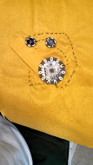
Once again make sure your threads do not touch each other. If they will touch add felt between so that they do not.
- Sew or staple the sensor onto your case.

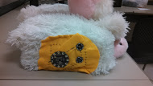
It is important to sew the LilyPad on felt or similar material. We originally sewed on to a silk like material and that caused the LilyPad to smoke and die!
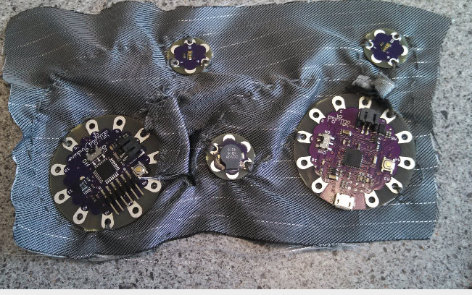

Coding the Sensor
Lanetta’s fiancé, Andrew, helped us know what the notes are of the songs and then when testing the songs telling us which notes where off. He was a great help!
Knowing the frequency of the notes was hard at first. It helped once we realized how the notes matched the piano on the following website: http://en.wikipedia.org/wiki/Piano_key_frequencies (Thanks for the help Andrew!) Arduino has a library for notes but we had already done the frequencies for the notes. If you use the library the songs will not work if you mix in the notes you define using frequencies. To know what kind of values the light sensor reads with various light expose you can use the serial code that is given in Arduino.
//Pin Setup
int speaker=9;
int sensorPin = A3; // Light Sensor connected
int sensorValue; // variable to store the value coming from the sensor

//Website for the notes: http://www.phy.mtu.edu/~suits/notefreqs.html
int a=440;
int b=493.883;
int c=523.251;
int e=329.628;
int mc=261.626;
int d= 293.665;
int f=349.228;
int eflat=311.127;
int bflat=466.164;
int g=391.995;
int nosound=0;
//To The Left
//All the notes are put into an array
int totheleft []={d,f,f,d,f,f,nosound,eflat,f,f,eflat,f,f};
//how long each note is 4=quater note, 3=quater with dot, 8=eighth note, 2=half note
int durationleft[]={16,16,8,16,16,4,1,16,16,8,16,16,4};
//Choose the Right, beginning of song
int chooseright[]={e,f,g,g,g,a,c,b,a,g,e,d,e,f,g,b,a,g,f,e};
int durationCTR[]={4,4,3,16,16,8,8,8,8,4,4,4,4,3,8,9,16,8,8,2};
//Setting up the pins, A3 is an input (how much light) where the speaker is an output (there is noise coming out)
void setup()
{
pinMode(speaker,OUTPUT);
pinMode(A3, INPUT);
}
void loop()
{
sensorValue = analogRead(sensorPin); // read the value from the sensor
if (sensorValue >=40 && sensorValue <= 100) //Light Detected
{
for(int thisNote=0; thisNote<100; thisNote++){ //go through the array of notes
int noteDuration=18000/durationleft[thisNote];
tone(speaker,totheleft[thisNote],noteDuration);//play each not
delay(noteDuration*0.30);//have a short time between each note so the ear can hear the note
noTone(9);
}
}
else if (sensorValue>101){ //lots of light detected
for(int thisNote=0; thisNote<100; thisNote++){
int noteDuration=18000/durationCTR[thisNote];
tone(speaker,chooseright[thisNote],noteDuration);
delay(noteDuration*0.30);
noTone(9);
}
}
else //No Light Detected
{
noTone(9); //do nothing
}
}

Final Outcome 3D view of the Project:

Front View:
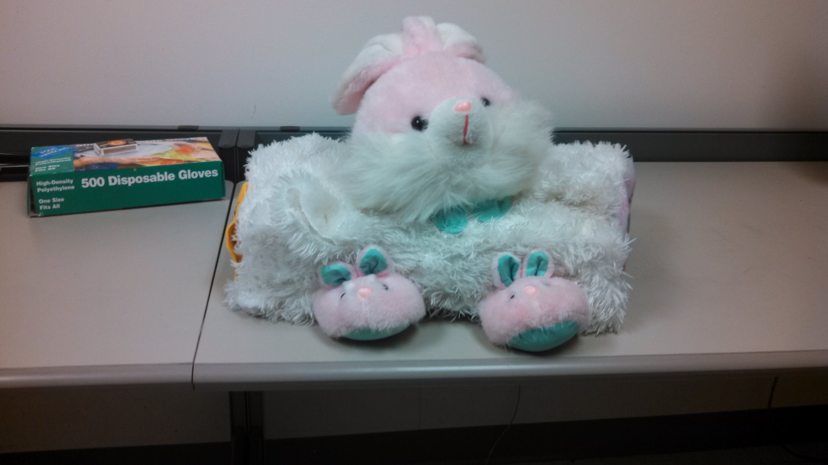

Side View Racing Stripes
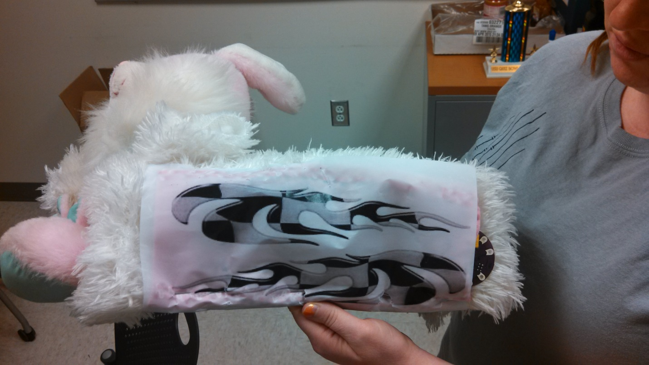
The American Flag View people favorite view:
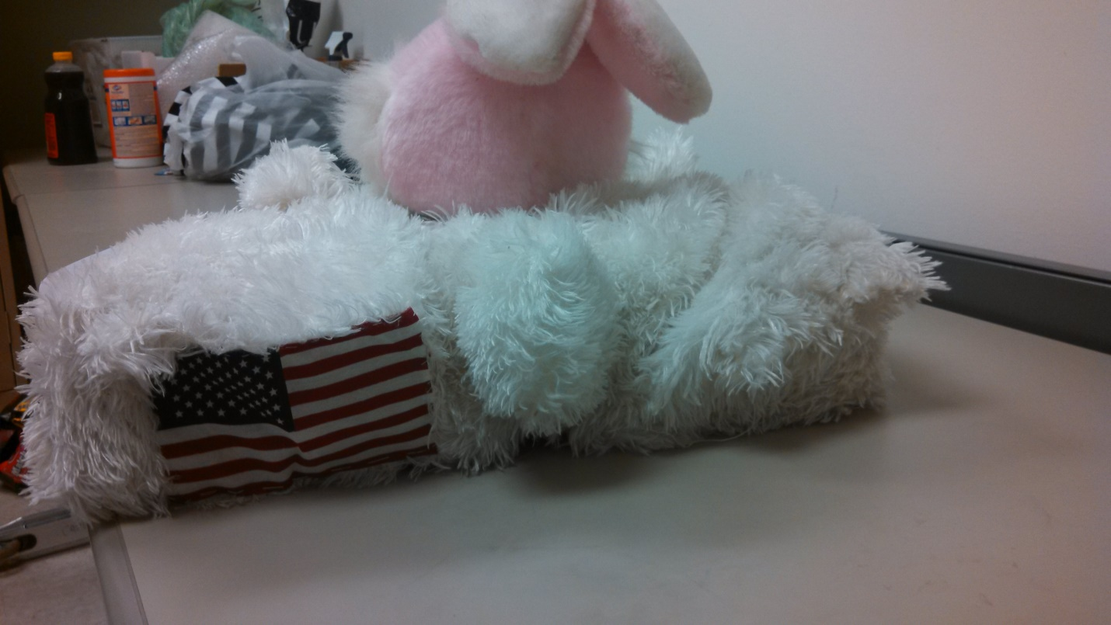

Under the Bunny:
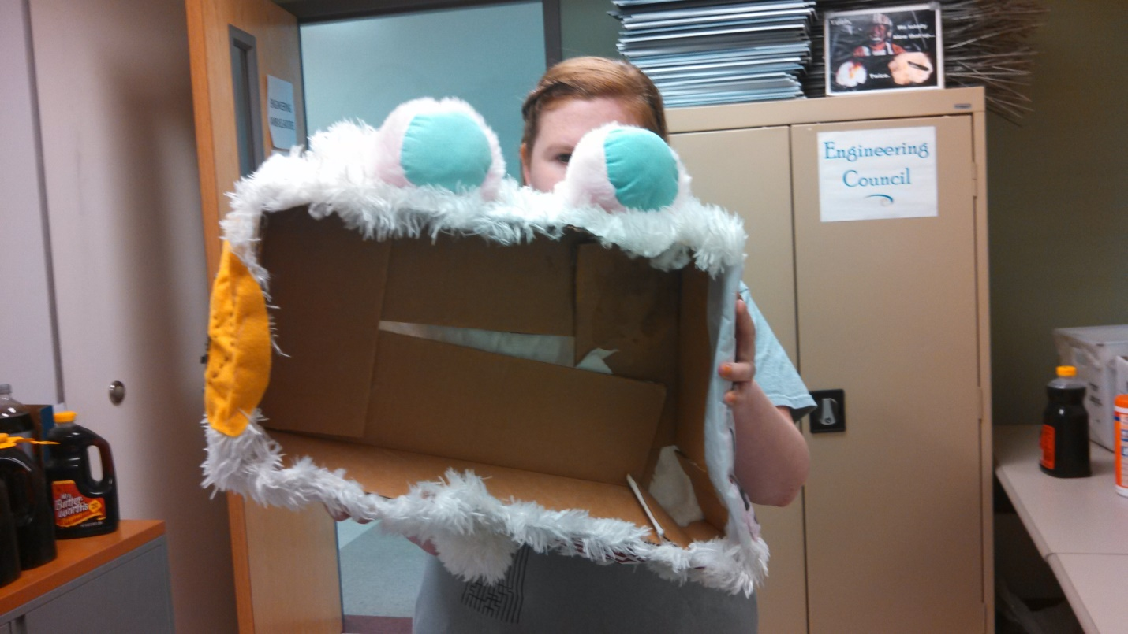

Bunny Tail:
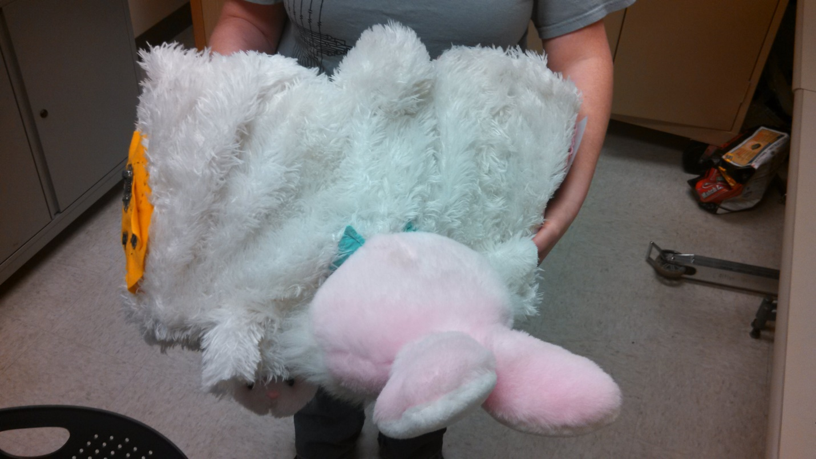

Front View:

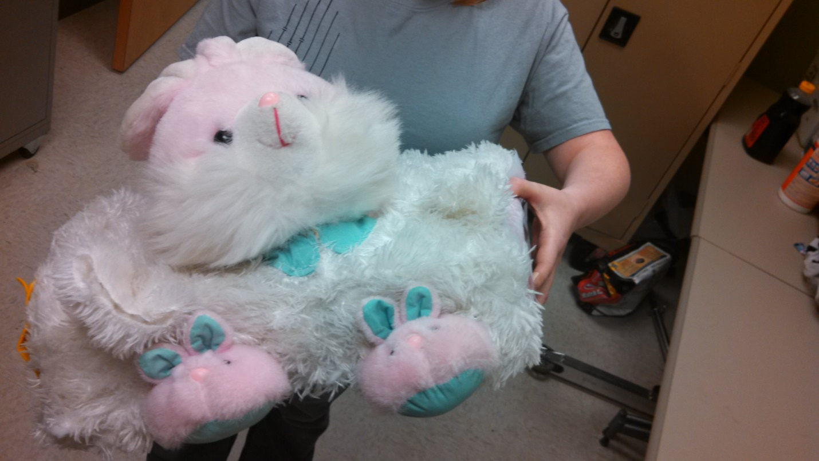

Lilly pad, Speakers and Light Sensor:

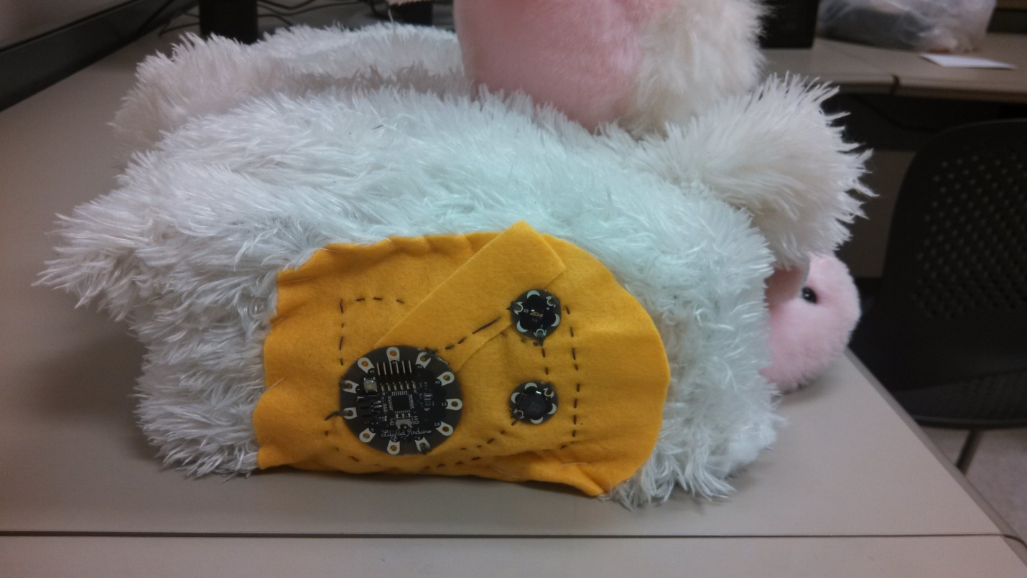

The “Robot” the Bunny Case will be the body of this amazing Robot.
