AURDINO AC VOLTMETER 0 to 230/300 VAC MEASUREMENT USING LEAF VOLTSNS300 V1
Here is a useful circuit for Arduino lovers and experimenters.
It is a simple digital voltmeter, which can measure input ac voltages in 0 to 300V range. The Arduino board can be powered from a standard 9V battery pack, as usual.
As you may well know, Arduino’s analog inputs can be used to measure DC voltage between 0 and 5V (when using the standard 5V analog reference voltage) and this range can be increased by using LEAF VOLTSNS300 V1.
Important Note :: This sensor Needed calibration initially with actual voltmeter.
During first time use. use one voltmeter check voltage and using POT set accurate Value in Arduino serial since value in AC and DC for sensor will be different .
Code in the Arduino sketch is then used to compute the actual voltage being measured.
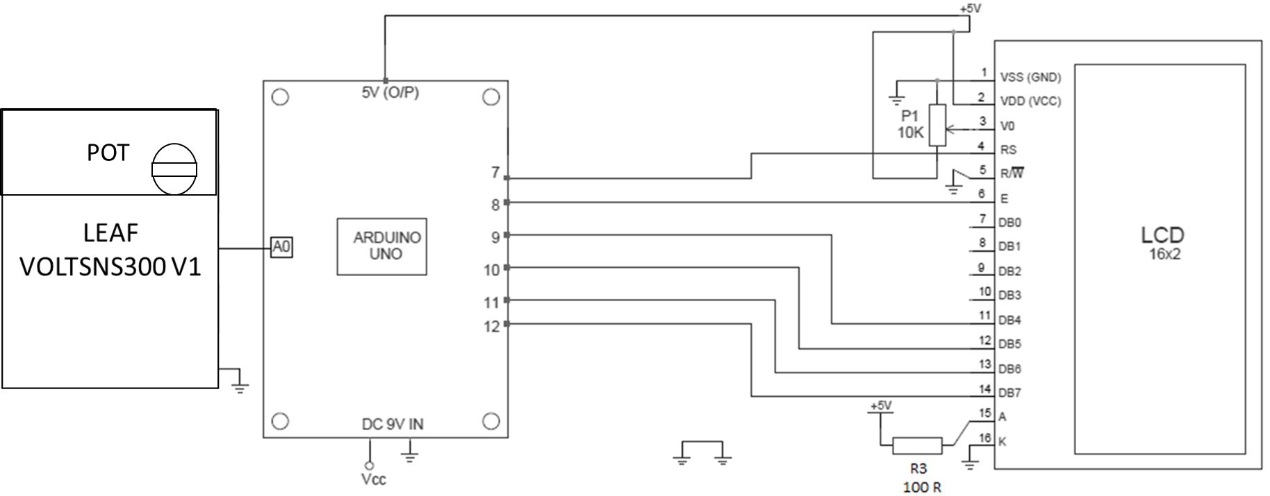

The analog sensor on the Arduino board senses the voltage on the analog pin and converts it into a digital format that can be processed by the microcontroller. Here, we are feeding the input voltage to the analog pin (A0) using a simple LEAF VOLTSNS300 V1.
So, in practice, it is better to label this voltmeter as “0-300V DVM” to add a Hurrah!
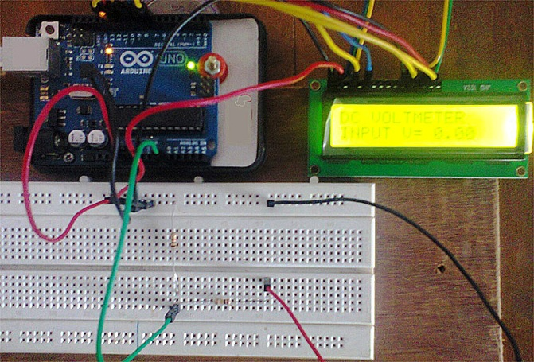
Aurdino Code ::
/*
AURDINO DC VOLTMETER 0 to 230/300 VDC MEASUREMENT USING LEAF VOLTSNS300 V1
*/
#include LiquidCrystal lcd(7, 8, 9, 10, 11, 12);
int VOLTAGESENSORPIN = A0; // Current sensor connected to A0 in this so
selected A0
void setup(){
Serial.begin(9600); // initialize serial communication at 9600 bits per second:

lcd.begin(16, 2);
lcd.print("DC VOLTMETER");
}
void loop()
{
int sensorValue = analogRead(VOLTAGESENSORPIN); // Getting value from voltage sensor
sensorValue=sensorValue; // Storing value or getting it calculated if needed
Serial.println(sensorValue); // Send value to Serial Port
delay(100); // delay in between reads for stability
lcd.setCursor(0, 1);
lcd.print("INPUT V= ");
lcd.print(sensorValue);
delay(500);
}

https://create.arduino.cc/projecthub/Leaf_elect/aurdino-ac-voltmeter-0-to-230-300-vac-measurement-using-leaf-90dee8

