Sample Lower end prices for Recording Accessories
(This does not include the laptop, desktop, or tablet)

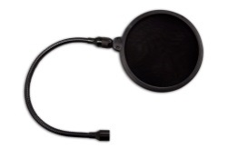
Samson Pop Filter $18

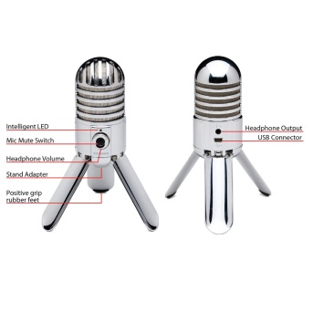
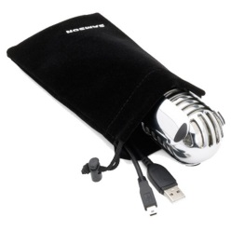
Samson Meteor Mic $50

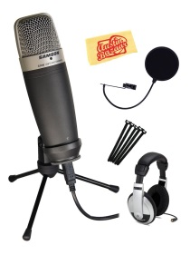
Samson Q2U Bundle $90 Mic, Headphones, Pop filter, cords

Samson Q2U Bundle $53 Microphone with Headphones and Windscreen ball
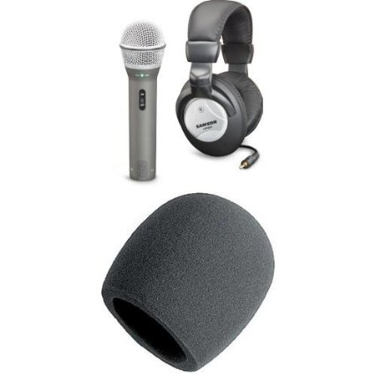

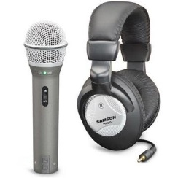
Samson Q2U Pack $50 Mic and Headphone pack

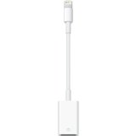
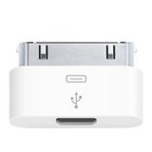
For Apple, you will need a USB Adapter for the Microphone. $13-30

