How to Make a Quadcopter Drone and Components List

Basically a drone quadcopter using several main parts below:

1. Frame
2. Motor 4 pieces
3. Electronic Speed ​​Control ( ESC ) 4 pieces
4. Flight Control Board
5. Radio transmitter and receiver
6. Propeller 4buah ( 2 clockwise and 2 anti-clockwise )
7. Battery & Charger

In the tutorial how to make drone quadcopter this time, the addition of GPS , cameras and other accessories can be adjusted with the budget and the use of drone quadcopter each of you .

Motor Or Rotor

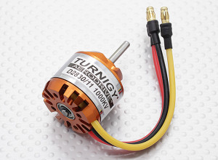

Motor is used as the player vane in order homemade quadcopter you can fly and maneuver . There are so many types of motorcycles sold in the market , but there are some things that are required of you noticed.
Motor kilovolt be sorted by size , the higher the faster his kV motors also can rotate. Usually when you buy a special bike quadcopter , you will get the specifications such as : how much amperage required ESC and propeller size recommendations .
In the tutorial how to make drone quadcopter this time , you can buy a bike with a size of 1000 kV , you can search for it by typing the phrase " sell brush -less motors 1000kV " in google . then you will get a lot of people who sell goods at prices ranging from 300 thousand to 400 thousand to four motors .

ESC (Electronic Speed Controls)
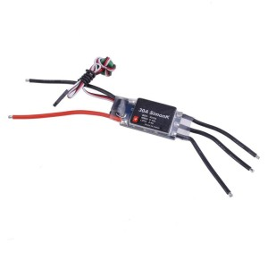
ESC or Electronic Speed ​​Controls is a component that works set on each motor rotation speed . You need four pieces of ESC are connected to each of the four motors earlier.
Later, the ESC is connected to the battery as a power source via a socket or via power distribution board first. The level of accuracy of motor rotation is very important to maintain the stability quadcopter , so use the appropriate and qualified ESC .
As a recommendation , use ESC contained therein Simonk Firmware , firmware is able to change the refresh rate of the ESC so as to provide instructions per second more than the ESC to the motor

Flight Controller
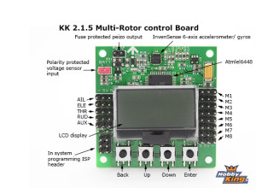
This is the central component of a Quadcopter , in the board Flight Controller on duty there gyroscope sensor for determining the orientation of motion and accelerometer sensor that reads the speed and slope of the quadcopter .

Radio Transmitter dan Receiver
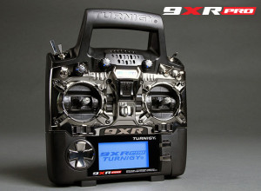
To be more simple , we call it the Remote Controller . If you want to use Flight Controller HobbyKing KK2.0 , at a minimum you should buy a remote controller that has 4 channels .
Usually to control quadcopter , could use 9xR Turnigy brand , the brand is very popular in Indonesia so you will have no trouble in finding this stuff . Turnigy 9xR has 9 channel , so you can use this remote to other projects in the future .
Propeller

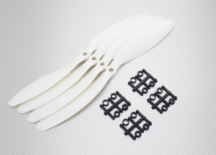

Better known as Propeller , to create artificial quadcopter you fly , propeller used is 2 pairs pair rotates clockwise and another pair rotates counter-clockwise or so-called pusher .

Battery

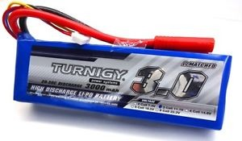
Typically , quadcopter using the battery types LiPo ( lithium polymer ) , for the project in this article , use a LiPo battery with 3000mAh 3S1P 20C specification . Means the battery capacity is 3000mAh , 3S1P means 3 cell mounted in parallel , with each cell has a 3.7 volt battery means is the voltage of 11.1 volts . while C stands for Capacity, so 20 C with 3000mAh means 20 * 3000 = 60000mAh = 60 A. 60A was issued battery current in a moment .
The greater capacity of the battery , the greater its enormous size , the larger the size of the batteries will add to the load received by quadcopter .

Charger
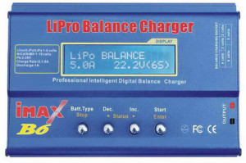

LiPo battery charging process has a difficult process because the charger must charge and discharega on some cell in a LiPo battery at the same time .
The most popular and widely available on the market are trademarks of IMAX B6 Lipo Balance Charger , because it is believed to have the stability of charging .

