Kids Plant Moisture Detector
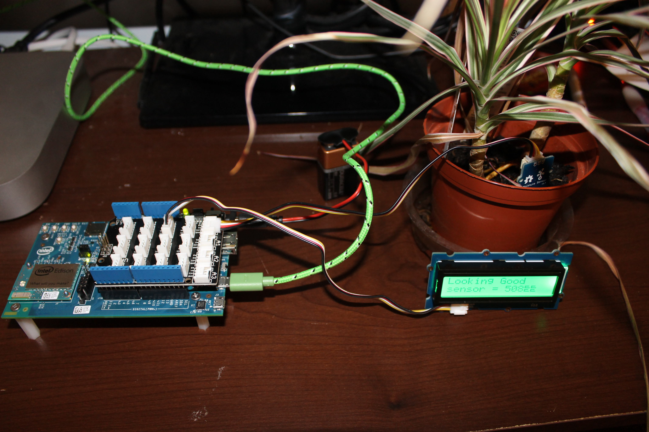

Introduction

Step 1: Function of Plant Moisture Detector
The moisture will give a visual indication using an RGB LCD Display as to whether your plant is in need of water.

Step 2: What you need
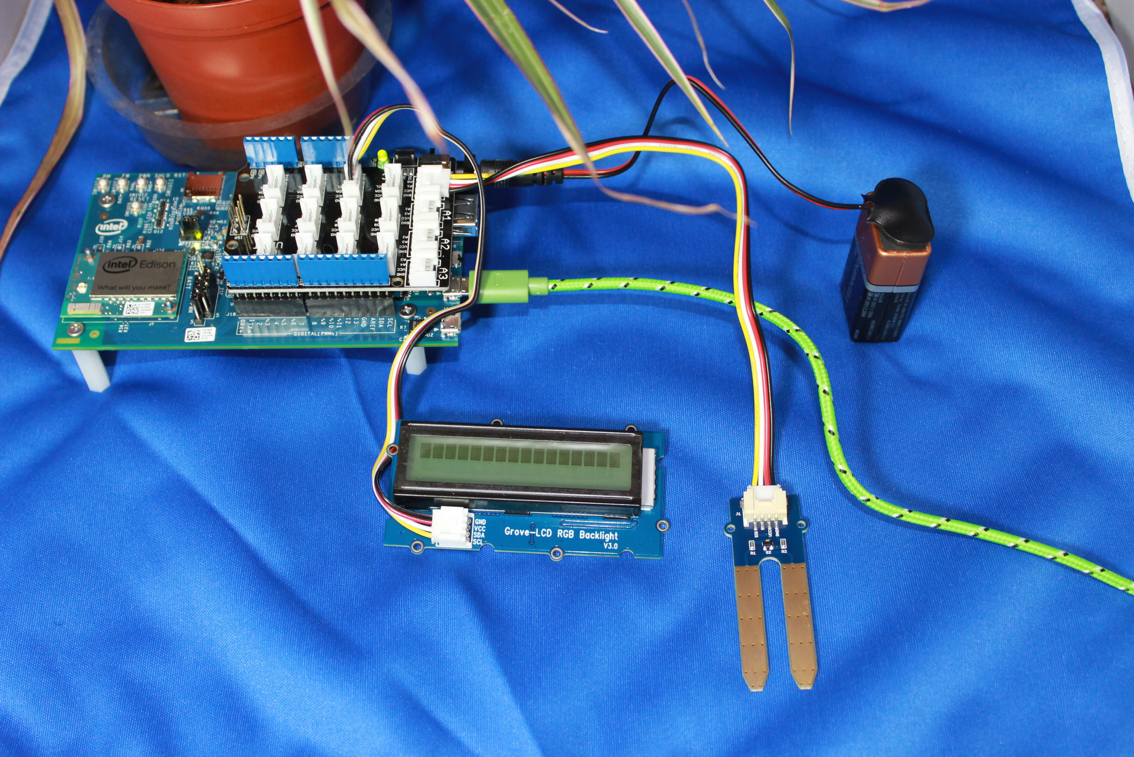
Intel Edison Module
Arduino expansion board for Edison
Moisture Sensor
RGB 16*2 LCD Display
Power Supply (9 Volt Battery)
USB Cable
Jumper Wires

In this project we are using the Grove Moisture Sensor with the Grove Base Shield. The code is Arduino.

Step 3: The Connections
Connect the power supply to the Edison board and connect the USB cable between your PC and connector J16 on the Edison board. It will take 15 to 20 seconds to boot up. After boot up, stack the Grove Base Shield in the expansion slot of the Edison. Connect the moisture sensor to analog pin A0. Connect the LCD Display to one of the I2C ports.

Step4: Programming
Using Arduino 1.6.6, establish your serial port connection to the Edison.

The control code is as follows:
/* This program is use to monitor the moisture in the soil of a potted plant.
* It uses the Grove - Moisture Sensor and Grove RGB Backlight LCD.
* When the moisture level falls below 300, the display will change color to yellow
* and display a message "Needs Water".
* When the moisture level is above 300, the display is green and displays the message
* "Looking Good".
*
*/

#include <Wire.h>
#include "rgb_lcd.h"

rgb_lcd lcd;

int colorR = 0;
int colorG = 255;
int colorB = 0;
int sensorPin = A0; // select the input pin for the potentiometer
int sensorValue = 0; // variable to store the value coming from the sensor

void setup() {
// declare the ledPin as an OUTPUT:
Serial.begin(9600);

// set up the LCD's number of columns and rows:
lcd.begin(16, 2);

lcd.setRGB(colorR, colorG, colorB);

// Print a message to the LCD.
lcd.print("Monitor Moisture");

delay(1000);
}

void loop() {
// read the value from the sensor:
sensorValue = analogRead(sensorPin);
delay(1000);
if (sensorValue < 300) {
colorR = 200;
colorG = 150;
colorB = 0;
lcd.setRGB(colorR, colorG, colorB);
lcd.setCursor(0, 0);
lcd.print("Needs Water ");
lcd.setCursor(0, 1);
lcd.print("sensor = " );
lcd.println(sensorValue);
}

if (sensorValue >= 300) {
colorR = 0;
colorG = 255;
colorB = 0;
lcd.setRGB(colorR, colorG, colorB);
lcd.setCursor(0, 0);
lcd.print("Looking Good ");
lcd.setCursor(0, 1);
lcd.print("sensor = " );
lcd.println(sensorValue);
}

delay(100);
}

Step 5: Run the code
Compile and upload the Plant Moisture Control Code to the Edison. Insert the moisture sensor into the soil of your plant.
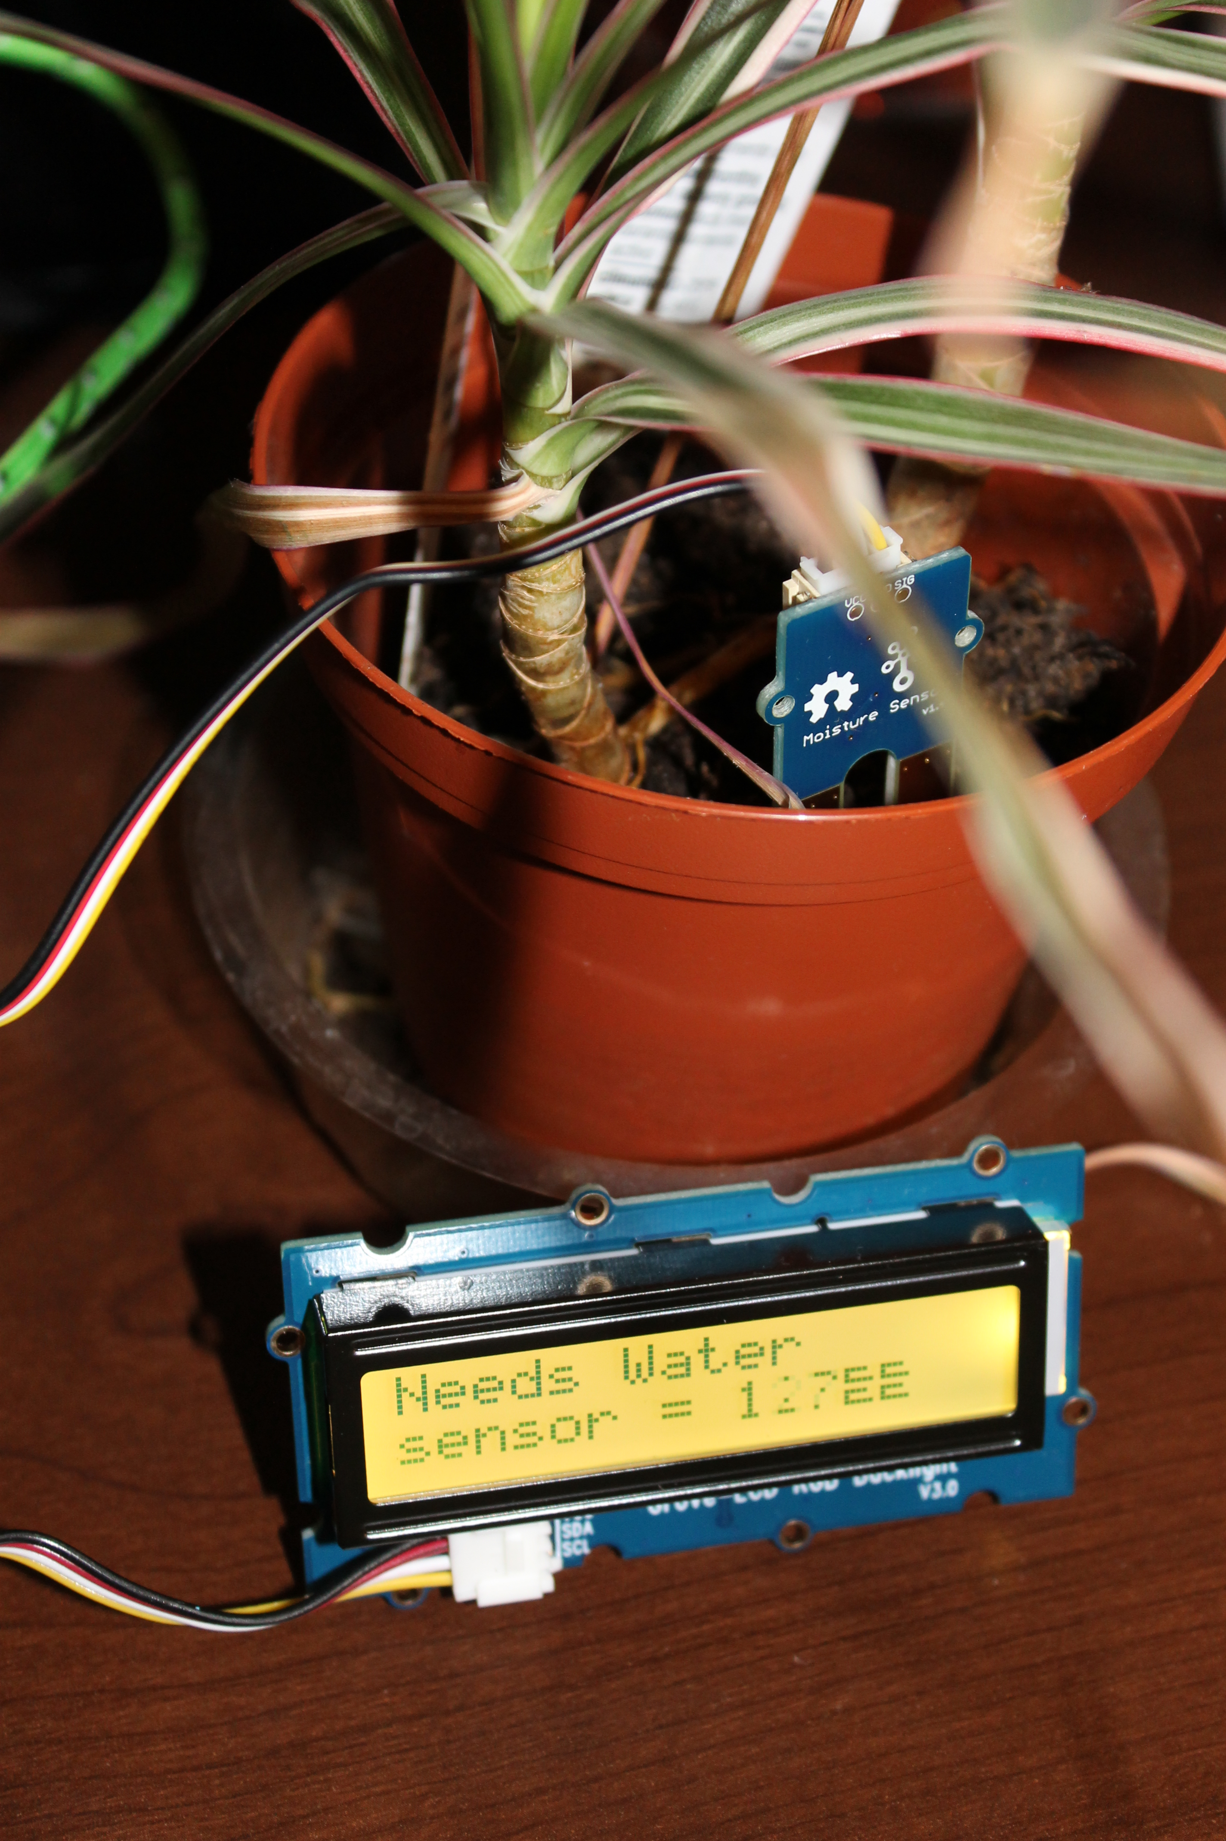Moisture Detector indicates that you need to add water. 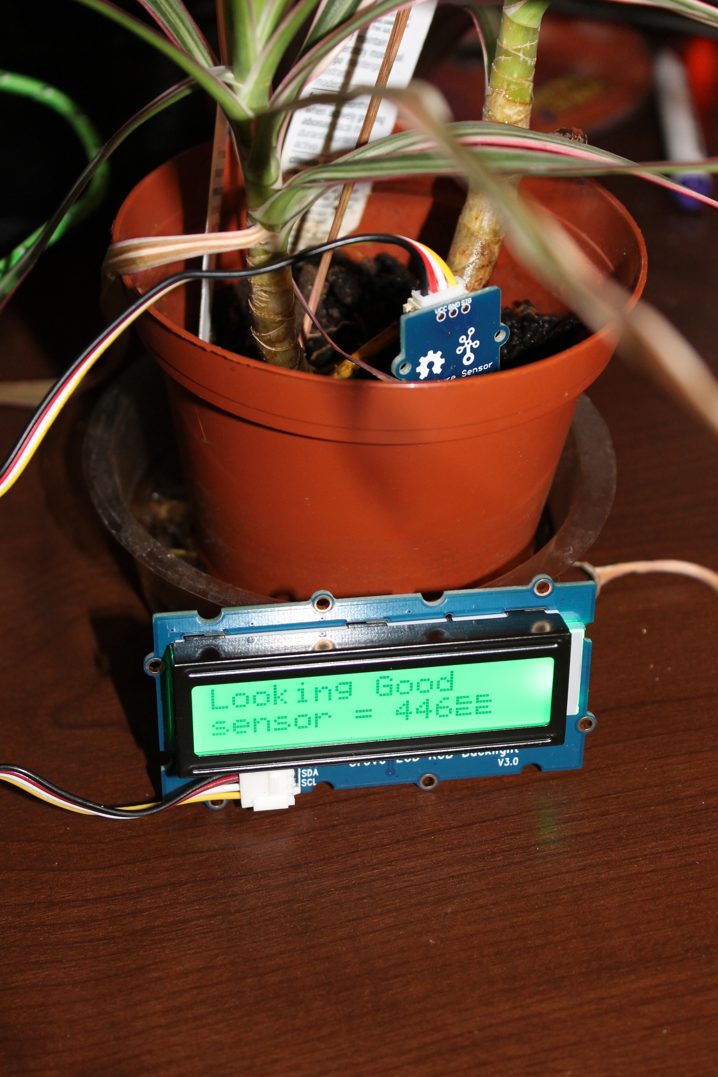Moisture Detector indicates water level is good.

Advance Applications:
More advance kid programmers may use the IoT features of the Edison and send wireless alerts to smart phones or computers.

