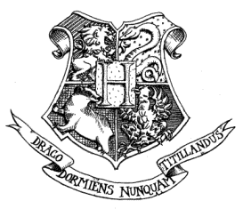

Hogwarts School of Witchcraft and Wizardry
Headmaster: Albus Dumbledore (Order of Merlin, First Class, Grand Sorc., Chf. Warlock, Supreme Mugwump, International Confed. of Wizards)
Dear Cookie the House-Elf,
We are pleased to inform you that you have been granted emancipation from your duties at Hogwarts School of Witchcraft and Wizardry. Please accept this sock as a token of your freedom. Also, this 10 House Point token will serve as compensation for your years of servitude. This emancipation is the result of the tireless advocacy of S.P.E.W. on behalf of all house-elves. In light of your new freedom, we would like to make you an offer of employment at Hogwarts. The duties would include cooking and cleaning at Hogwarts. The compensation would be one Galleon per week, and you will have one day off per month. We await your owl by no later than July 31.
Yours sincerely,
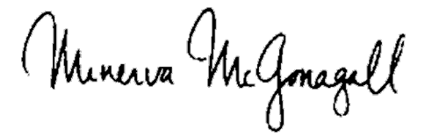
Minerva McGonagall
Deputy Headmistress

