BackpAQ Kit Parts List
Part | Quantity | Image
DOIT ESP8266 Grove  Expansion Board | 1 | 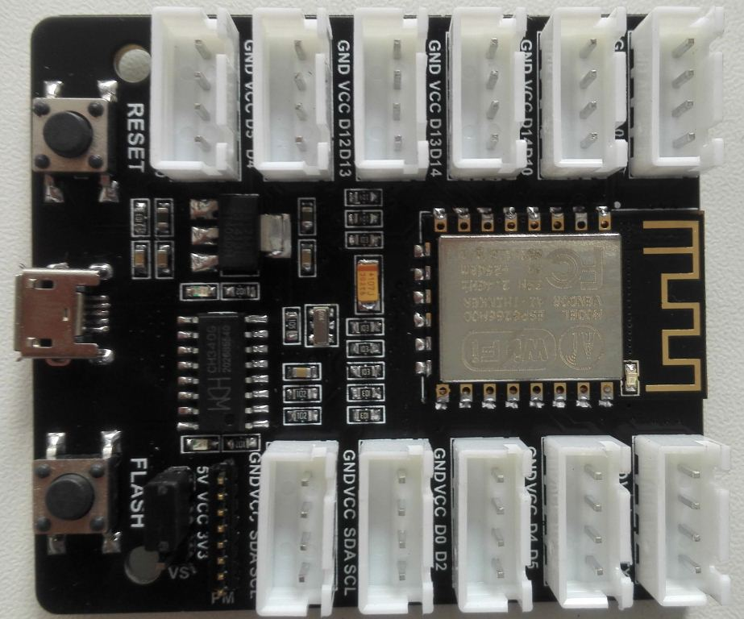
Plantower PMS5003 PM  Sensor w/cable | 1 | 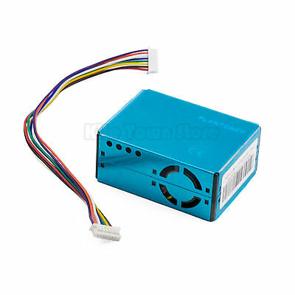
BME280 Temperature &  Humidity Sensor w/cable | 1 | 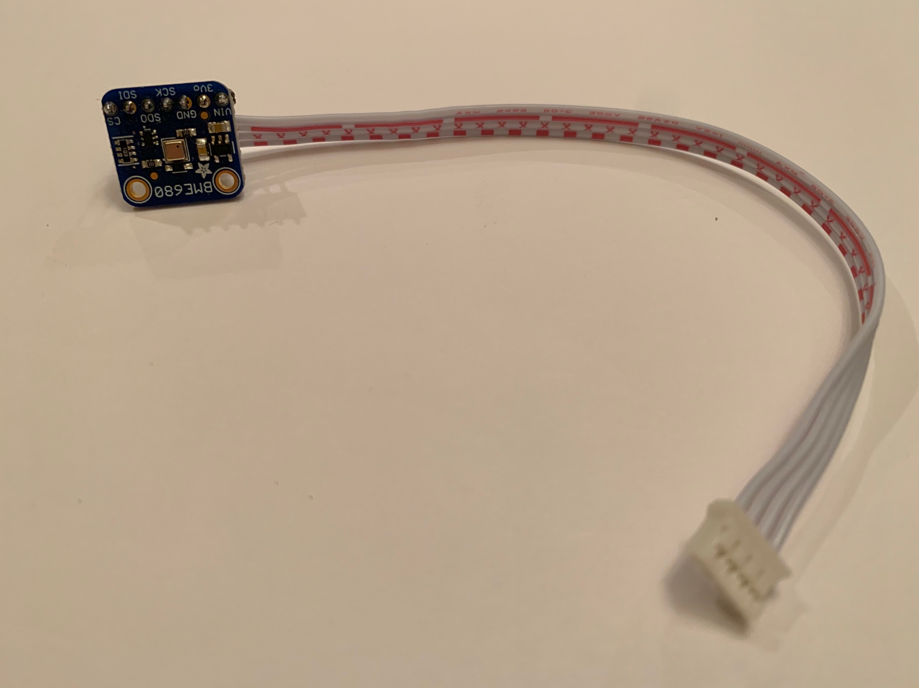
128 x 64 OLED Display  w/cable | 1 | 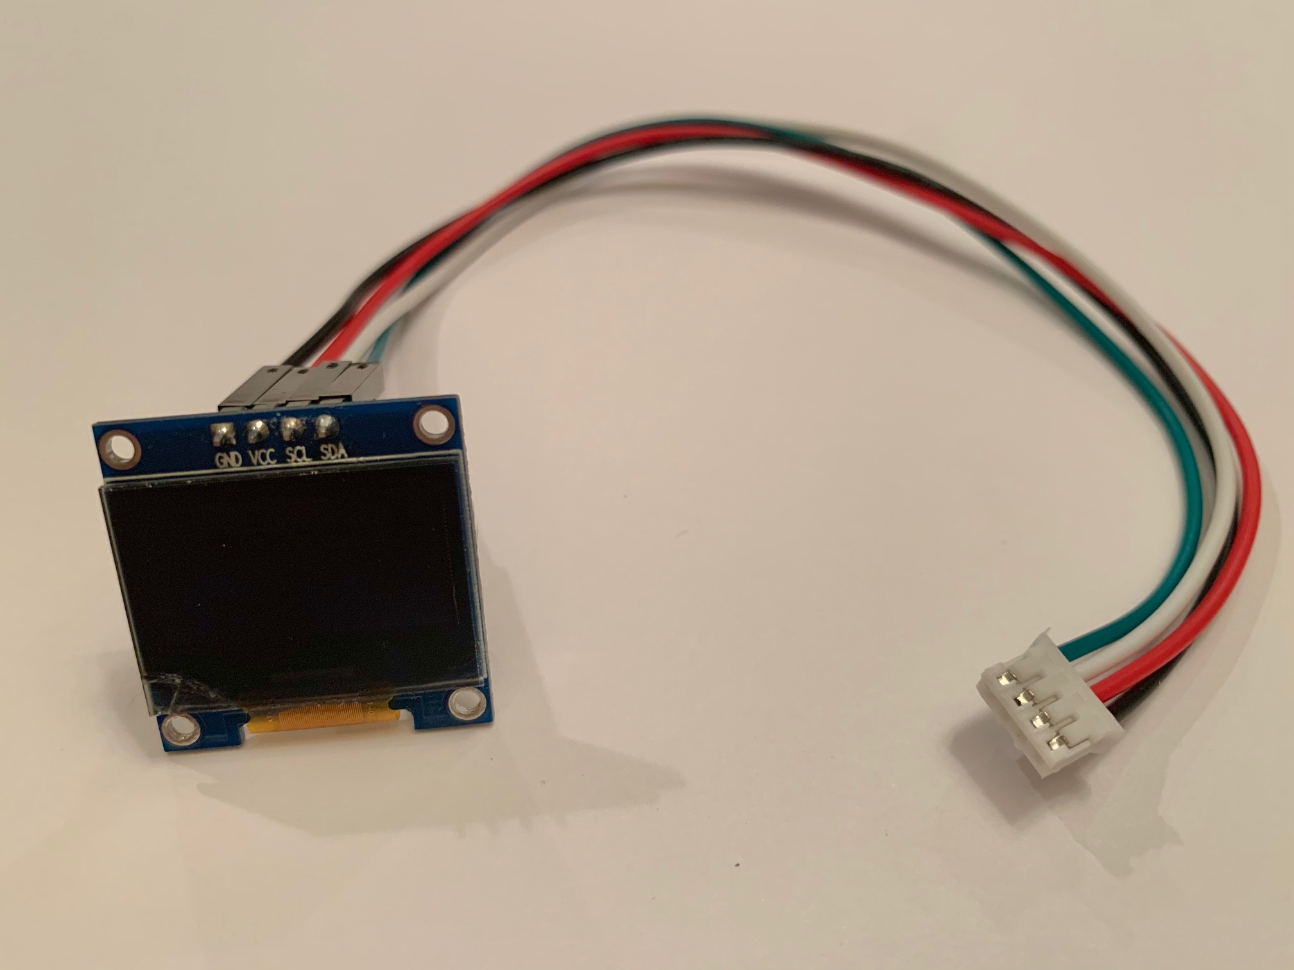
3.7V 2500 ah LiPO  Battery w/cable  LiPO Charger Board  w/ cable | 1  1 | 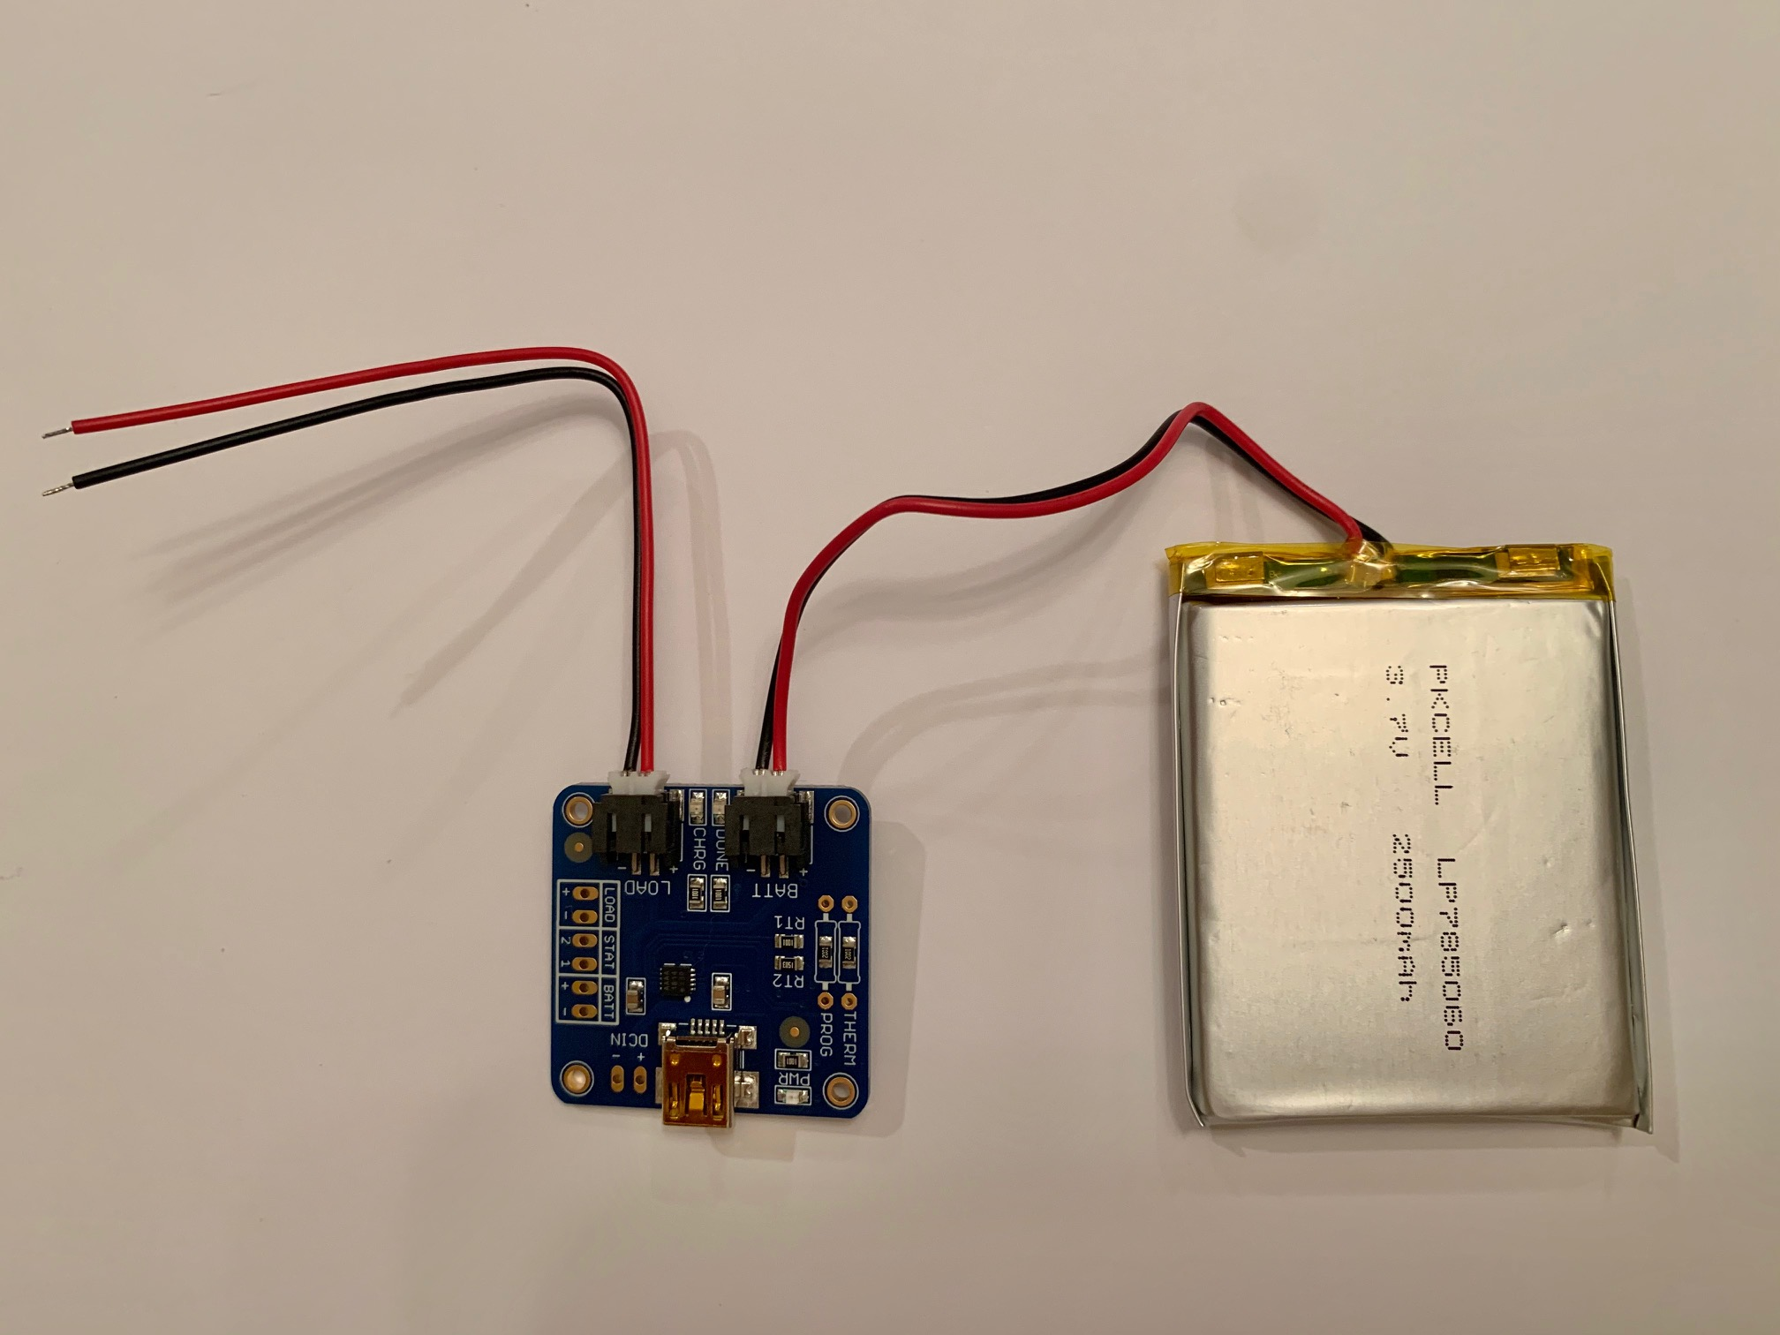
5V Booster Card | 1 | 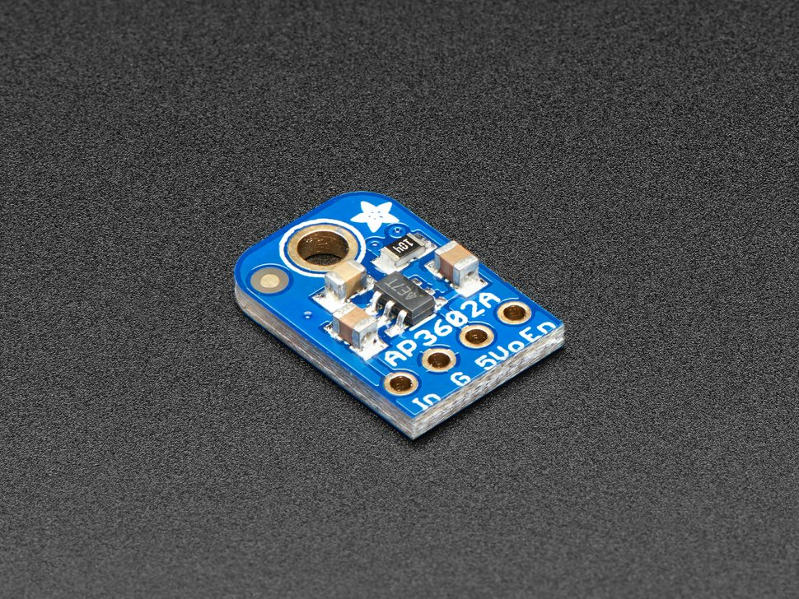
Pelican 1010 Poly Case w/carabiner clip | 1
Toggle Switch | 1 | 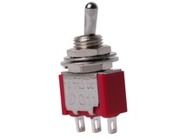
Power Jack | 1 | 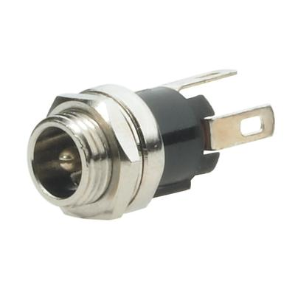
Misc Wires (Red, Black, Yellow, Green) with female Dupont on one end | 4
180K resistor w/JST connector | 1
Cable Ties | 3 | 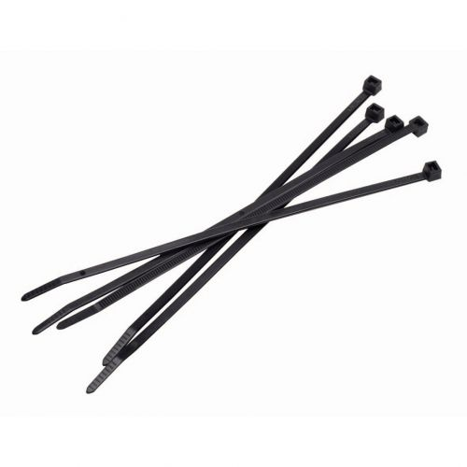
3M double side pad | 2
Black foam pad | 1 | 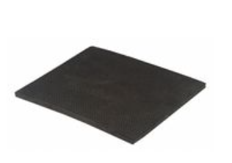
Assort. Screws & nuts | bag
6V DC Power  Adapter w/2.1mm  Barrel connector | 1 | 