Mason Jar Lanterns
Technical Instructions Handout
By: Lydia Hoyle, Brianna Marmol, and Sara Weidner
Warning: This project requires safety when handling hot glue guns and is not appropriate for unattended children or children under 5 due to the choking hazard of the small pebbles.
Disclaimer: Read all instructions before starting

Materials: Can be bought at craft stores such as A.C. Moore, Hobby Lobby, or Michaels
- Mason jars (any color, size, etc)
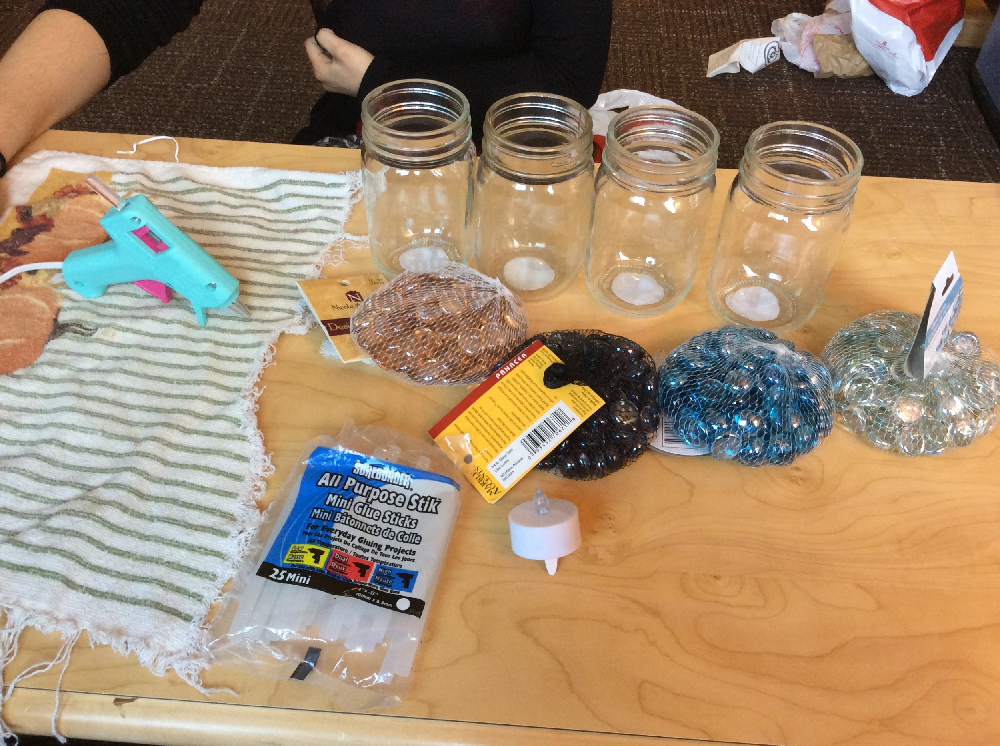
- Small glass pebbles
- Hot glue gun
- Glue sticks for hot glue gun
- Small electric tea lights
- Towel for hot glue gun/cleanup
- Heat mat or ceramic plate to place hot glue gun on
- Scissors
- Ziploc bags for extra pebbles, beads, etc.

Optional:
Twine/hemp/other decorative string, ribbon, & decorative beads

Figure 1
Step 1:
- Lay out all of your materials on a clean surface; see figure 1

Step 2:
- Warm up hot glue gun (if the mason jar has a lid, remove the lid from the mason jar & set lid aside)
- Carefully using scissors, cut open the bags of gems

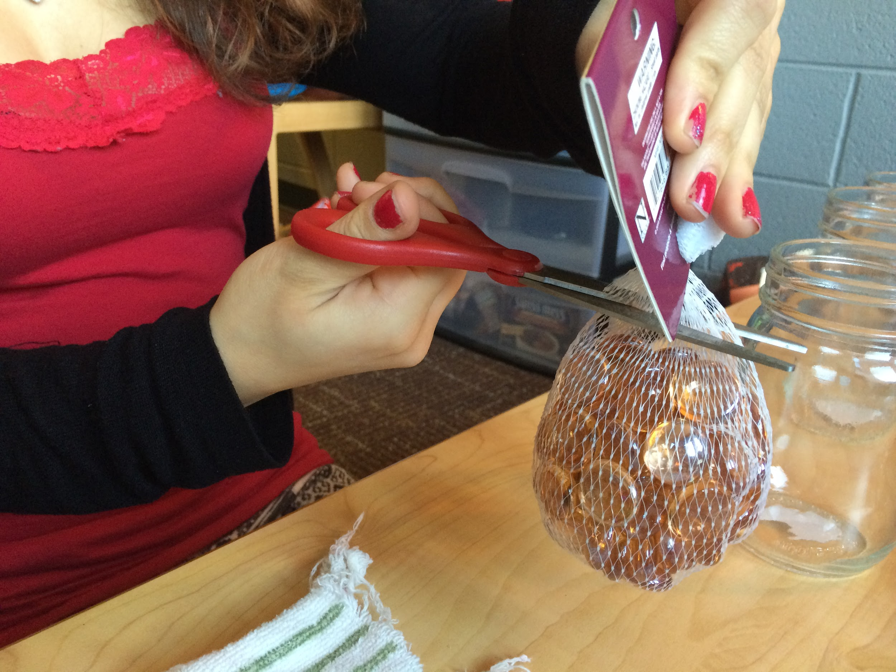
Figure 2 Figure 3

Step 3:
- Carefully using hot glue gun, start from the bottom of the mason jar and glue pebbles flat side against the jar, encircling the jar
- See video for example of “encircling” → http://youtu.be/01cchM8ASTg
- Note--glue dries quickly, so place pebbles on fast!
- Hold pebbles in place each time you glue one to ensure they stick
- Important! Do not glue pebbles to the bottom, the inside of the jar, or the area the lid will cover; see figures 4-6 for details

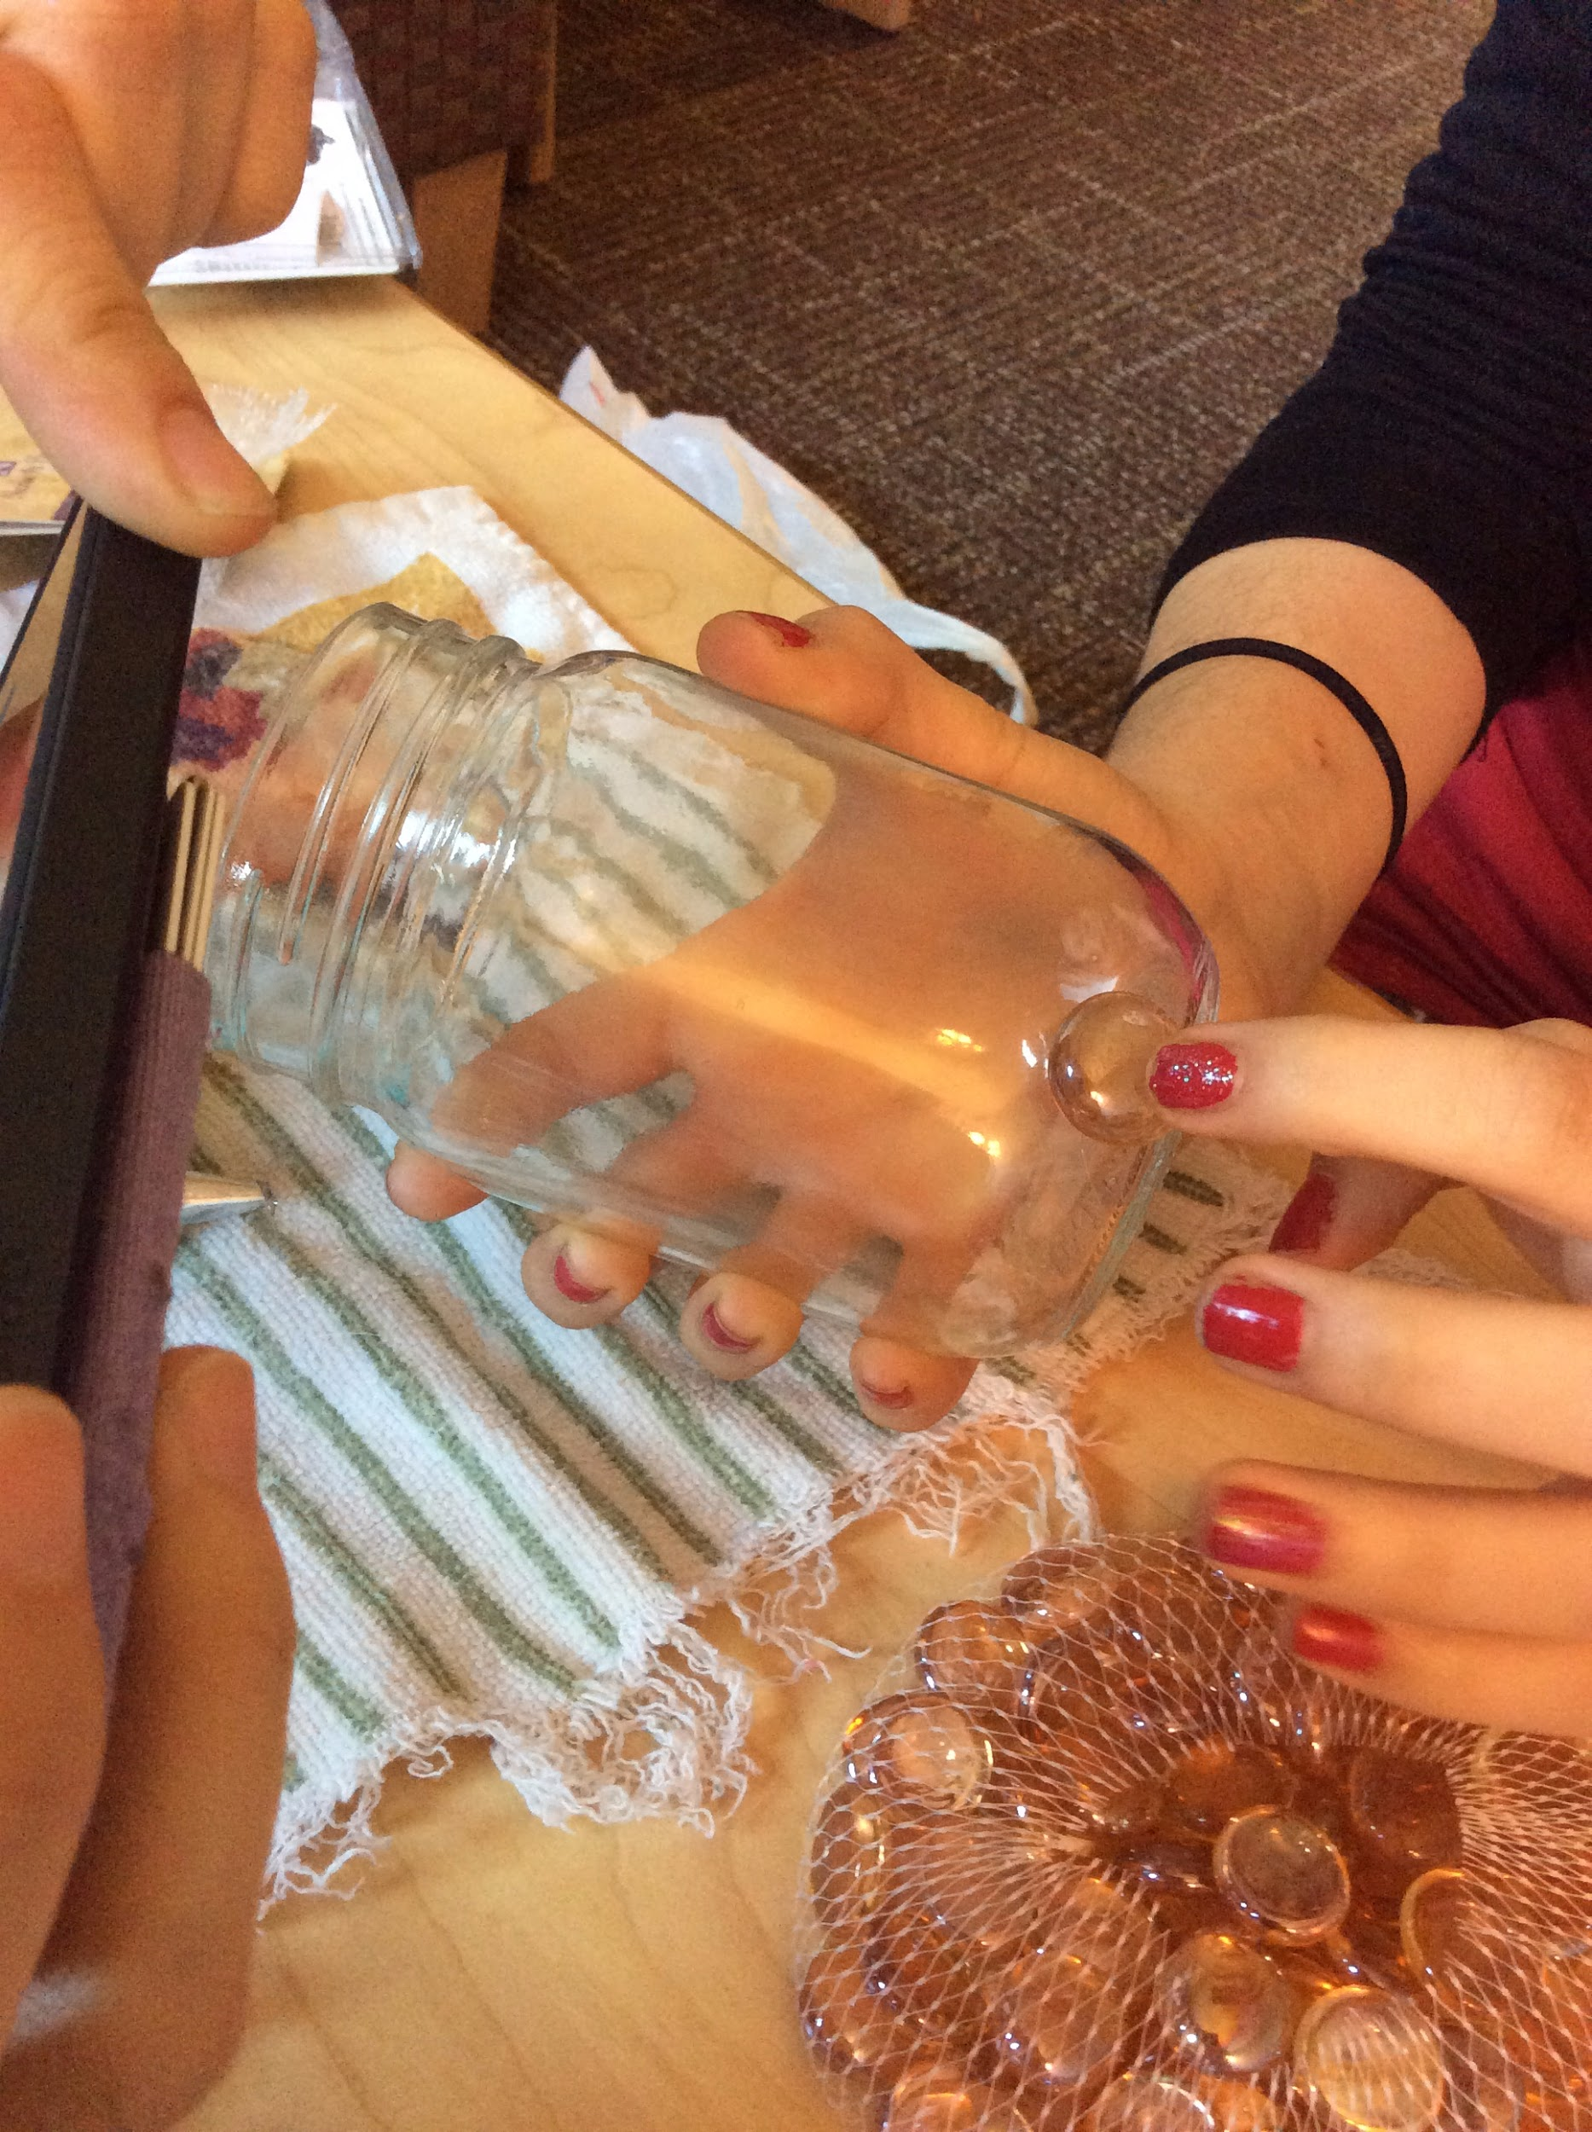
Figure 4 Figure 5
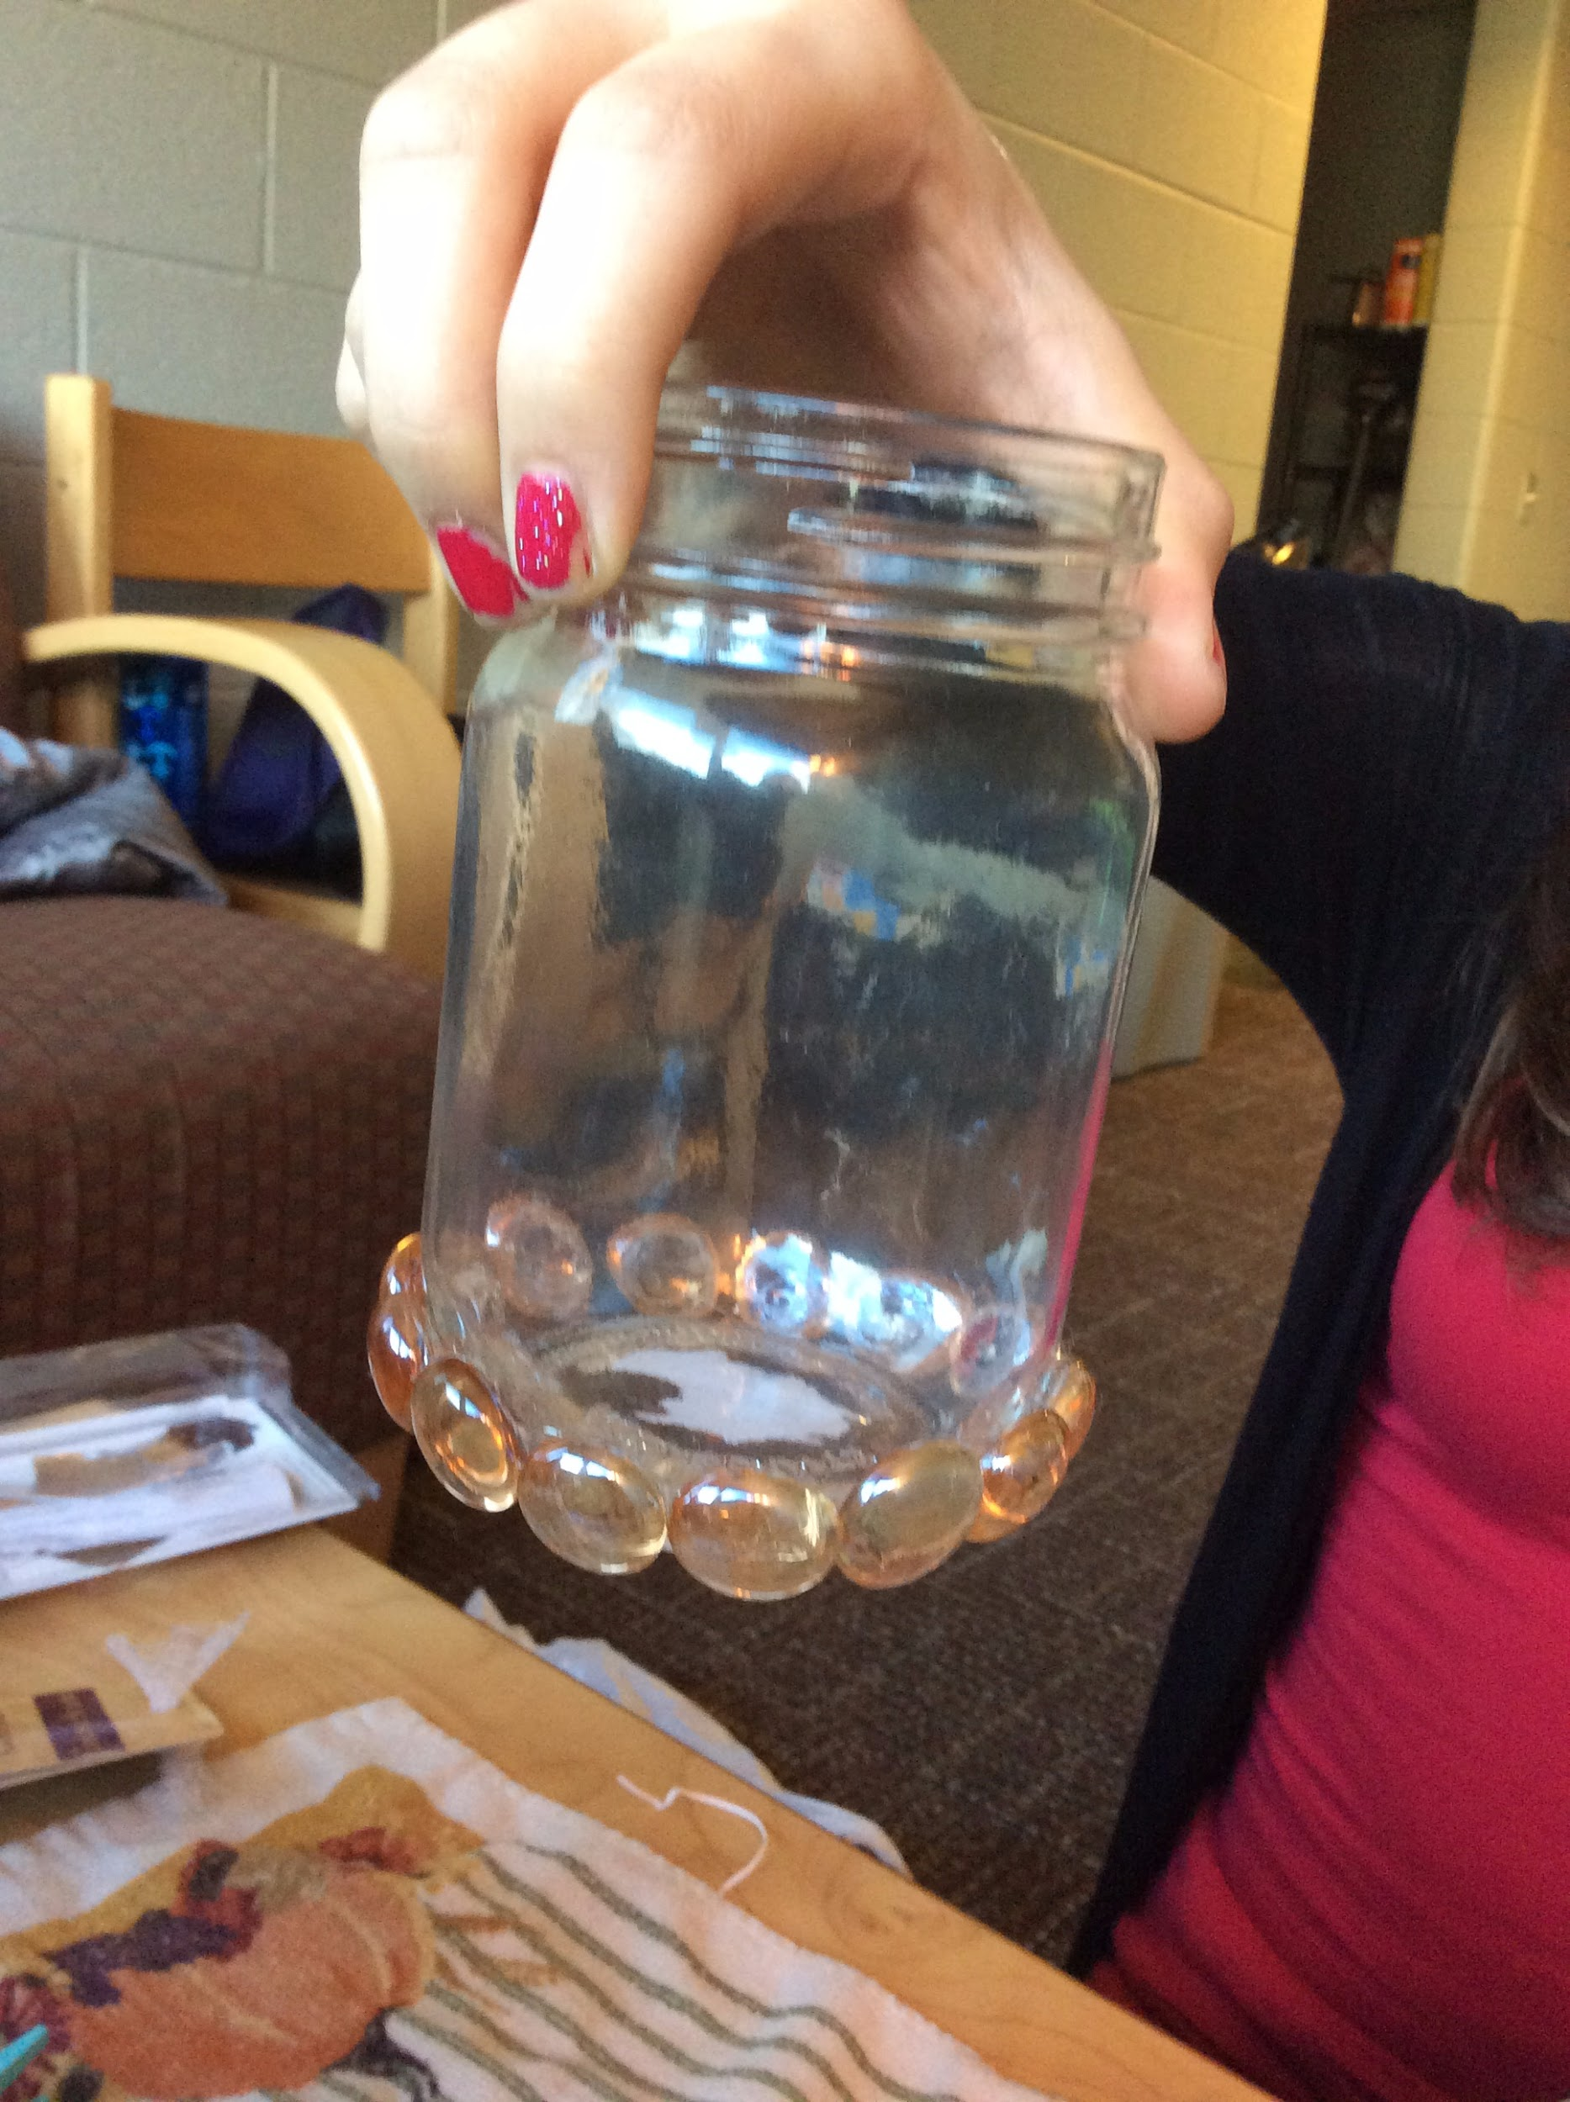

Figure 6

Step 4:
- Continue gluing the pebbles so they encircle the sides of the jar; see figure 7
- Spacing of pebbles will not be consistent; you will have some areas where a pebble will not fit. Just work around this and keep gluing the next row.
- Glue dries immediately, so jars should be ready for handling quickly, but still handle with care

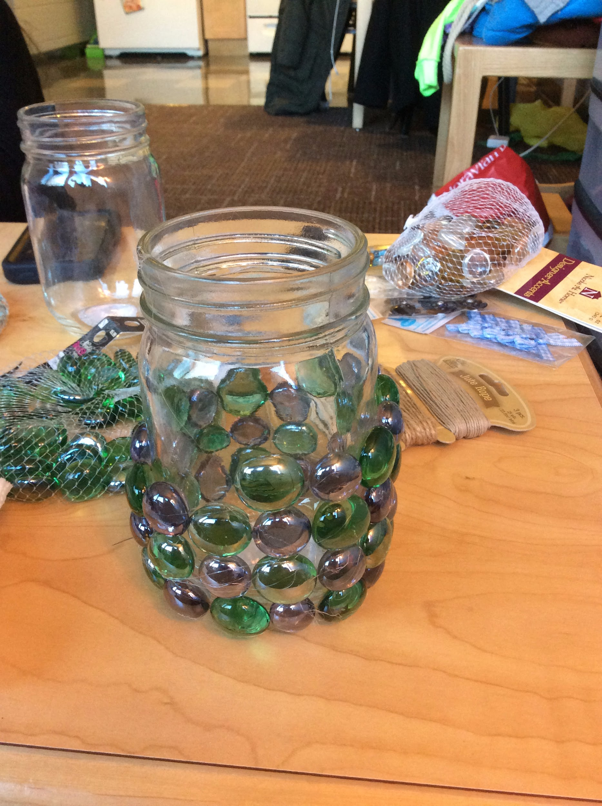
Figure 7
Step 5:
- Turn on tea light candle and place one inside each jar; see figure 9
- For mason jars with lids, screw lids back on and set aside
- If desired, embellish jars with twine/hemp, beads, or ribbon to give it a personal touch!

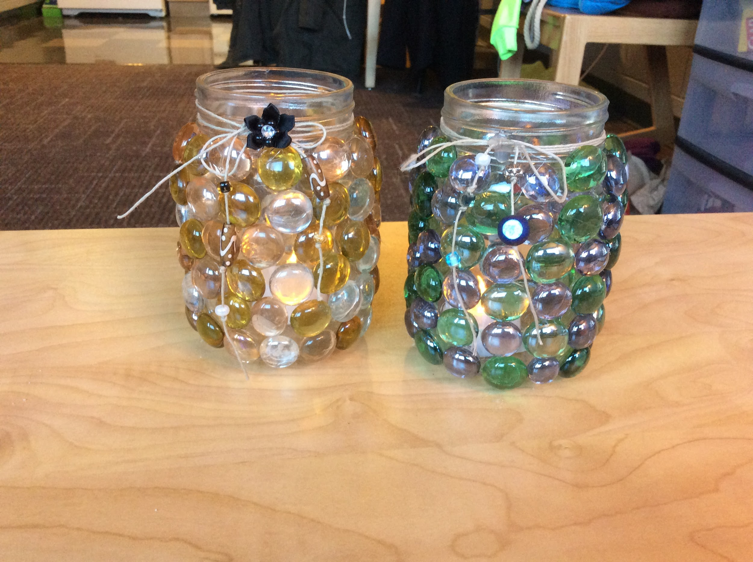
Figure 8

Step 6:
- Use towel for cleanup if needed

Conclusion:
Now you have the perfect lantern for any occasion, like home decor, dorm decorations, party table centerpieces, or even flashlights during a blackout. So be ready to light up your world with these festive glass lanterns!

**Note** Handle with care. The pebbles may fall off with rough or excessive handling. If this happens, simply re-apply hot glue and re-glue the pebble.

Figure 9 Figures 10
