Electricity Final Task

Overview
Wiring in a house is complex array of parallel and series circuits, with a variety of voltage and current limitations. You will use your knowledge of electricity to effectively wire lights throughout a doll house.

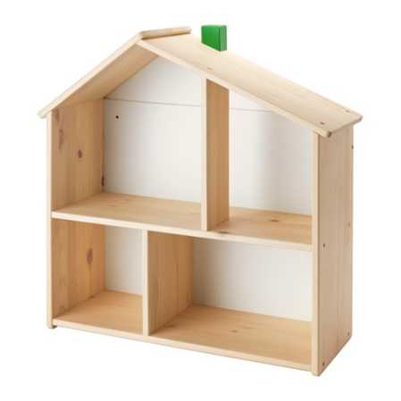
Materials
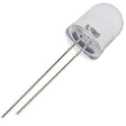
- IKEA Flisat Doll House
- LEDs
- Various Resistors
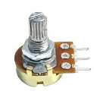
- Potentiometer
- Switches
- Copper Tape
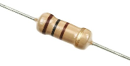
- Power Supply

Wiring Requirements
- The lights in each lower room need to be individually controlled by a switch
- One of the lower rooms needs to have 2 LEDS
- One of the lower rooms needs to have a dimming system
- The upper area needs multiple lights that are controlled equally by two switches
- *BONUS* There could be an “outlet” so that another LED could be “plugged in”

Submission Requirements (1 per person)
- Complete circuit diagram of the entire circuit
- Reasoning for using series/parallel circuits
- Ohm’s Law calculations used to identify resistors, explained as needed
- Power calculation for each different resistor to check it is under 0.5 W (max power of these resistors)
- Calculation of overall current using Kirchoff’s Rules

Helpful Links
- Understanding LEDS
- What is a Potentiometer?

