What is the MaKey MaKey?

The MaKey MaKey is a collaborative project between Jay Silver and Eric Rosenbaum of the MIT Media Lab.
It's an invention kit that encourages people to find creative ways to interact with their computers, by using everyday objects as a replacement for keyboards and mice.
With the MaKey MaKey, you could replace your space key with a banana, use play-doh to move and click your mouse, or high-five your best friend to advance PowerPoint slides.

It's a Mouse/Keyboard
The MaKey MaKey is a two-sided circuit board. On the more simple, top side, the MaKey MaKey has 6-inputs: the up/down/left/right arrow keys, as well as the space bar and mouse left click:
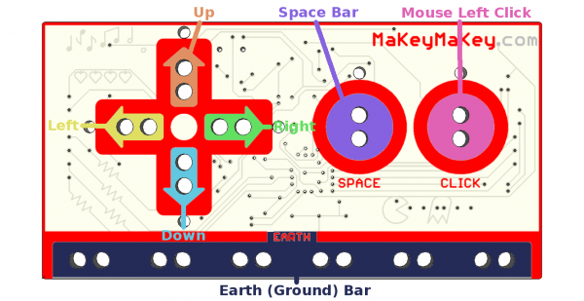

Each of those inputs as well as the very important “Earth bar” are available in the form of “alligator-bait” connectors. You'll use the included alligator clip cables to clip right into the hole pairs.

When you flip the board over, you've got access to 12 more keys: W, A, S, D, F, and G on the keyboard side, and up/down/left/right mouse movement and left/right clicks on the mouse side. The bottom header has six ground (aka Earth) outputs, while the top header is an expansion/output header. There are also a few LEDs on the back to indicate whether you're pressing a mouse or keyboard key.
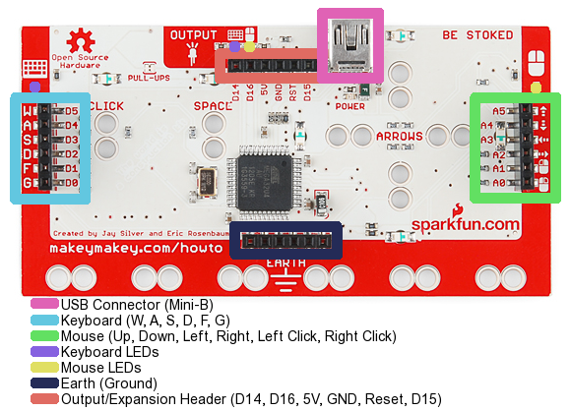

The pins on the back side are all available in the form of “jumper-wire” connectors.

