Project Name: Spongebob Squarepants
1. Identify and clarify problems
Spongebob squarepants is a popular cartoon character. So we chose to make a spongebob squarepants toy for appreciation and and make them enjoyable.
Design positioning:
● Design task: testing the mechanical model
● Operating environment: place where toys can be shelved (for appreciation)
● Design requirements
Functions: appreciation, amusement
Technical indicators: Arduino pro mini mainboard, 3D printer (printing material: PLA).

2. Formulate the design scheme
- Collect information (conduct research, market situation)
Market demand
How much do people like about different cartoon characters
How to make parts of the toy to move

- Design analysis (factors to be considered)
Whether the materials are environmentally friendly
Whether the work is artistic or not
Whether the work can be promoted

- Scheme Conceptions
Plan A: Design a spongebob squarepants with movable eyebrows
1. Use fusion360 for appearance design and modification, and make sketches.
2. Print the work, polish the work and paint it with pigment
3. Use arduino for programming to enable parts to be automatically movable
Plan B: Design voice-controlled spongebob squarepants
1. Use fusion360 for appearance design and modification, and make sketches.
2. Print the work, polish the work and paint it with pigment
3. Use arduino for programming to enable parts to be movable based on voice command (such as saying hello)

4. Evaluate and decide design scheme
Plan A is of higher practical value, would be more popular and convenient.
While plan B is more difficult to make and is not as practical and convenient as plan A.

5. Detailed design scheme
1. The body of spongebob squarepants is divided into four parts: head, lower body, feet and eyebrows.
2. Emery paper is used to polish the surface and make it easy to paint with pigment..

3.Make models
1. Select materials and tools
Tools: Software fusion360 (appearance processing)
Emery paper, pigment (appearance beautification)
3D printer (printing tools)
Arduino(programming tool)
Materials: PLA (printing material)
Mainboard (information storage and transmission)

List of materials
Number | Name | Size (unit: mm) | Quantity | Remark
1 | PLA |  | 1
2 | Arduino mainboard | 38*39 | 1
3 | Steering gear |  | 2

2. Processing and making
Cover
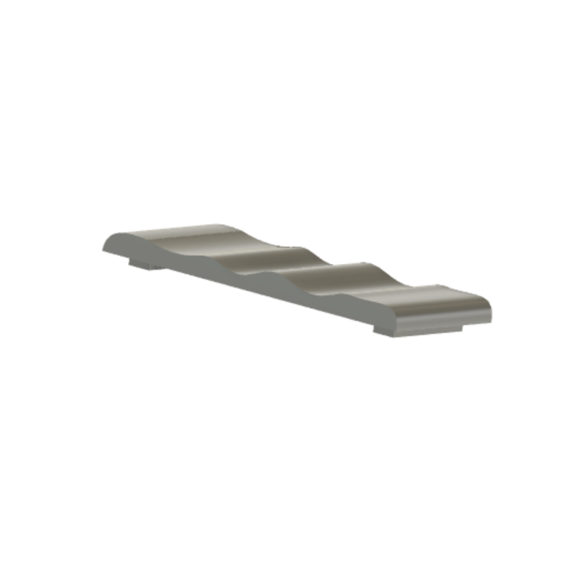
Left and right eyebrows
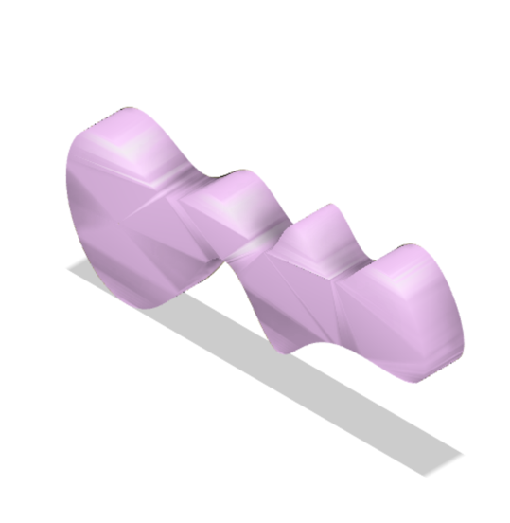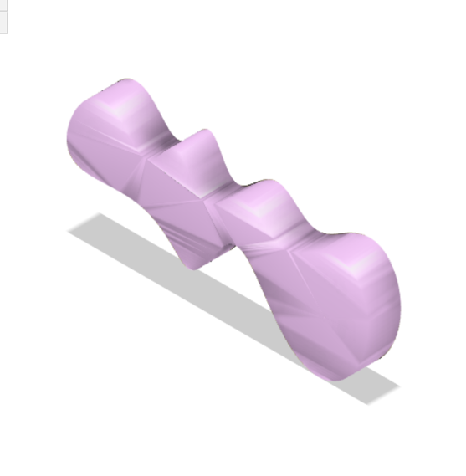

Legs
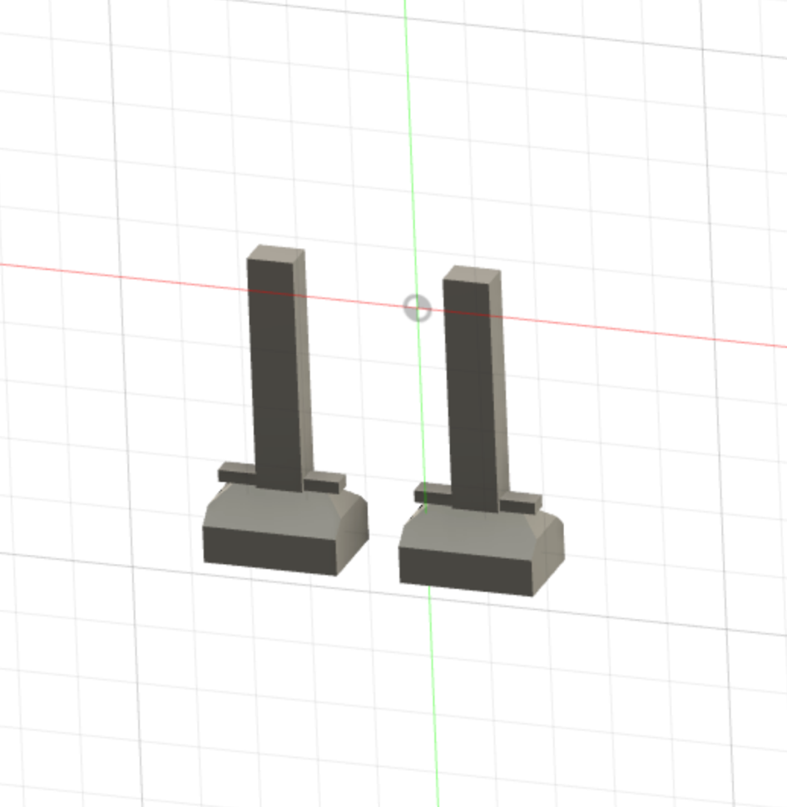
Print the work
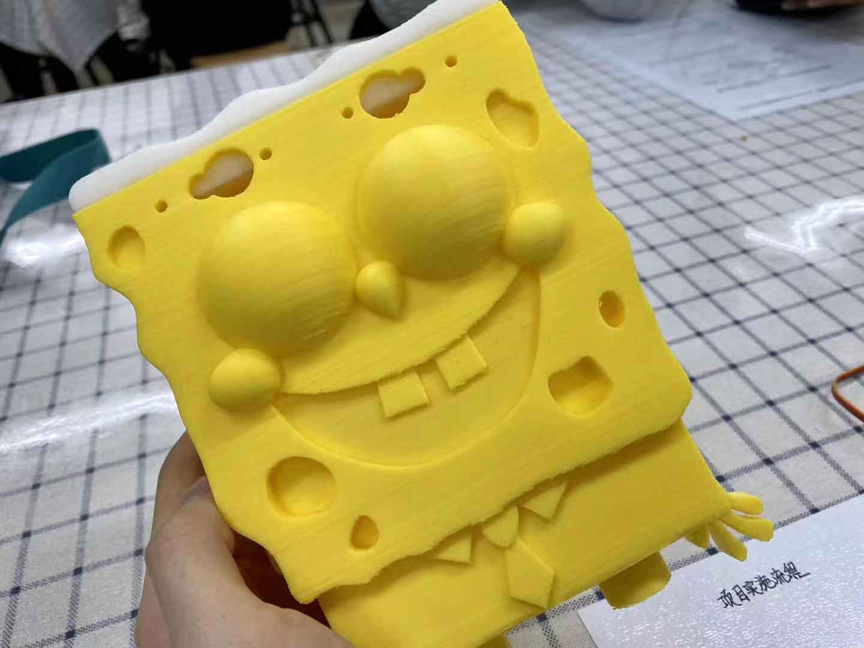

Process the work
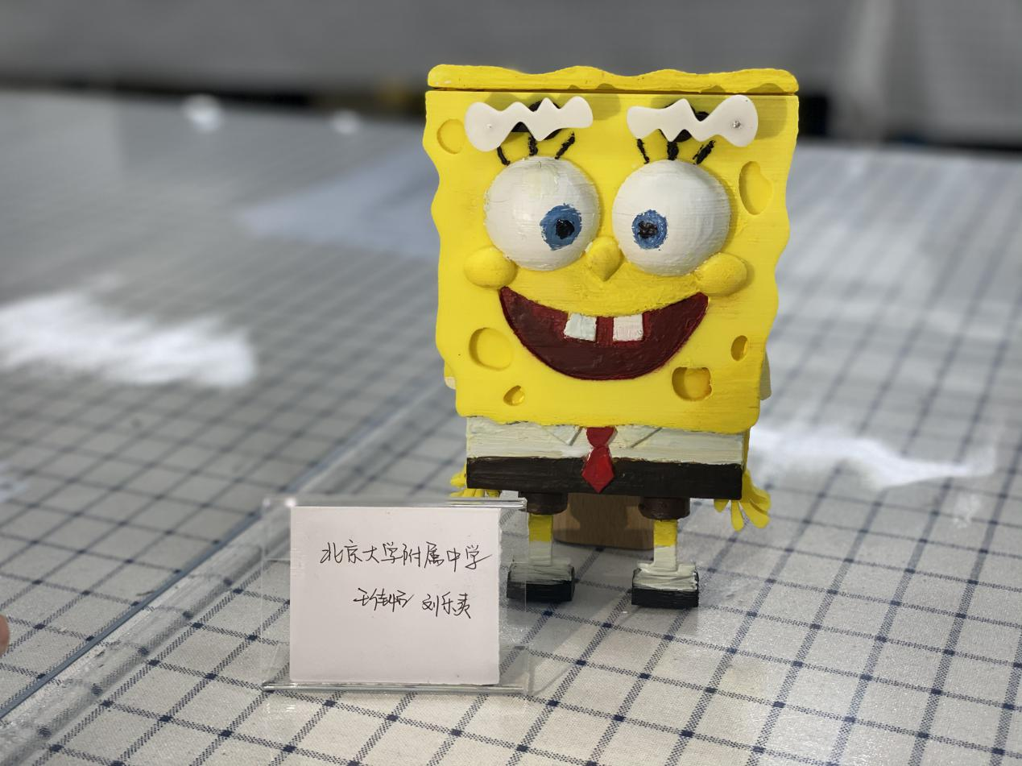
3. Put pieces together
4. Process the surface (with pigments)

4.Test, evaluate and optimize
Through testing, it has been proven that spongebob's eyebrows are able to move.
Optimization scheme: improve the material for surface treatment

