The Bubble Mask Instructable
By Leandro Rolon

See the attached link for more sketchup tutorials

http://www.sketchup.com/learn/videos?playlist=58

Step 1: Download and Install Sketchup Make 2015. Its free!

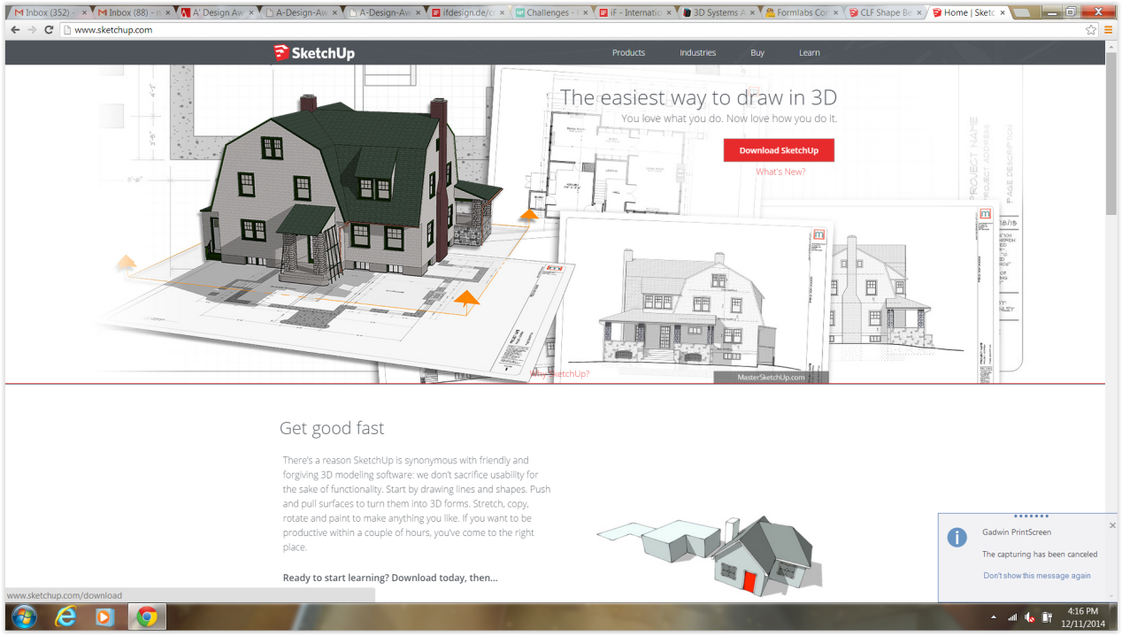

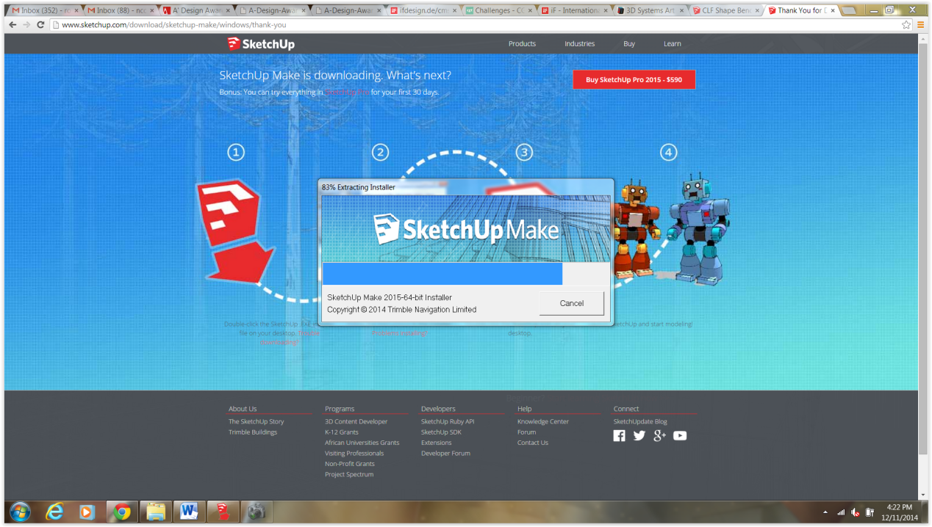
Step 2: Download and Install Shape Bender Extension from
https://extensions.sketchup.com/en/content/clf-shape-bender

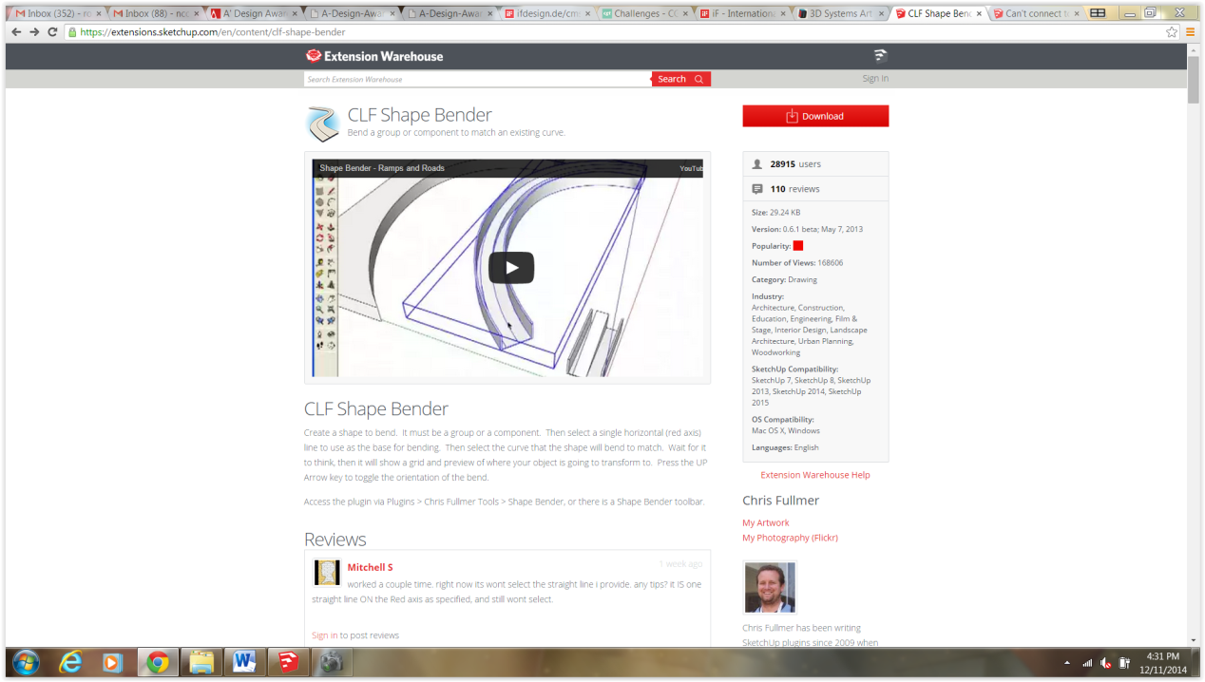

Open sketchup and Follow install instructions. For this model we will me using the millimeter template

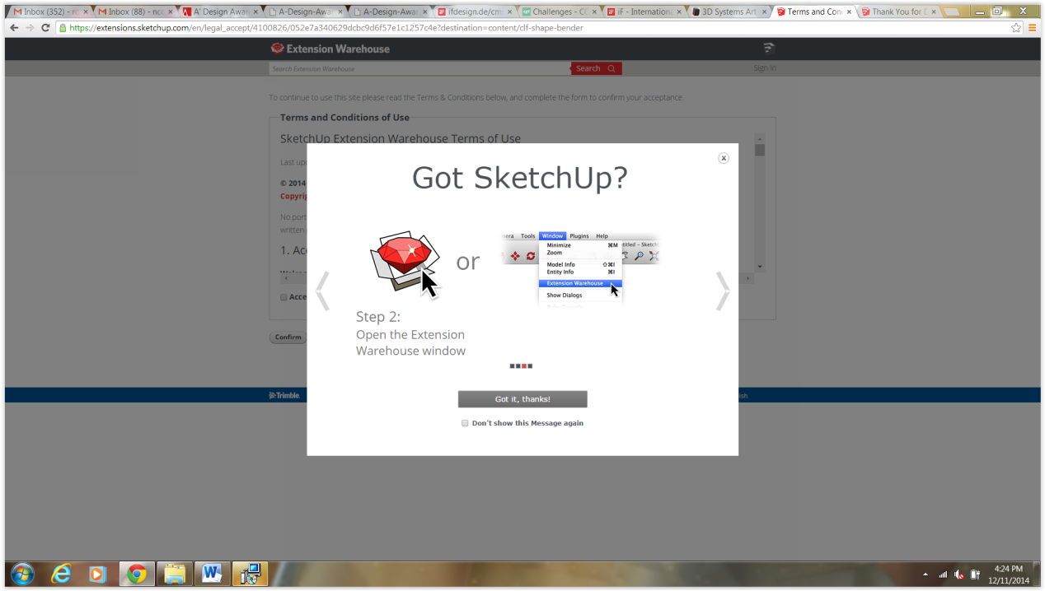

This is where you will find the shapebender extension or plugin

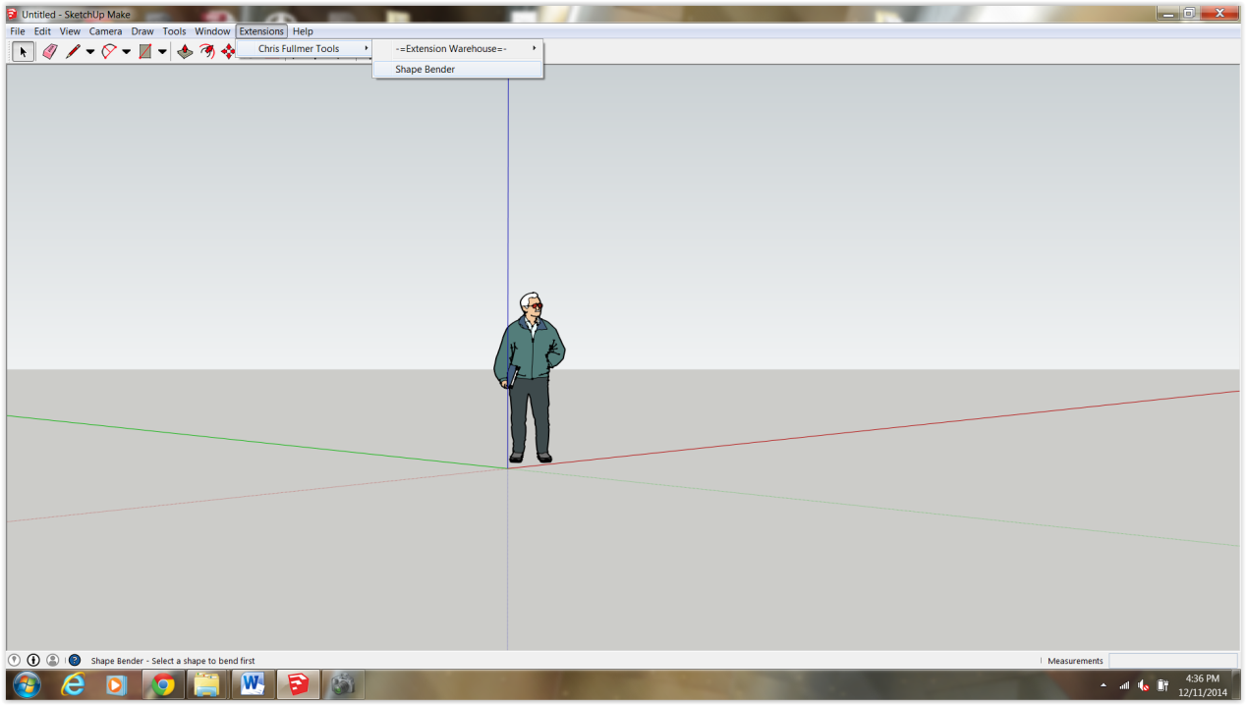

You can also add the icon to your toolbar for easy access if you wish (view>toolbar>shapebender)

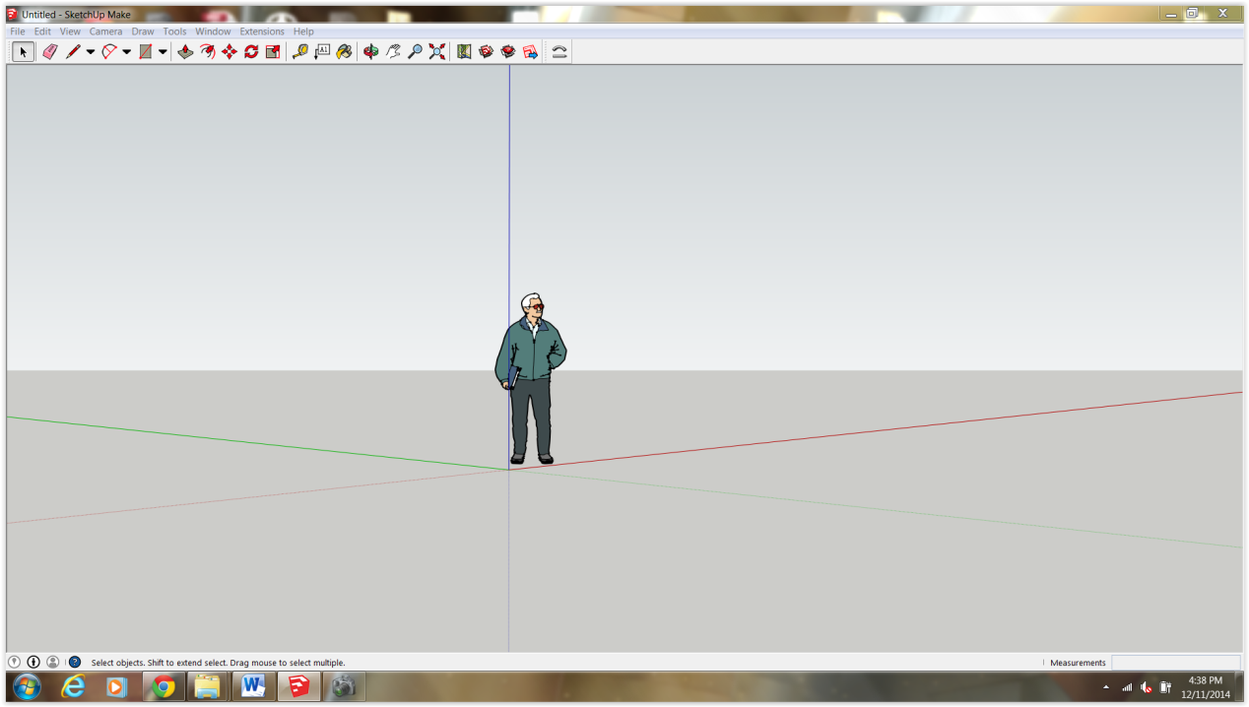

Step 3: Import images Ive provided from the instructables attachment.
(File>Import)

The photos are named front and side. Make sure you have jpeg displayed in the bottom scroll menu

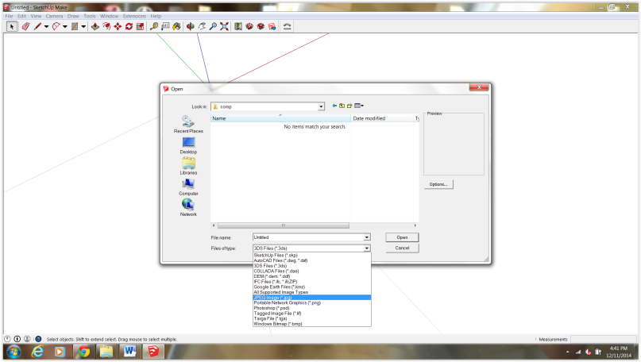
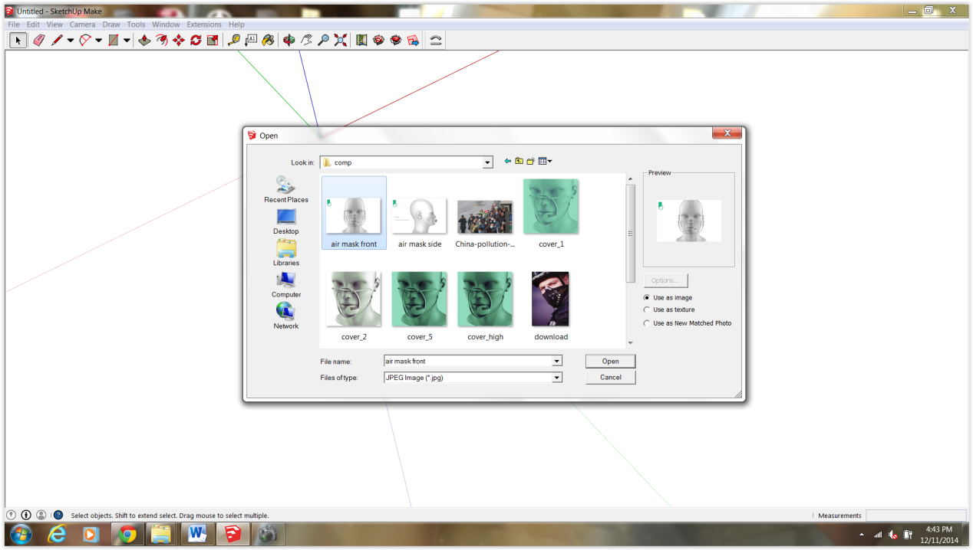

Step 3: Click one time and Place your image in the workspace. Do not press enter or click again

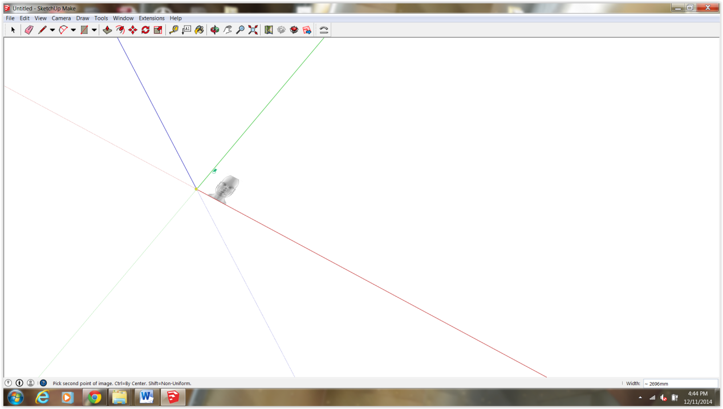

You will notice that your image scales up and down. At the lower right side of your screen there is an input box. Input the number 10000 and press enter. Your image should now be to correct scale in sketchup.
Do the same for the side image.

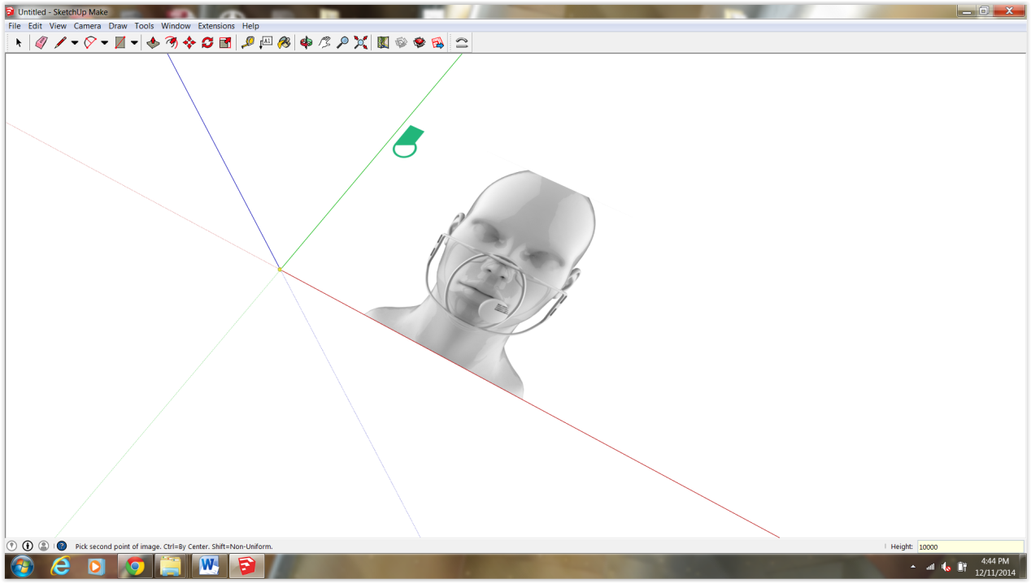

Ok, you’ve made it through boring part, Now some 3d modeling!

Step 4: If this is your first go at Sketchup, I recommend becoming familiar with the interface. Mainly you will want to be familiar with the toolbar (curser, pencil, eraser, etc). Click on the icon that reads Rectangle. Click once on the screen, drag the rectangle until sized, and then click again or press enter.

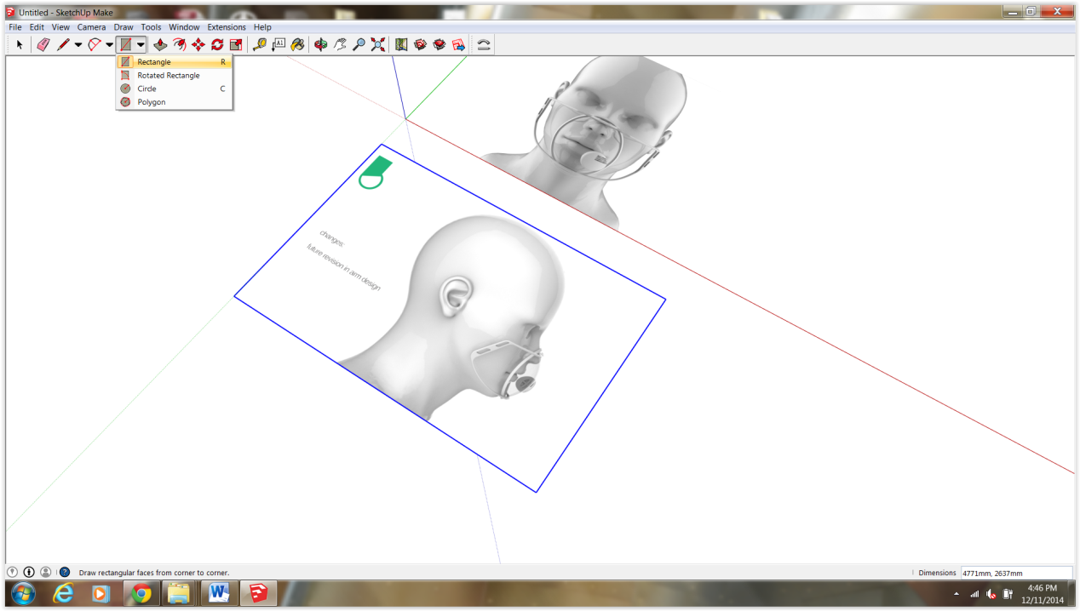

In sketchup it is really easy to extrude basic shapes. On the toolbar look for the push/pull icon. You can extrude your square and make it into a 3d box!
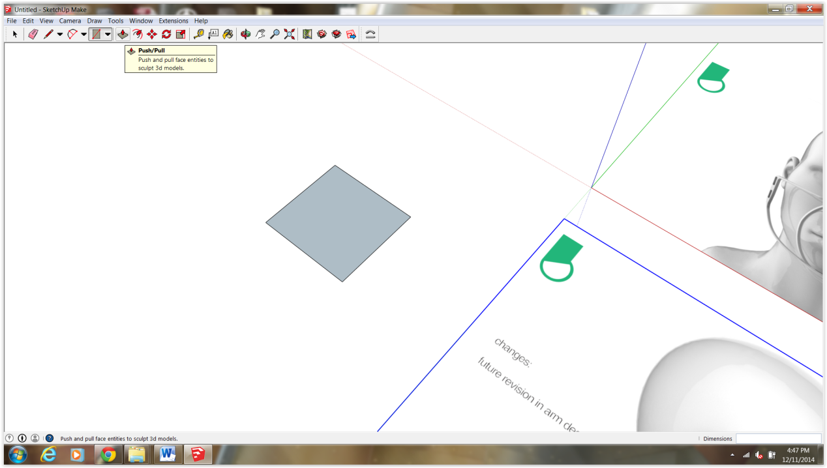
If this is your first time 3d modeling, you just created your first solid 3 dimensional object! You can 3d print this bad boy, although you probably won’t be too impressed.

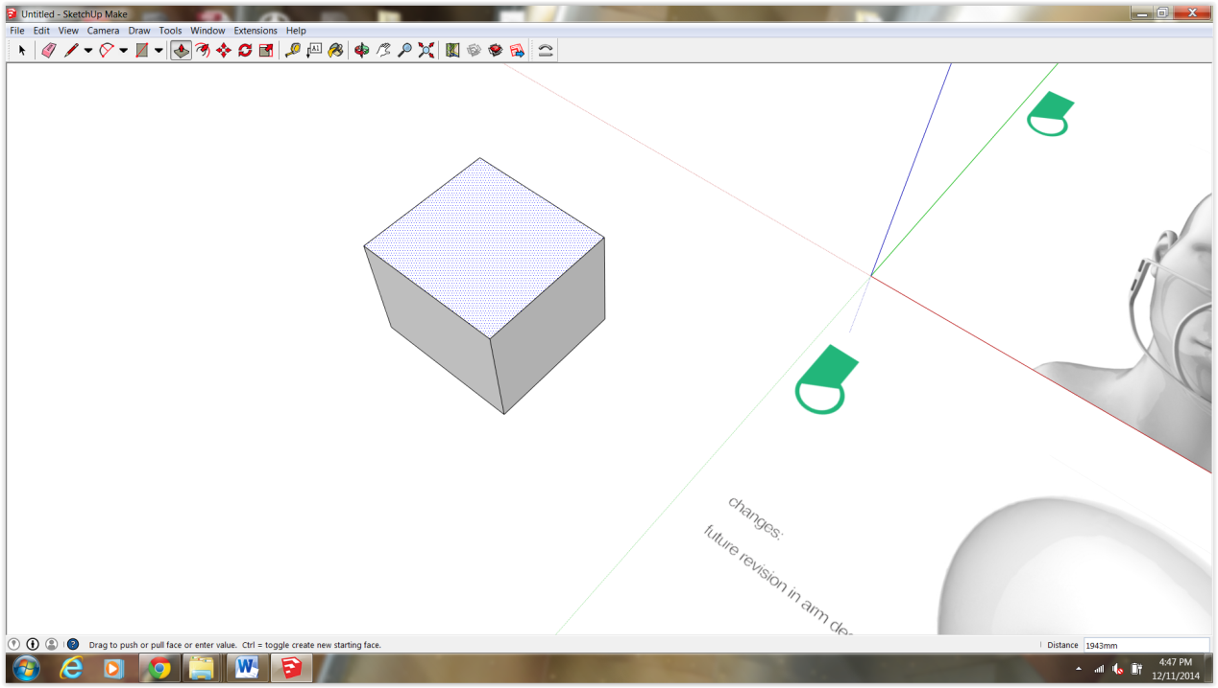

Sketchup works with groups and layers. This allows you to isolate individual components without messing with the rest of your model. From the toolbar select your curser and Triple click the box. Once all the edges are blue, right-click and select Make Group from the pulldown menu. To enter the group again simply double click.

Youtube is a great resource for learning sketchup. If youde like to learn more about groups, click the link below.
https://www.youtube.com/watch?v=LeKsBMXtmj8
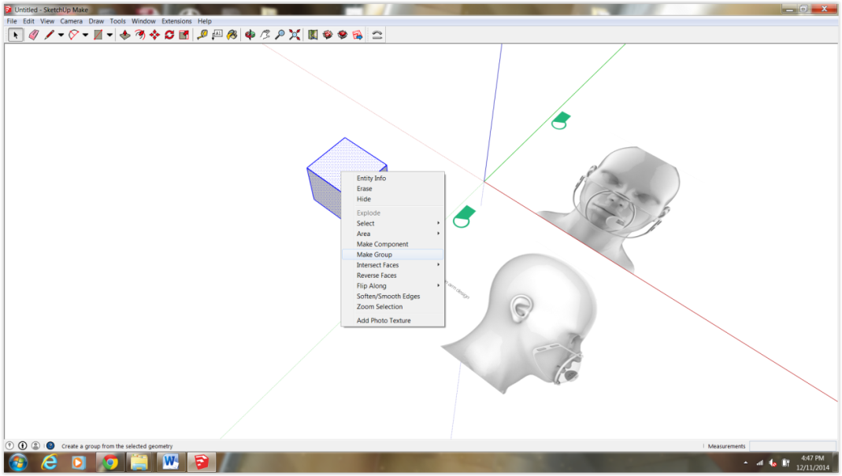
Step 5: In the last step we created a group from a box. The reason we’ve included a box in this file is for reference only, mainly rotating. We will get back that later. How you doing so far? 3D modeling is a lot more intimidating than it seems. Treat it like a video game and you will learn in no time!

So now were ready to trace the outer frame! We are going to trace over the image creating a flat, 2d Outline. From the toolbar menu select the pencil icon. Starting at the upper left corner draw a line from left to right and type 4000 mm. If you’re wondering why the crazy scale, don’t worry we will adjust this later.
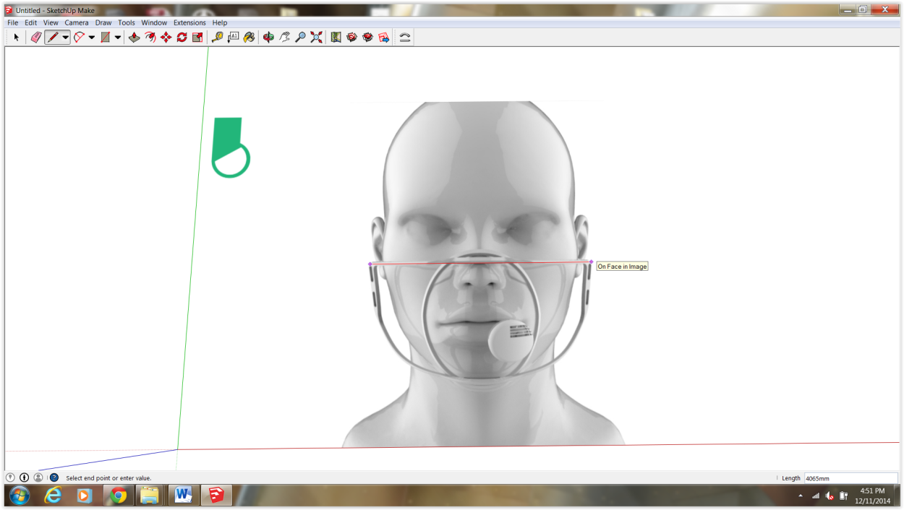
Draw lines projecting downward from the two endpoints. FYI the green guide is an indication you are drawing on axis. If no green, your line is not straight…Straighten up! lol
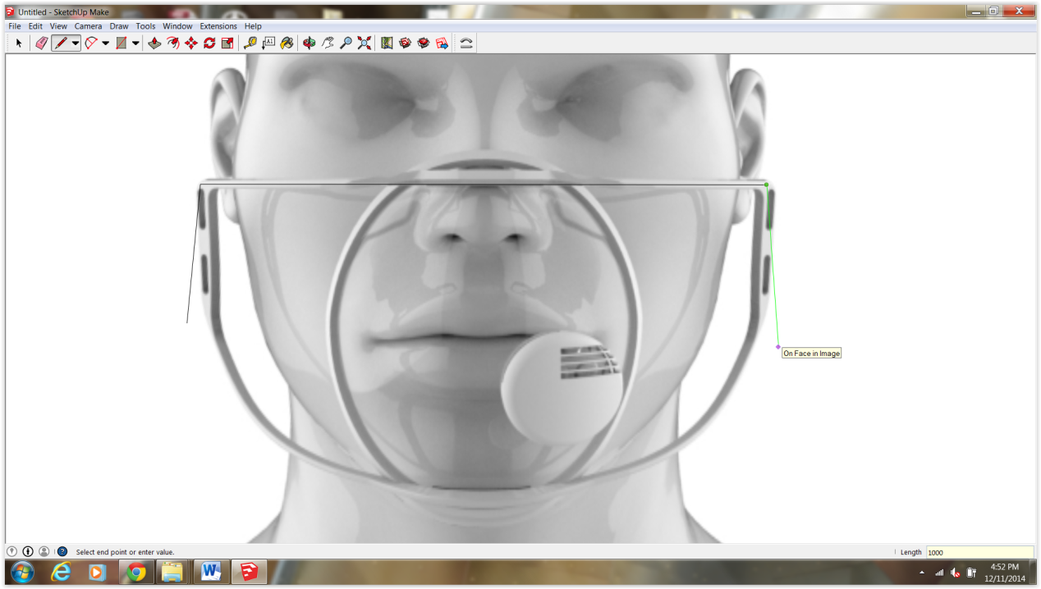

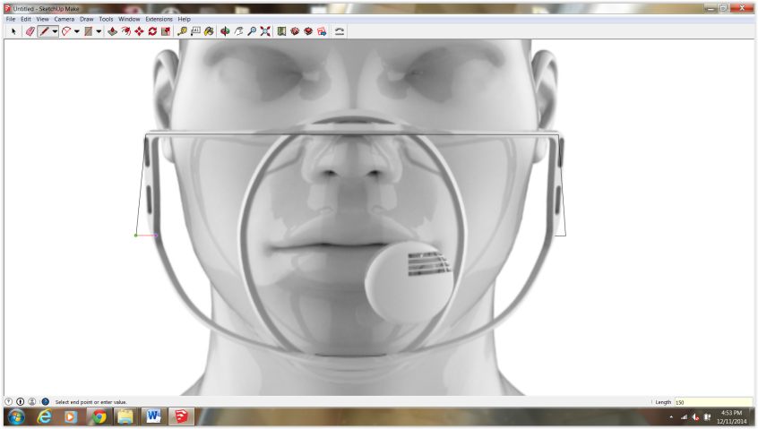
Our mask projects in a bit so we will draw some guides and to locate our actual edge. Project a line inwards toward the inside of the mask about 150mm. Then complete the triangle.
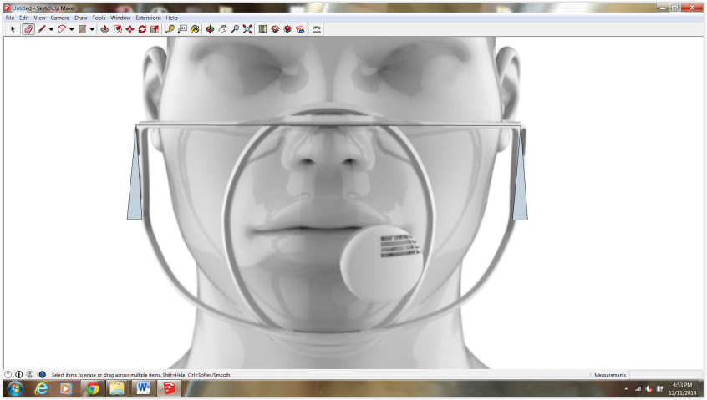
Using your eraser delete the two triangles surfaces and outside lines. Your model should look like the image below. Select the line tool, draw a line from the midpoint of the horizontal line toward the lower frame.

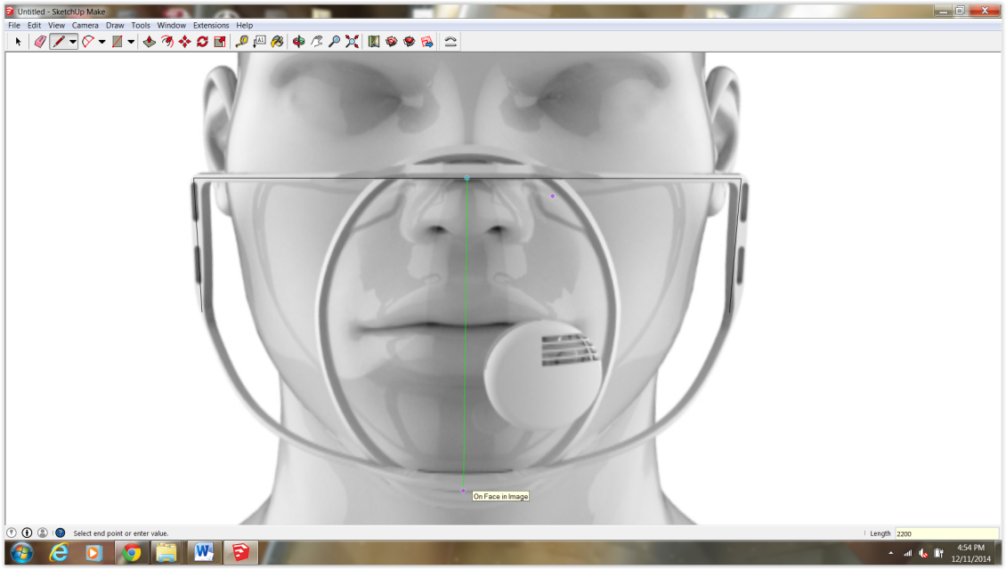

From the toolbar select 2pt arc. Draw a shallow arc like the one below. Try to line things up as best as possible but don’t go crazy.
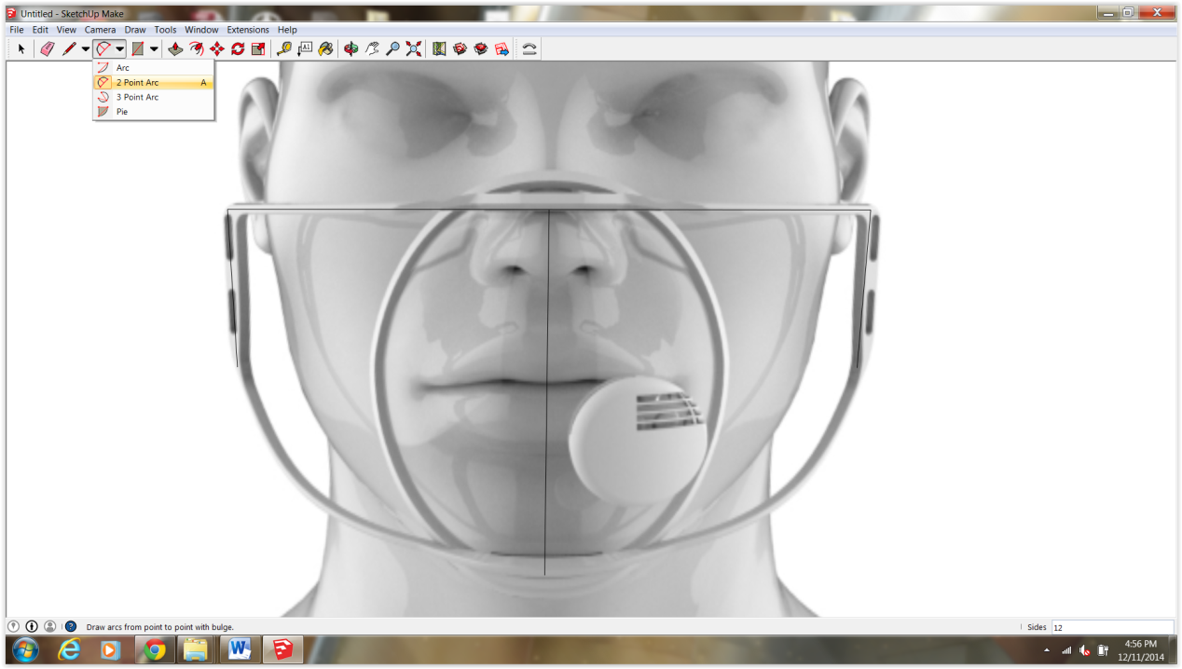

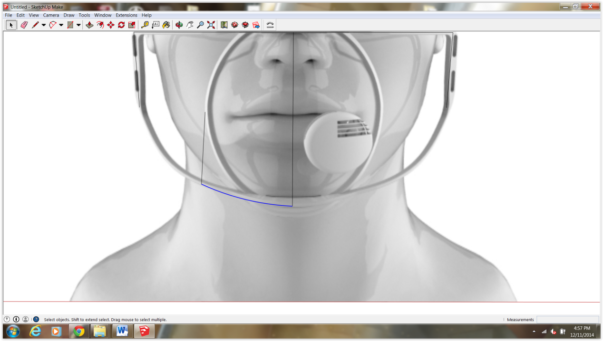

Select your 2 pt arc again and connect the endpoint to your arc. A blue surface should appear. This means your now working with a closed set of lines/
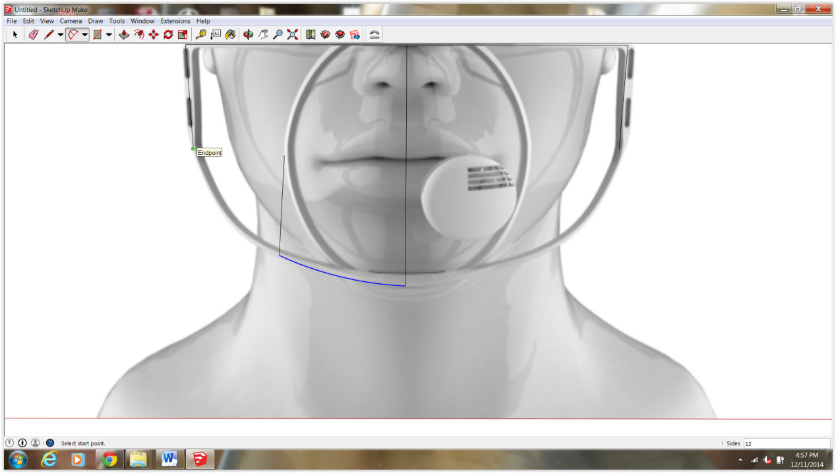

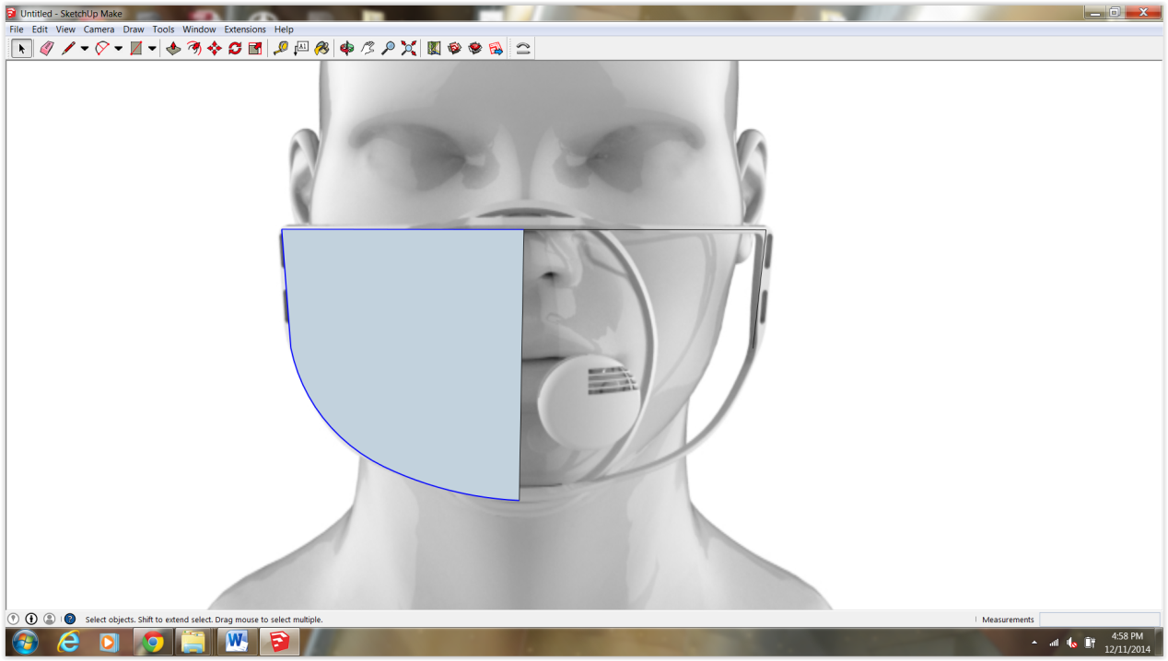

Now select your blue surface with the move tool. Once you’ve selected the surface click CTRL on your keyboard. This is a shortcup for copy. Drag your new surface out to the side.
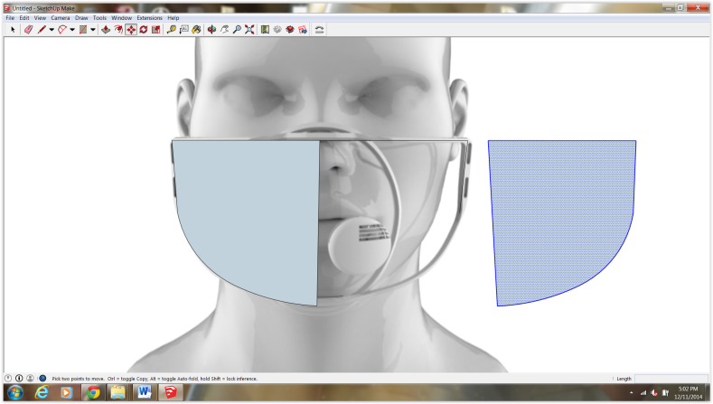
Next we will mirror this surface and attach it to the original surface. Select your surface and right click. From the pulldown menu find Flip Along then click on Red Direction. This basically means you are flipping or mirroring along the red axis.
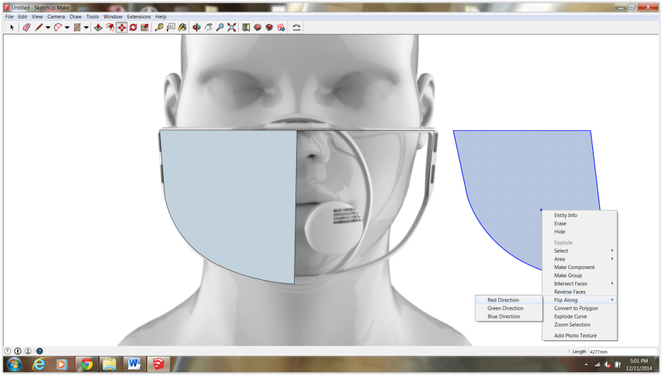
Once flipped go ahead and attach it to the original surface. Select on the corner with your move tool and drag toward the right upper hand corner of the original surface.
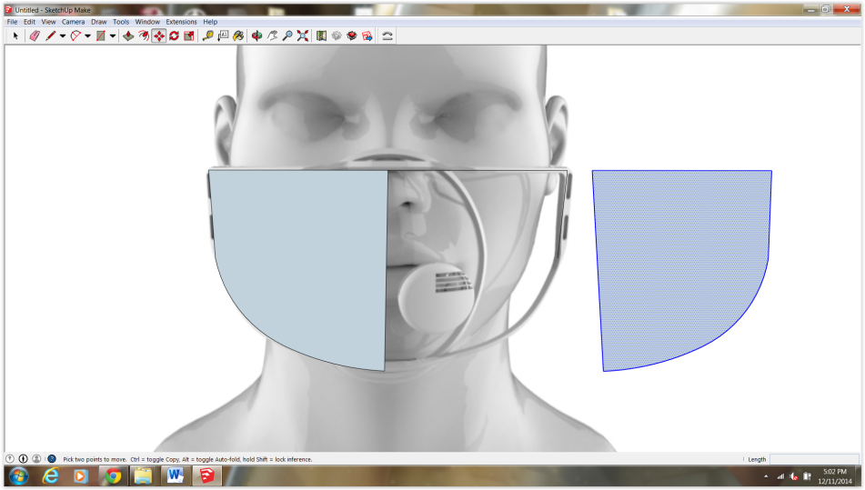
After deleting that center line your surface should look like this.
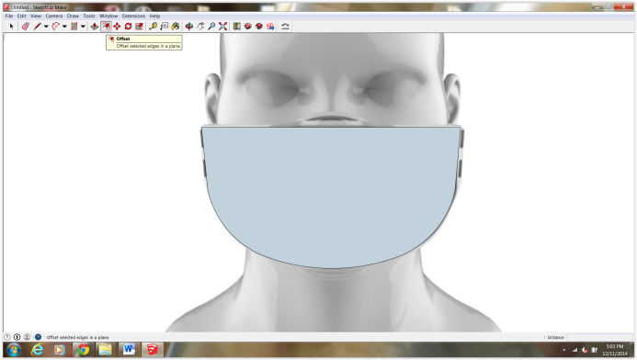
From the toolbar look for offset (two arcs with an arrow). Click on the surface to offset inwards. Input 400 mm and delete the center surface.
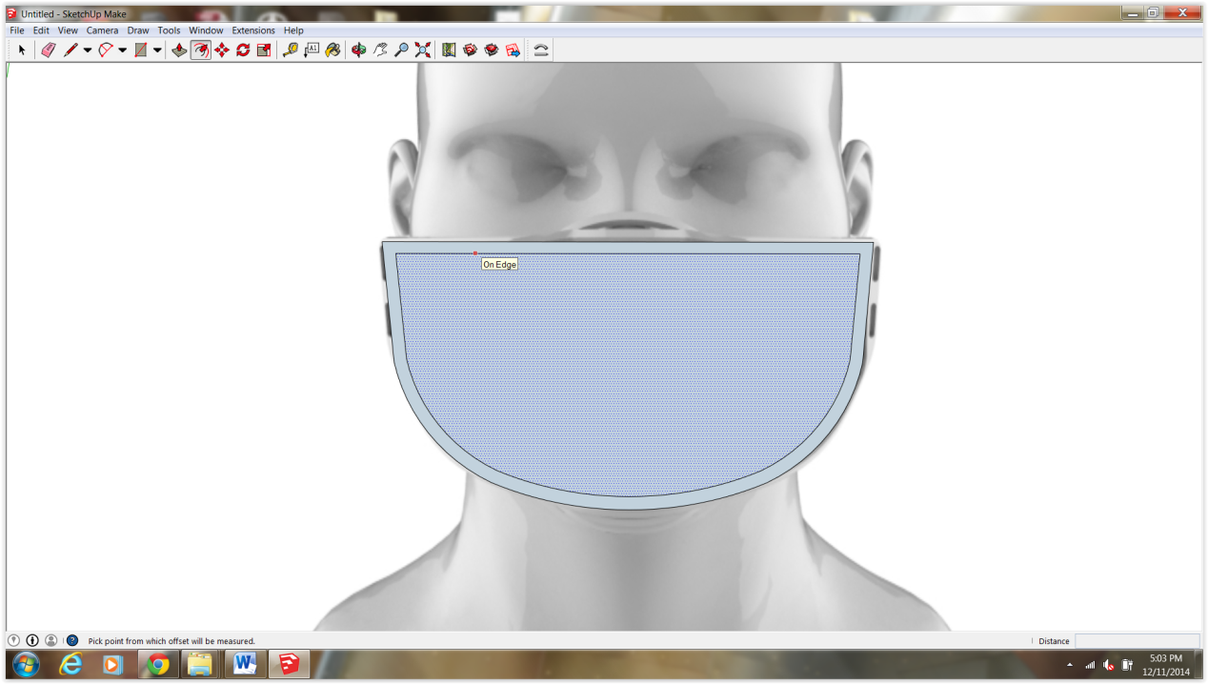
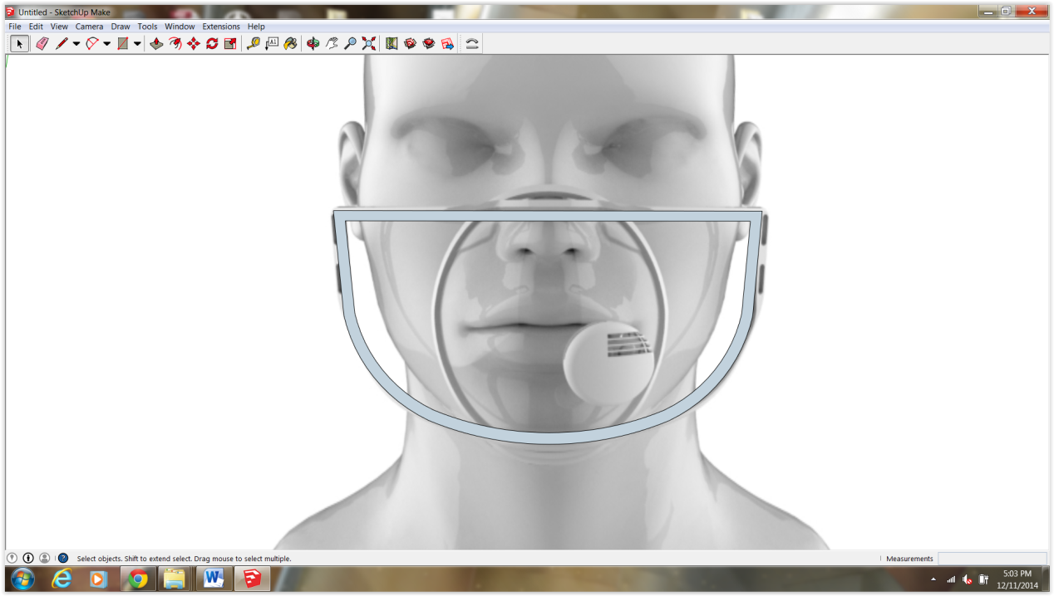

Remember to group your object. Triple click and Make Group.

Step 6: model the inner ring

On to the inner ring. Tilt your view a bit and draw a straight line down from the upper edge of the ring to the bottom.
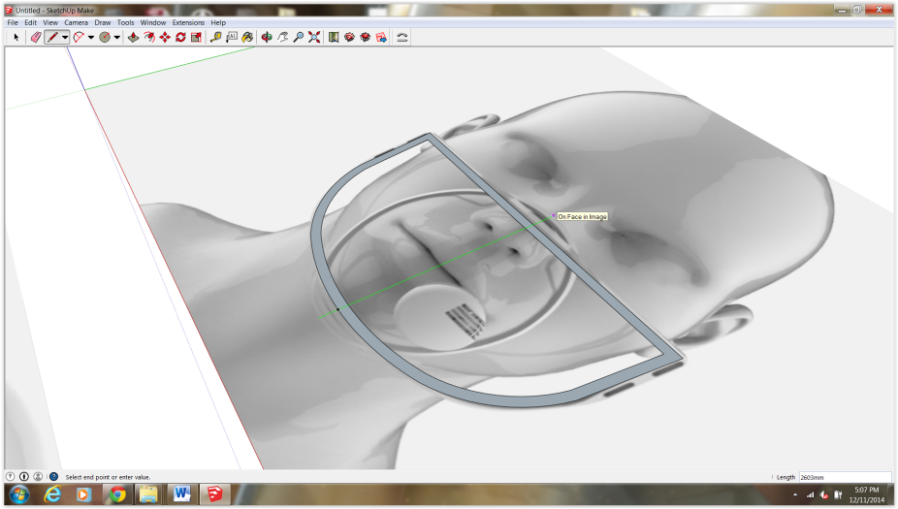
Locate the circle tool and from the midpoint of the line draw a circle. Notice my circle looks a bit strange. We can adjust the amount of facets on the circle by inputting a value which represents the number of sides. By default the number is 12, go ahead and adjust it to 48 (Click on the circle again, input 48 and enter)
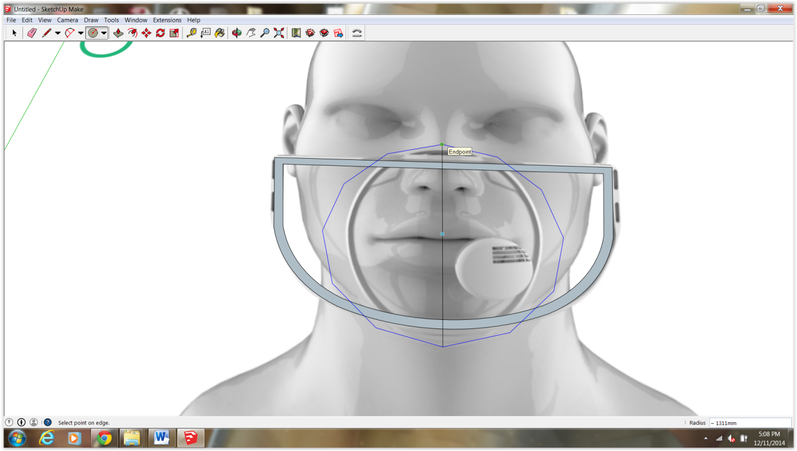

Once you’ve created your smooth circle delete one half. We will scale the perfect arc inward creating a half-ellipse. From toolbar find scale. You want to scale from outside in and from bottom up or top down (Not diagonal as this scales your object proportionally). Again, it doesn’t have to be spot on, just ballpark.
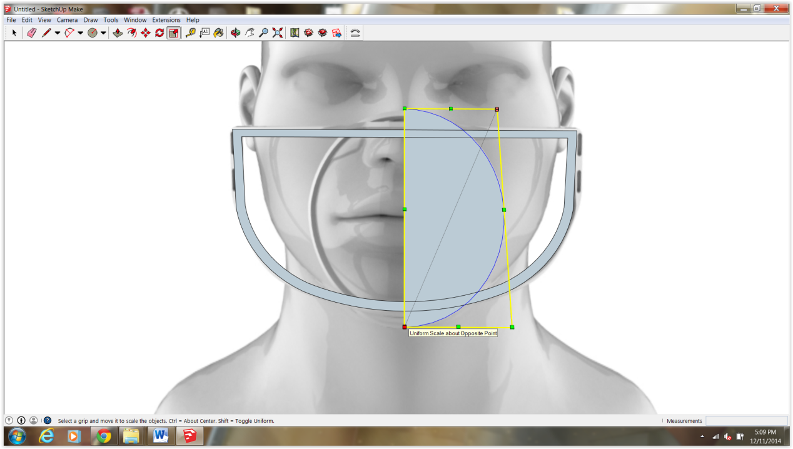
Once your happy go ahead and mirror the surface (like in step 5)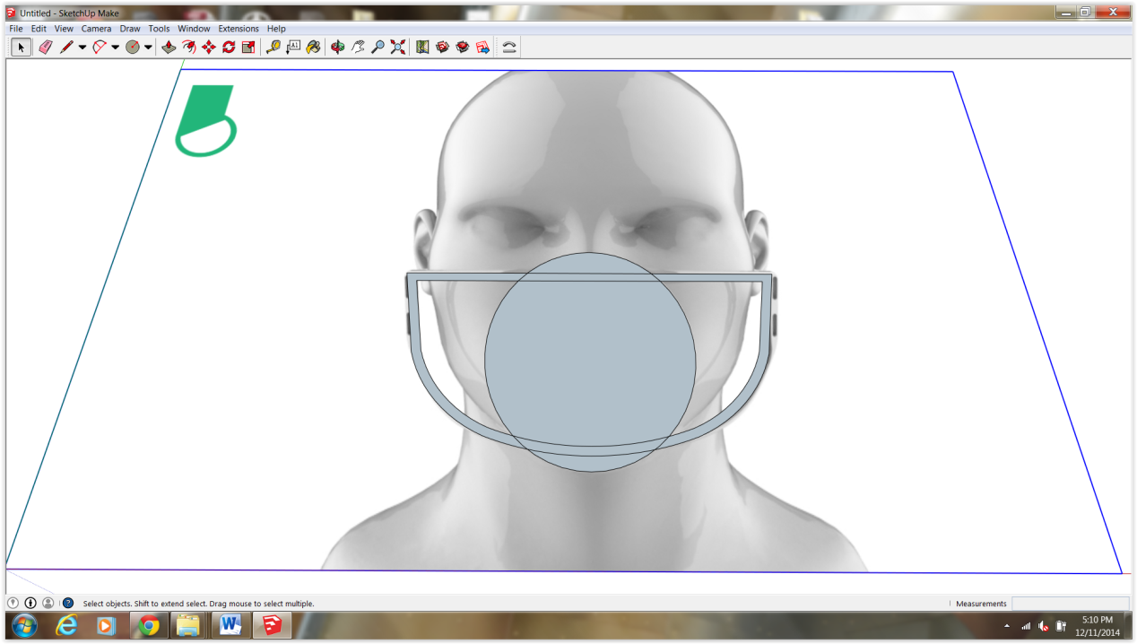

GROUP!!!
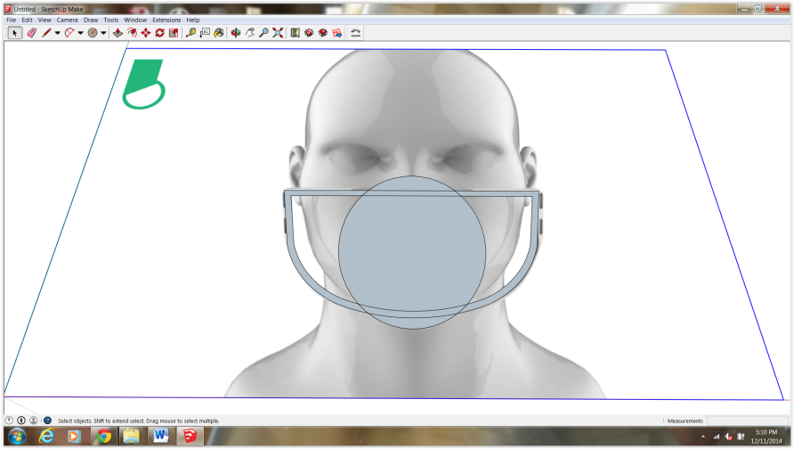
Offset 400 mm
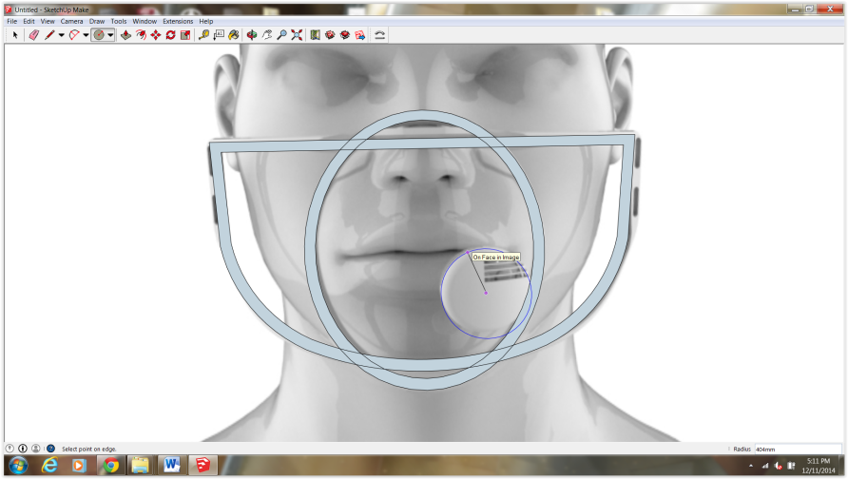
Trace the circle filter, triple click and group
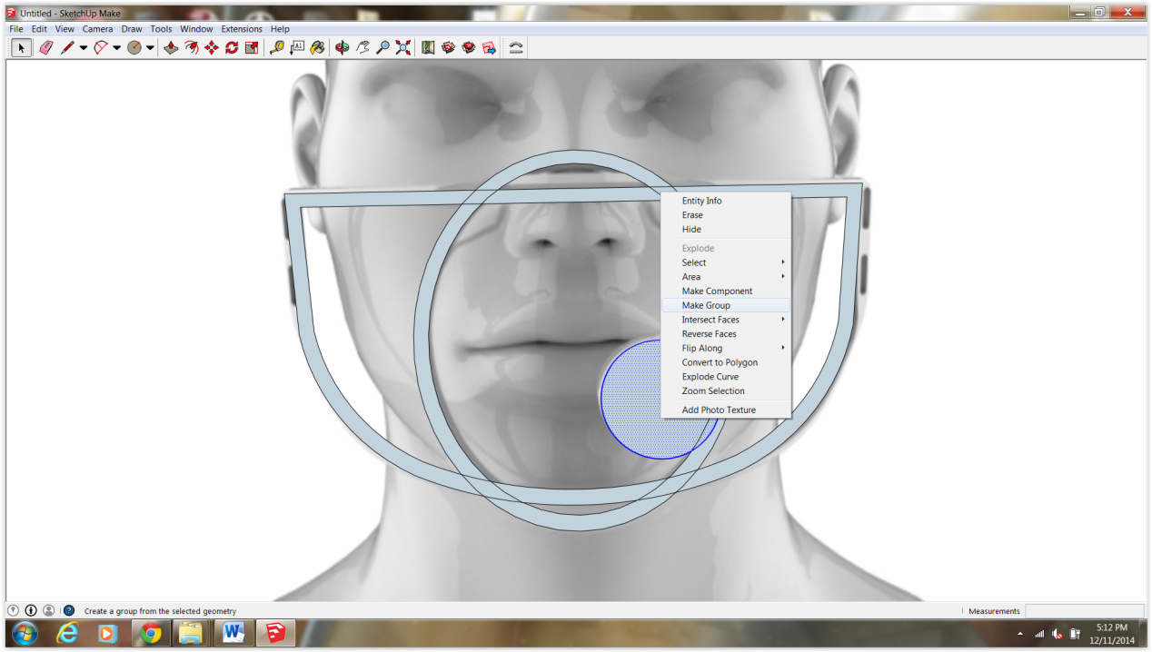

Finally, double click in each group and extrude each piece 400 mm
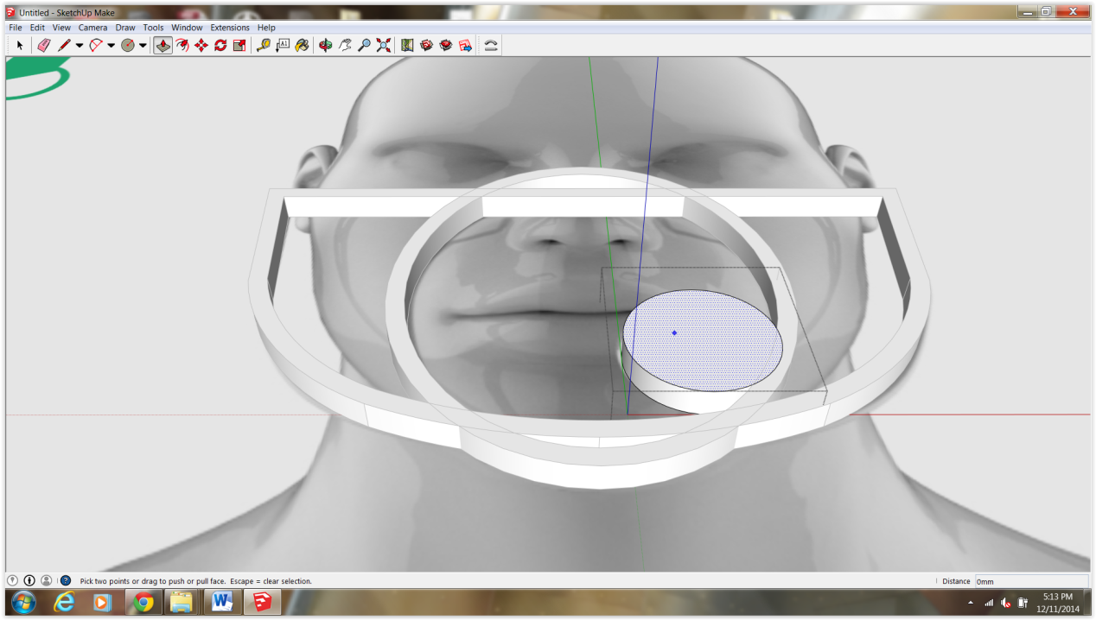

Step 7: BUBBLE TIME…

Please watch this tutorial first. It will clue you in on how to make a sphere in skethcup. Trust me its easier when seen live. See how they use the box as a reference. Also you can hide the frame and filter in the meantime.
Edit>Hide
https://www.youtube.com/watch?v=iDbQhQjeP9g

Draw a line from top to bottom

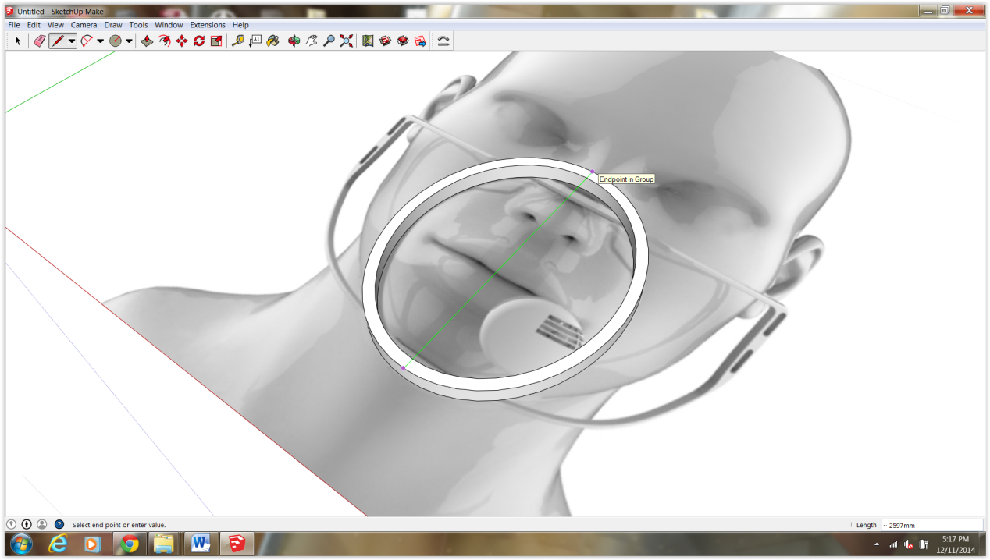
From the midpoint draw your circle again.
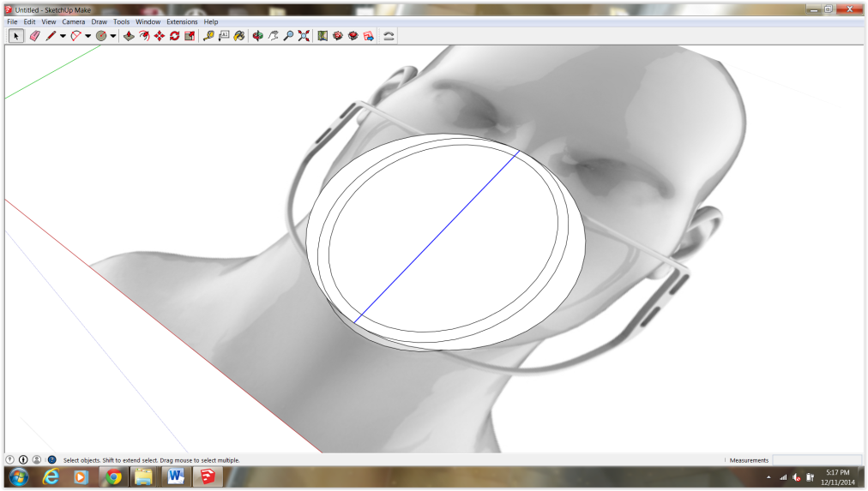
Using the box as a reference draw the inner vertical circle (see video above). Before making the sphere copy the flat circular surface as it will serve as a cutting plane in the next step.
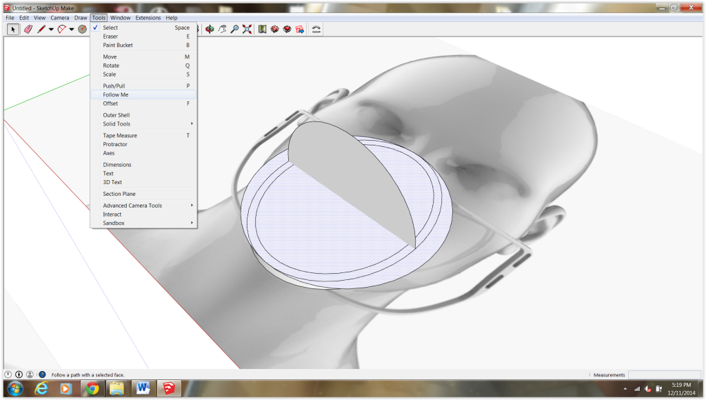
Ahaaa!! Spehere!!! Double click to see the fancy linework
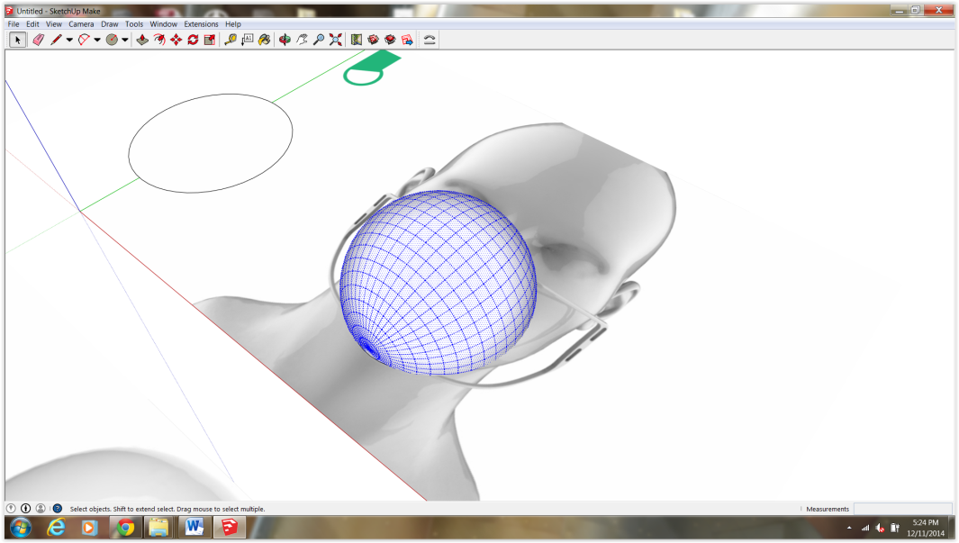

Next you will delete the bottom portion of the sphere by pasting your circle in place. This is the cutting plane I mentioned.. Edit>Paste in place. If you lost it, no sweat just redraw the circle from the midpoint again.

You should now be able to select and delete the bottom portion of the sphere
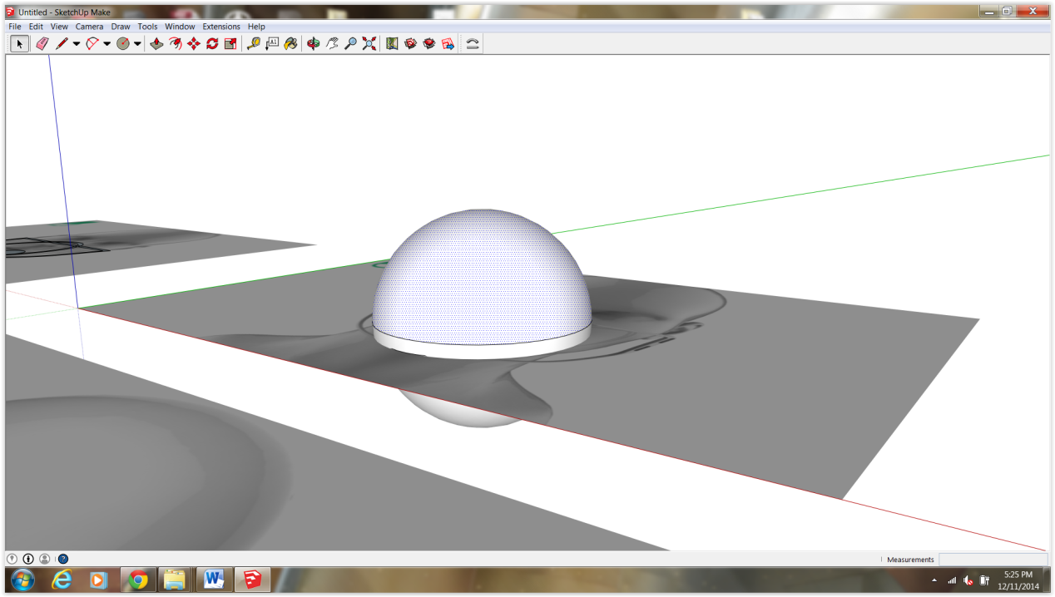
You From the toolbar hit scale and scale the dome inward. Input .99 as a scale value. You want to do this from all sides as it will essentially proportionally scale your sphere to be smaller than the ring.
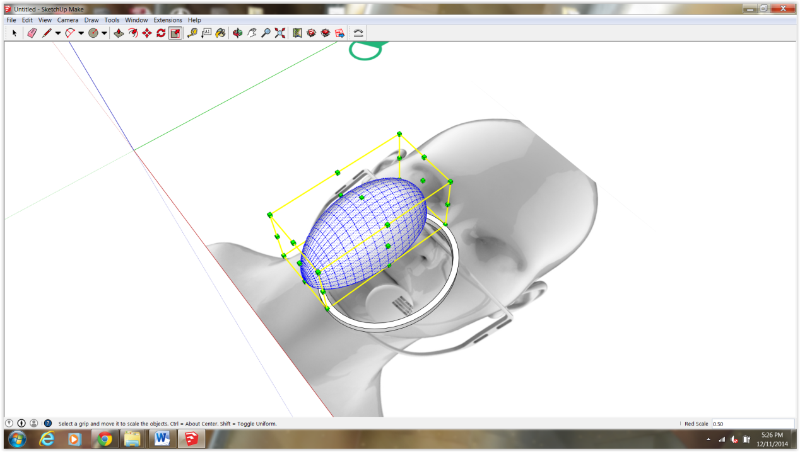

Hows that dome looking?
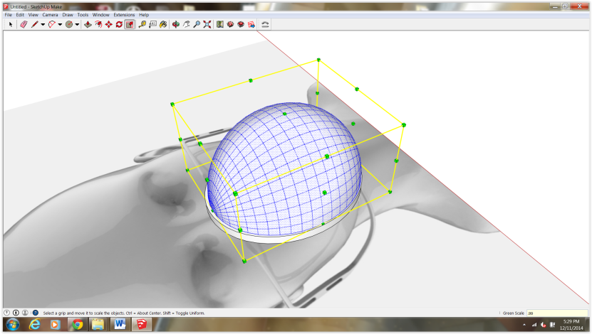

Once your dome is centered in place you can flatten it by scaling down toward the image.
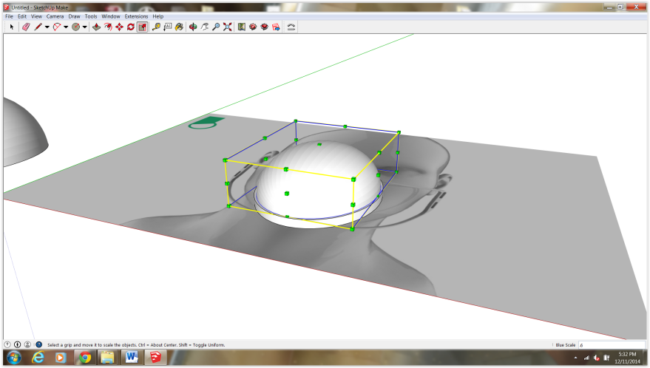

If you want to change the appearance (material) go Window>Materials>Translucent, click your material and with the paint bucket change the objects material. (youtube materials sketchup)

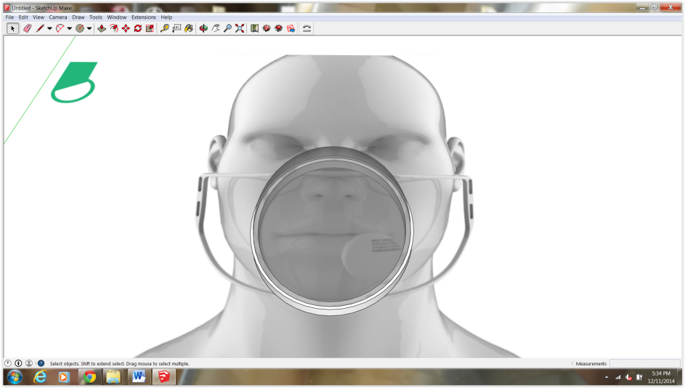
Edit>Unhide All

Step 8: Position filter cap.

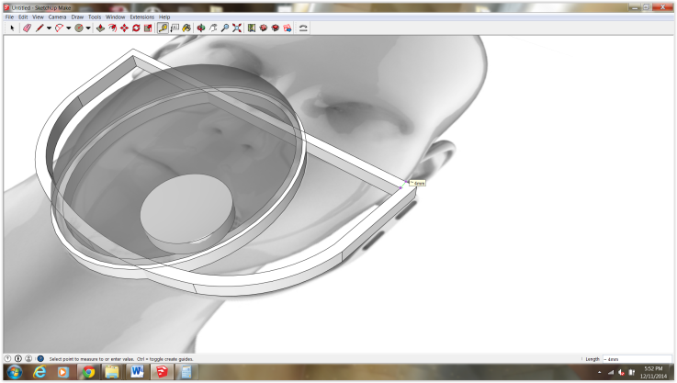

For this part you will need your reference box.
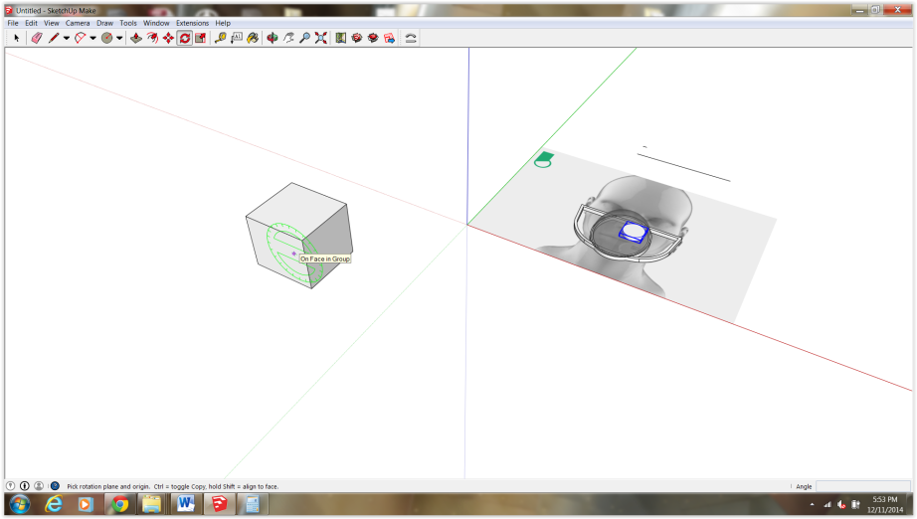
Holding shift will allow you to rotate your object along your desired axis. In this case along the green axis. Tilt your cap about 30 degrees
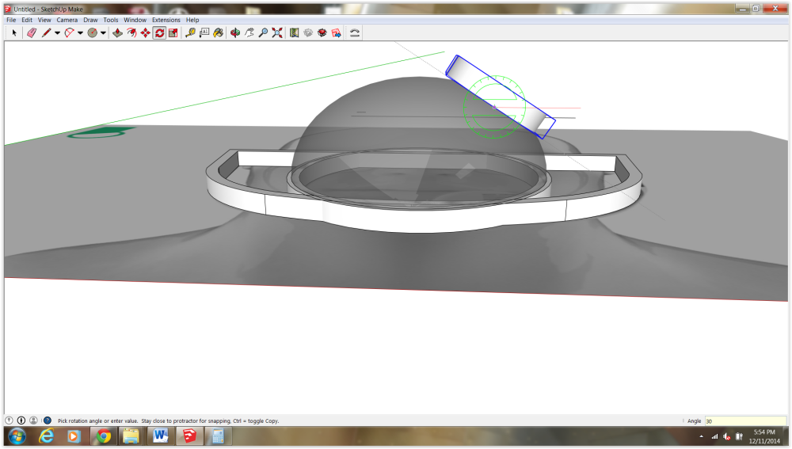

Do this again along the red axis. This time about 15-20 degrees should do.
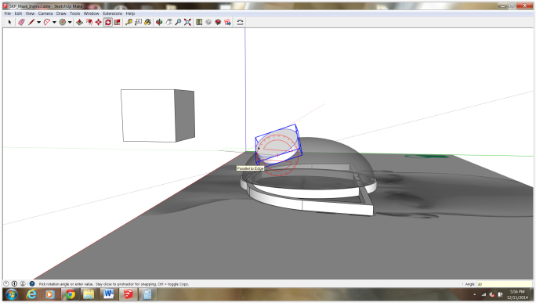
You can push/pull the circle until it fully intersects the bubble.
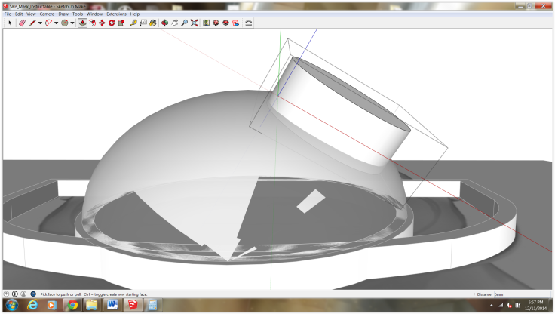
Not perfect but it will do for our prototype. Typically we would print these pieces separate so we would lay the filter down flat.
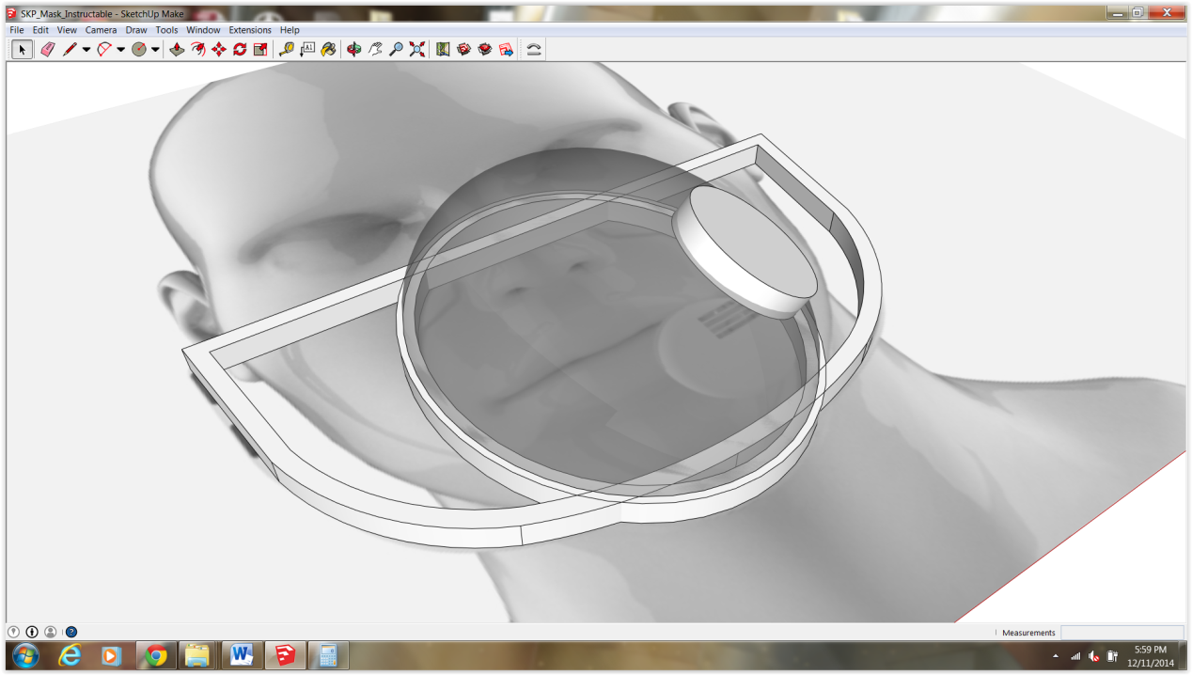

Step 9: Fit the bubble to the ring and thicken.

Offset the ring in 200mm
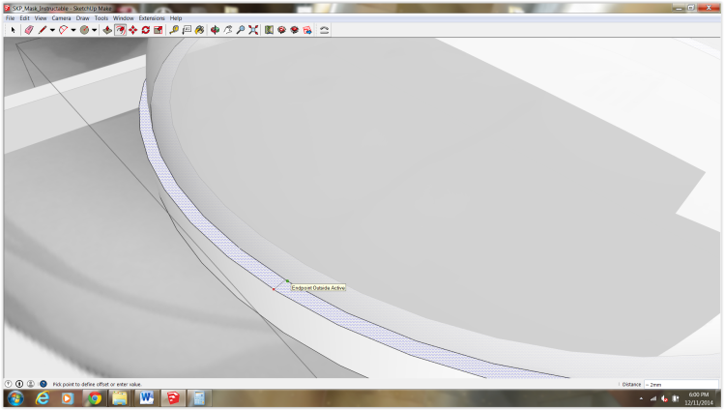

Push the inner ring down about 200 mm.

Double click the dome and draw a line down the center of the underside.
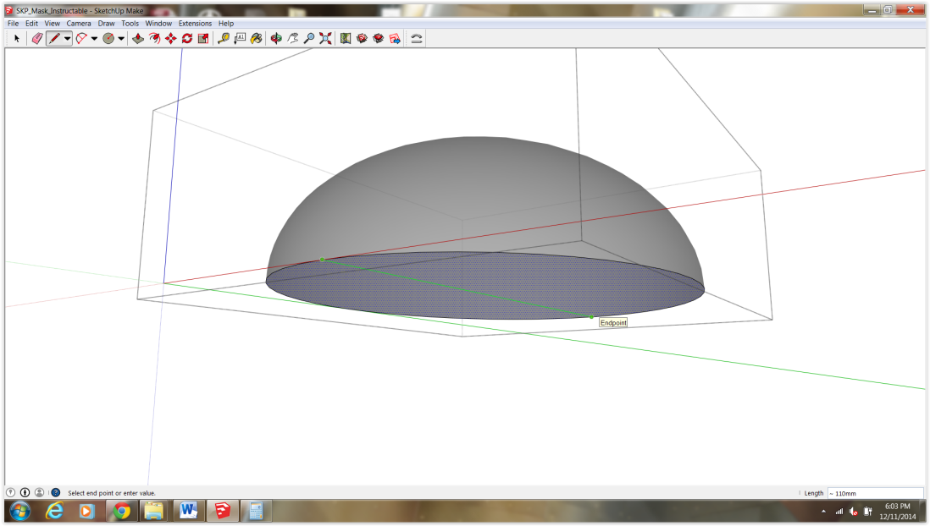

Double click the dome and draw a line down the center of the underside.
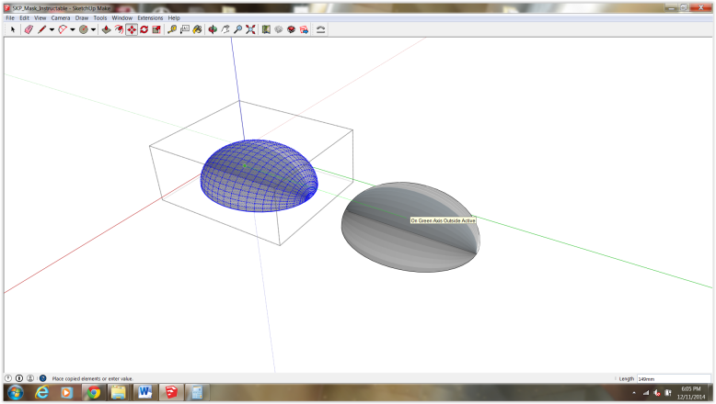

Scale down the copy .96 proportionally. (click one of the corners of the scaling tool and drag inward, input .96).
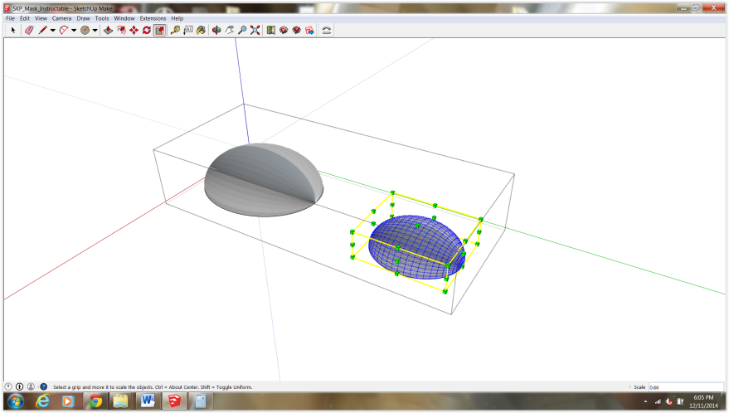

Looking at the underside of the domes, copy the small form the midpoint of the line into the larger one.

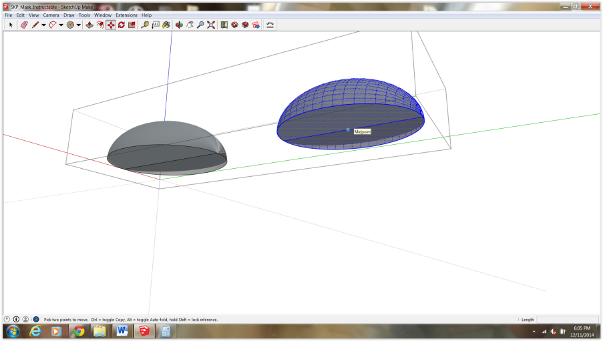

It should look like this.
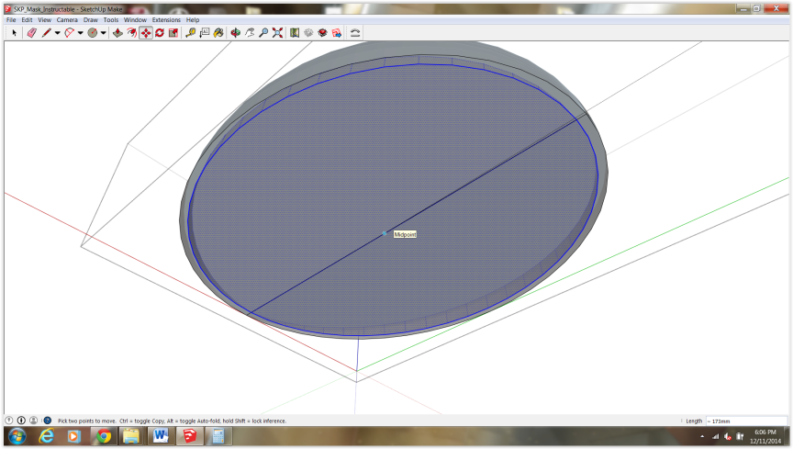

Delete the inner face only , leacving the outer circle or trim in place.
You may have to draw a line along one of the facets to separate the
Two circles

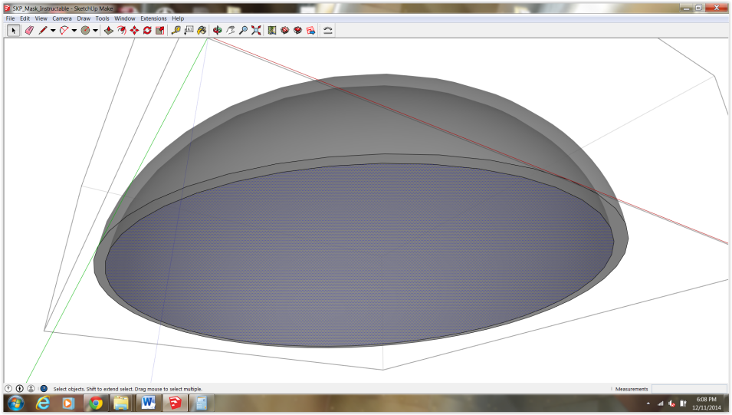

You know have a solid and printable dome!

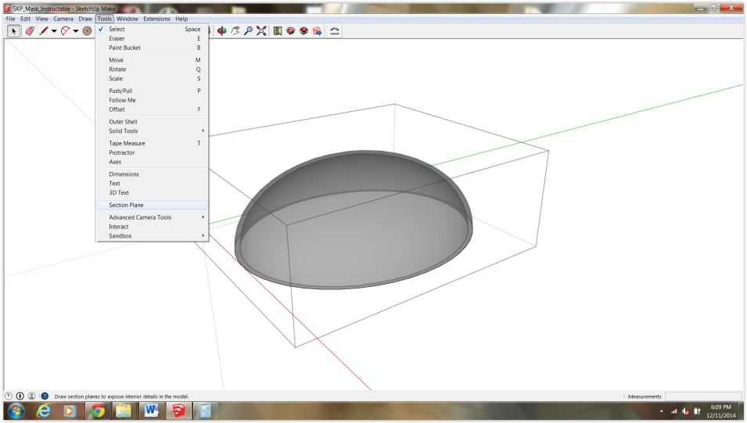
Step 9: Adjust scale

As I mentioned earlier you would typically start by using correct sizes. It
Will allow you to accurately model for prototyping.
Seeing as I broke rule lets go ahead and fix it.

The mask should be a width of approximately 6-7 inches (175mm)
The bottom line (above his head) is about 4000 mm. The correct line above this line is 175 mm. We need to match the lower line (along with the model) to the upper line. (my bad!)
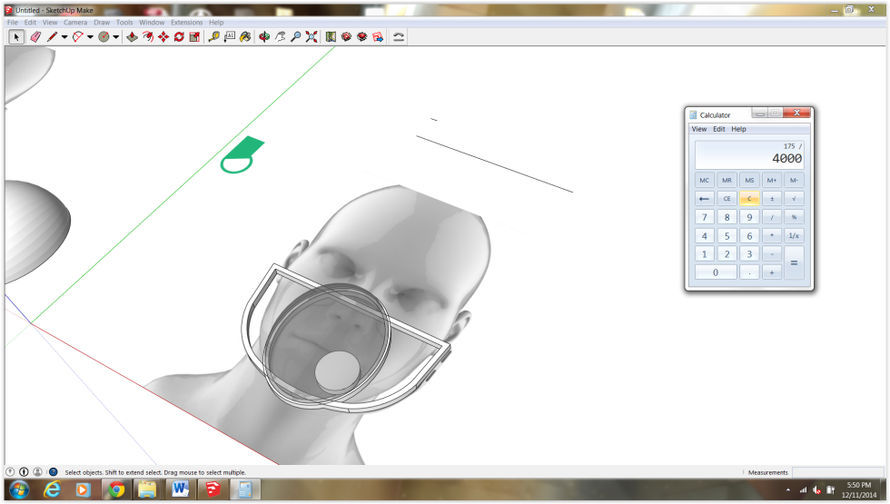

Select all your objects and scale. 175/4000 = .04375 , We need to scale the entire model down by .04375

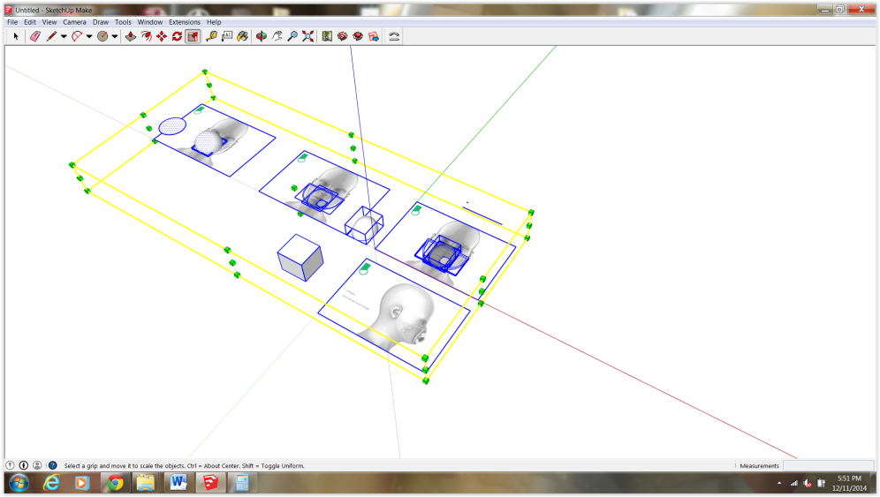

It will look like this. Just drag your entire model back to the main axis and zoom in. Now everything should be to correct scale for printing. Sorry If that was confusing, I usually work in big scale (Architects!)

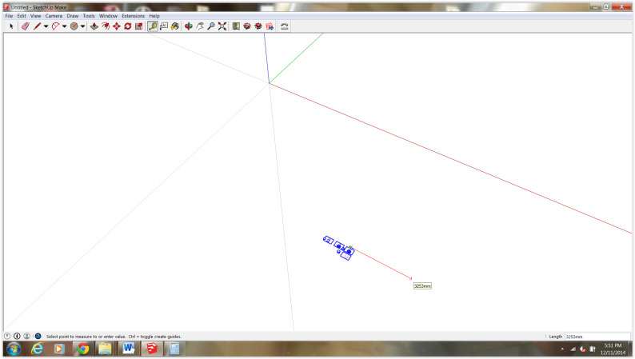

Step 10: Almost there. Just a few minor adjustments to the main frame.

At this moment if we pushed to 2mm holes into the frame (for the headstrap) we would have a risky print file. Typically you want your walls to be above 2 mm. Our frame is roughly 4mm so were good, but if you add a 2mm hole for the strap your now looking at 1mm walls on either side. No good! So let’s thicken these up.

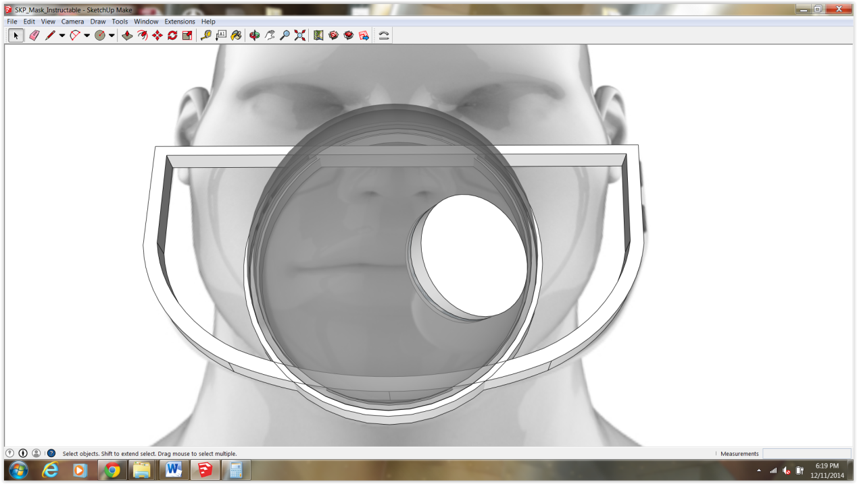

First drag in the upper inside edge about 5mm
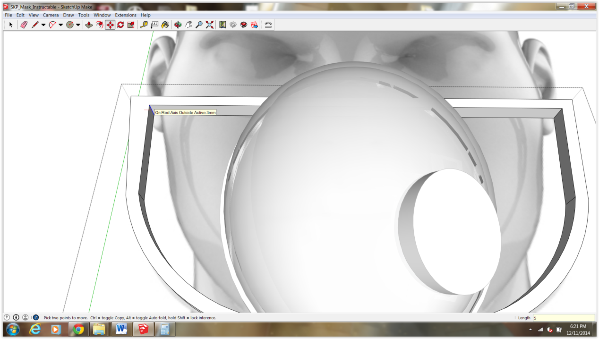

Then the bottom inside edge about 3mm. Do this to both sides

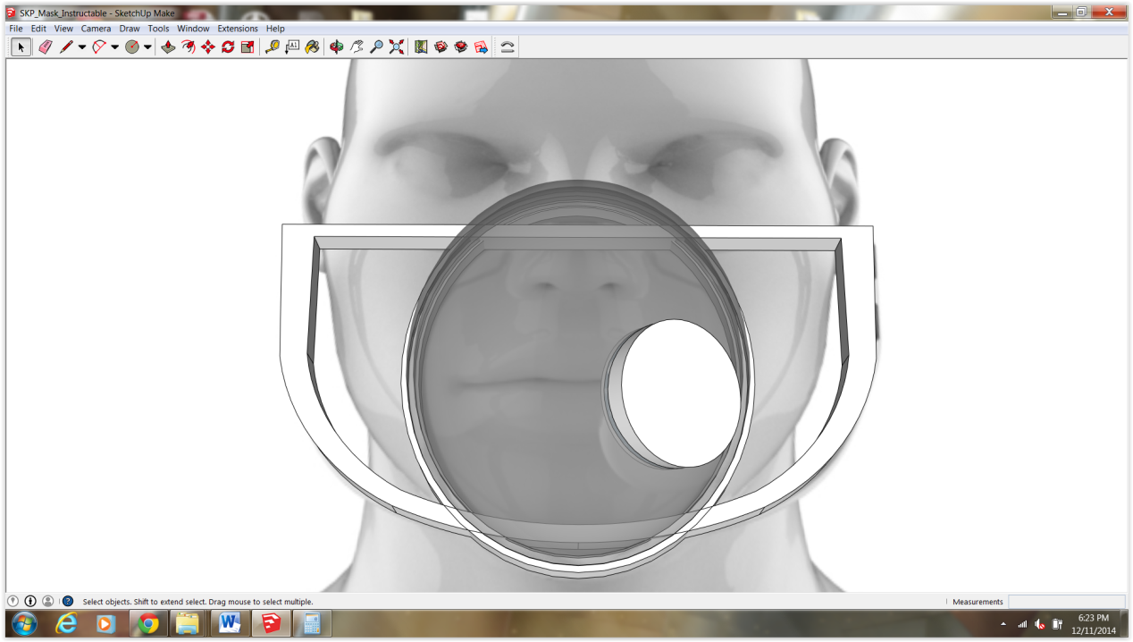

Now create some guides and add holes into your mask
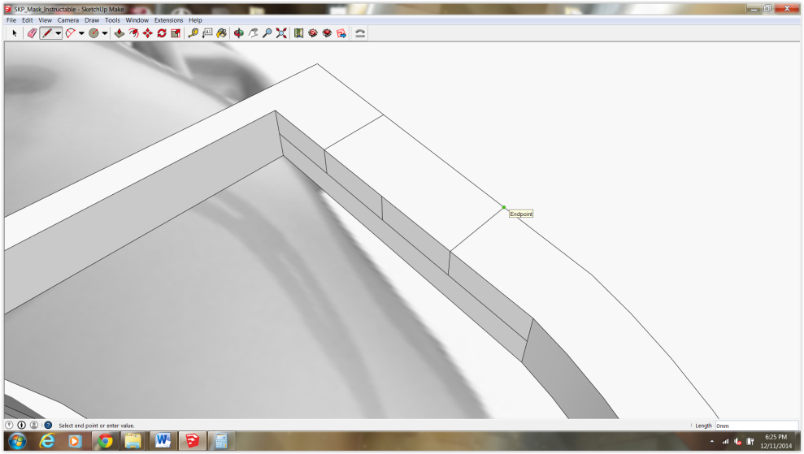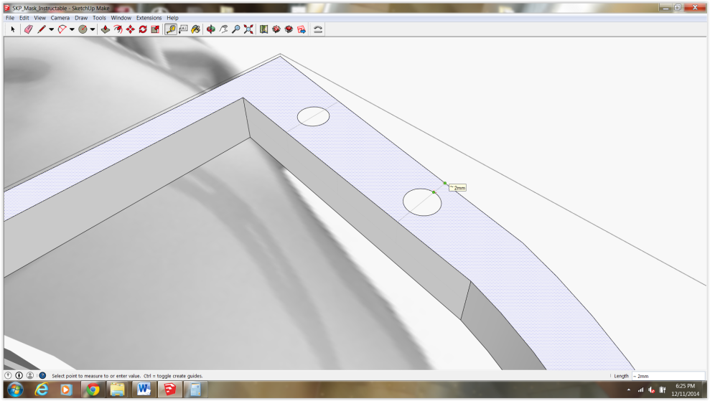

I think you’re getting it!
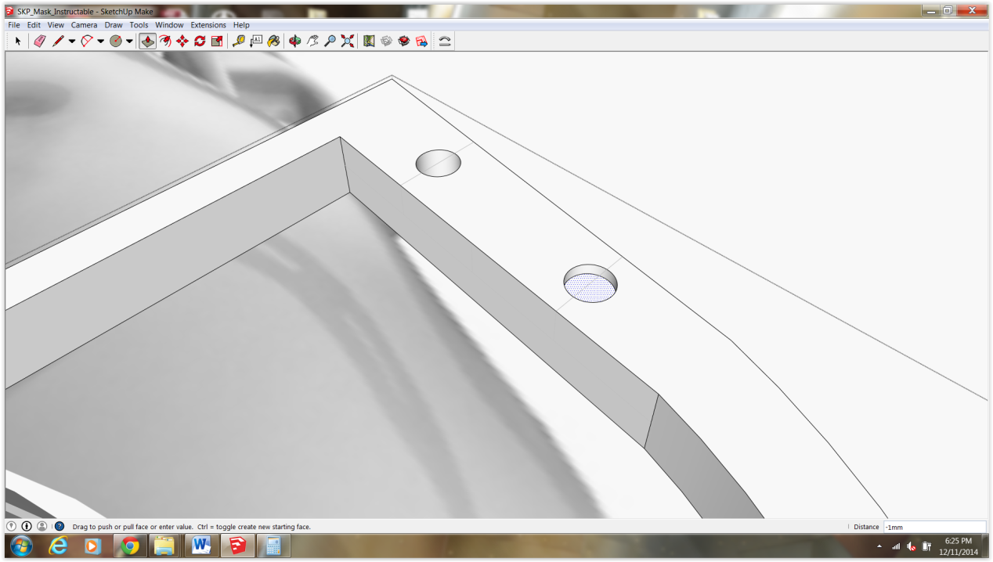
Lastly, Ive add a hole in place of the filter so we can breathe while trying on the prototype.

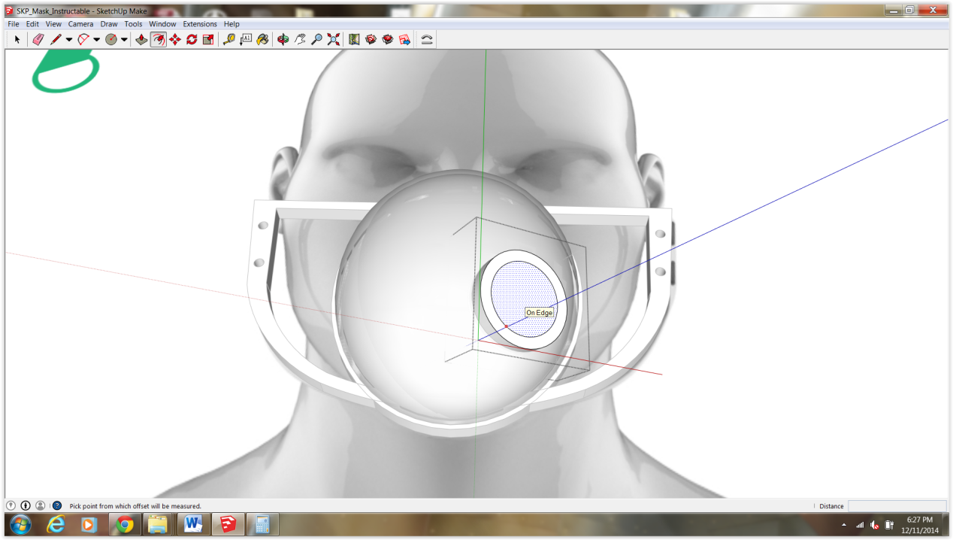

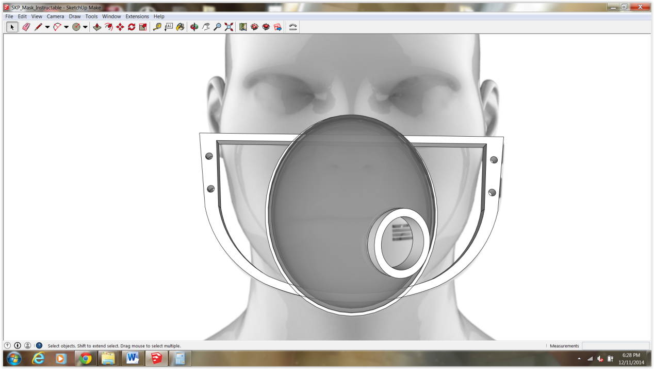

Step 11: Shape Bender Time!

Rotate your mask so its standing up right (Group and rotate using the box as a reference)

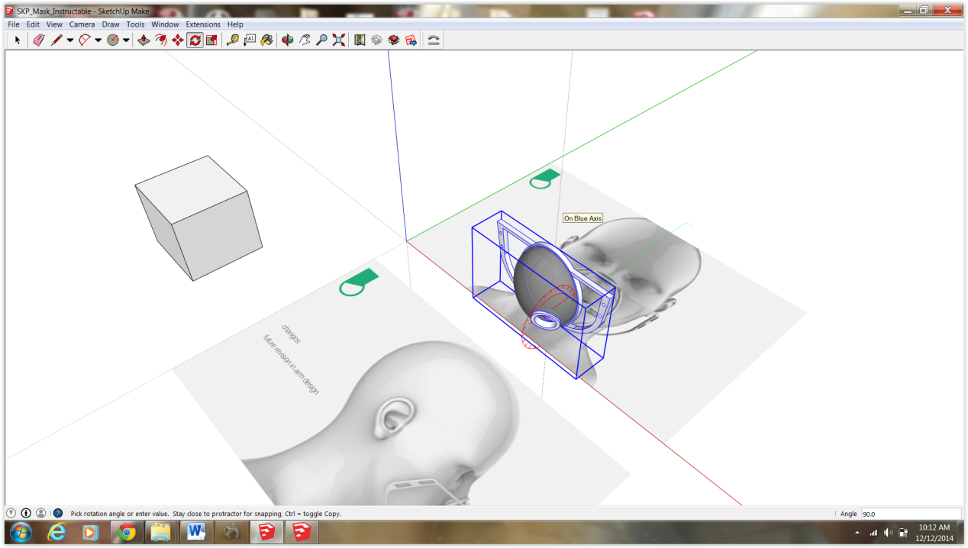

Draw a straight line along the flat edge of the mask. Draw an arc, roughly the depth of your face, directly behind it. You can use the second image for reference.

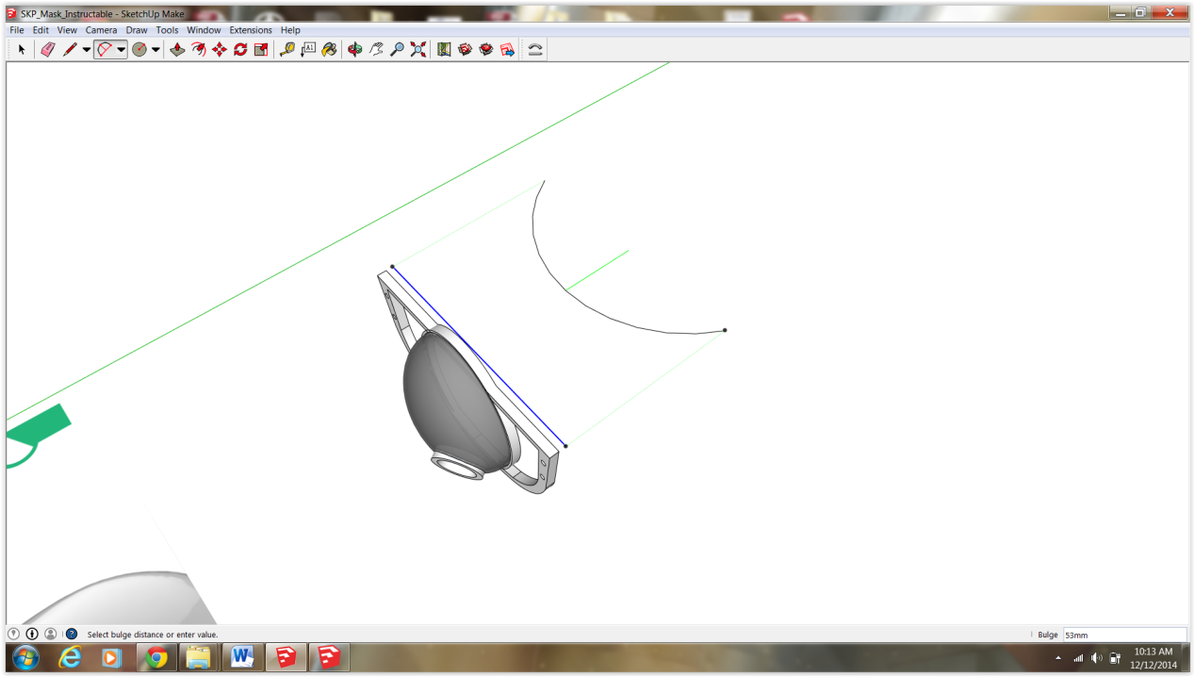

As we will only be bending the large frame around the arc, make sure it is on its own and in a group. Select the group then select the shapbender icon tool (Look at the bottom of the screen for prompts from sketchup)

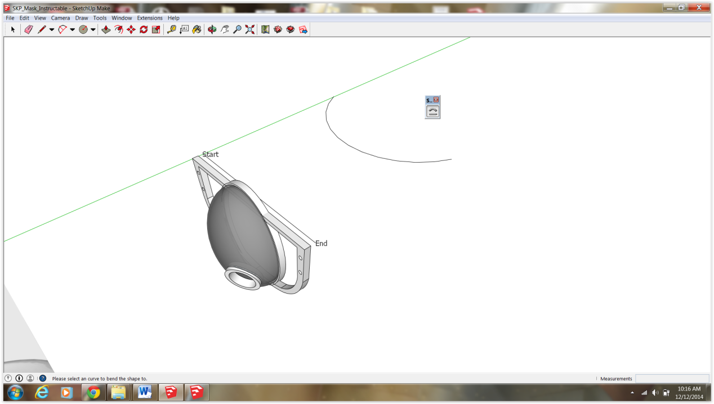

Next select the arc.

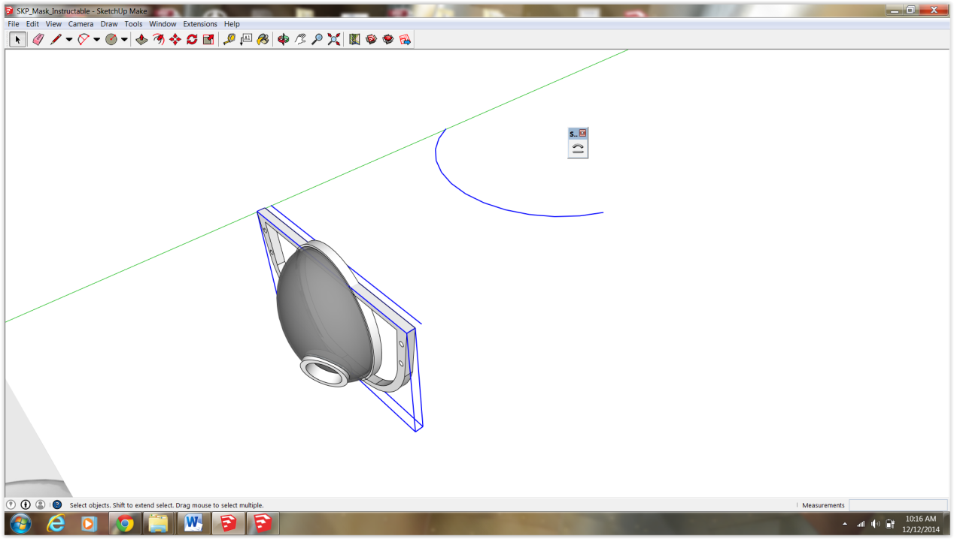

After a minute or two you will see a wireframe preview of the bent frame. If you are happy with the result press enter. (see command prompt at bottom of skp screen for further instructions)

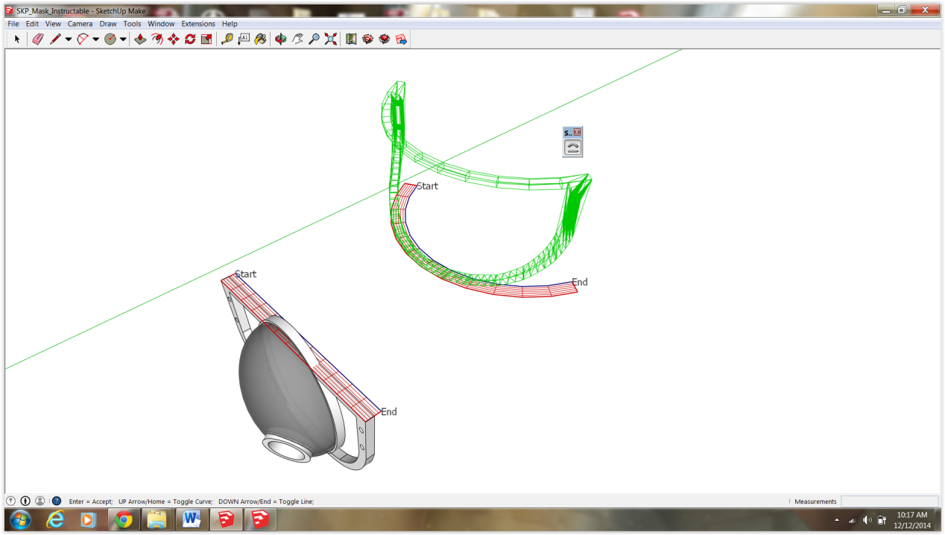
After positioning the face frame in elevation, copy the bubble, ring and filter cap as one group and drag toward your new frame.
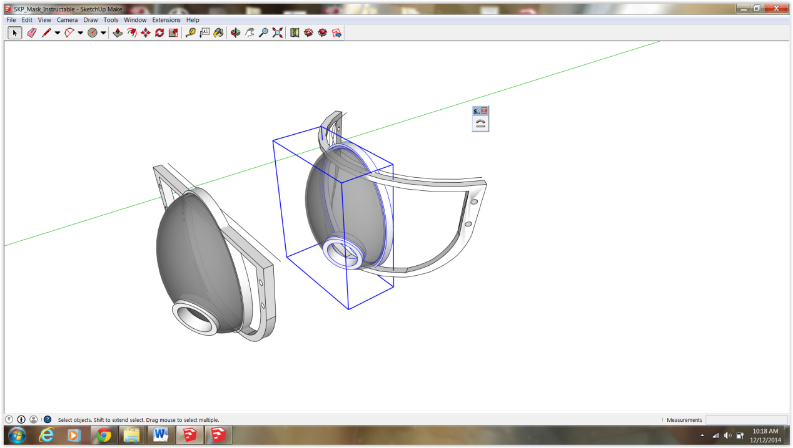

Nice! Your All Done

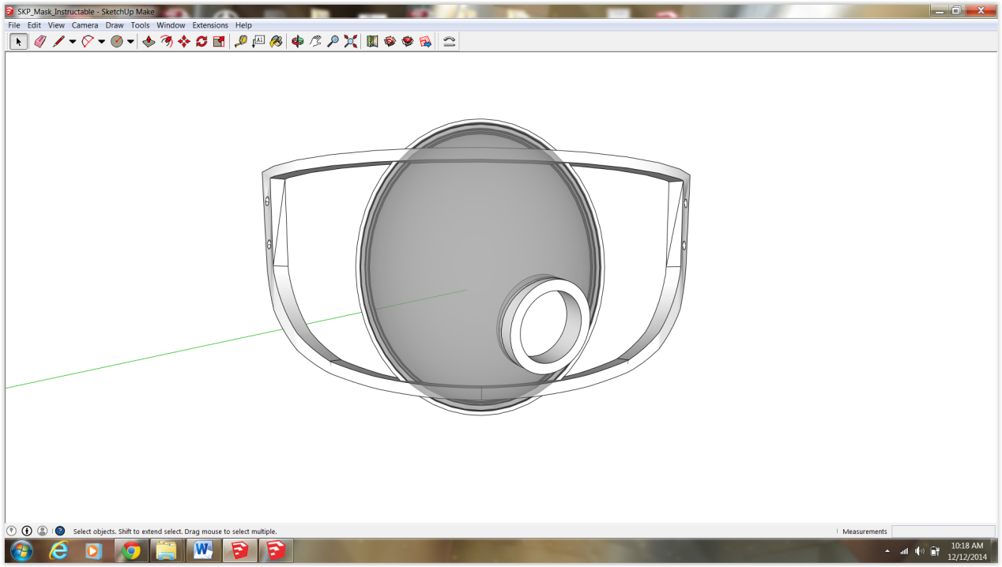

Congratulations!

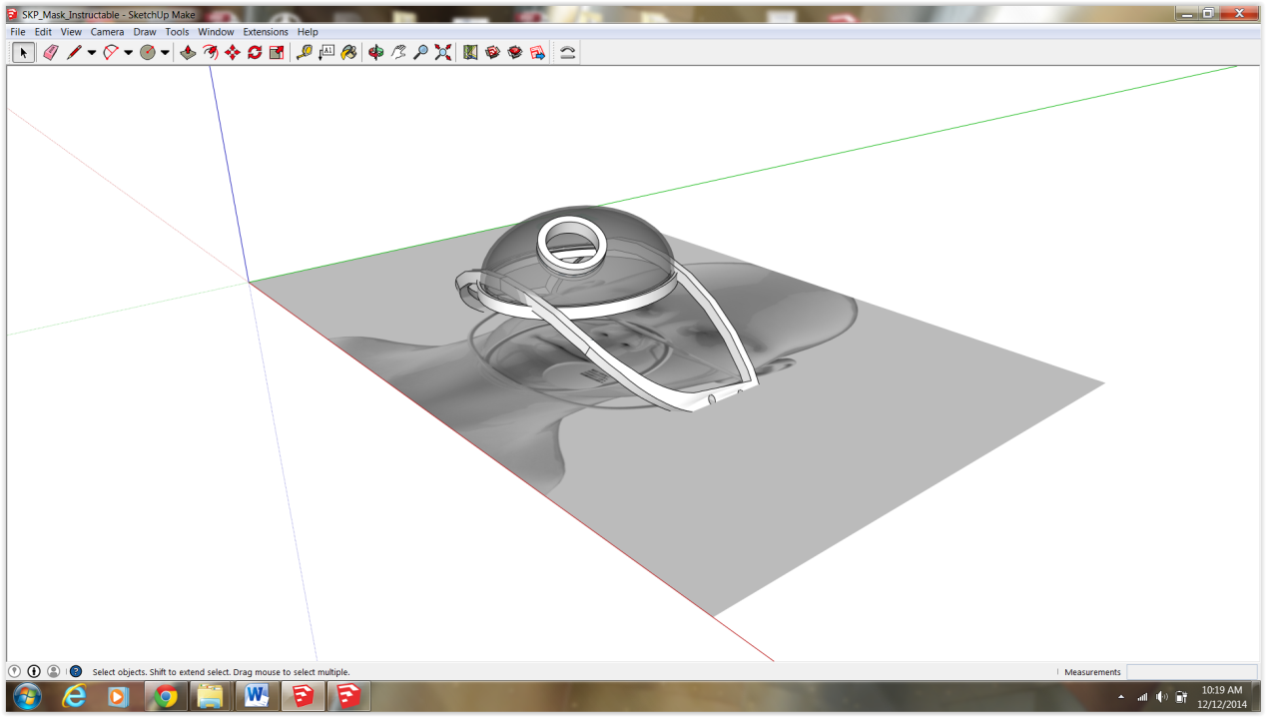

I hope you’ve enjoyed this tutorial. Feel free to message me if you have any questions. Your votes and friendly comments are much appreciated!

