BOM Open PCB.

Electronics PCB

ID | Value | Amount
D1 | 1N4004 | 1
Q1 | TIP120 | 1
R1 | 100 K ohms | 1
R2 | 470 ohms | 1
R3 | 330 ohms | 1
T1 | 2N2222 | 1
Pin Header | Female 2.54 mm | 11 (4,5,2)
Pin Header | Male 2.54 mm | 32 (8,10,6,8)
Heat-sink per TIP120 | -- | 1*
Screw Terminal | 2 pins 5mm | 4

* Heat-sink: https://solectroshop.com/product-spa-1736-Disipador-de-calor-para-transistores-con-caja-TO-220-TIP120.html

It’s very important the heat sink use, otherwise, it may burn the pcb. The current design also uses a 40x40 fan plugged to the heating system connectors

.Additional Electronics

Screen LCD 16 x 2 - I2C.

https://www.amazon.es/dp/B01N3B8JMN/ref=twister_B0821N9LCV?_encoding=UTF8&psc=1

Rotating Encoder

https://www.amazon.es/AZDelivery-040-drehwinkelgeber-donante-Encoder-Arduino/dp/B07TKK4QQD/ref=sr_1_4?__mk_es_ES=%C3%85M%C3%85%C5%BD%C3%95%C3%91&crid=2ISVGVTMBN15X&keywords=encoder%2Brotativo&qid=1584701774&s=industrial&sprefix=Encoder%2Br%2Cindustrial%2C180&sr=1-4&th=1

1 Sensor Termistor 100k

https://www.amazon.es/UKCOCO-Termistor-cableado-clavija-impresora/dp/B07BMT6H45/ref=sr_1_9?__mk_es_ES=%C3%85M%C3%85%C5%BD%C3%95%C3%91&keywords=sensor+termistor&qid=1584701812&s=industrial&sr=1-9

1 12V 3A Momentary Push Button Switch

1 AC/DC 12v 1,5 A

1 Arduino UNO,

The current design requires removing the input diode, and making a jumper as it is not ready to withstand the input amps.

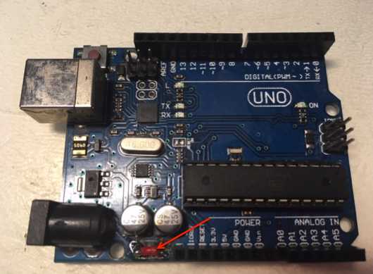

PCR reactor

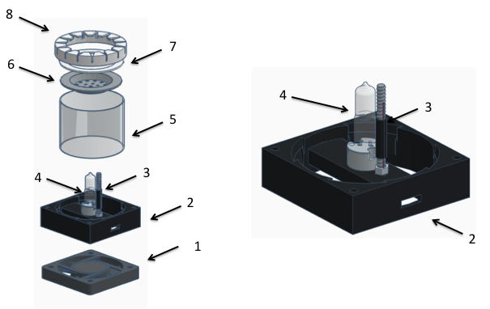

1.- cooling system | Fan 70x70
2,- Reactor armour | (See SLT file)
3.- temperature probe support | M5 or M6 Screw ( 60mm) & nut + thermo retractile tube
4.-heating system | Halogen lamp G4 12v 25-50W & G4 Socket Base Holder
5.- reactor wall | Steel tube, 63,5 mm external diameter
6.- PCR tube holder | Domestic drain filter, 61 mm external diameter, 19 holes. The diameter of some holes needs to be increased with a 6mm drill bit for metal
7.- Silicone ring | 63,5 mm external diameter. Some moka coffee maker joints are perfect
8.- Support for tube holder | (See SLT file)
It’s advisable the use of Thermal tape for improving the reactor wall assembly, with the other reactor elements.

