M A C A W S

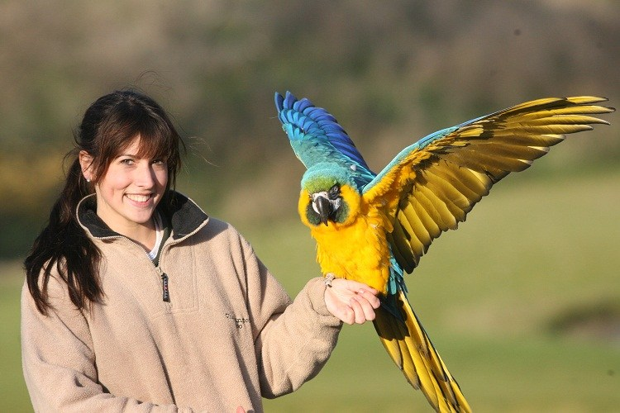

FAST FACTS:

1. Macaws belong to the parrot family.
2. There are about 20 species of macaws, many of which are endangered.
3. Macaws have long life spans and are able to live up to 60 years in the wild!
4. Macaws are very social birds and will often live in flocks with more than 30 birds.
5. Macaws are one of few species who mate for life.

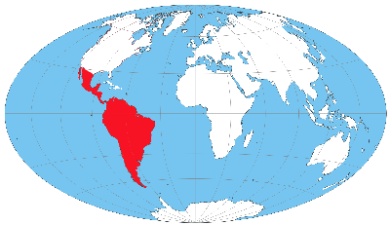

Where do macaws live?

Some macaws, such as the Hyacinth Macaw can have wingspans up to 4 or 5 feet!

Macaws are famous for their ability to copy human speech! They are naturally programmed to mimic different sounds made by flock members.

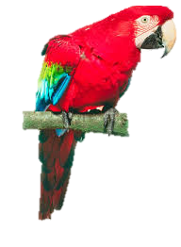

B e n g a l T i g e r

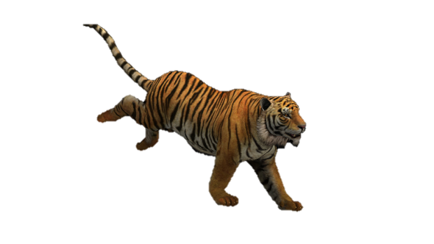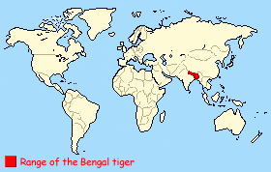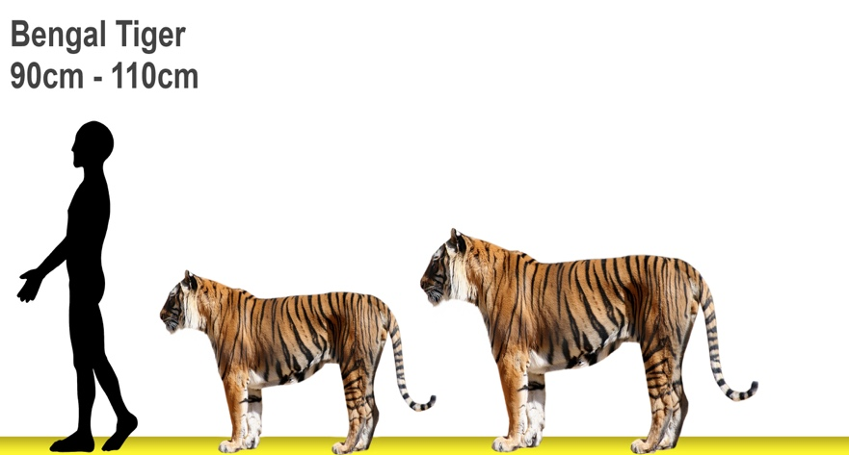

Where do Bengal Tigers live?

There are only around 2,000 Bengal tigers left in the wild today, and their population is decreasing.

Males can be up 10 feet tall on its hind legs and can weigh up to 490 pounds. Females can be up to 8.7 feet tall and weigh up to 310 pounds!

FAST FACTS:

1. The Bengal Tiger is the national animal of India and Bangladesh.
2. Each tiger has their own unique set of stripes, just like human fingerprints!
3. Bengal Tigers have canine teeth that are four inches long.
4. They are capable of eating up to 40kg of food in one sitting.
5. Their stripes help them to camouflage in long grasses.

P l a i n s B i s o n

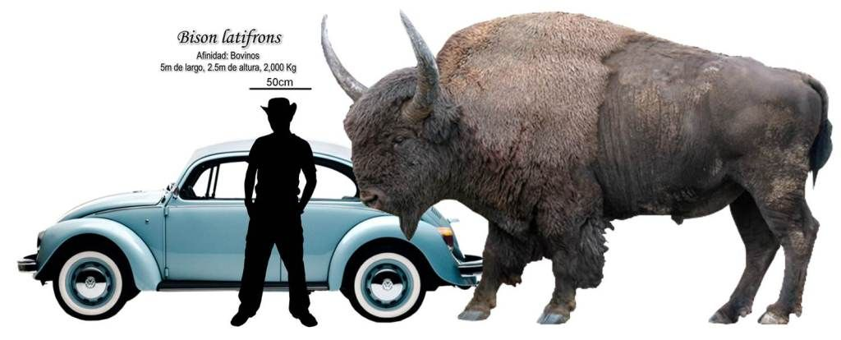

FAST FACTS:

1. Bison are the largest mammal in North America.
2. The scientific name for bison is actually bison bison bison!
3. A baby bison is called a “red dog”.
4. Bison can live to be up to 20 years old.
5. Bison are nearsighted, but although they have poor eyesight, they do have great senses of smell and hearing.

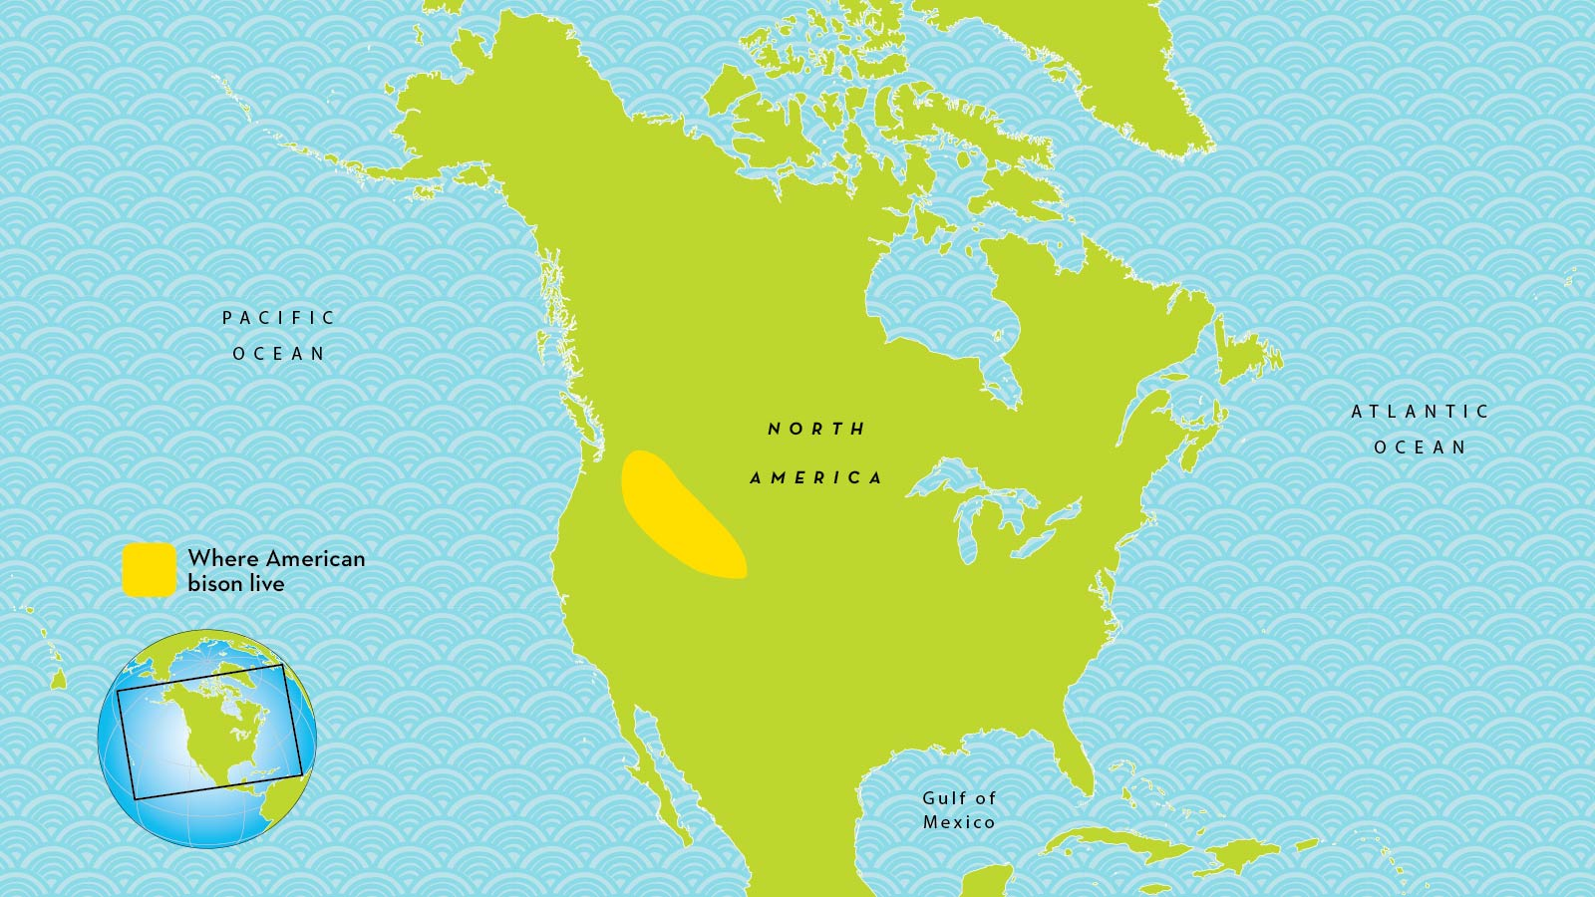

Where do bison live?

Did you know you can judge a bison’s mood by its tail? If it hangs down naturally it is calm. If it stands on end it may be ready to charge!

Male bison weigh up to 2,000 pounds and stand 6 feet tall, while females weigh up to 1,000 pounds and stand 4-5 feet.

S e a T u r t l e s

Where do sea turtles live?

Adult sea turtles are about 3 to 4 feet long. The largest sea turtle ever found was 5 feet long and weighed 871 pounds!

FAST FACTS:

1. Many sea turtles can hold their breath for over 30 minutes.
2. Sea turtles eat all kinds of food, including seaweed, crabs, and jellyfish.
3. Sea turtles can be found in every ocean except the Arctic Ocean.
4. They can live to be up to 80 years old.
5. During nesting season, female turtles will go back to the same beach where they were born.

A f r i c a n E l e p h a n t

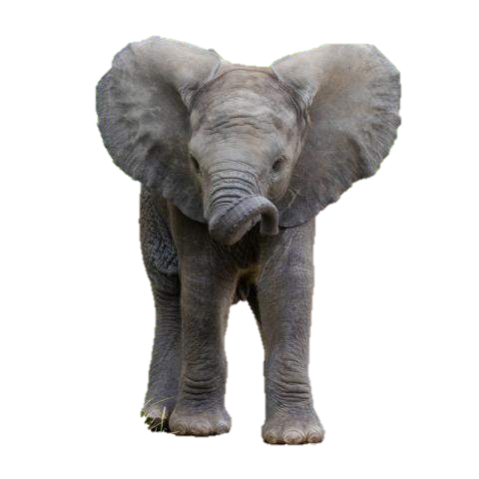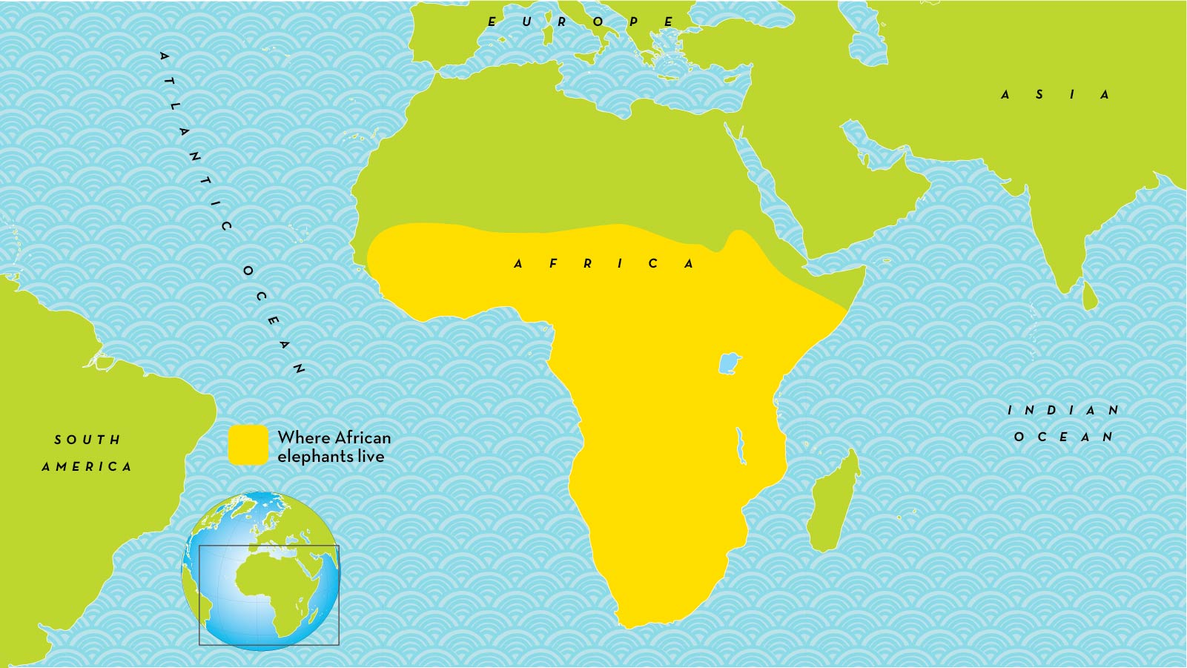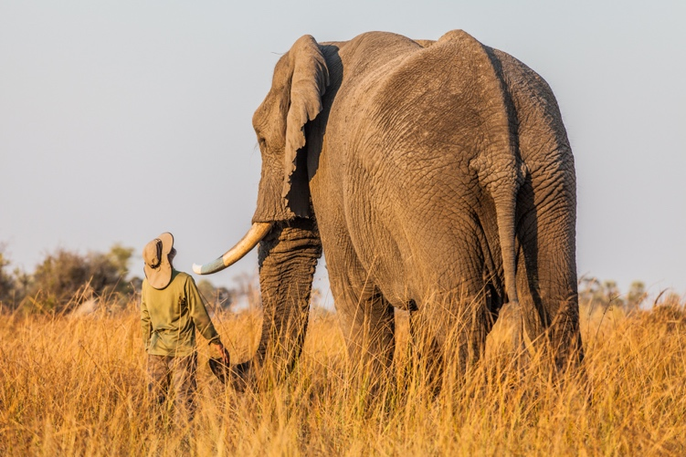

Where do African Elephants live?

Elephant tusks never stop growing! The older the elephant, the longer the tusks!

African Elephants can be up to 11 feet tall, and they can weigh up to 13,000 pounds. At birth they already weigh 200 pounds!

FAST FACTS:

1. An adult trunk is about seven feet long! They are used for smelling, like a nose.
2. Elephants are very social and like to make friends. They hug each other by wrapping trunks together!
3. Their tusks are made of ivory.
4. Elephants can live to be up to 70 years old.
5. Elephants are able to recognize themselves when looking in the mirror!

P o l a r B e a r s

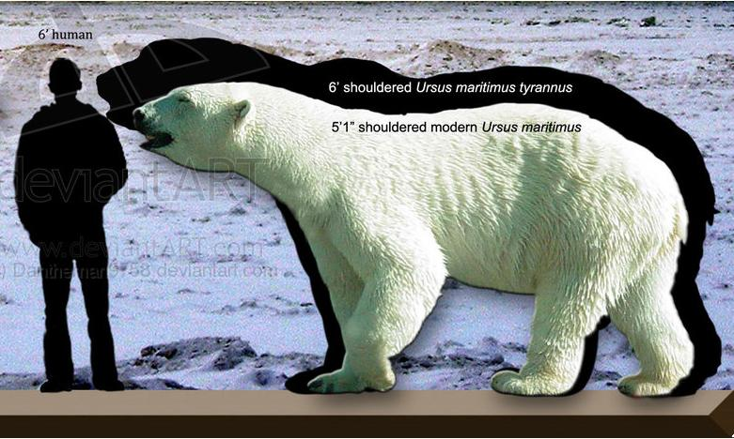

FAST FACTS:

1. Largest carnivore (animal that eats meat) that lives on land.
2. Polar Bears have 42 teeth.
3. Polar bears spend most of their time at sea.
4. Polar bears keep warm thanks to nearly 10 cm. of blubber under their skin.
5. Polar bears can reach speeds up to 25 mph on land and 6 mph in water

Males can reach more than 10 feet tall when standing!

Did you know that polar bears actually have clear fur? The way light hits the fur makes it appear white!

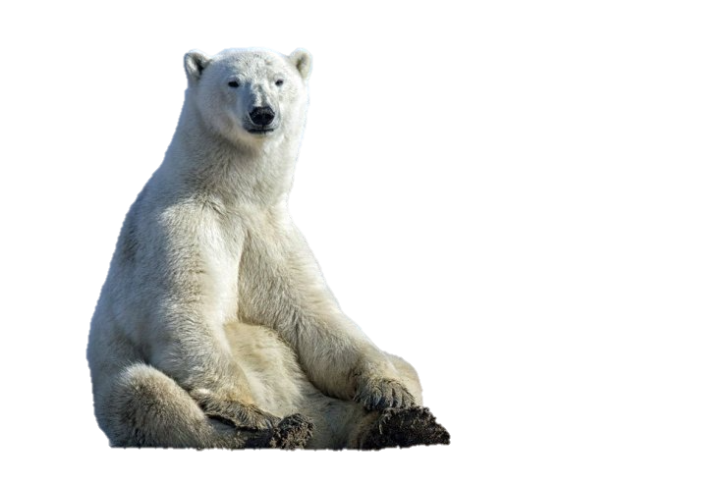

Where do polar bears live?

