Salt Dough-盐面团

Step 1:  - Gather _____ ingredients  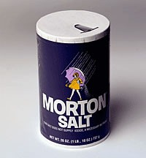  - 收集所有成分  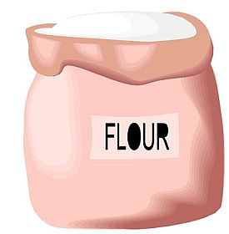 | Step 2:  - Measure ______ cups flour  - 测量2杯面粉  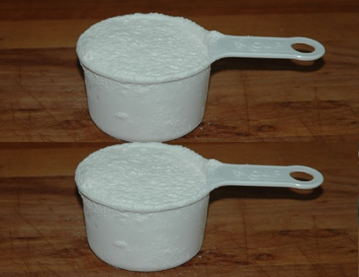
Step 3:  - Measure _____ cup salt  - 测量1杯盐  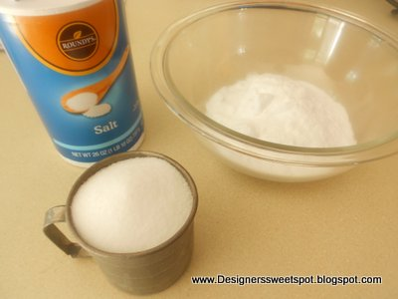 | Step 4:  - Measure ____ cup warm water  - 测量1杯温水  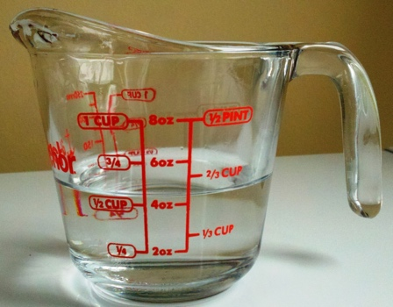
Step 5:  - Mix _____ and _____ until dissolved  - 混合水和盐直至溶解  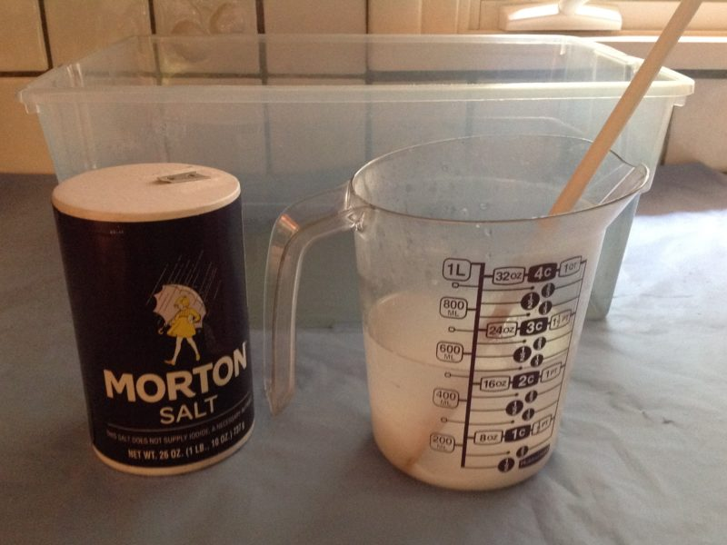 | Step 6:  - Slowly add _____ until dough forms  - 慢慢加入面粉, 直到面团形成  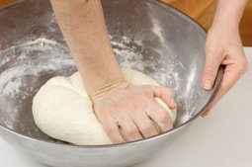
Play with your salt dough
和你一起玩盐面团

