TowerPro MG996R Servo

Specifications
Modulation: | Digital
Torque: | 4.8V: 130.54 oz-in (9.40 kg-cm)  6.0V: 152.76 oz-in (11.00 kg-cm)
Speed: | 4.8V: 0.19 sec/60°  6.0V: 0.15 sec/60°
Weight: | 1.94 oz (55.0 g)
Dimensions: | Length:1.60 in (40.7 mm)  Width:0.78 in (19.7 mm)  Height:1.69 in (42.9 mm)
Motor Type: | (add)
Gear Type: | Metal
Rotation/Support: | Dual Bearings
Rotational Range: | (add)
Pulse Cycle: | 1 ms
Pulse Width: | (add)
Connector Type: | JR
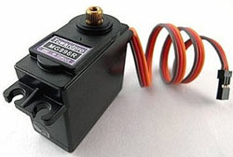
Brand:
Product Number: | (add)
Typical Price: | 10.50 USD

