How to build
- Take a white card board poster of 20X30 inch. (Dimension may vary to the user’s fantasy)
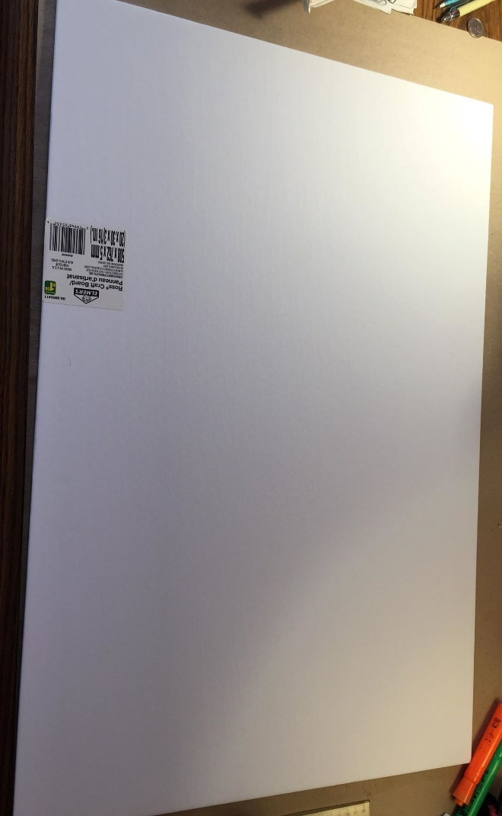
- Cut of a ½ inch strip from its length

- Draw a ½ border all around the card board
- Separate the board into 4cm x 4cm squares. (12 per 18 tiles)

- Indicate the 4 sides with the geographic coordinates (north, south, east, west) by taking 2 squares in the middle of a side and separating it with arches and writing the letter of the coordinate
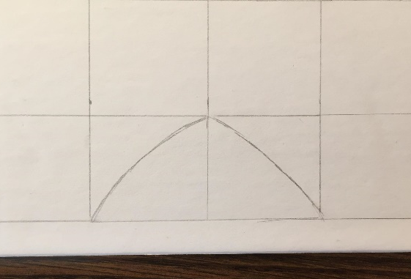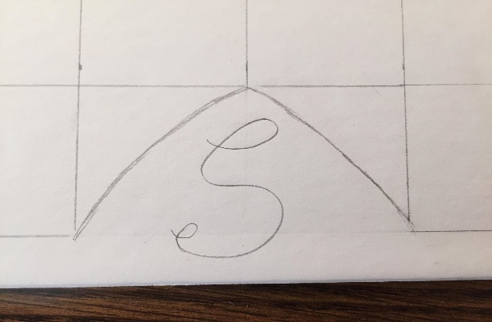
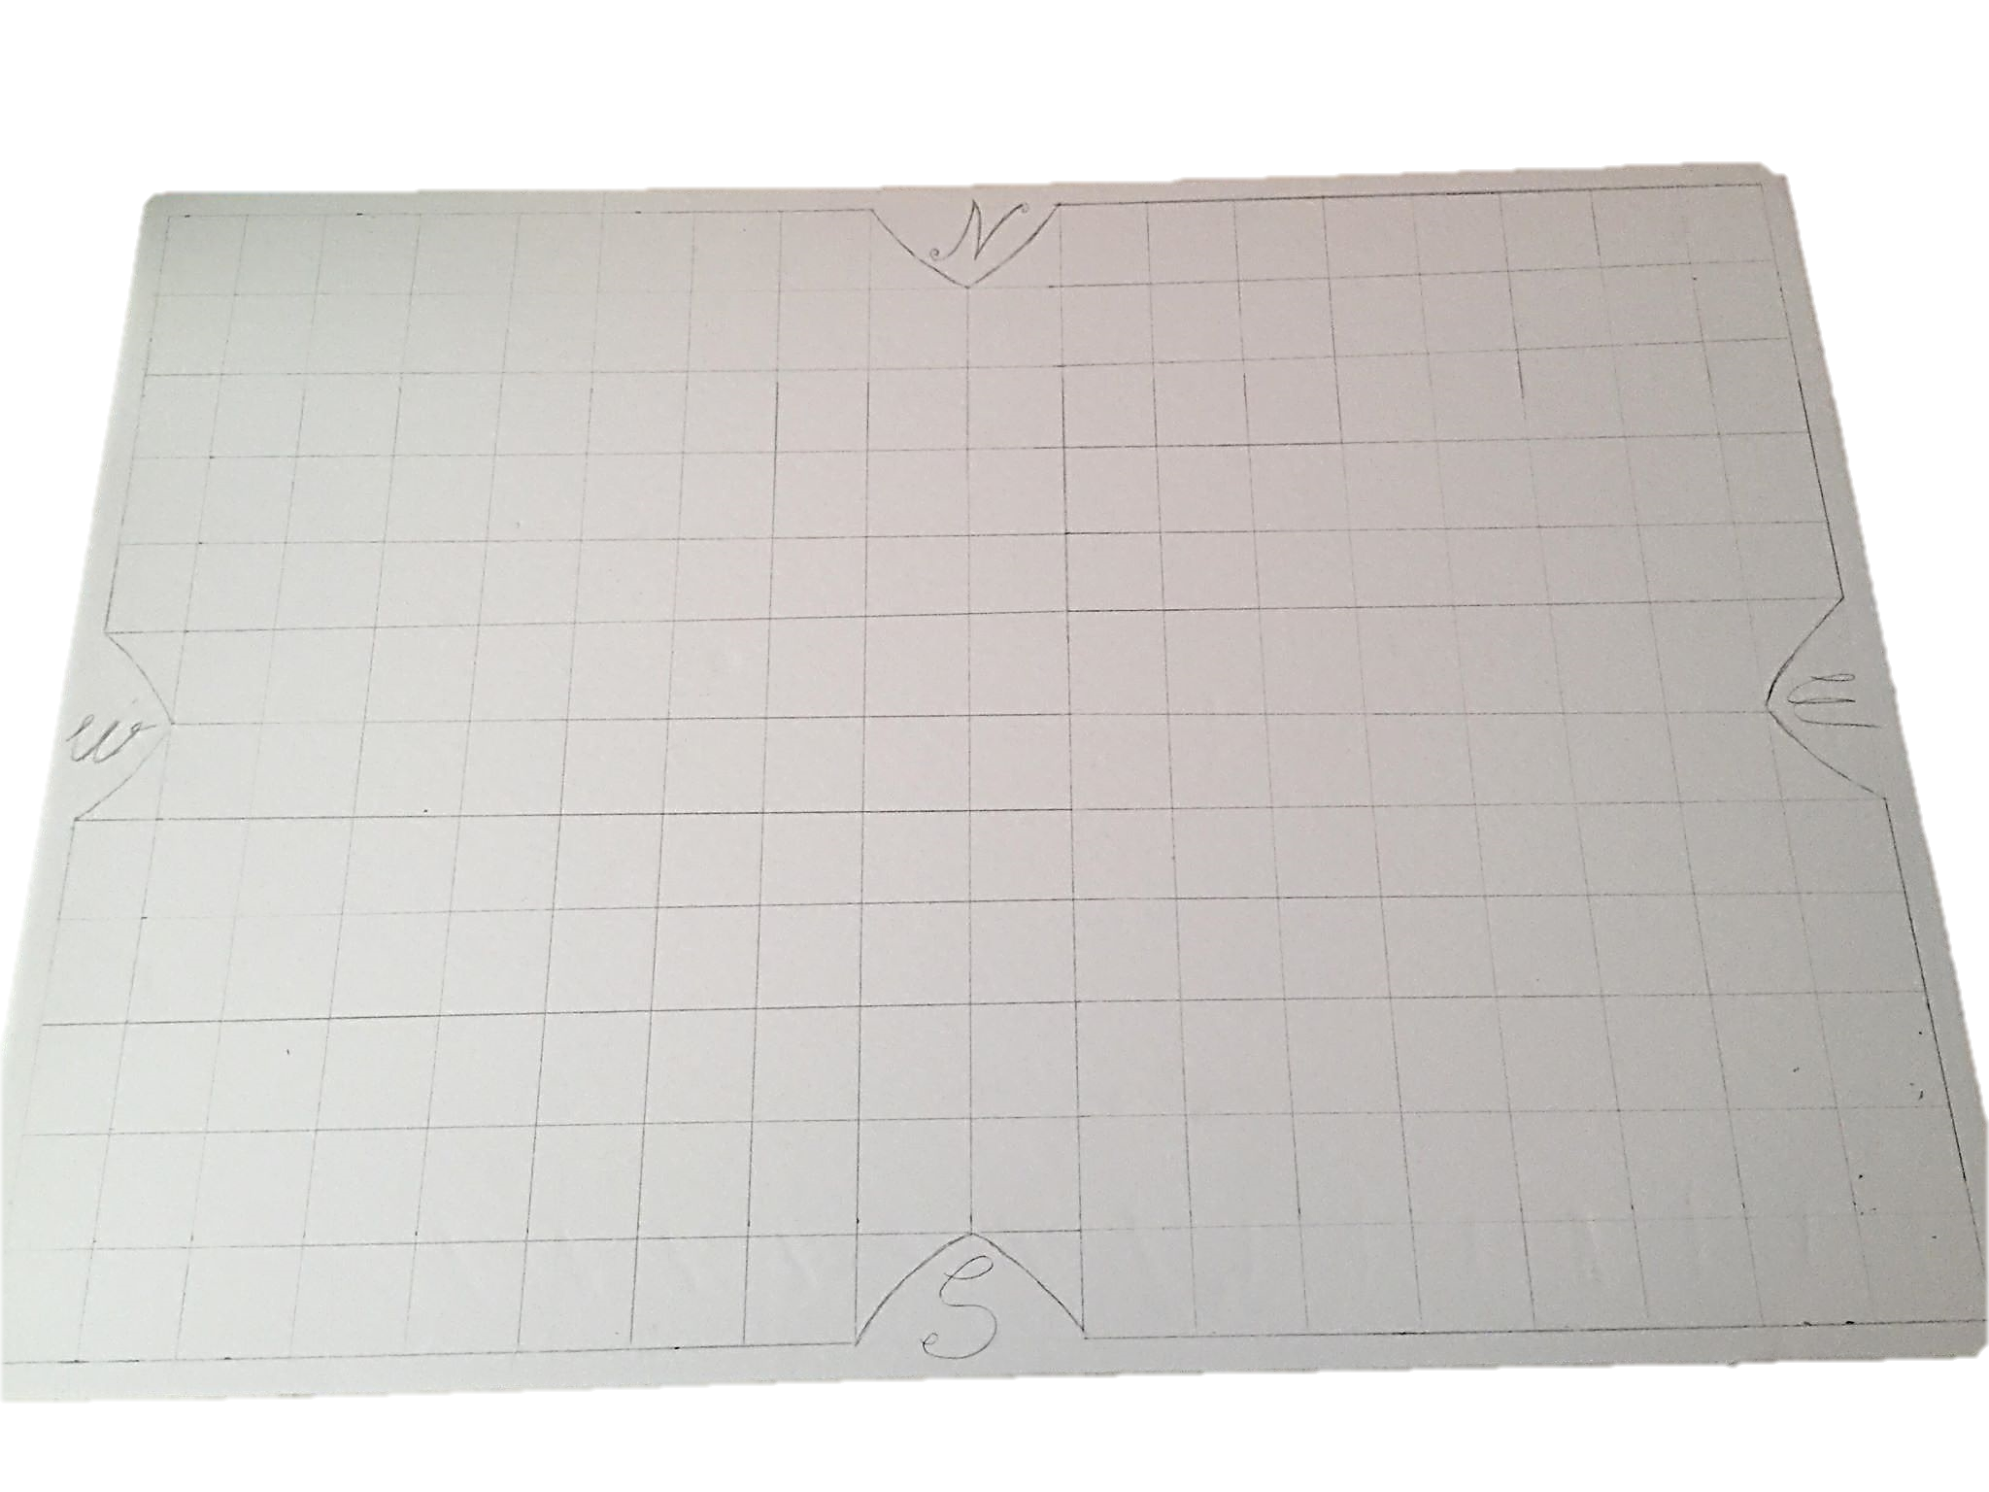

- To the north draw a continent that has 27 land squares and 12 water and land squares (coast of the continent) (this includes the two squares used for the geographic coordinates) with a max of 3 land squares and 1 water and land square towards the south
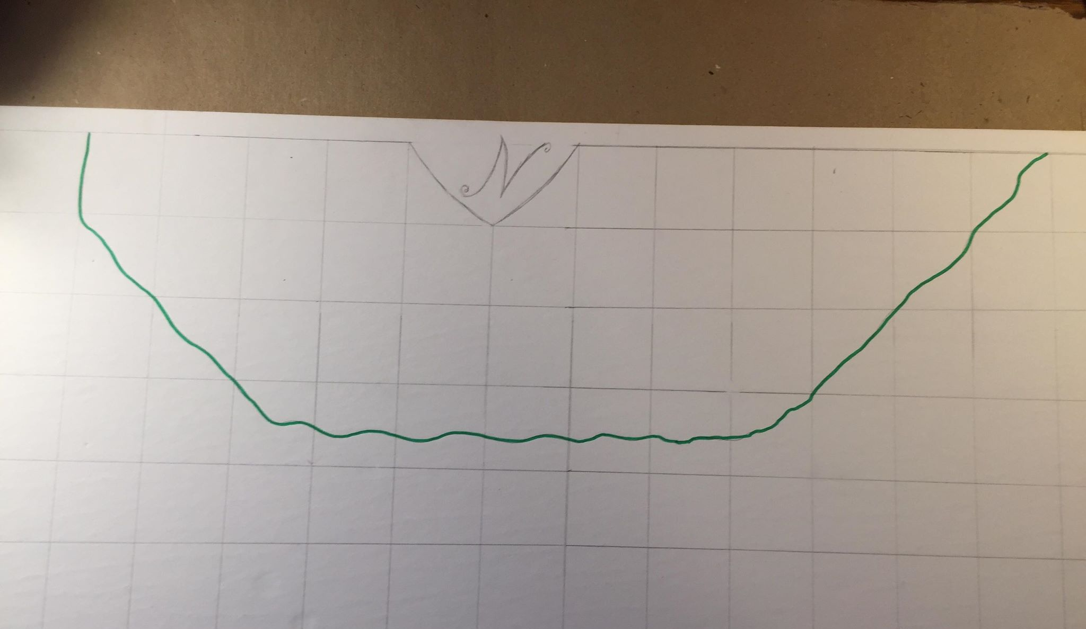

- To the south draw a continent that has 27 land squares and 12 water and land squares (coast of the continent) (this includes the two squares used for the geographic coordinates) with a max of 3 land squares and 1 water and land square towards the north

- To the west draw a continent that has 20 land squares and 7 water and land squares (coast of the continent) (this includes the two squares used for the geographic coordinates) with a max of 4 land squares towards the east
- To the east draw a continent that has 24 land squares and 4 water and land squares (coast of the continent) (this includes the two squares used for the geographic coordinates) with a max of 4 land squares towards the west

- In the center of the board draw a central continent that has 13 land squares and 6 water and land squares leaving at least 1 square of water between all other continents
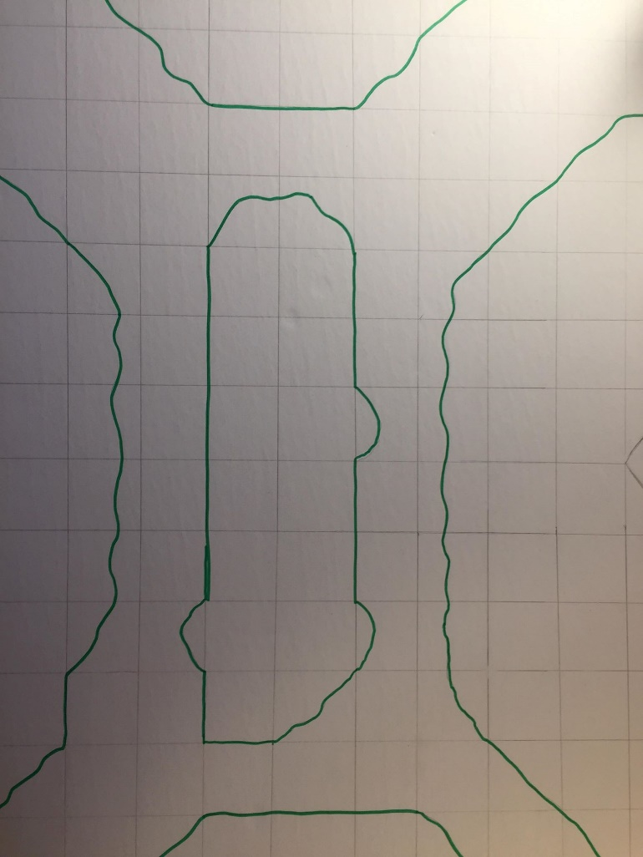
- Islands are added in the rivers between the continents:
- Between the north and west continent 2 islands are put each have a max size of 1 square (can be separated into many small ones in one square for artistic effect)
- Between the south and west continent 2 islands are put each have a max size of 1 square (can be separated into many small ones in one square for artistic effect)
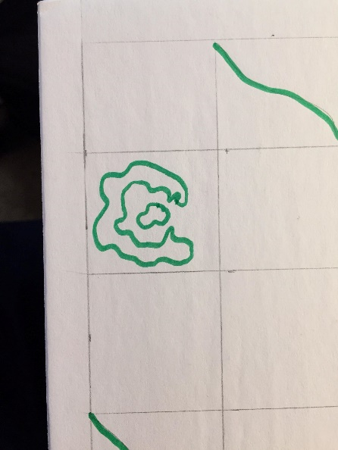
- Between the south and east continent 1 islands is put has a max size of 1 square (can be separated into many small ones in one square for artistic effect or as a joke)

The math islands ;) ↑

- Draw the capitals / sanctuaries using a star placed on the 5 continents.
- Put star under the north symbol on the eastern side
- Put star over the south symbol on the eastern side
- Put star under the west symbol
- Put star over the east symbol by 2 squares
- On the central continent in the most central square
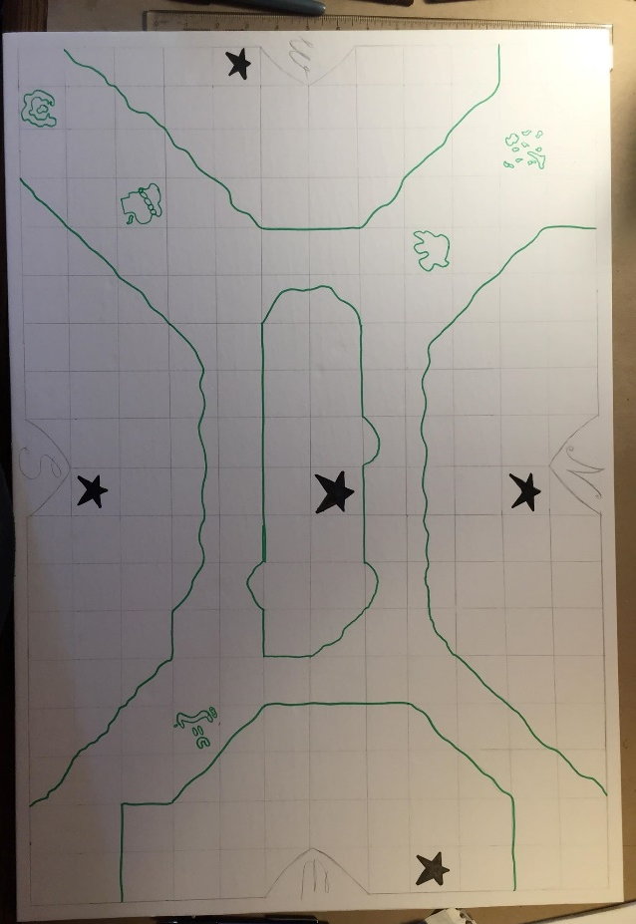

- The mountains on each continent :
- On the north and south continents put a mountain range that circles the capital and goes westward for 3 squares.
- On the center island put a mountain range on the north ridge and the south ridge each of 5 squares long. Also on the south-east end put a mountain range than encircles the eastern most point with the opening of the mountains being towards the west.
- On the eastern and western continents surround a path to the sanctuaries and other power ups using the mountains, starting from the point nearest to the center of the board.
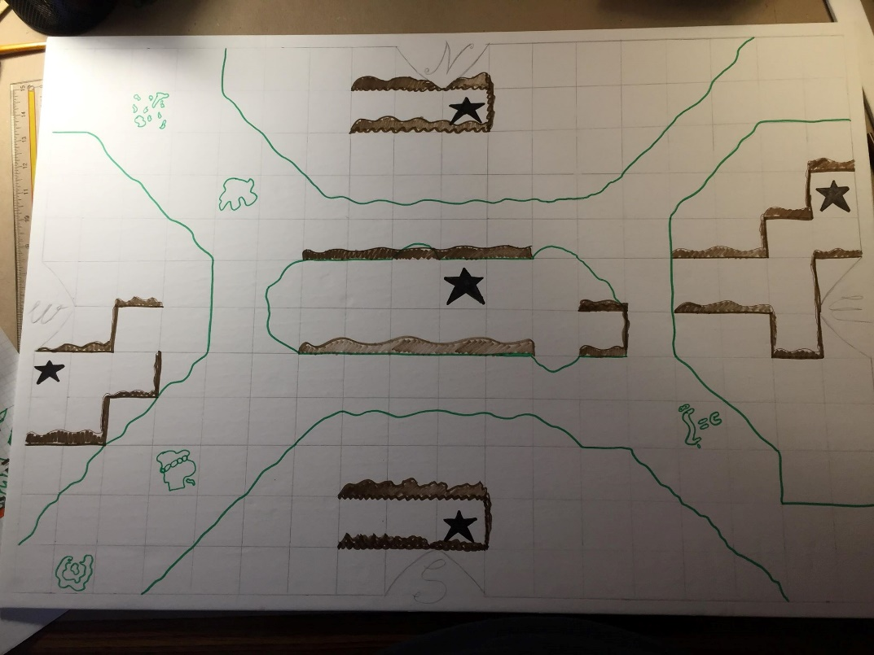

- Place evenly 14 ruins (use π as symbol) on the map
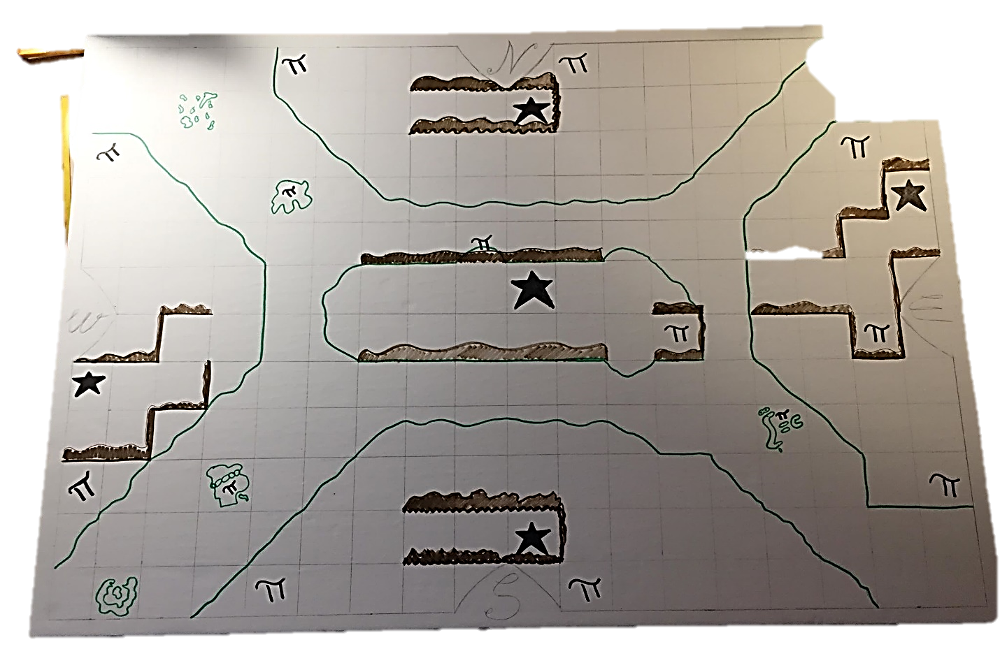
- Place at the eastern most point of the north and south continent the boat wreckage and use ⚓ as symbol.
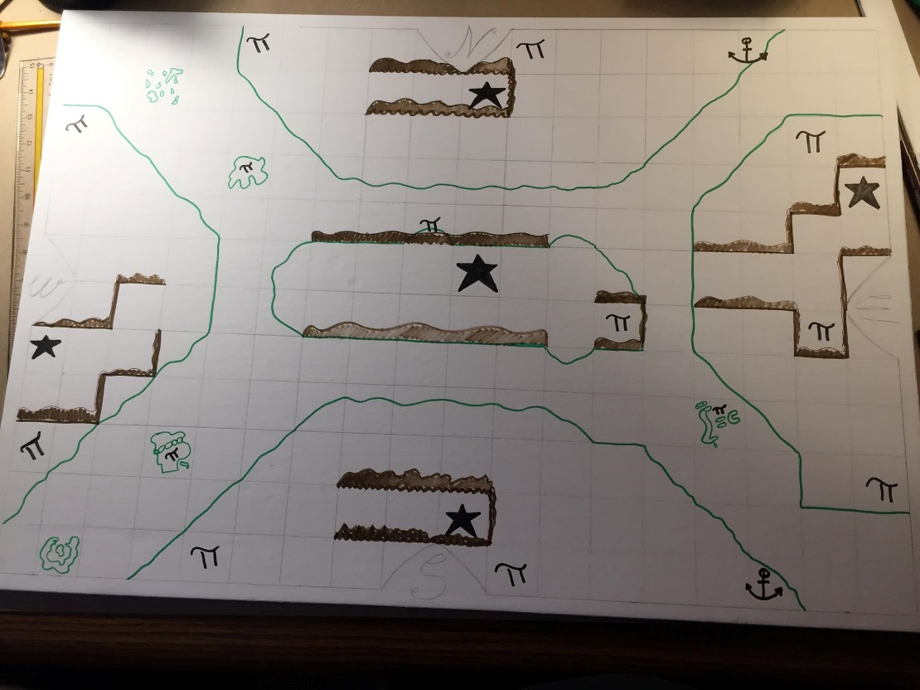
AND YOU’RE DONE !!!!

