Instructables Car Audio Contest Entry Information
BEFORE WE START: I, for one, am very open to constructive criticism but any comments that seem to be hurtful to other comments or to this post itself can and shall be removed. Thank you
How to make and tune a Subwoofer Enclosure/Box
Alright, so before we begin we need to get some basic information down about subwoofers and their enclosures. In this instructable you’re going to learn how to figure out the correct measurements and design for a subwoofer enclosure that suits you and your needs.
I’ll also be teaching you some basics for choosing a subwoofer and some technical details on the electrical part of all of this
- Technicalities of speakers and subwoofers
- Choosing a Subwoofer
- Formulas for tuning a subwoofer enclosure
- Choosing wood for your box
- How to build the box
Now it seems like a lot, but a lot has to go into tuning a box if you want it to sound and look great. 20% of the sound and its quality come from the subwoofer, 80% comes from the enclosure and how the whole thing is tuned.

Technicalities of speakers and subwoofers

Now I’m sure we all know this but a speaker works by taking an electrical signal and turning it into sound waves, these sound waves are produced by the vibrations of the cone on the speakers. When looking for speakers you want to look for quality cones, not to thin, not to thick, and strong enough to handle powerful vibrations. Take this into consideration when looking at materials found in the cones of speakers or subwoofers you are looking at.

To reproduce sound speakers have to have a range in which what types of pitch they can hit. This is called “Frequency Response” and is measured in (Hz). 20 Hz – 20,000 Hz is typically the correct range for speakers. Subwoofers, as you may have guessed are in the lower range of the scale (20-200 Hz). Also when looking for a subwoofer, visit the brands website and see if they have a response curve chart for that speaker/subwoofer. When looking at these charts you want to try and find one that has a relatively flat line. What this means is, no matter what the frequency is at whether it be high or low, as long as the power is the same, the sound will not be any louder or quieter.

Speakers Volume is measured in Decibels or (dB). When looking at speakers/subwoofers you’re going to want to look at the decibel level and sensitivity rating. A 3dB jump usually takes twice the power; a typical home audio system runs at 75dB-105dB while a rock concert can get all the way up to 115dB-121dB. If you’re running for a loud room with little power, try finding a speaker you like that has a high sensitivity rating.

Choosing a Subwoofer
Now when choosing a subwoofer there are a few things to take into mind: Size, power, and price.

1st: Size, I hear a lot that the bigger the driver, the louder it is, this is because of the amount of air being moved by the subwoofer itself, although when you get a bigger driver you are also giving up better accuracy because of the slower movements of the driver. 12” are what most people get, although 10”, although smaller, give a lot more accurate and a lot of times better range with sound.

2nd: Power, now this is where the fun comes in, now you get to choose, do you want a sub that will blow the cobwebs off your wall or the rattle the rust off your car, then you’re going to want to get a higher power rated subwoofer. Now when looking at wattage, it’s important to remember that wattage is actually a measurement of heat, this be the reason why you want to keep your amplifier vented and not covered. But basically, wattage is the measurement of heat, the higher the wattage power rating on a subwoofer the more heat it can take thus meaning the more power it can handle. When looking at power handling you want to look at the “Nominal Power Handling” number. This tells you how much wattage (heat/power) it can handle normally, where it will sound the best. Don’t forget to check with one’s spouse before making a decision xP.

3rd: Look at the price, as with everything, more expensive doesn’t mean better. Look into details and if you’re looking at a different retailers site, or even Amazon.com, then don’t be afraid to go look into more detail at the dealers site and see if the information give is actually true. And just like everything else in this world, compare, look at reviews and test if you can.

Formulas for Tuning a Subwoofer

Now that you know the basics of speakers and subwoofers, how they work, and you’ve chosen one; it is time now that we build a box.

BEFORE I SAY ANYTHING: Building your own box will not necessarily bring better quality to your sound, professionally made boxes are equally as good if not any better.

Formulas and what they mean:

Select an equation to solve for a different unknown
efficiency bandwidth product
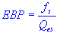 | efficiency bandwidth product
 | speaker resonance frequency
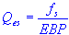 | speaker electrical Q
box or enclosure volume
 | box or enclosure volume
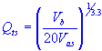 | speaker total Q at f_{s}
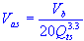 | air volume with same acoustic compliance  as the speaker suspension

box or enclosure tuning frequency
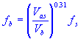 | box or enclosure tuning frequency
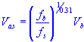 | air volume with same acoustic compliance  as the speaker suspension
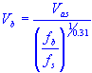 | box or enclosure volume
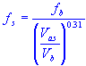 | speaker resonance frequency
box or enclosure tuning frequency
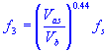 | minus three decibel half power frequency
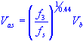 | air volume with same acoustic compliance  as the speaker suspension
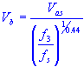 | box or enclosure volume
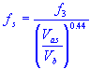 | speaker resonance frequency

peak sound pressure level
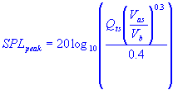 | peak sound pressure level
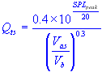 | speaker total Q at f_{s}
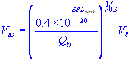 | equivalent air compliance
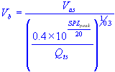 | box enclosure volume
sound pressure level
 | sound pressure level
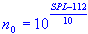 | free air reference efficiency
maximum air volume displaced by cone excursion
 | maximum air volume displaced by cone excursion
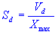 | cone effective radiation area
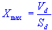 | cone peak linear displacement

cone effective radiation area
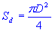 | cone effective radiation area
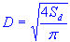 | cone diameter plus one third of surround
port or vent length
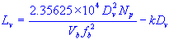 | port or vent length
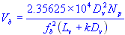 | volume of enclosure or box
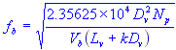 | tuning frequency
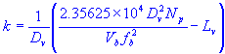 | end correction factor
minimum port or vent diameter
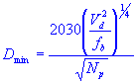 | minimum port or vent diameter
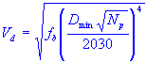 | maximum air volume displaced  by cone excursion
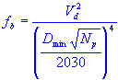 | tuning frequency

Courtesy of: http://www.ajdesigner.com/phpsubwoofervented/box_tuning_frequency_equation.php
Since all of these formulas seem quite daunting and confusing to most of us, instead of explaining each and everyone thoroughly enough and wasting your time, I’m going to list a few sites with calculators for these formulas.

Subwoofer Box Design Sites:

Subwoofer Box Calculator for Sealed, Ported, or Bandpass
http://www.ajdesigner.com/fl_subwoofer/subwoofer.php

Free Software Download for bandpass, sealed and ported subwoofer boxes
http://www.ajdesigner.com/speaker/index.php

Top of the page it brings you too… the lower part of the page explains each software in a summary

For most of the speakers/subwoofers you buy, you will get a data sheet with all of the numbers to punch in on the calculator, it may even be on their website.

Courtesy of: http://www.ajdesigner.com/fl_subwoofer/subwoofer.php

Choosing Wood for Your Box
you’re going to want to get ¾” plywood at the LEAST, make sure it is plywood or MDF board and not particle board OR sold wood. Particle board is made with wood chips and resin and will fall apart so easily its ridiculous, Plywood is good for the job and so is MDF board, this is because they are very tightly packed together and the density is the same throughout. This will keep the sound equal throughout. The type of plywood you choose is up to you, but just make sure it is a minimum of ¾”.

