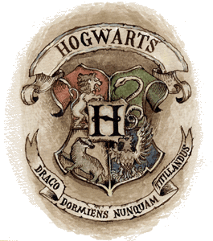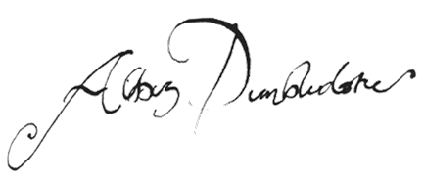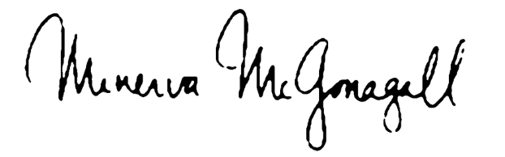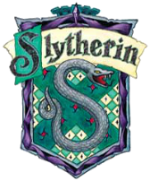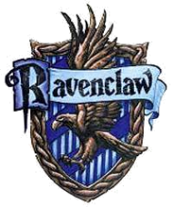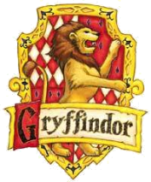

Professor Albus Dumbledore Headmaster

(Enter name here)

**The Degree of**

Having honorably fulfilled all requirements in the study of Ancient Runes, Arithmancy, Care of Magical Creatures, Charms, Defense Against the Dark Arts, Dibination, Herbology, Potions, and Transfiguration for this degree together with all the rights and privileges thereunto.

In Testimony Whereof the authorized officers have hereto subscribed their name and affixed the seal of Hogwarts School of Witchcraft and Wizardry at British Isles

**Master of Wizardry**

Hogwarts School of Witchcraft and wizardry

The ministry of magic upon recommendation of the faculty by the virtue granted to them hereby bestow upon

Professor Minerva McGonagall Deputy Head Mistress