Digital Clock using LED’s and 89C51 from scratch
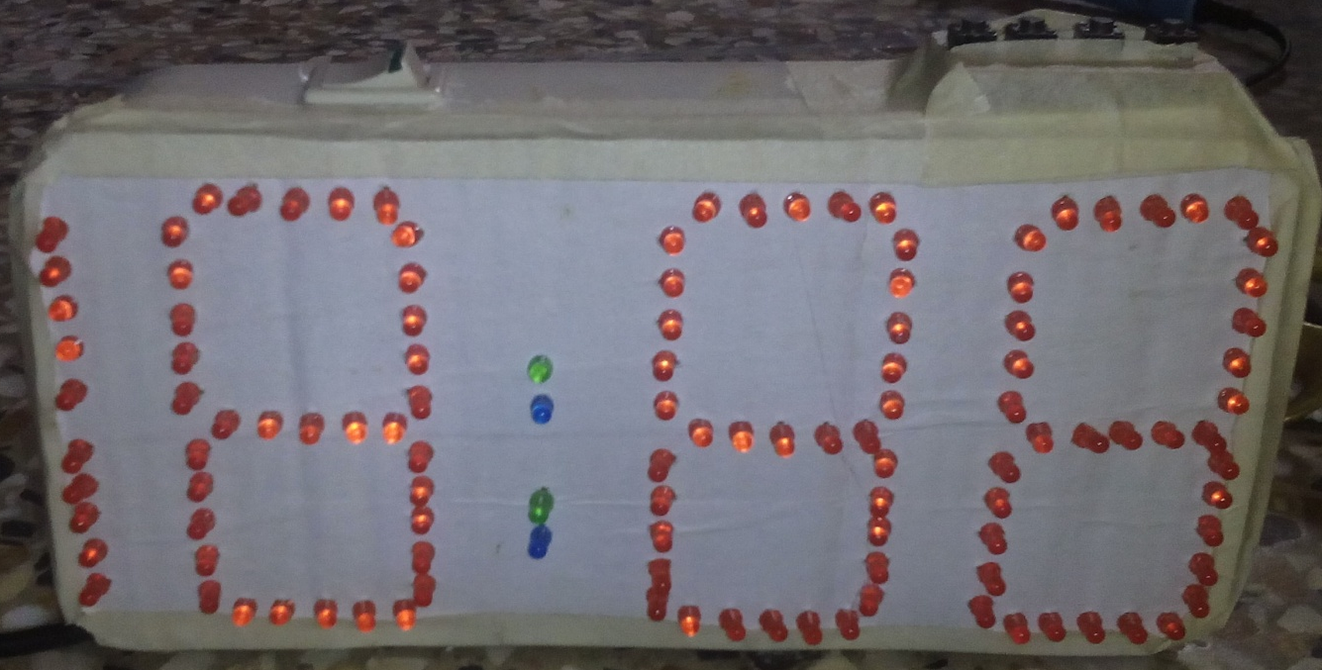
In this Instructable, I will show you how to make Microcontroller Based Digital Clock using LED’s and Atmel 89C51 from scratch.

Step 1: What you will need
Components we need are
121 LED’s
1 Atmel 89C51
1 40 pin IC base
1 LM 7805
2 20pin SIL connectors (male and female)
1 vero board
117 Resistance 330 ohm
4 Buttons
1 switch
1 usb cable
1 power bank (optional)
1 paper box
1 white paper
1 needle

Step 2: Initial Start
First of all you need the 8 Segment Design for that I use the proteus to design the 8 segment and got a print of that.
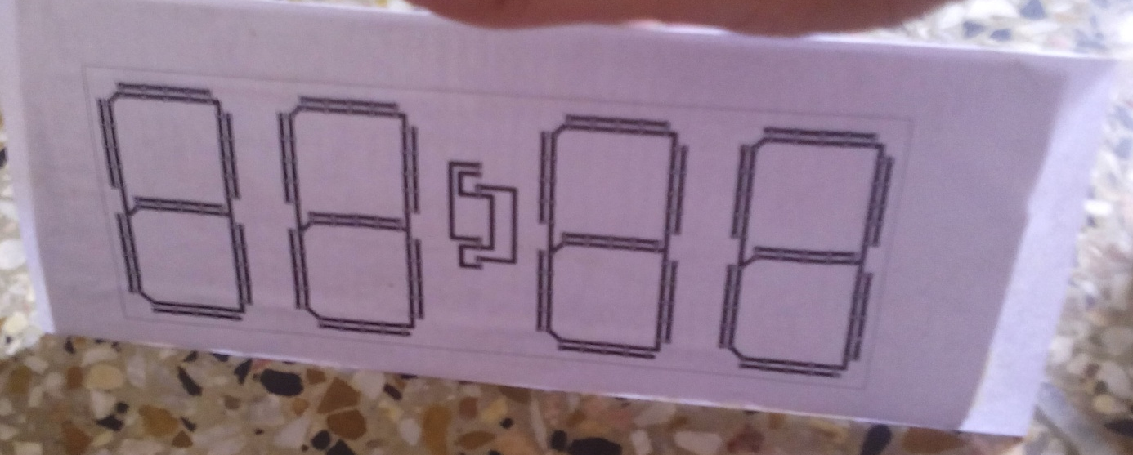
After printing the segments use hard paper and attach the white segmented paper upon it using gum. Make holes on the LED footprint of all segments just like in the picture below.

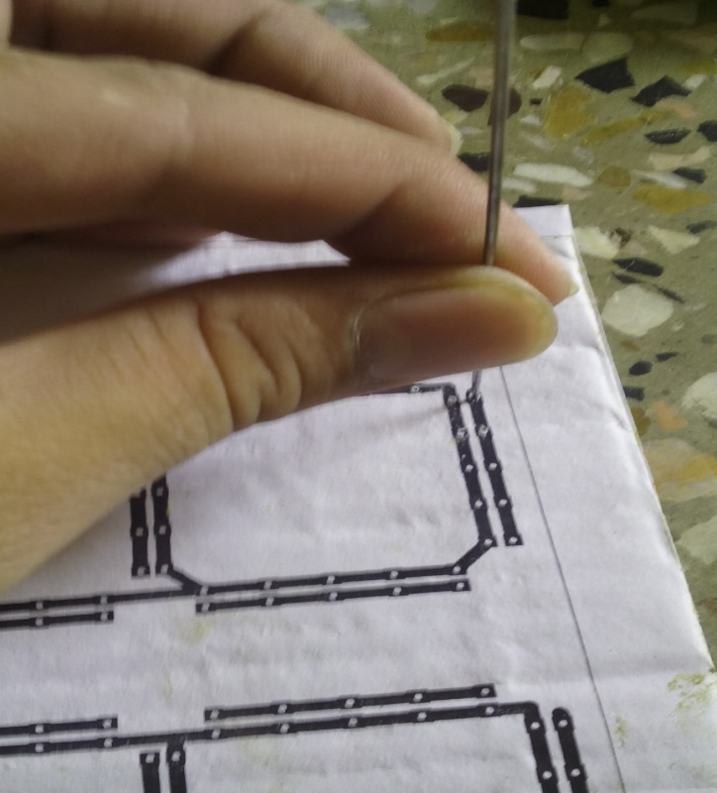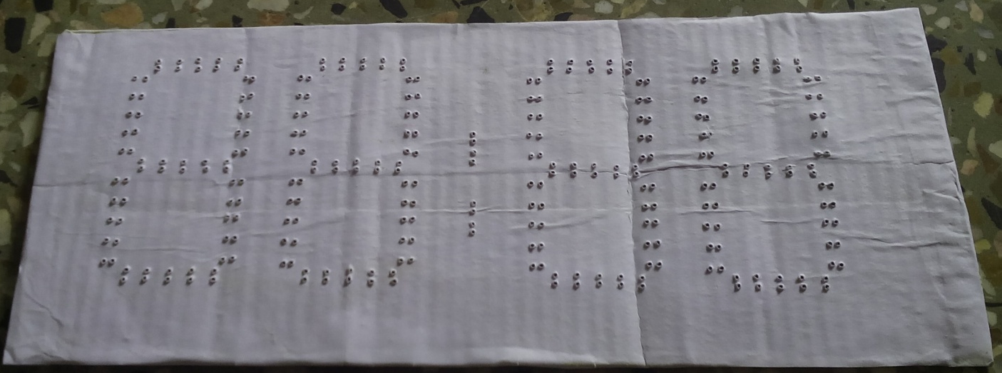

Step 3: placing and soldering LED’s
After making the holes place LED’s always remember to note the terminals of LED’s.

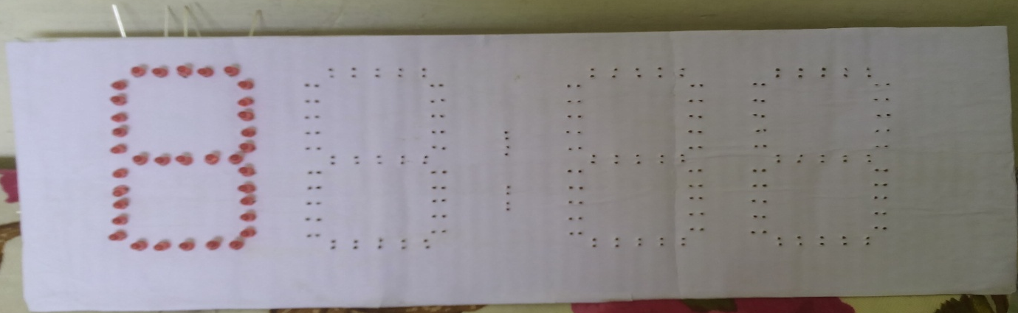

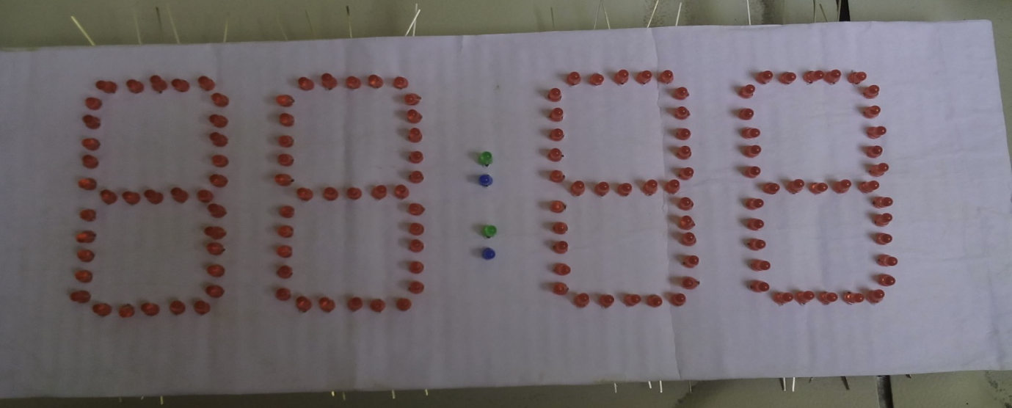
Step 4: Making the Controller Board circuit
First Cut a Piece of vero board . Attach components to Board . I use 40 pin IC base so that it could be easily programmed and place to the board.Use the schematic diagram to implement the circuit. I have not the alarm but you can use it. And also set the am and pm time LED’s indications.

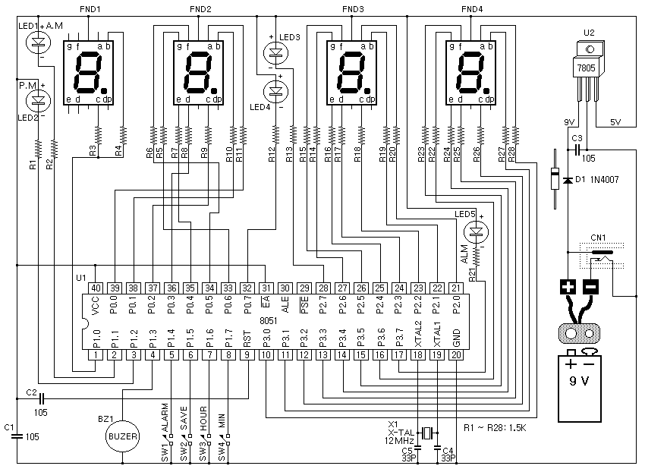
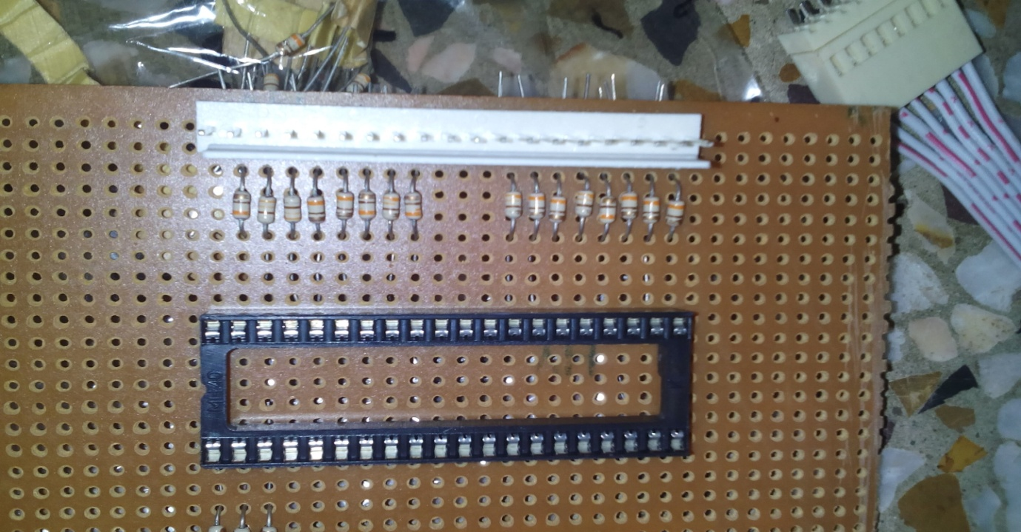
Attach the wires to the LED panel and use the SIL connectors of 20 pins for each sides.
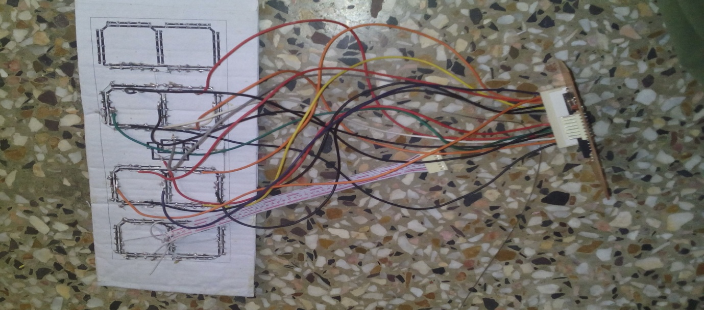
Step 5: Switch Board
Cut the small piece of vero Board . place 4 push buttons for the time and alarm.
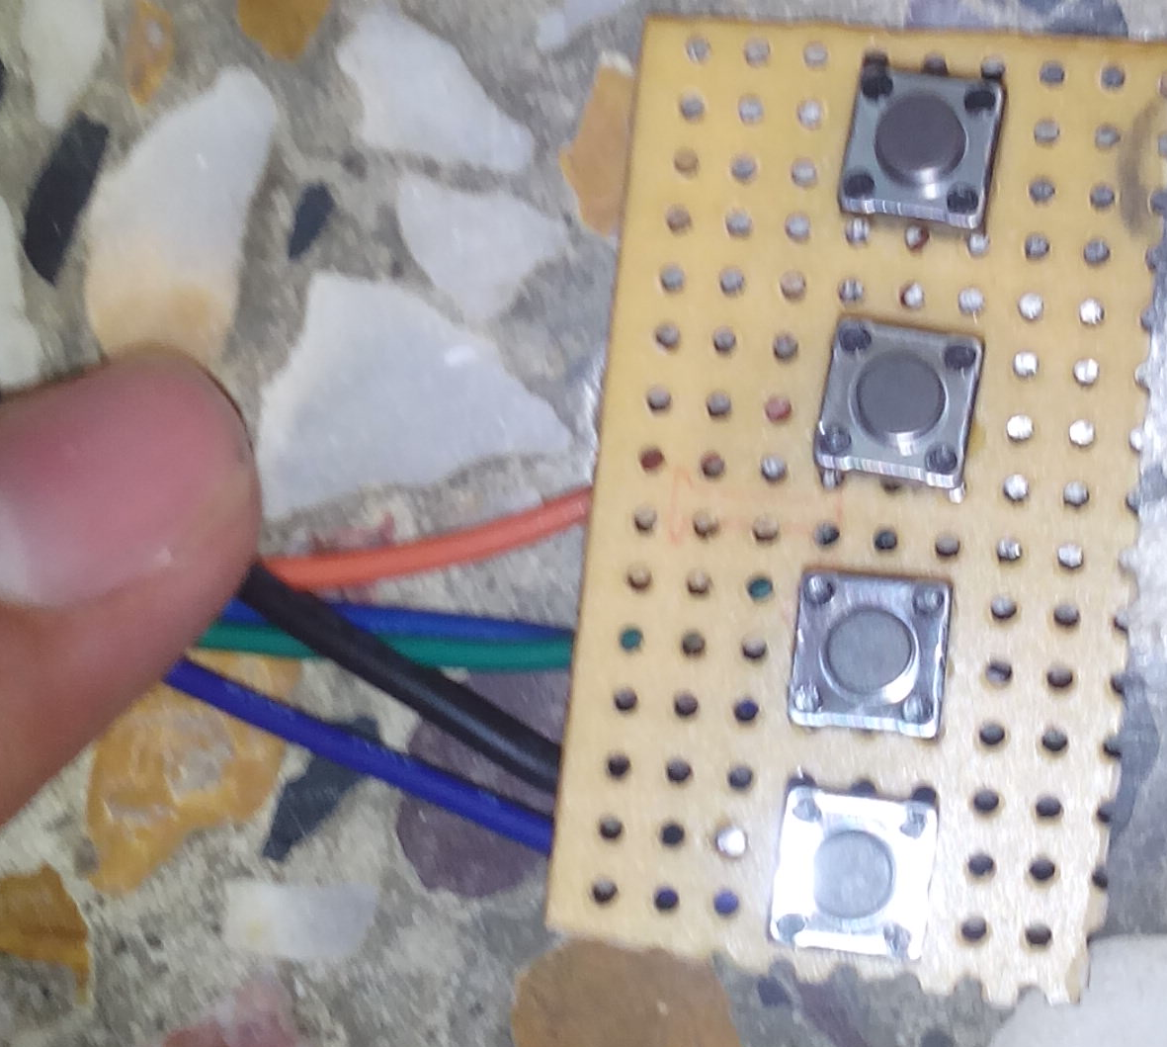
Step 5: Programming the 89C51
Now time to give a life to the Clock yeh! Its programming time.open the code in keil and make the HEX file after that burn that HEX file into the 89C51.
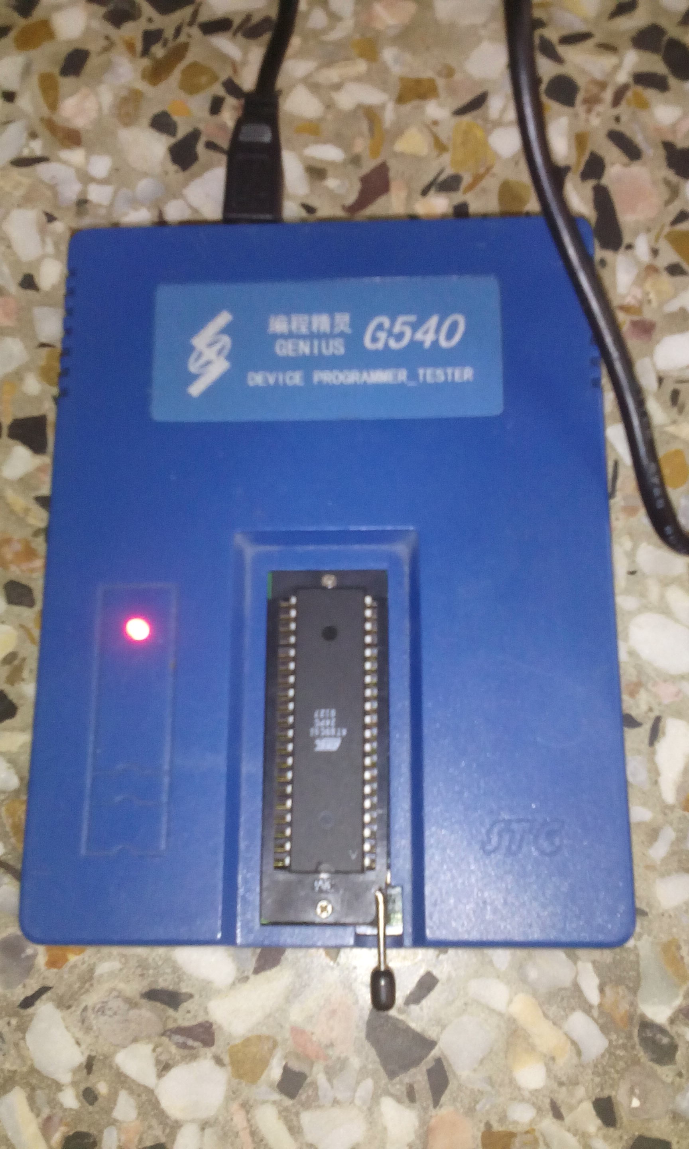
Step 7: Case the Clock
Last step is to case the whole into a plastic box as shawn in figure.


All Done must Comment thanks alot for your views.
Attachments:
Code HEX file.
LED print PDF.

