

A Project Plan on

GSM BASED AUTOMATED IRRIGATION SYSTEM USING RAINGUN

A MAJOR PROJECT REPORT

SUBMITTED IN PARTIAL FULFILLMENT OF THE REQUIREMENT
FOR THE DEGREE
B.TECH. (ELECTRONICS & TELECOMMUNICATION)

By

SANTANU MUKHOPADYAY (A1607111013)

PARAMVEER MARWAH (A1607111031)
B-TECH (E&T)

BATCH (2011-15)

UNDER THE EXPERT GUIDANCE OF
Mr. VK SHARMA

AMITY INSTITUTE OF TELECOM ENGINEERING AND MANAGEMENT
AMITY UNIVERSITY
UTTAR PRADESH

I
DECLARATION

We SANTANU MUKHOPADHYAY and PARAMVEER MARWAH student(S) of B-Tech (E&T) (2011-15) hereby declare that the project titled “GSM BASED AUTOMATED IRRIGATION SYSTEM USING RAINGUN” which is submitted by us to DEPARTMENT OF ELECTRONICS & TELECOMMUNICATION ENGINEERING, AMITY INSTITUTE OF TELECOM ENGINEERING & MANAGEMENT, AMITY UNIVERSITY, UTTAR PRADESH, in partial fulfillment of requirement for the award of the Degree of Bachelor of Technology in 2015, has not been previously formed the basis for the award of any degree, diploma or other similar title or recognition.

Place: NOIDA
Date:
Signature of Student(s)

II
CERTIFICATE

This is Certified that the Project entitled “GSM BASED AUTOMATED IRRIGATION SYSTEM USING RAINGUN” submitted by SANTANU MUKHOPADHYAY (A1607111013) & PARAMVEER MARWAH (A1607111031), students of AMITY INSTITUTE OF TELECOM ENGINEERING & MANAGEMENT, AMITY UNIVERSITY, UTTAR PRADESH in the partial fulfillment of the requirement for the award of B. TECH (ELECTRONICS & TELECOMMUNICATION) degree is a record of students own study carried under MY SUPERVISION & GUIDANCE.

NAME: Mr. VK SHARMA
AITEM
SIGNATURE AMITY UNIVERSITY
NOIDA
UTTAR PRADESH

1

ABSTRACT

Modern digitalized era of our 21st century needs automation in each and every sector. Combining technology to increase the credibility of an another technology is not at all a very good idea. India is a country where agriculture is the main and vast field for our national financial system. So we have tried to implement the fruitfulness of technology to combine with agricultural field so that the growth of crops can increase exponentially. Irrigation is the methodology of misleadingly supplying water to land where harvests are developed. Generally hand pumps, channel water and precipitation were a significant wellspring of water supply for watering system. This strategy has prompted serious disadvantages like under watering system, over-watering system which thus causes filtering and loss of supplement substance of soil. Changing ecological conditions and lack of water have prompted the requirement for a framework which effectively oversees watering system of fields. Computerized watering system framework is a machine based framework, which robotizes the watering system of area by joining different programming and equipment approaches together for field watering system.

This paper manages a definite study of different GSM based mechanized ranch watering system frameworks. GSM serves as an essential part since it is in charge of controlling the watering system office and sends them to recipient through coded sign. Our study is focused on examination of different GSM approach.

2

ACKNOWLEDGEMENT

We would like to express our sincere and profound gratitude to our MENTOR & GUIDE MR. V K SHARMA for his constant support, encouragement, supervision and useful suggestions throughout the course of this project. His moral support and continues guidance helped us to complete our work successfully.
We also acknowledge the facilities extended to us by the employees of PAGARIA ELECTRONICS LTD, who provided us efficient support to help us understand the core basics on which are project is based upon.
Above all we have no words to express our gratefulness towards OUR PARENTS, FACULTIES AND STAFF for their blessings and confidence they infused in us. Finally, we are grateful to all those who extended their help in the completion of this project directly and indirectly.

3

Fig. No. | List of Figures | Page No.
1  2  3  4  5  6  7  8  9  10  11  12  13  14  15  16  17  18 | Practical Field Implementation  Block Diagram  AT89S51 Microcontroller  Transformer  Voltage Regulator 7805  Rectifier Diodes  Electrolytic Capacitors  LCD Display  Light Emitting Diode (LED)  Sensing Electrodes  Op-Amp  Relay  BC 548 Transistor  Moisture Sensor  Circuit Diagram  Flowchart  Flowchart- AMC  Flowchart-MMC | 14  15  21  21  22  23  24  25  26  26  27  28  28  29  30  32  34  35

4
Fig. No. | List of Figures | Page No.
19  20  21  22  23  24  25  26  27  28 | Flowchart-HCM  Project Prototype Model  Output 1  Output 2  Output 3  Output 4  Output 5  Output 6  Output 7  Setup | 36  47  48  48  49  49  50  50  51  51

5
Table of Contents

1. Introduction
1.1 What is GSM based automated irrigation system 9
1.2 Uniqueness of our project 9
1.3 Advantages and Disadvantages 10-11
1.4 Index Terms 11

2. Literature Survey
  - General concept 12-13

3. Materials
3.1 Block Diagram 15
3.2 Hardware Requirements
a. PCB 16
b. Microcontroller 17-20
c. Transformer 21
d. Voltage Regulator 22
e. Rectifier Diodes 23
f. Electrolytic Capacitors 23
g. LCD Display 24
h. LED 25
i. Sensing Electrodes 26
j. Op-Amp 26-27
6
k. PVC Wires 27
l. Relay 28
m. BC 548 Transistor 28
n. Moisture Sensor 29

4. System Circuit Architecture
- Circuit Diagram 30

5. Methodology
5.1 Proposed S/M Hardware Working 31
5.2 Flowchart 32
5.3 Algorithm 33
5.4 Modes of Operation
a. AMC 34
b. MMC 35
c. HCM 36
5.4 System Program 37-46

6. Present Prototype Model 47
7. Result & Discussion
- Output Results 48-51

7
8. Conclusion 52
9. Future Scope for Research 53
10. References 54
11. Plagiarism Check Result 55-56

8

CHAPTER 1__ ____________________________

Introduction”

1.1 What is GSM Based automated Irrigation System?

Watering system is an experimental methodology of misleadingly supplying water to the area or soil that is the main base of our farming system. Primarily water must be supplied to the fields either through trenches.. This system would decrease the workload of the rancher and help keep up fitting quality of soil for better growth. Henceforth with the development of innovation it was conceivable to outline frameworks that killed the immediate inclusion of the agriculturist concerning watering system of their fields. These frameworks mechanized the whole watering system framework by controlling the engines that inundated the fields. A GSM based homestead watering system framework has two noteworthy advancements behind it, essential being the "GSM" and optional one is the controller or processor. GSM (Global System for Mobile Communication) is a standard situated used to depict conventions for computerized cell systems.

The watering system on field and sending the outcomes to the agriculturist utilizing coded signs to a cell phone which by implication controls the whole homestead watering system framework. The processor or the controller acts as a focal center for working of the robotized process after it has been launched by the GSM based gadget lastly exhibits the yield to the gadget.

This paper contains five point by point similar investigation of GSM based homestead watering system approach.. It gives a neat gritty investigation of the preferences and detriments of the different advances proposed by the frameworks in the papers under study.”

9
1.2 Uniqueness of our project

- Less Man-Power
- Less Power consumption
- Cost Efficient
- Time Saving
- Accuracy
- Compactness
- Precise

1.3 Advantages & Disadvantages
The framework depicted in likewise is a low power customer with basic and effective GSM offices. It quantifies all conceivable soil natural elements including the wellbeing of the plant and recognizes measure of water or ice on the leaf's surface likewise..

The framework portrayed in has fused Bluetooth for remote checking which diminishes the issue of extent with GSM system and spares CALL/CALL/SMS cost for the rancher. The smoke sensors used to send crisis data to client in case of flame in field. It has the same issues as the frameworks over, that scope of GSM and Bluetooth is not reliable and client needs to acquaint himself with an excess of complex AT charges. GSM innovation's prepared accessibility, straightforwardness, less flag crumbling improves it for sending control signals and For basic applications obliging continuous checking the field condition can be transmitted utilizing radio connection.

The disadvantage of this framework was that GSM has a settled greatest cell site scope of 35km which is forced by various cases. Moreover the rancher needs to be upgraded the whole complex AT charges, lastly soil parameters in regards to manures and plant ailments are not joined in the framework.
10

The framework depicted in utilizes sprinkler watering system instead of customary engines which builds the territory of water supply. Likewise, low penetrated soil can be handled utilizing this framework and since it is a remote framework it has expanded versatility, movability and suitability in unfavorable conditions. Likewise it is minimal effort and client does not need to remember complex guidelines because of basic missed call position. Issue of restricted directions, and agriculturist needs to recollect the quantity of missed requires every direction and it may not be conceivable to achieve the quantity of missed brings in that time delay.

The framework depicted in give ideal water conveyance in fields in view of manual settings, number of missed brings in determined time span, CALL/CALL/SMS from PDAs. It guarantees security of engine against over-burdens and overheating and confronts lopsided characteristics furthermore gives robotized restarting .It utilizes bells, missed calls for ready reason. The main downside it has is that it utilizes the same system administrator for control framework and client phones to guarantee more noteworthy likelihood of fruitful association; and it obliges additional capacity memory for including different sensors.

1.4 Index Terms
- Microcontroller
- Rain-gun-Irrigation
- GSM Module
- Moisture Sensor
- Water Pump

11
CHAPTER 2____ __________________________

Literature Survey

In Veena Divya,k, AyushAkhouri "A Real time execution of a GSM based Automated Irrigation Control System utilizing dribble Irrigation Methology" deal GSM based Irrigation Control System, which could give the offices of keeping up uniform. A software operating system is utilized for cell phones that incorporate a working framework, middleware and key implicational features.

In Mansour Sway “The Automatic Control Of Closed Circuits Raingun Irrigation System On Yellow Corn Development And Yield" this exploration paper arrangements of programmed control of shut circuits dribble watering system framework as a altered watering system framework on yellow corn crop vegetative also, yield parameters under (KSA) Saudi Arabia conditions. The basic experiment carried out watering system framework for three watering system horizontal lines 40, 60, 80 m under the accompanying three dribble watering system circuits (DIC) of: an) one complex for horizontal lines or shut circuits with one complex of trickle watering system framework (CM1DIS); b) shut circuits with two manifolds for horizontal lines (CM2DIS), request to adjust for ETc furthermore, salt filtering necessity and also takes more power.

In M. Guerbaoui,elafou,a.ed-dahhak " GSM based mechanized dribble watering system framework " we proposed a framework commitment to the advancement of nursery generation in Morocco. The proposed arrangement includes the advancement of incorporated framework for mechanize the trickle treating watering system in greenhouse. The arrangement embraced includes an information procurement card PCL-

12

812PG controlled by PC. The watering system is given by a water driven circuit based on an electric pump. Water needs are assessed by measuring soil water status by soil stickiness sensor.
In Purnima, S.R.N Reddy, "Configuration of Remote Monitoring furthermore, Control System with Automatic Irrigation System utilizing GSM-Bluetooth", proposed falsely supplying water to land where products are developed.

Customarily hand pumps, waterway water and precipitation were a real source of water supply for watering system. This strategy has prompted extreme downsides like under watering system, over-watering system which thus causes filtering and loss of supplement and lack of water have prompted the requirement for a framework which effectively oversees watering system of fields. Robotized watering system framework is a machine based framework.

13

CHAPTER 3____ __________________________

Materials

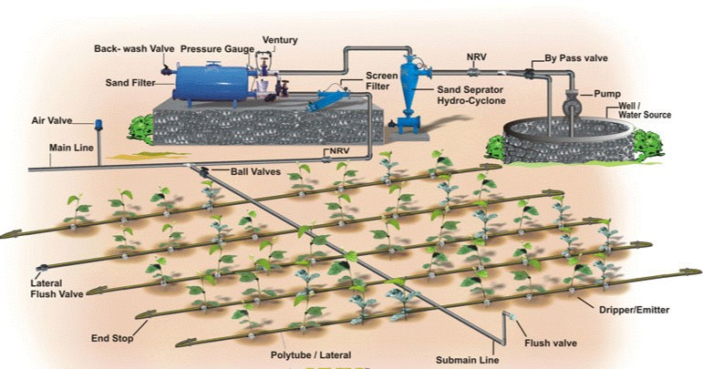

Figure 1: Practical Field Implementation

14
3:1 Block Diagram

Step Down
T/F
Full Wave Bridge Rectifier
Voltage Regulator

Multiplexer

DTMF
Decoder Ckt.

Mobile Tx

16x2 LCD Display

Microcontroller AT89S51

+5VDC/500mA
230V AC

WATER PUMP

( MOTOR )
RELAY
Ckt. For

WATER PUMP

Mobile
RX
Figure 2: Block Diagram
15
3:2 Hardware Requirements
- PCB
- MICROCONTROLLER
- STEP DOWN TRANSFORMER 12V/500mA
- VOLTAGE REGULATOR LM7805
- RECTIFIER DIODES 1N4001
- ELECTROLYTIC CAPACITORS
- LCD DISPLAY
- LEDs
- SENSING ELECTRODES
- OPERATIONAL AMPLIFIER
- PVC WIRES
- RELAY
- WATER PUMP

PCB
A printed circuit board (PCB) mechanically backings and electrically unites electronic segments utilizing conductive tracks, cushions and different highlights carved from copper sheets covered . Progressed PCBs may contain parts - capacitors, resistors or dynamic gadgets - inserted in the substrate.
Printed circuit sheets are utilized as a part of everything except the most straightforward electronic items. Distinct options for PCBs incorporate wire wrap out the circuit, however assembling and get together can be mechanized. Assembling circuits with PCBs is less expensive and speedier than with other wiring systems as segments are mounted.

At the point when the board has just copper associations and no inserted parts, it is all the more effectively called a printed wiring board (PWB).

A PCB populated with electronic parts is known as a printed circuit gathering (PCA), printed circuit board get together or PCB get
16
together (PCBA). The IPC favored term for amassed prepares to leave is circuit card get together (CCA), and for collected backplanes it is backplane congregations. The term PCB is utilized casually both for exposed and amassed sheets

Microcontroller

Description
The AT89S51 is a low-power, high-performance CMOS 8-bit microcontroller with 4K bytes of In-System Programmable Flash memory. The device is manufactured using Atmel’s high-density nonvolatile memory technology and is compatible with the industry-standard 80C51 instruction set and pinout. The on-chip Flash allows the program memory to be reprogrammed in-system or by a conventional nonvolatile memory programmer. By combining a versatile 8-bit CPU with In-System Programmable Flash on a monolithic chip, the Atmel AT89S51 is a powerful microcontroller which provides a highly-flexible and cost-effective solution to many embedded control applications.

The AT89S51 provides the following standard features: 4K bytes of Flash, 128 bytes of RAM, 32 I/O lines, Watchdog timer, two data pointers, two 16-bit timer/counters, a five-vector two-level interrupt architecture, a full duplex serial port, on-chip oscillator, and clock circuitry. In addition, the AT89S51 is designed with static logic for operation down to zero frequency and supports two software selectable power saving modes. The Idle Mode stops the CPU while allowing the RAM, timer/counters, serial port, and interrupt system to continue functioning. The Power-down mode saves the RAM con-tents but freezes the oscillator, disabling all other chip functions until the next external interrupt or hardware reset.
Pin Description
VCC- Supply voltage.

GND- Ground.
17
Port 0 Port 0 is an 8-bit open drain bi-directional I/O port. As an output port, each pin can sink eight TTL inputs. When 1s are written to port 0 pins, the pins can be used as high-impedance inputs.
Port 1 Port 1 is an 8-bit bi-directional I/O port with internal pull-ups. The Port 1 output buffers can sink/source four TTL inputs. When 1s are written to Port 1 pins, they are pulled high by the inter-nal pull-ups and can be used as inputs.
P1.5 MOSI (used for In-System Programming)
P1.6 MISO (used for In-System Programming)
P1.7 SCK (used for In-System Programming)
Port 2 Port 2 is an 8-bit bi-directional I/O port with internal pull-ups. The Port 2 output buffers can sink/source four TTL inputs. When 1s are written to Port 2 pins, they are pulled high by the inter-nal pull-ups and can be used as inputs.
Port 3 Port 3 is an 8-bit bi-directional I/O port with internal pull-ups. The Port 3 output buffers can sink/source four TTL inputs. When 1s are written to Port 3 pins, they are pulled high by the internal pull-ups and can be used as inputs
P3.0 RXD (serial input port)
P3.1 TXD (serial output port)
P3.2 INT0 (external interrupt 0)
P3.3 INT1 (external interrupt 1)
P3.4 T0 (timer 0 external input)
P3.5 T1 (timer 1 external input)
P3.6 WR (external data memory write strobe)
P3.7 RD (external data memory read strobe

RST Reset input. A high on this pin for two machine cycles while the oscillator is running resets the device. This pin drives High for 98 oscillator periods after the Watchdog times out.

ALE/PROG Address Latch Enable (ALE) is an output pulse for latching the low byte of the address during accesses to external memory. This pin is also the program pulse input (PROG) during Flash programming.
18
PSEN Program Store Enable (PSEN) is the read strobe to external program memory. When the AT89S51 is executing code from external program memory, PSEN is activated twice each machine cycle, except that two PSEN activations are skipped during each access to exter-nal data memory.

EA/VPP External Access Enable. EA must be strapped to GND in order to enable the device to fetch code from external program memory locations starting at 0000H up to FFFFH. Note, however, that if lock bit 1 is programmed, EA will be internally latched on reset

XTAL1 Input to the inverting oscillator amplifier and input to the internal clock operating circuit.

XTAL2 Output from the inverting oscillator amplifier

Memory Organization
MCS-51 devices have a separate address space for Program and Data Memory. Up to 64K bytes each of external Program and Data Memory can be addressed.

Program Memory If the EA pin is connected to GND, all program fetches are directed to external memory. On the AT89S51, if EA is connected to VCC, program fetches to addresses 0000H through FFFH are directed to internal memory and fetches to addresses 1000H through FFFFH are directed to external memory.

Data Memory The AT89S51 implements 128 bytes of on-chip RAM. The 128 bytes are accessible via direct and indirect addressing modes. Stack operations are examples of indirect addressing, so the 128 bytes of data RAM are available as stack space

19
Watchdog Timer (One-time Enabled with Reset-out)
The WDT is intended as a recovery method in situations where the CPU may be subjected to software upsets. The WDT consists of a 14-bit counter and the Watchdog Timer Reset (WDTRST) SFR. The WDT is defaulted to disable from exiting reset. To enable the WDT, a user must write 01EH and 0E1H in sequence to the WDTRST register (SFR location 0A6H). When the WDT is enabled, it will increment every machine cycle while the oscillator is running. The WDT timeout period is dependent on the external clock frequency. There is no way to disable the WDT except through reset (either hardware reset or WDT overflow reset). When WDT over-flows, it will drive an output RESET HIGH pulse at the RST pin.

Using the WDT
To enable the WDT, a user must write 01EH and 0E1H in sequence to the WDTRST register (SFR location 0A6H). When the WDT is enabled, the user needs to service it by writing 01EH and 0E1H to WDTRST to avoid a WDT overflow. The 14-bit counter overflows when it reaches 16383 (3FFFH), and this will reset the device. When the WDT is enabled, it will increment every machine cycle while the oscillator is running.

WDT during Power-down and Idle

In Power-down mode the oscillator stops, which means the WDT also stops. While in Power-down mode, the user does not need to service the WDT. There are two methods of exiting Power-down mode: by a hardware reset or via a level-activated external interrupt, which is enabled prior to entering Power-down mode. When Power-down is exited with hardware reset, servicing the WDT should occur as it normally does whenever the AT89S51 is reset. Exiting Power-down with an interrupt is significantly different. The interrupt is held low long enough for the oscillator to stabilize. When the interrupt is brought high, the interrupt is serviced. To prevent the WDT from resetting the device while the interrupt pin is held low, the WDT is not started until the interrupt is pulled high. It is suggested that the WDT be reset during the interrupt service for the interrupt used to exit Power-down mode.

20
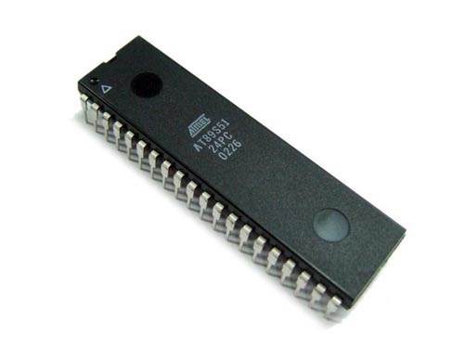
Figure 3: Microcontroller
Transformer (12v 500 mA) (230V to 12V)
Great Quality Transformer, power supplies for a wide range of venture & circuit sheets. Venture down 230 V AC to 12V with a greatest of 500mAmp current. By and large known as 12 - 0 - 12

Determination
- Voltage: 2 x 12V
- Current: 1 x 500Ma
- Rated force
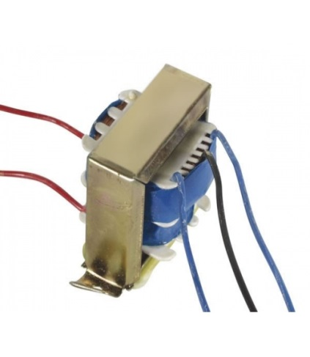
Figure 4: Transformer

21
Voltage Regulator (LM7805)

A LM7805 Voltage Regulator is a voltage controller that yields +5 volts.

A simple approach to recollect the voltage yield by a LM78XX arrangement of voltage controllers is the last two digits.
It yields 5 volts. The "78" section is simply the tradition that the chip creators utilization to indicate the arrangement of controllers that yield positive voltage.

Pin 1 (Input Pin): The Input pin is the pin that acknowledges the approaching DC voltage, which the voltage controller will in the long run direct down to 5 volts.
Pin 2 (Ground): Ground pin creates the ground for the controller.

Pin 3 (Output Pin): The Output pin is the controlled 5 volts DC
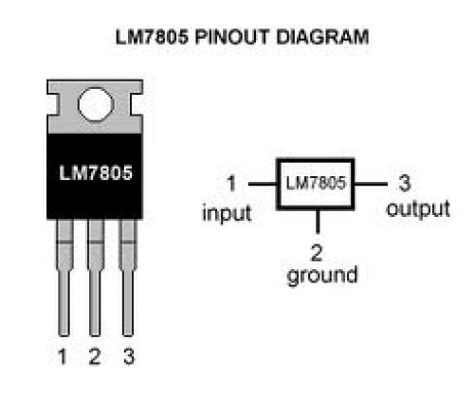
Figure 5: Voltage Regulator 7805

22

Rectifier Diodes (1N4001)

1N4001 is an individual from 1N400x diodes. Diode is a correcting gadget which leads just from anode to cathode. Diode acts open circuited for the present stream from cathode to anode. 1N4001 is a 1A diode with low forward voltage drop and high surge current capacity. It involves diffused PN intersection and has low invert spillage current of 5µA. Its DC blocking voltage is 50V. The cathode (n) is distinguished by a bar on diode case. The other terminal is the anode (p)

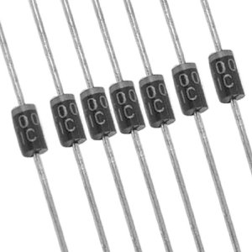
Figure 6:Rectifier Diodes

Electrolytic Capacitors

Electrolytic capacitors (e-tops) are spellbound capacitors whose anode cathode (+) are made of an uncommon metal on which a protecting oxide layer begins by anodization (framing), which goes about as the dielectric of the electrolytic capacitor. A non-strong or strong electrolyte which covers the surface of the oxide layer on a basic level serves as the second terminal (cathode) (-) of the capacitor. The expansive capacitance of electrolytic capacitors makes them especially suitable for passing or bypassing low-recurrence flags up to some super hertz and putting away a lot of vitality. They are broadly utilized for decoupling or clamor filtereng in force supplies and DC connection circuits for variable-recurrence drives.
23
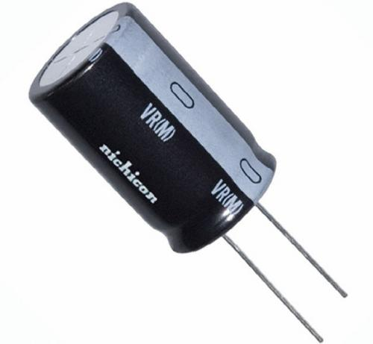
Figure 7: Electrolytic Capacitors

LCD Display

LCD is an electronic visual showcase, or feature show that uses the light balancing properties of fluid gems. Fluid gems don't discharge light directly.

LCDs are accessible to show discretionary pictures (as in a broadly useful PC show) or altered pictures which can be shown or covered up, for example, preset words, digits, and 7-section shows as in a computerized clock. They utilize the same fundamental innovation, with the exception of that discretionary pictures are comprised of an extensive number of little pixels, while different showcases have bigger components. LCDs are utilized as a part of an extensive variety of utilizations including PC screens, TVs, instrument boards, airplane cockpit presentations, and signage. They are basic in shopper gadgets, for example, DVD players, gaming gadgets, timekeepers, watches, number crunchers, and phones, and have supplanted cathode beam tube (CRT) shows in many applications. They are accessible in a more extensive scope of screen sizes than CRT and plasma shows, and since they don't utilize phosphors, they don't endure picture blaze in. LCDs are, nonetheless, powerless to picture ingenuity.

24
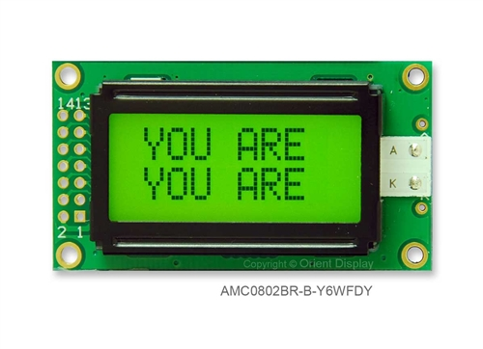
Figure 8: LCD Display

LED
Light radiating diodes, regularly called LEDs, are genuine unsung saints in the hardware world. They do many diverse occupations and are found in a wide range of gadgets.
In addition to other things, they frame numbers on computerized tickers, transmit data fromremote controls, light up watches and let you know when your apparatuses are turned on. Gathered together, they can shape pictures on a large TV screen or enlighten an activity light.

Fundamentally, LEDs are simply minor lights that fit effectively into an electrical circuit. Be that as it may, not at all like common brilliant globules, they don't have a fiber that will wear out, and they don't get particularly hot. They are enlightened exclusively by the development of electrons in a semiconductor material, and they keep going generally the length of a standard transistor. The lifespan of a LED surpasses the short existence of a brilliant knob by a great many hours. Minor LEDs are as of now supplanting the tubes that light up LCD HDTVs to make drastically more slender TVs.

In this article, we'll inspect the innovation behind these pervasive signals, enlightening some cool standards of power and light simultaneously

25
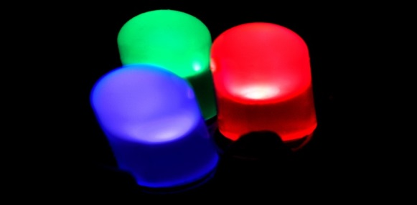
Figure 9: LED
Sensing Electrodes

A particle particular cathode (ISE), otherwise called a particular particle terminal (SIE), is a transducer (or sensor) that changes over the movement of a particular particle broke down in an answer into an electrical potential, which can be measured by a voltmeter or pH meter. The voltage is hypothetically reliant on the logarithm of the ionic action, as per the Nernst comparison. The detecting piece of the cathode is normally made as a particle particular layer, alongside a reference terminal. Particle specific anodes are utilized as a part of scientific
science and biochemical/biophysical examination,
where estimations of ionic fixation in a fluid arrangement are needed, as a rule on an ongoing premise.

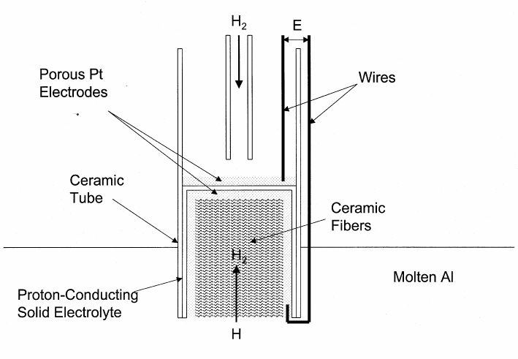
Figure 10: Sensing Electrodes
Operational Amplifier
An operational intensifier ("operation amp") is a DC-coupled high-increase electronic voltage speaker with a differential data and, normally, a solitary finished output.

26

In this arrangement, an operation amp creates a yield potential (in respect to circuit ground) that is ordinarily a huge number of times bigger than the potential distinction between its info terminals.

Operational enhancers had their causes in simple PCs, where they were utilized to do scientific operations in numerous direct, non-straight and recurrence ward circuits.
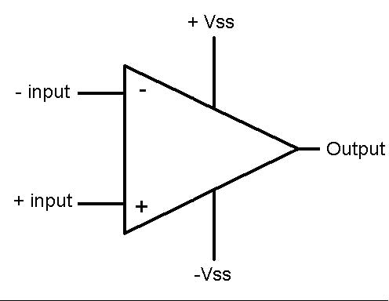
Figure 11: Op-Amp

PVC Wires

Applications:

- Open and covered wiring in businesses/private and business structures.
- House meter and water pump associations.
- Road light and movement signal associations.
- Covered wiring on transports, rail line mentors, ships, flying machines and so on.
- Being light can be utilized on false roofs.
- Notable highlights:
- Most temperate when contrasted with steel conductor.
- Very protected non conductor anticipates short out perils.
- Erosion verification free from rust saltiness and mugginess.

27
Relay
It is an electrically worked switch. Various exchanges use an electromagnet to mechanically work a switch, yet other working models are similarly used, for instance, solid state exchanges. Exchanges are used where it is vital to control a circuit by a low-power signal (with complete electrical withdrawal amidst control and controlled circuits), or where a couple of circuits must be controlled by one sign. The main transfers were utilized as a part of long separation broadcast circuits as enhancers: they rehashed the sign rolling in from one circuit and re-transmitted it on another circuit..
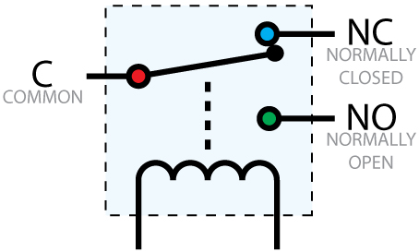
Figure 12: Relay

BC 548 Transistor

BC548 is a broadly useful NPN bipolar intersection transistor discovered generally in European electronic hardware and present-day plans in Australian and British gadgets magazines where a regularly accessible minimal effort NPN transistor is needed..
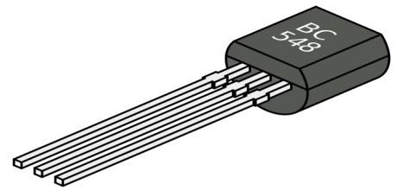
Figure 13: BC 548 Transistor

28
Moisture Sensor

Distinguishes vicinity of fluid or dampness between two wire leads and gives dynamic High yield. The uncovered wire is permeable; consequently it permits transmission of water vapors into the sensor. These uncovered zones are built daintily. Hence the sensor reacts quickly to changes in connected dampness, both while being dried (on methodology start-up) and when called vigorously if there is dampness entrance into a procedure. These are the sorts of sensors essentially utilized for, •Interfacing with Microcontroller to identify fluid levels. •Moisture recognition for programmed watering of plants. •Liquid level discovery by putting different tests at every fluid

Figure 14: Moisture Sensor

29
CHAPTER 4 __ __________________________

System Circuit Architecture

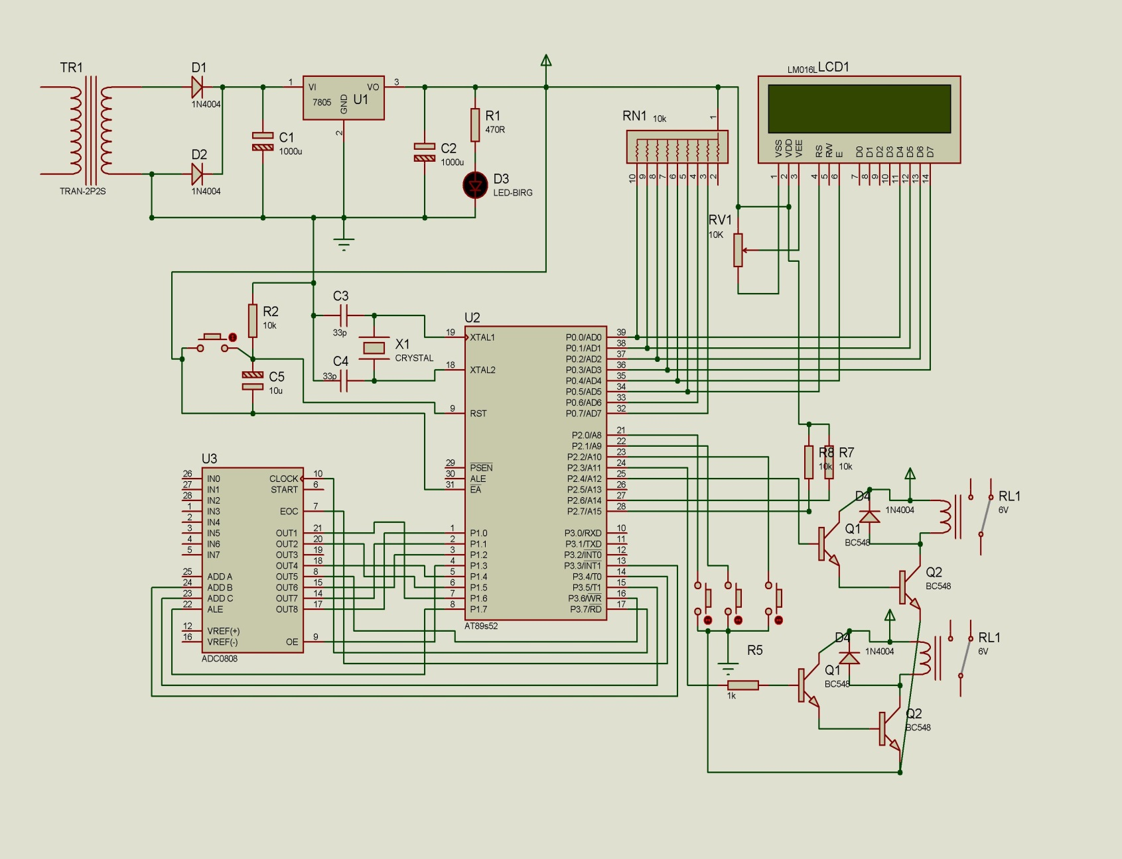

Figure 15: Circuit Diagram

30
CHAPTER 5 ____________________________

Methodology

5.1 Proposed System Hardware working

1. Pipe is associated from the engine joined water pump and the other opening is close to the foundation of the plant.

2. Flow of water is controlled by a solenoid valve.

3. The opening and shutting of the solenoid valve is finished by the microcontroller

4. The microcontroller gives the sign to the valve which makes it open and water is given to the base of the arrangement drop by drop.

5. When the dampness level achieves a certain level, it is detected by the sensors associated and it gives a sign to the microcontroller.

6. The client is educated about the dampness level through a CALL/CALL/SMS sent by means of the GSM modem joined.

7. Similarly, the sensors sense if the dampness level is low and convey ahead the aforementioned method.

8. The raingun is controlled by the "ON" and "OFF" orders.
31
5.2 Flowchart

Figure 16: Flowchart

32
5.3 Algorithm
Step1: Start the methodology.

Step2: introduce force is supplied to GSM

Step3: The dampness level not exactly or more than.

Step4: If the level is showing exceeding 50% there is no need of watering.
Step5: Moisture level under 50% begin watering system

Step6: The instate the pump and rain-gun

Step7: After the procedure finished it getting move to unique state.

Step8: Stop the procedure.

33
5.4 Modes Of Operation

Automatic Motor Controller
This module is utilized to control the pump consequently. The pump will be turned on consequently consistently at a specific time for 2 minutes, promptly following 2 minutes the pump will turns off. The turning on and off of the pump will work paying little respect to the dampness rate around the field range. This programmed mode can be set by sending a CALL/CALL/SMS/call containing SET2 to the GSM modem in the inserted framework associated with the pump

Figure 17: Flowchart
34

Manual Motor Controller

This module is utilized to control the water regulating system. We can kill on/the pump when we oblige it to. There is no specific time to switch it on or there is no time limit when to turn it off. This module meets expectations just by sending a CALL/CALL/SMS as ON to switch on the engine and OFF to kill the engine. This CALL/CALL/SMS must be sent to the GSM modem associated with the pump.

Figure 18: Flowchart
There is an another mode of operation, although that is not functional for our project, but we decided to discuss in our report.
35

Humidity control Manager
This module is utilized to check the dampness content around the field region. The dampness sensor is associated with the microcontroller which thus is associated with the water pump, will sense the dampness encompassing the rancher's field region.

Else if the dampness rate is over the limit rate then the water pump won't be turned on. The Humidity Mode is set by sending a CALL/SMS as SET1 to the GSM modem in the inserted framework associated with the framework.

Figure 19: Flowchart

36
5.5 System Program
[“ #include<AT89X52.h>
#define lcdport P0
#define adcport P1
sbit enterkey=P2^5;
sbit downkey=P2^6;
sbit upkey=P2^7;
sbit rs=P2^0;
sbit rdwr=P2^1;
sbit lcde=P2^2;
sbit relay=P2^3;
sbit buzzer=P2^4;
sbit intr=P3^0;
sbit wr=P3^1;
sbit rd=P3^2;
unsigned char adcdata;
unsigned char referenceval;
unsigned char enterkeyflag;
unsigned char enterkeycount;
unsigned char buzzercount;
unsigned char buzzerentrycount;
unsigned char loopflag=1;
unsigned char adcdatagreaterflag;
const unsigned char slogan1[]="Soil Irrigation ";
const unsigned char slogan2[]=" Contrl System ";
const unsigned char slogan3[]="Reference Value ";
const unsigned char slogan4[]=" Soil Value ";
void delay();
void lcdinit();

37
void clr_lcd();
void dispslogan(char*);
void senddata(unsigned char);
void send_command(unsigned char);
void next_line();
void delay1();
unsigned char xch(unsigned char);
void timer0() interrupt 1
{
buzzercount++;
TF0=0;
TH0=00;
TL0=00;
if(buzzercount==100)
{
buzzercount=1;
buzzer=0;
ET0=0;
TR0=0;
}
}
void longdelay()
{
unsigned int i,j;
for(i=0;i<100;i++)
{
for(j=0;j<400;j++)
{}
}}

38
void adccontrol()
{
wr=0;
delay();
wr=1;
delay();
while(intr == 1 ); /* wait until the INTR signal makes */
/* high-to-low transition indicating */
/* completion of conversion
/* Read the voltage value from the port */
delay();
rd =0;
delay();
delay();
adcdata=adcport;
rd=1;

}
void sndconvdata(unsigned char convdata)
{
unsigned char convdata1;
convdata1=convdata/10;
senddata(convdata1/10 + 48);
senddata(convdata1%10 + 48);
senddata(convdata%10 + 48);
dispslogan(" % ");
}
void upkeychk()
{
if(upkey==0)
39
{
referenceval++;
send_command(0xc4);
sndconvdata(referenceval);
}}

void downkeychk()
{
if(downkey==0)
{
referenceval--;
send_command(0xc4);
sndconvdata(referenceval);
}}
void enterkeychk()
{
if(enterkey==0)
{
enterkeycount++;
if(enterkeycount==1)
{
enterkeyflag=1;
clr_lcd();
dispslogan(slogan3);
send_command(0xc4);
sndconvdata(referenceval);
}}} “]
[“/**********STARTING OF THE TEMPERATURE CONTROLLER PROJECT******************************/
void main()
40
{
relay=0a;
buzzer=0;
TMOD=0x01;
TH0=00;
TL0=00;
EA=1;
ET0=0;
TR0=0;
rdwr=0;
delay();
lcdinit();
clr_lcd();
dispslogan(slogan1);
next_line();
dispslogan(slogan2);
longdelay();
clr_lcd();”
[“/************STARTING OF THE MAIN LOOP**********************************************/
while(enterkeycount<2)
{
enterkeychk();
if(enterkeyflag)
upkeychk();
if(enterkeyflag)
downkeychk();
}
rd=1;
WR=1;
41
intr=1;
clr_lcd();
dispslogan(slogan4);
while(1)
{
delay();
adccontrol();
delay();
send_command(0xc4);
sndconvdata(2*adcdata);
if(2*adcdata>referenceval)
{
if(!adcdatagreaterflag)
{
adcdatagreaterflag=1;
buzzerentrycount++;
lcde=1;
relay=0;
if(buzzerentrycount==1)
{
buzzer=1;
ET0=1;
TR0=1;
}}}”]
[“/****************FUNCTION FOR SWAPPING LSBYTE AND MSBYTE OF THE DATA***************/
unsigned char xch(unsigned char data1)
{
unsigned char temp,temp1;
temp=data1;
42
data1=data1>>4;
temp1=data1;
data1=temp;
data1=data1<<4;
data1=data1|temp1;
return(data1);
} “]
[“/********************** INITIALIZATION OF LCD ***********************************/
void lcdinit()
{
clr_lcd(); /*FUNCTION SET */
send_command(0x28);
delay();
send_command(0x28);
delay();
send_command(0x28);
delay();
send_command(0x06); //ENTRY MODE
delay()
send_command(0x0e); //DISPLAY ON/OFF
delay(
clr_lcd();
} “]

[“/* FUNCTION FOR DISPLAYING DATA ON THE LCD *************************************/

void dispslogan(unsigned char *p)
{
43
unsigned char data1;
while(*p)
{
data1=*p;
senddata(data1);
p++;
}
} “]

[“/***************** FUNCTION FOR SENDING LCD COMMANDS***********************************/

void send_command(unsigned char data1)
{
unsigned char newdata;
rs=0;
delay();
lcde=1;
delay();
lcdport=data1;
lcde=0;
delay();
lcde=1;
newdata=xch(data1);
lcdport=newdata;
delay();
lcde=0;
delay();
rs=1;

44
} “]

[“/************************** FUNCTION FOR WRITING DATA ON THE LCD***********************/

void senddata(unsigned char data1)
{
unsigned char newdata;
rs=1;
delay();
lcde=1;
delay();
lcdport=data1;
lcde=0;
delay();
lcde=1;
newdata=xch(data1);
lcdport=newdata;
delay();
lcde=0;
delay();
rs=0;
} “]

[“/************ delay for 20 micro second **********************************************/

void delay()
{
45
unsigned char i,j;
for(i=0;i<80;i++)
{
for(j=0;j<120;j++)
{}
}}”]

[“/*********** COMMAND FOR BRINGING LCD CURSOR ON SECOND LINE ***************************/

void next_line()
{
send_command(0xc0);
delay();
} “]

[“/**************COMMAND FOR CLEARING LCD AND BRINGING LCD CURSOR ON FIRST LINE********/

void clr_lcd()
{
send_command(0x01);
delay();
send_command(0x02);
delay();
} “]

46
CHAPTER 6__________ _____ ______________

Project Prototype Model

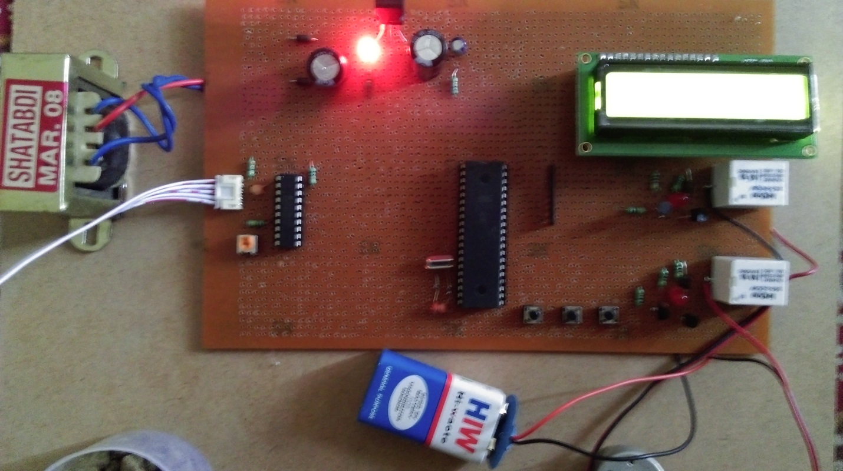

Figure 20: Project Prototype Model

47

CHAPTER 7__________ ___________________

Result & Discussion

We connected our prototype model to the main ac current source and reset the AT89S51 Microcontroller, output of the LCD Display was

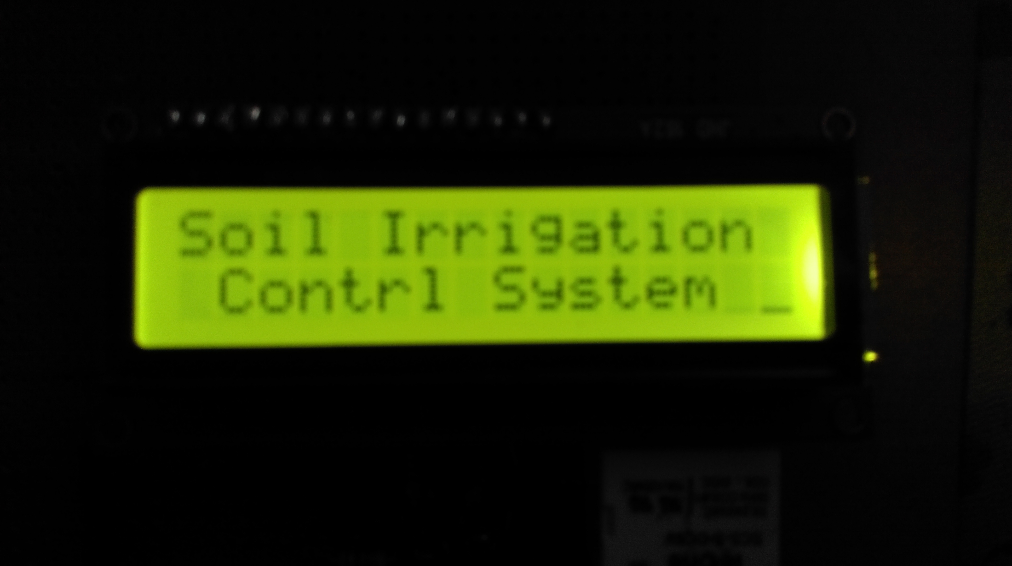

Figure 21 : Output 1

Then we press the enter button and the output of the LCD Display was

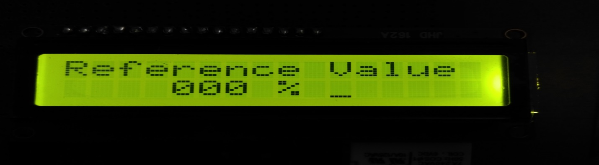
Figure 22:Output 2

48
We have to set a reference moisture content value for soil, we set it as 230%

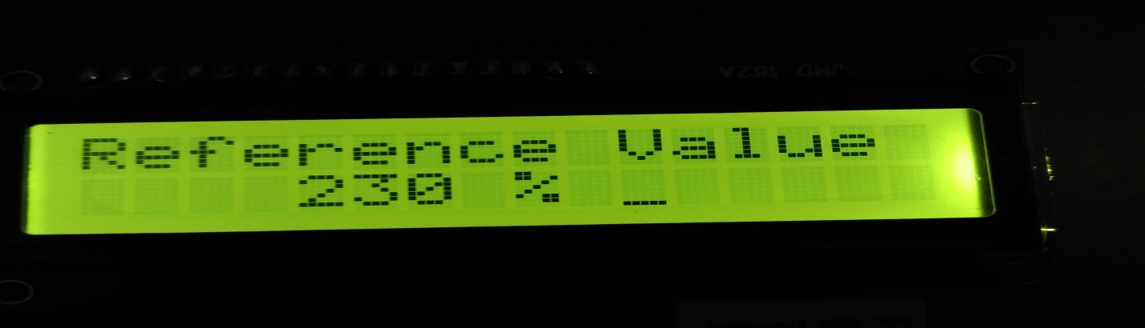

Figure 2: Output 3

Now when we press the enter button it showed

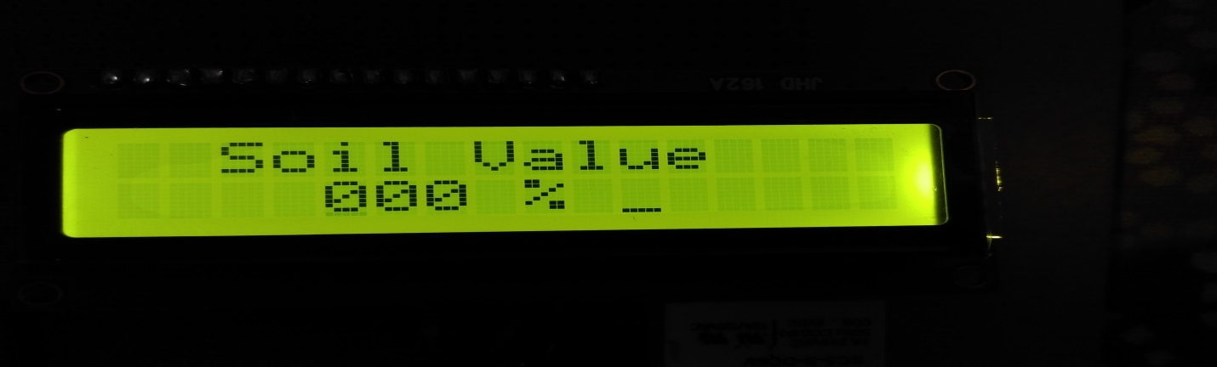

Figure 24: Output 4

49

And the actual moisture content of the soil is

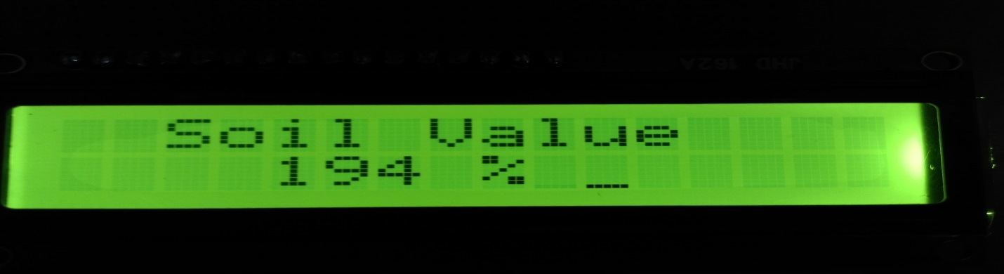

Figure 25: Output 5

As the moisture content of the soil is less than the reference moisture content value, the motor will start pumping water.

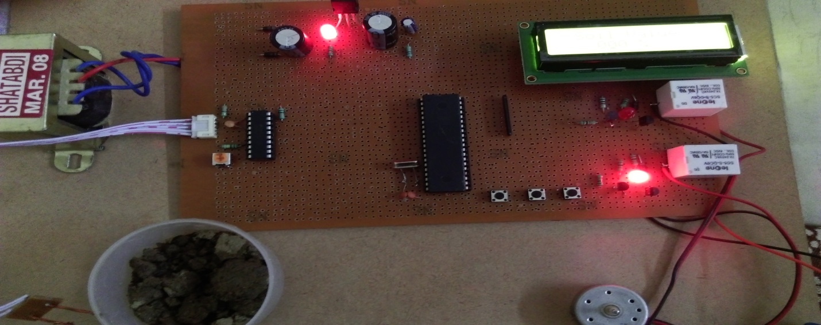

Figure 26: Output 6

50
It will inform the farmer to start the water supplying to the field, which we have showed through voice command.

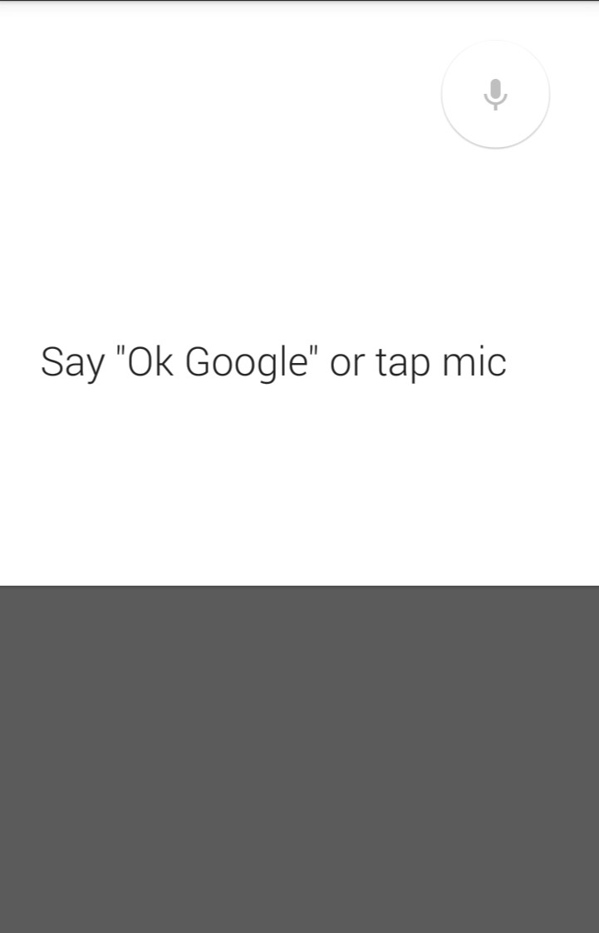

Figure 27: Output 7
The whole setup

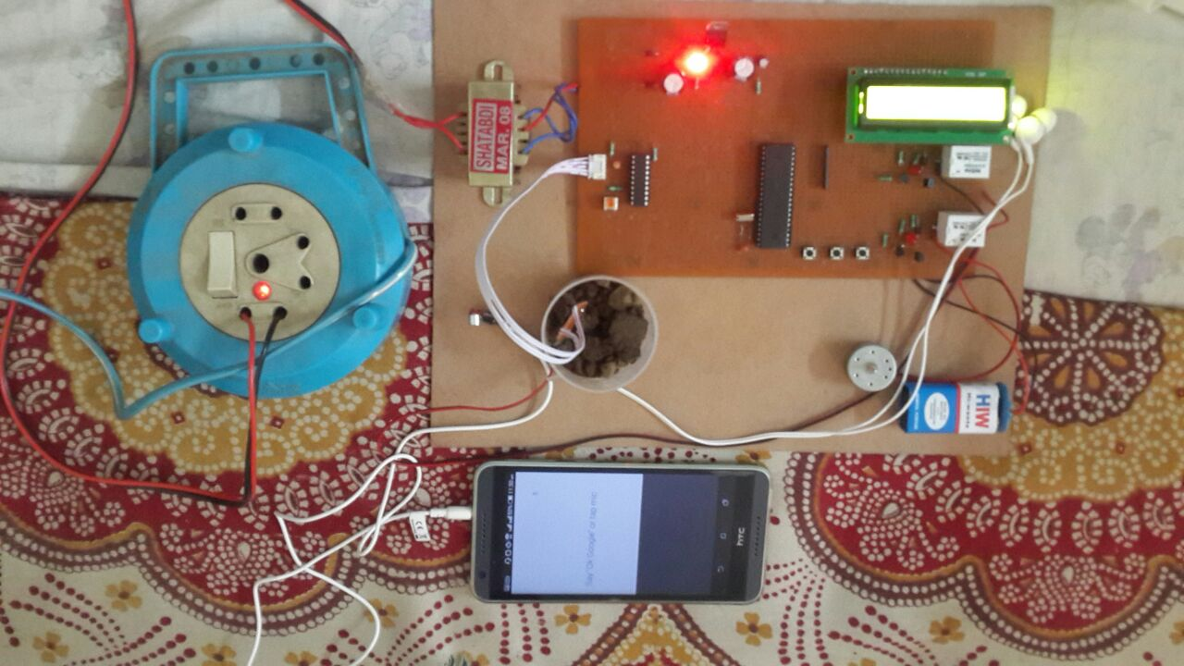
Figure 28: Whole Setup

51
CHAPTER 8____ __________ _______________

Conclusion

Since prior days agriculturist should visit their horticultural land and check the dampness substance of soil physically. It permits the client to screen and keep up the dampness remotely regardless of time. It is truly a viable and financial approach to decrease human exertion and water wastage in farming area. Ebb and flow systems in farming have decreased the ground-water level and accessibility of human asset. This Irrigation control framework utilizing Android can help agriculturist as a part of numerous courses.

Aside from horticultural fields, this framework can be utilized as a part of Cricket stadiums or Golf stadiums furthermore openly cultivates. The framework has an immense interest and future extension as well.

It permits a ton of improvement inside it and prompts the standard and valuable framework which can be utilized differ generally as a part of rural field.

52

CHAPTER 9 ____________________________

Future Scope for Research

1. Our project is based on automation technology and we tried our best to implement all the possible mechanism for that.

2. A helpful future add on feature could be the addition of Bluetooth technology along with it for the better automatic functioning.

53
CHAPTER 10 ___________________________

References

1. GSM based Automated Irrigation Control using Raingun Irrigation System
(By-R.suresh, S.Gopinath, K.Govindaraju, T.Devika, N.SuthanthiraVanitha)

2. Irrigation Control System Using Android and GSM for Efficient Use of Water and Power
(Laxmi Shabadi, Nandini Patil, Nikita. M, Shruti. J, Smitha. P, Swati. C).
3. GSM based Automatic Irrigation Control System for Efficient Use of Resources and Crop Planning by Using Mobile ( Pavithra D. S, M. S .Srinath)

4. www.scribd,com

5. www.wikipedia.org

6. www.worldscience.org

54

CHAPTER 11 ___________________________

Plagiarism Check Result

1. Site: http://paperrater.com/plagiarism_checker


2. Site: http://smallseotools.com/plagiarism-checker

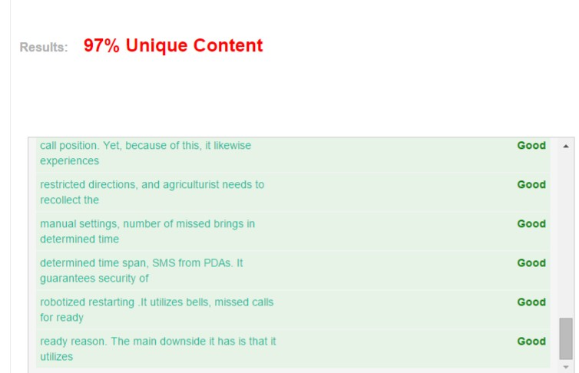

55

ACCORDING TO THE TURNITIN SOFTWARE PROVIDED BY AMITY UNIVERSITY,

THE UNIQUENESS PERCENTAGE OF OUR REPORT IS 98%

(CHECKED BY OUR PROJECT GUIDE MR. VK SHARMA, AITEM, AMITY UNIVERSITY, UTTAR PRADESH)

THANK YOU

56

