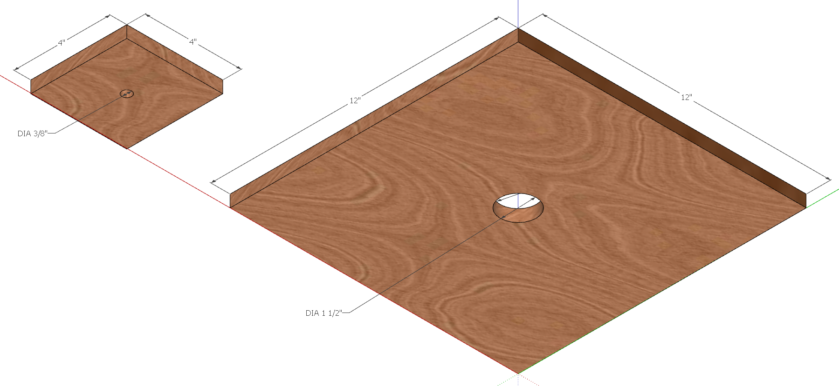

Cut and drill the mounting base. I built mine with Baltic birch cut offs from a cabinet shop.