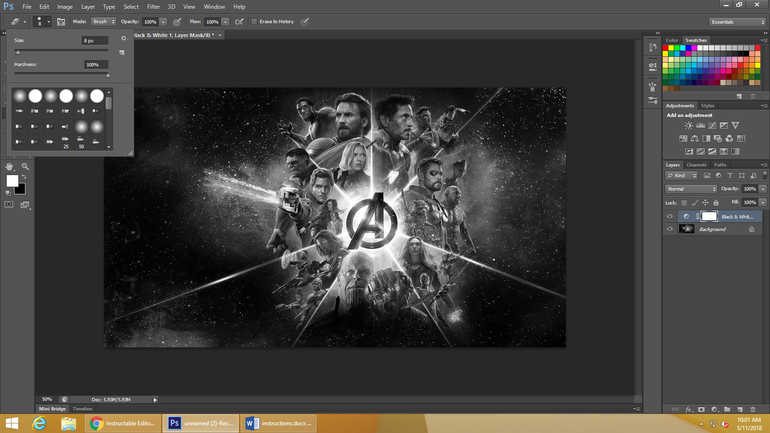

You can use this fancy drop down menu to edit the eraser settings

Use this to switch coloring on/off