Ten rings project
This project is super fun to make and play, you can spend hours learning how to solve it in minuets!
Well without any further delay let’s start building.

Materials you’re going to need
Tools
- Hammer
- Pliers
- Knife
- Drill
- Wood Clamp
- Drill bit [the same thickness of your coper wire]
- Sandpaper grit 80 and 220
- Marker
- Ruler
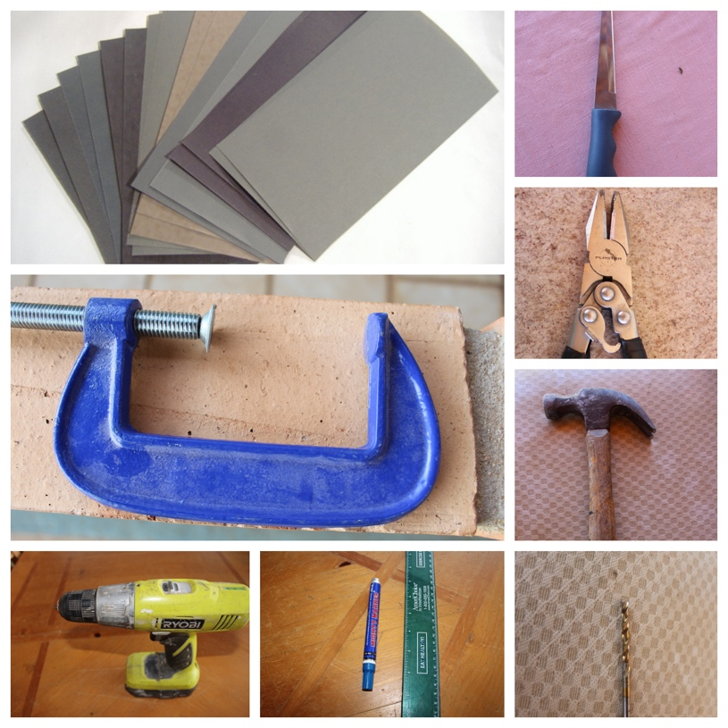
Materials
- Piece of wood 2 inches x 9 inches
- Two feet of aluminum wire folded in the middle
- Five feet of coper wire
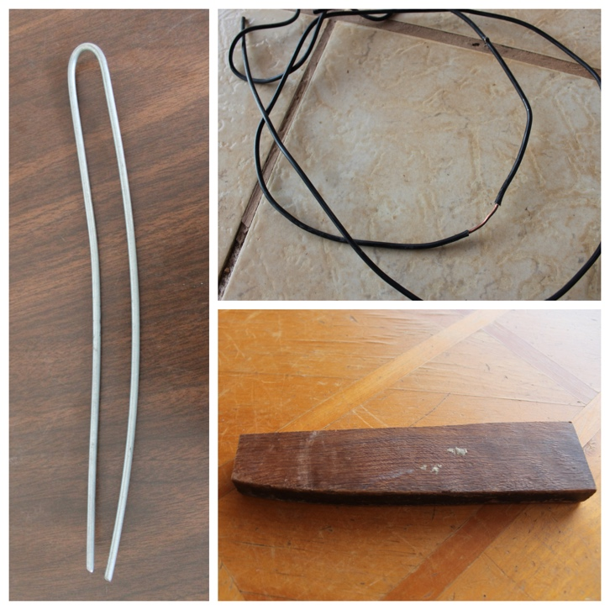

1st Step
Measure your wood every one inch and mark it with a marker, as shown in the first picture. And then clamp it to the table were your working at.
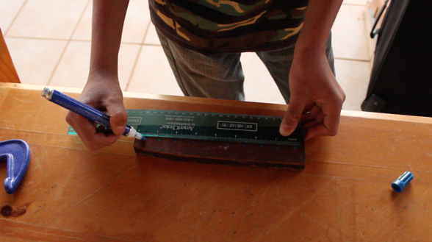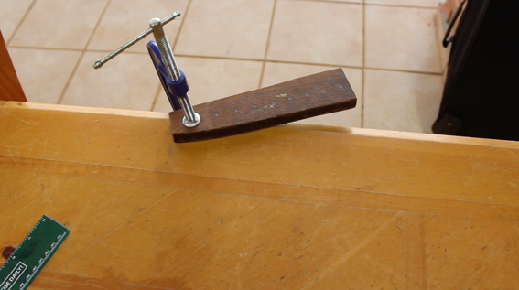

2nd Step
Then drill holes were you marked with your drill.
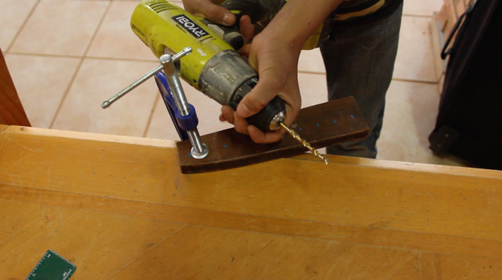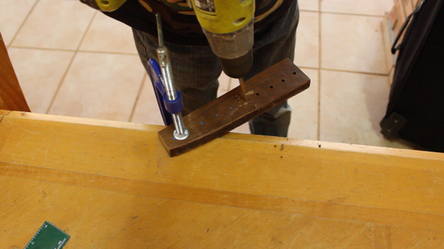

3rd Step
Now get the wood you are working with and sand it first with 80 grit and then 220.
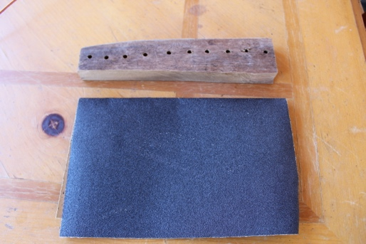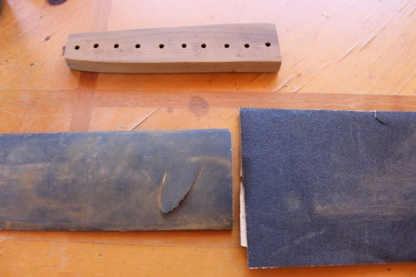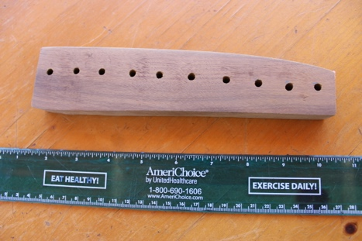

4th Step
Get the coper wire and peel one side of it, then pull out the wire from the wire coating as shown.

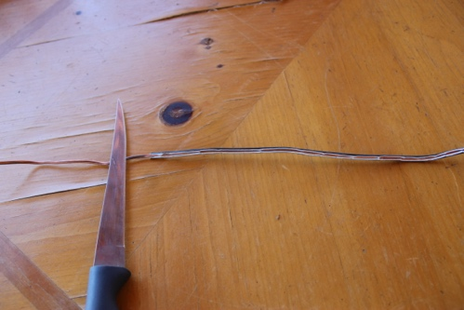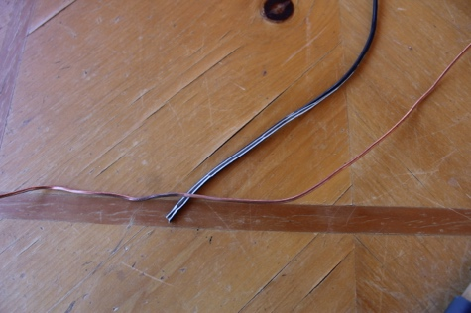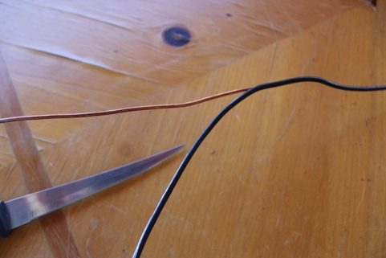

5th Step
Set your wood aside for a minuet or two, because we’re going to make the wire part now.
Cut with the pliers ten pieces of coper wire
3 inches long, and bend them in the format of rings.
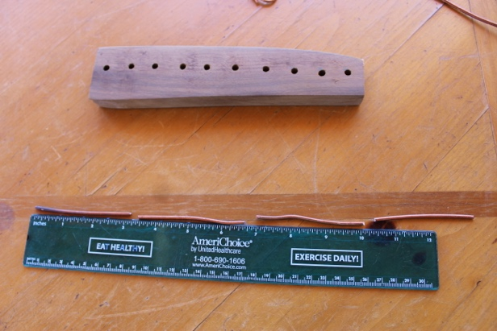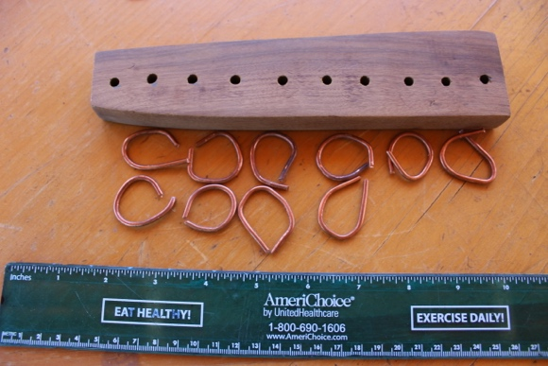

6th Step
Hold the rings with the pliers as shown
while hammering it to get a better circle. If you
have some wire from the rings two ends that ends
up one on top of the other cut it so that it stays
end with end as shown in second picture.
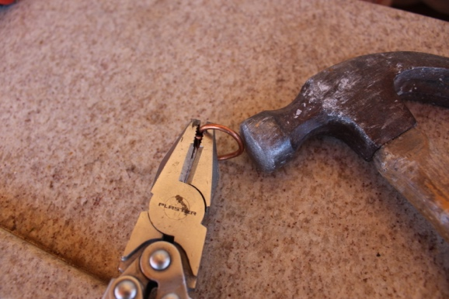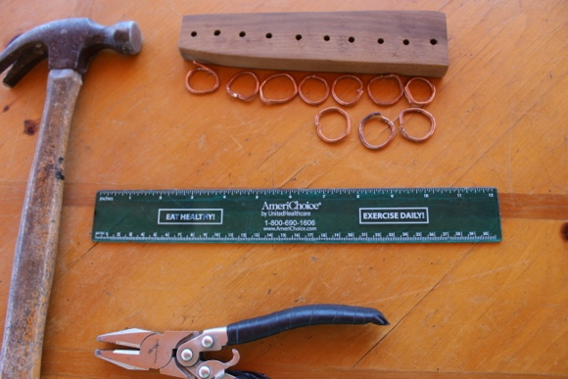

7th Step
Ok, time to look at all we made till now:
Ten holes in a wood 9 in x 2 in
Ten coper rings
If you have that you’re all right. Let’s keep going now. Cut ten pieces of wire 3 ½ inches.
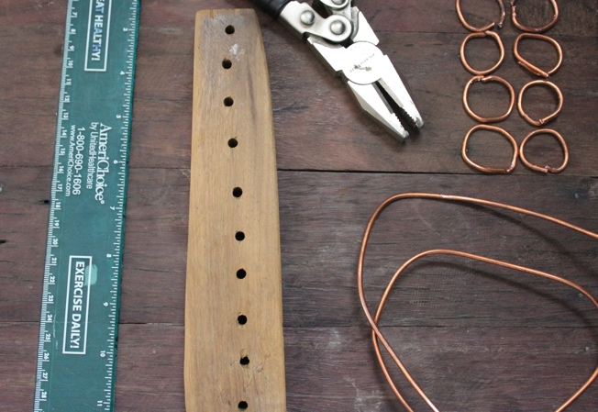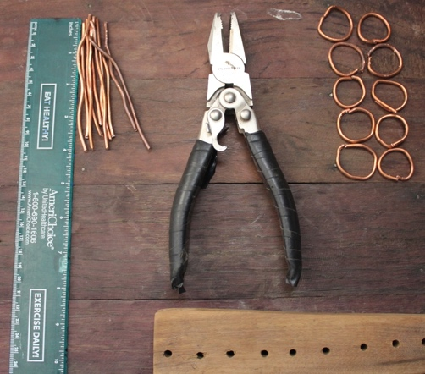

8th Step
Make “fish hooks” in the end of the ten wires you just cut [remember DON’T CLOSE the wire’s hooks leave them slightly open]. Hammer the hooks to make them flat, as shown in the third picture.

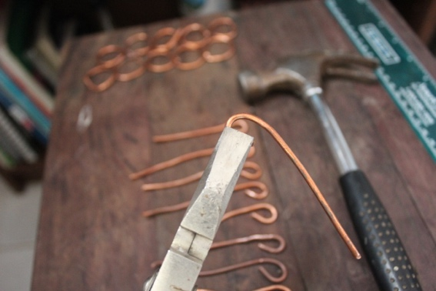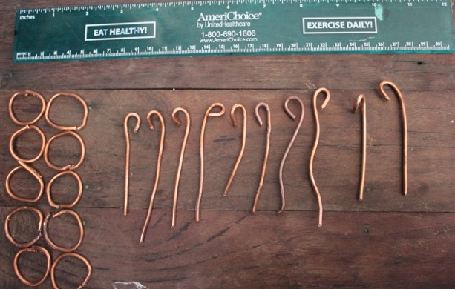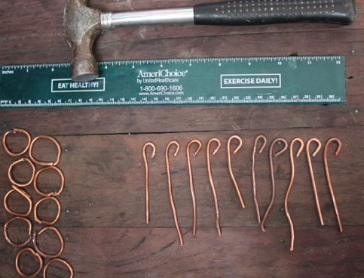

9th Step
Put the rings inside of the hooks
and clamp the hooks shut.
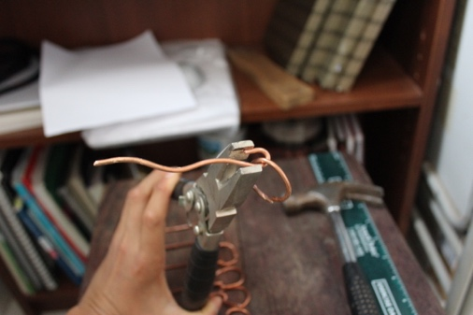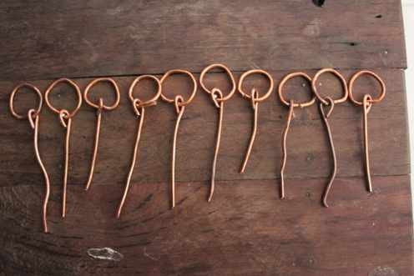

10th Step
Now bring back your wood because we’re going to put everything together.
Get the wire and start to put them in as shown in the pictures one by one, till you put all ten of them in. The last one is going to hang over but that’s normal.

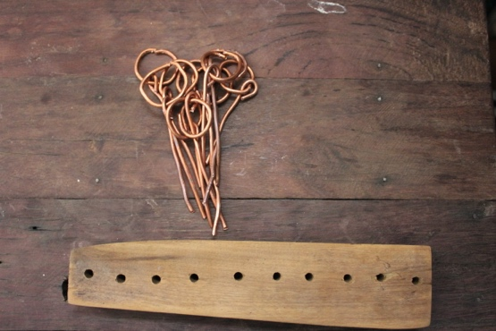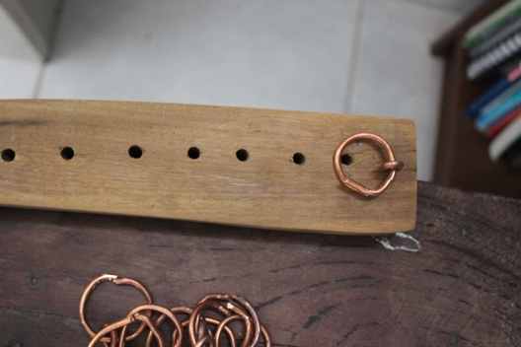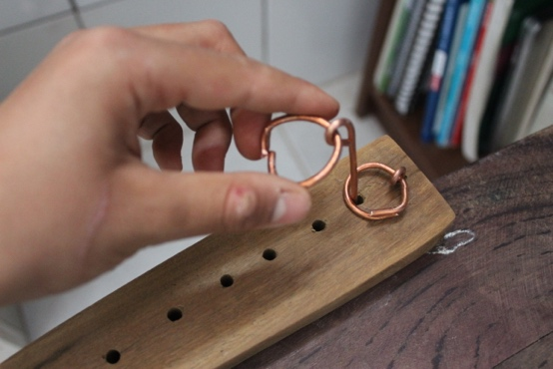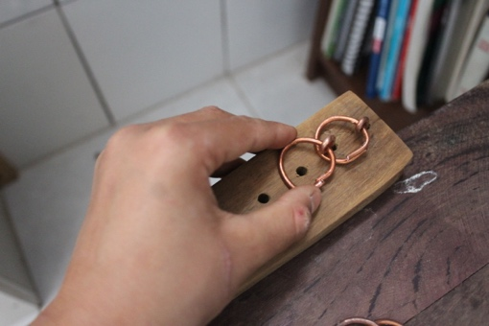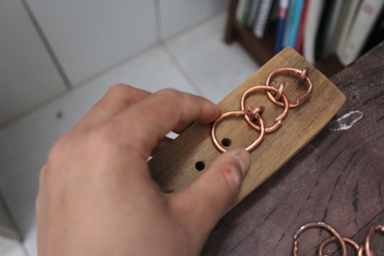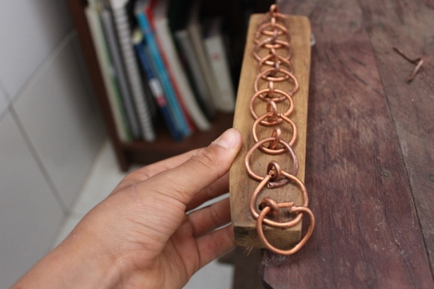

11th Step
Turn every thing on its side as shown, and clamp the pliers on the top part of the wires. With your hand pull the other side down so that the wires don’t come off.
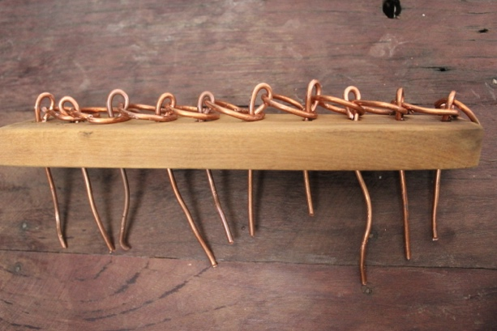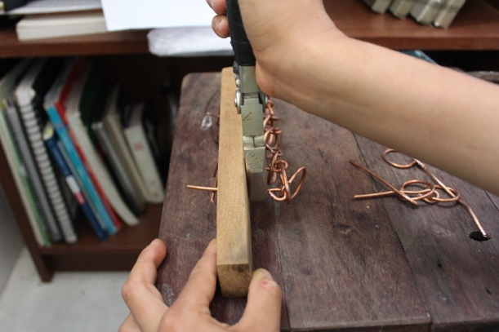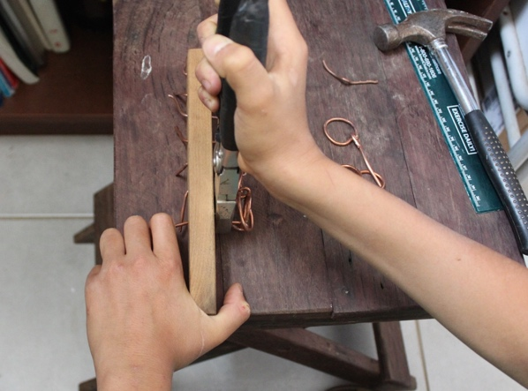

12th Step
Clamp the wood to your working table. It should
look like the first picture.
Cut off the end of the wires as shown,
letting only about 3 centimeters on the bottom for
the wire not to come out.
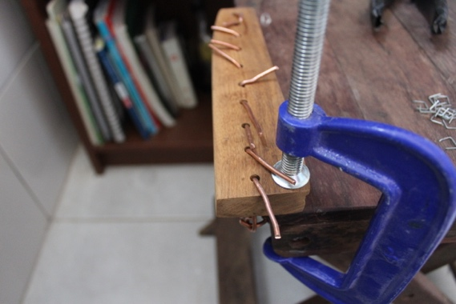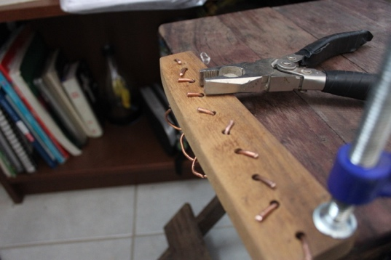

13th Step
Now bring the 2 feet of aluminum wire that are folded in half and put it in the middle of the wires as shown in the pictures, from the beginning to the end. Don’t forget to fold in the end of the needle like it is in the last picture so that it doesn’t come out the wrong side.
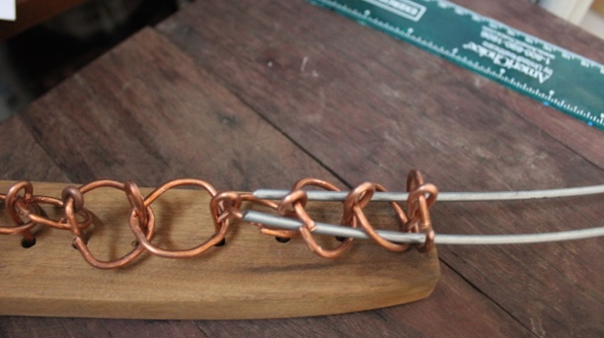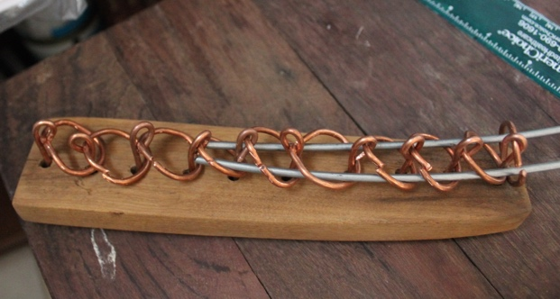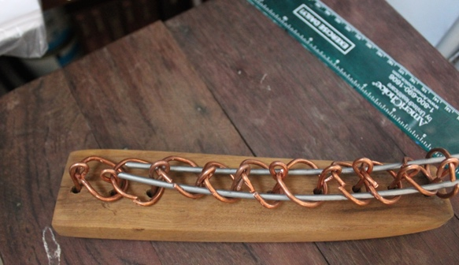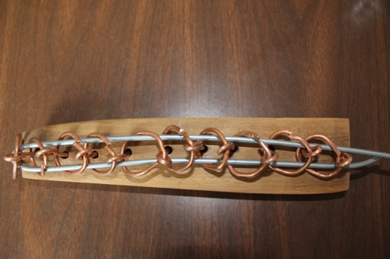
Purpose of the puzzle. remove the aluminum wire from the coper wires.

