Brain Puzzle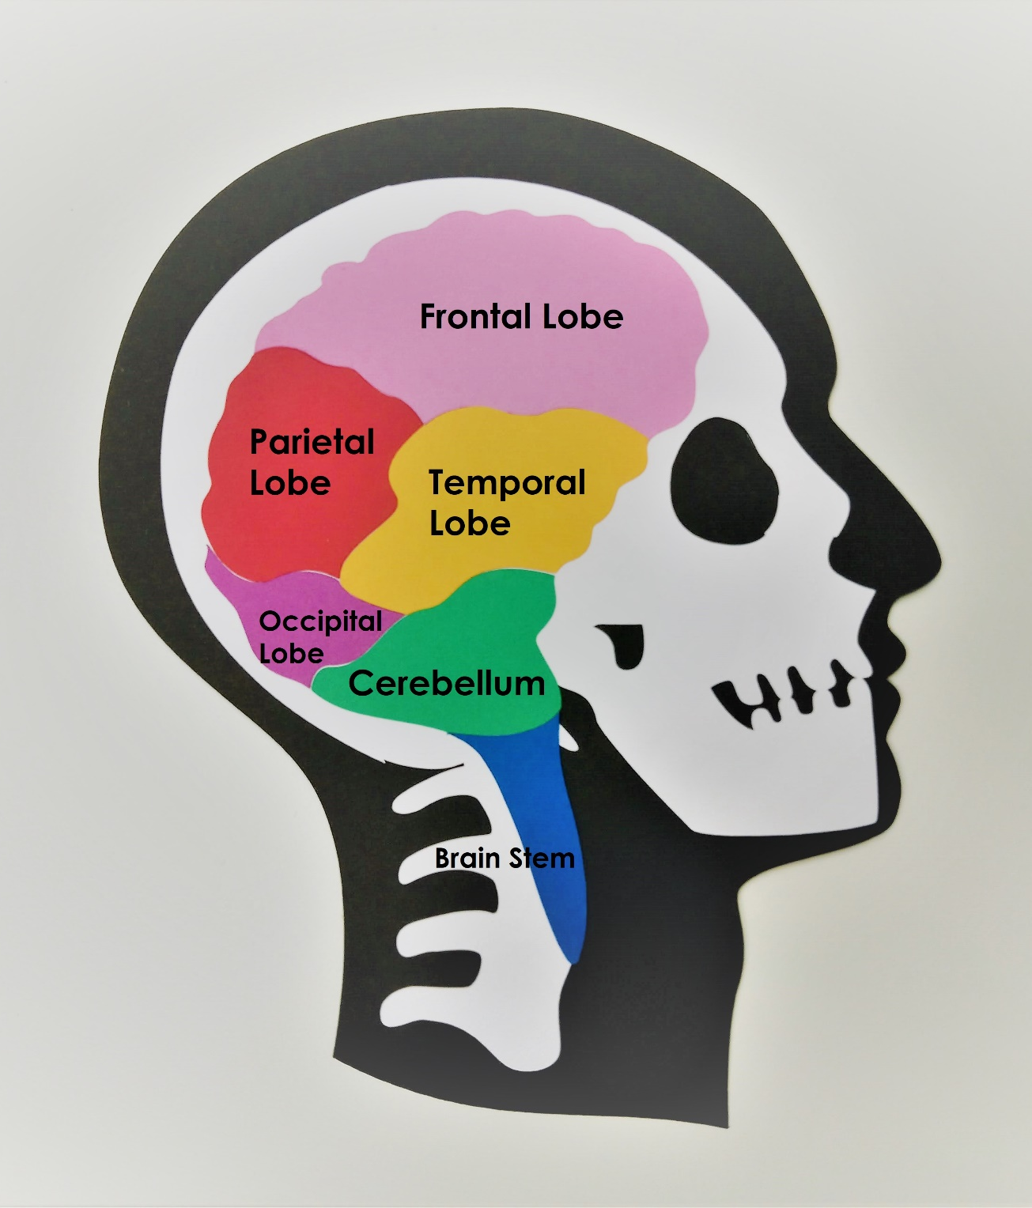 Brain Puzzle

