Double-Cardan and Cardan Joint
Lesson Plan

Goals/Objectives
- Notice that a Double-Cardan Joint transmits a constant input shaft speed as a constant output shaft speed
- Notice that a Cardan Joint has a varying output speed based on a constant input speed – this becomes more evident as the misalignment angle increases
- Notice that as the misalignment angle increases, the joints begin to bind

Background
Both Cardan and Double-Cardan Joints are used to transmit angular motion through misalignment angles. A Cardan Joint will not transmit a constant input speed as a constant output speed through the misalignment angle leading to vibrations. A graph of the output velocities of a Cardan Joint based on an input angular velocity of 1 unit can be seen in Figure 1 where θ is the misalignment angle.

A Double-Cardan Joint has two Cardan Joints phased apart from one another which works to cancel out these variations leading to a steady output speed and no vibrations.

Instructor Prep
Follow the Instructables instructions to print and assemble the device.

Familiarize yourself with the concepts demonstrated by the device.

Class Activities
Show videos from the Instructables site to show the difference in output speeds of the two shafts.

Discuss why the Cardan Joint creates a varying output speed and how the Double-Cardan Joint cancels out these variations.

Pass around the 3D printed mechanism to allow the students to see the concepts at work.

After Class Activities
Have students research the most common uses of these joints.

Have students determine situations where a Cardan Joint is acceptable even though it can cause vibrations and does not perfectly transmit the input speed.

Additional Materials:

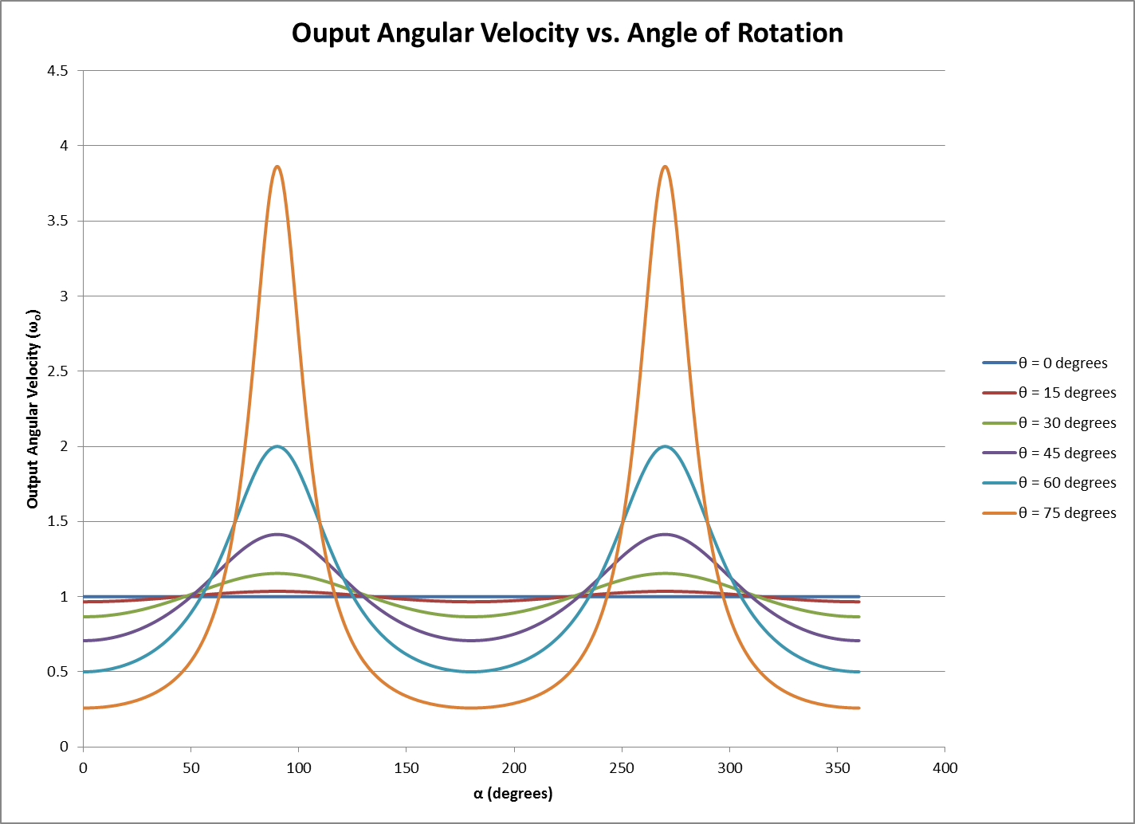
Figure 1 - Cardan Joint Output Speeds based on an Input Speed of 1 Unit

