1 Introduction 1

2 Block diagrame

2.1 Diagramme . . . . . . . . . . . . . . . . . . . . . . . . . . . . . . . . . . . . . . . 1

2.2 Desciption . . . . . . . . . . . . . . . . . . . . . . . . . . . . . . . . . . . . . . . . . . 2

3 Circuit diagramme and Working

3.1 Transmiter Circuit . . . . . . . . . . . . . . . . . . . . . . . . . . . . . . . . . . . . . . . . . . . . 3

3.1.1 Circuit Working . . . . . . . . . . . . . . . . . . . . . . . . . . . . . . 3

3.1.2 Component. . . . . . . . . . . . . . . . . . . . . . . . . . . . . . . . . . . . . . . . . . . 5

3.1.3 Receveur Circuit . . . . . . . . . . . . . . . . . . . . . . . . . . . . . . . . . . . . . . . . . . . . . . 9

3.1.4 Circuit Working . . . . . . . . . . . . . . . . . . . . . . . . . . . . . . . . . . . . . . . . . . . 10

3.1.5 Component. . . . . . . . . . . . . . . . . . . . . . . . . . . . . . . . . . . . . . . . 11

3.1.6 PCB layout . . . . . . . . . . . . . . . . . . . . . . . . . . . . . . . . . . . . . . . . . . . . . 13

4 Conclusion 22

Références

Chapter 1

**INTRODUCTION**

Over the past few years there has been a rapid growth in the utilization of the RF region of the electromagnetic spectrum. This is because of the huge growth in the number of mobile phones subscriptions in recent times. This has been causing a rapid reduction in free spectrum for future devices. Light-fidelity (*Li-Fi*) operates in the visible light spectrum of the electromagnetic spectrum i.e. it uses visible light as a medium of transmission rather than the traditional radio waves that are more eco-friendly compare to RF use more simple circuit and light the room which can in the same time save money and energy

*Li-Fi* stands for Light-Fidelity. *Li-Fi* is transmission of data using visible light by sending data through an LED light bulb that varies in intensity faster than the human eye can follow. If the LED is on, the photo detector registers a binary one; otherwise it’s a binary zero. The idea of *Li-Fi* was introduced by a German physicist, Harald Hass, which he also referred to as “Data through Illumination”. The term *Li-Fi* was first used by Haas in his TED Global talk on Visible Light Communication. According to Hass, the light, which he referred to as „DLight‟, can be used to produce data rates higher than 1 Giga bits per second which is much faster than our average broadband connection.

# The high speed achievement of *Li-Fi* can be explained using frequency spectrum of Electromagnetic Radiations.

# From the electromagnetic spectrum we can see that the frequency Band of the visible light is in between 430THz to 770THz and that of Radio Frequency Band is in between 1Hz to 3THz, Hence the Frequency Bandwidth of the visible light is about 400 Times greater than the Radio Frequency Bandwidth. So more Number of bits can be transferred through this Bandwidth than in the radio frequency bandwidth. Hence Data rate will be higher in the *Li-Fi* and higher speed can be achieved. Using *Li-Fi* we can transmit any data that can be transferred using conventional *Wi-Fi* network. That can be Images, Audio, Video, Internet connectivity, etc…

# 

This Mini Project discusses the implementation of the most basic *Li-Fi based* system to Transmit Sound signal from one device to another through visible light. The purpose is to demonstrate only the working of the simplest model of *Li-Fi* with no major consideration about the data transfer speed. This model will demonstrate how the notion of one-way communication via visible light works, in which Light emitting diodes (LEDs) are employed as the light sources or Transmitter antennas. The model will transmit digital signal via direct modulation of the light.

The emitted light will be detected by an optical receiver. In addition to the demonstration Purpose, the model enables investigation into the features of the visible light and LEDs

# ♣This project presents about eco-friendly data communication through visible light which consists of the white LEDs that transmit audio signals to the receiver, Using PWM signals.

# ♣The receiver circuit consists of Photodiode connected with the amplifier a High pass Filter and a speakers to recover back the amplified version of original input signal.

# ♣The receiver can also be used on its own as a detector for investigating other sources of light and infrared.

# **Chapter 2**

# Block Diagramme :

In general, based on the modulation technique, there are two trends of modulation technique widely used in various studies, which are single carrier and multi-carrier modulation .

Several examples of single carrier modulation techniques commonly applied to VLC (visuelle light communication ) or lifi are On-Off Keying (OOK) and Pulse Position Modulation (PPM ) ,OOK modulation, beside it has low data transfer rate, OOK modulation **scheme is also vulnerable to the effects of dimming and even blinking on the LED** for on-off conditions. In OOK, the on-off duration ratio is very dependent on the data to be transmitted. , we propose an alternative single-carrier modulation technique, **which is called pulse width modulation (PWM) .**

**2.1 DIAGRAMME:**

Reception

Emetter

Modulation

PWM

Source

LED DRIVER

Detection

# So

Amplification

Filtrer

BF Output

**2.2 DESCRIPTION**

The basic block diagram consist of

➢  Source

➢ modulating PWM

➢ Lamp Driver.

➢ LEDs.

➢ Photo Detector.

➢ Amplifier.

➢  Filtrate.

# ➢ Output Speaker.

# **2.1.1 SOURCE**

# Input consists of analog signal, which is usually taken from the Audio output of the Mobile Phone, Laptop or any other Musical Instruments. The signal will be at low voltage level which is not enough to drive an LED, So in order to drive the LEDs we have to amplify the signal using amplifiers.

# **2.1.2 PWM MODULATING**

# The input signal from an audio device will be at low voltage level, so in order to modulate the signal using visible light, we have to convert the signal in to a Pulse wave format (signal representing 0 & 1). To accomplish this task we use an NE555 IC, The oscillator will compare the amplitude of the sine wave and produces an output which will be in Pulse wave form (with a width according to the amplitude of the sine wave). The pulse wave so formed is amplified and modulated at the Lamp Driver.

# **2.1.3 LAMP DRIVER**

# The pulse wave from the comparator has to be amplified to drive the LEDs. And Modulation of the input signal and Carrier Light signal is also taking place at the Lamp driver using a Transistor called **TIP121** which is general purpose Darlington Transistor uses as Amplification transistor as well as Modulation transistor. The amplified and modulated pulse signal is used to drive the LEDs. These LEDs transmit the modulated signals to the receiver.

# **2.1.4 LEDs**

# In *Li-Fi* Transmission, the most important requirement of light source is its ability to turn ON and OFF Repeatedly in very short intervals (in ns range). So we use LEDs which have very low switching time. These LEDs turn ON and OFF in Nano second based on the Pulse signal. Since the switching taking at a faster rate, it cannot be detected by Human eye. So it 5 will appear as illuminating even though they are blinking. Thus modulated signal is transmitted to receiver via Visible Light

# .

# **2.1.5 PHOTO DETECTOR**

# The transmitted signal from the LEDs has to be detected, demodulated and acknowledged. So in order to detect the message signal from the blinking LED light, we use a photo cell or a Solar Cell (which comprises large no of photo cells connected in series). The solar cell detects only the variation of the light, since the blinking can be easily detected and output of the solar cell will be the message signal in the analog form. So using solar we could detect and demodulate the message signal transmitted.

# **2.1.6 AMPLIFIER AND SPEAKER** The demodulated signal will be at low voltage range. So it is Amplified to the arbitrary voltage level using an amplifier. This amplifier will be same type of amplifier which we used in transmitter side. This is due to the fact that if any phase errors occurred, it will be cleared at this stage. The speaker will convert the electrical signal to the audible form using electro magnets present in the speaker.

# **2.1.7 OUTPUT** The demodulated audible signal is transmitted from speaker to its final destination. So that the audience can listen to the message that has been transmitted from the source

# *What is PWM?*

[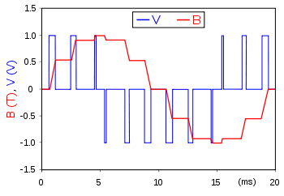](https://en.wikipedia.org/wiki/File:PWM,_3-level.svg)

**Pulse-width modulation (PWM), or pulse-duration modulation (PDM), is a**[**modulation**](https://en.wikipedia.org/wiki/Modulation)**technique used to encode a**[**message**](https://en.wikipedia.org/wiki/Message)**into a**[**pulsing signal**](https://en.wikipedia.org/wiki/Pulse_(signal_processing))**. Although this modulation technique can be used to encode information for transmission, its main use is to allow the control of the power supplied to electrical devices, especially ,In addition, PWM is one of the two principal algorithms used in**[**photovoltaic**](https://en.wikipedia.org/wiki/Photovoltaic)**solar battery chargers,**[**[1]**](https://en.wikipedia.org/wiki/Pulse-width_modulation#cite_note-1)**the other being**[**maximum power point tracking**](https://en.wikipedia.org/wiki/Maximum_power_point_tracking)**.**

The average value of [voltage](https://en.wikipedia.org/wiki/Volt) (and [current](https://en.wikipedia.org/wiki/Electric_current)) fed to the [load](https://en.wikipedia.org/wiki/Electrical_load) is controlled by turning the switch between supply and load on and off at a fast rate. The longer the switch is on compared to the off periods, the higher the total power supplied to the load.

The PWM switching frequency has to be much higher than what would affect the load (the device that uses the power), which is to say that the resultant waveform perceived by the load must be as smooth as possible. The rate (or frequency) at which the power supply must switch can vary greatly depending on load and application, for example

Switching has to be done several times a minute in an electric stove; 120 [Hz](https://en.wikipedia.org/wiki/Hertz) in a lamp dimmer; between a few kilohertz (kHz) and tens of kHz for a motor drive; and well into the tens or hundreds of kHz in audio amplifiers and computer power supplies.

The term [duty cycle](https://en.wikipedia.org/wiki/Duty_cycle) describes the proportion of 'on' time to the regular interval or 'period' of time; a low duty cycle corresponds to low power, because the power is off for most of the time. Duty cycle is expressed in percent, 100% being fully on.

The main advantage of PWM is that power loss in the switching devices is very low. When a switch is off there is practically no current, and when it is on and power is being transferred to the load, there is almost no voltage drop across the switch. Power loss, being the product of voltage and current, is thus in both cases close to zero. PWM also works well with digital controls, which, because of their on/off nature, can easily set the needed duty cycle.

PWM has also been used in certain [communication systems](https://en.wikipedia.org/wiki/Signalling_(telecommunication)) where its duty cycle has been used to convey information over a communications channel.

**CHAPTER 3**

**CIRCUIT DIAGRAM &WORKING**

**3.1 TRANSMITTER CIRCUIT**

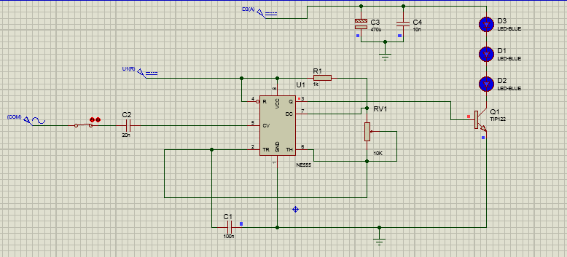

**Fig.3.1.1 *Li-Fi* Audio Transmitter Circuit**

# **3.2 CIRCUIT WORKING**

# In The Ne555 there in pin 5 a VCO a voltage Controlled Oscillator which basically Turn the amplitude of the sine wave into the width of the pulse as it’s shown in the oscilloscope:

# 

**Fig.3.1.1 *Li-Fi* Audio Transmitter Circuit**

# The Capacitors C3, C4 are filters to reduce AC components spike in circuit.. The width of the pulse wave is controlled by the Input signal Frequency. The Pulse signal is equivalent to the ON/OFF Signal in the Output pin 3 which control the intensity of the Light Source LED (D1)(D2)(D3). The Pulse wave is further Amplified and Modulated using Transistor TIP121 (T1), which is an Amplifier Modulator having high current gain. The transistor will act as a Lamp Driver and drives the LED. LED emits light according to the pulse wave form and make VLC (Visible light Communication)

# The resistor RV1 changes the frequency in the output so it changes the time of on/off signal, for the project we know that the human ear can only hear between 100 hz – 20khz so we are using the carrier frequency wave above 20 khz and by the way only hear the Audio source.

# **3.3 CIRCUIT COMPONENTS:**

# The Basic Components of the Transmitter Circuits are

# ➢ Power Supply (5V Supply) and (12V Supply for the LED)

# ➢ Capacitors

# ➢ Resistors

# ➢ NE555 IC

# ➢ Potentiometer (Change the frequency of the oscillator)

# ➢ Light Source – 1W LED (or Three led In series)

# **3.3.1 CAPACITORS**

# 

# Related image

**Fig.3.3.2.1 Capacitor**

A capacitor is a two-terminal, electrical component. Along with resistors and inductors,

they are one of the most fundamental passive components we use. What makes capacitors

special is their ability to store energy**;** they‟re like a fully charged electric battery*.* Caps, as we

usually refer to them, have all sorts of critical applications in circuits. Common applications

include local energy storage. Capacitance is its Unit**.** Not all capacitors are created equal. Each

capacitor is built to have a specific amount of capacitance. The capacitance of a capacitor tells

you how much charge it can store**,** more capacitance means more capacity to store charge. The

standard unit of capacitance is called the farad**,** which is abbreviated F. It turns out that a farad

is a lot of capacitance, even 0.001F (1 milli farad – 1mF) is a big capacitor. Usually we‟ll see

capacitors rated in the Pico- (10-12) to microfarad (10-6) range.

**3.3.2 RESISTORS**

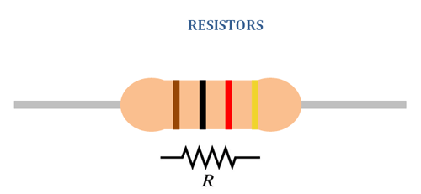

**Fig.3.3.3.1 Resistors**

Resistors are the most commonly used component in electronics and their purpose is

to create specified values of current and voltage in a circuit. The unit for measuring resistance

is the OHM. (The Greek letter Ω - called Omega). Higher resistance values are represented by

"k" (kilo-ohms) and M (Mega ohms).

Resistance value is marked on the resistor body. Most resistors have 4 bands. The first

two bands provide the numbers for the resistance and the third band provides the number of

# zeros. The fourth band indicates the tolerance. Tolerance values of 5%, 2%, and 1% are used.

# **3.3.4 POTENTIOMETER**

# 

**Fig.3.3.5.1 Potentiometer**

A potentiometer, informally a pot, is a three-terminal resistor with a sliding or rotating

contact that forms an adjustable voltage divider. If only two terminals are used, one end and

the wiper, it acts as a variable resistor or rheostat.

The measuring instrument called a potentiometer is essentially a voltage divider used

for measuring electric potential (voltage); the component is an implementation of the same

principle, hence its name.

Potentiometers are commonly used to control electrical devices such as volume controls

on audio equipment. Potentiometers operated by a mechanism can be used as position

transducers .

# **3.3.5 LIGHT SOURCE – LED**

# 

**Fig.3.3.7.1 LED**

The most important requirement that a light source has to meet in order to serve

communication purposes is the ability to be switched on and off repeatedly in very short

intervals. By utilizing the advantage of fast switching characteristics of LED‟s compared with

the conventional lightning, the LED illumination is used as a communication source. Since the illumination exists everywhere, it is expected that the LED illumination device will act as a lighting device and a communication transmitter simultaneously everywhere in a near future.

Typically, red, green, and blue LEDs emit a band of spectrum, depending on the material

system. The white LED draws much attention for the illumination devices. Comparing the

LED illumination with the conventional illumination design flexibility, long lifetime, and better spectrum performance.

LEDs emit light when energy levels change in the semiconductor diode. This shift in

energy generates photons, some of which are emitted as light. The specific wavelength of the

light depends on the difference in energy levels as well as the type of semiconductor material

used to form the LED chip. Solid-state design allows LEDs to withstand shock, vibration,

frequent switching (electrical on and off shock) and environmental (mechanical shocks)

extremes without compromising their famous long life typically 100,000 hours or more.

The basic LED consists of a semiconductor diode chip mounted in the reflector cup of a

lead frame that is connected to electrical (wire bond) wires, and then encased in a solid epoxy lens.

# Image result for ne555**3.3.6 NE555 Astable Mode :**

**Fig.3.3.7.1 NE555**

# The **555** timer IC is an integrated circuit (chip) used in a variety of timer, pulse generation, and oscillator applications. The **555** can be used to provide time delays, as an oscillator, and as a flip-flop element.

# An **Astable Multivibrator** is the **multivibrator** which has no stable states. Its output oscillates continuously between its two unstable states without the aid of external triggering. The time period of each states are determined by Resistor Capacitor ( RC ) time constant.

# This circuit is an **astable multivibrator**, or oscillator. The two transistors are cross-coupled in such a way that the circuit switches back and forth between two states. In one state, the base of Q1 is about one diode drop above ground, allowing a base current to flow.

# **3.4 RECIEVER CIRCUIT:**

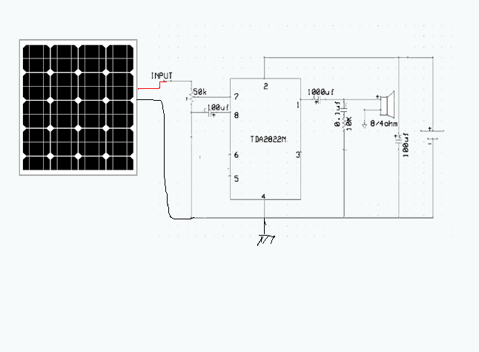

**Fig.3.4.1 Receiver Circuit**

**3.5 CIRCUIT WORKING**

The Solar cell is used to detect the Light from the Transmitting LEDs. And it produces

an Analog output corresponding to the input signal. The frequency of the analog will be same

as that of input signal, since the flickering of LED is controlled by the input signal and solar

cell detects only the fluctuation in the LED signal and produces the output. The output is then

amplified using TDA22. It also helps in removing any phase changes occurs in the transmitted signal. And then filtered to remove any other light room about 60hz high pass filter The Amplified signal is fed to the speaker. The speaker converts the analog signal to the

Audible Sound signal using the electromagnet present in the Speaker.

**3.6 CIRCUIT COMPONENTS**

The basic Components of the Receiver Circuits are:

• Photo Detector – Solar cell

• TDA2822n

• Speaker 4 ohm 1 w

• Capacitor

• Variable Resistance

• 9v battery or any power supply

**3.6.1 PHOTO DETECTOR – SOLAR CELL**

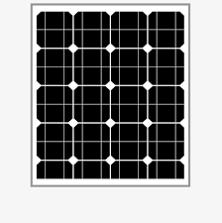

**Fig.3.6.1.1 Solar Cell**

A Solar cell is an electrical device that converts the energy of Light Directly to electric signal

or analog signal by the photovoltaic effect, which is a chemical physical phenomenon. When

photons are strikes on its walls electron flow occurs which will store as electrical energy. It

have slower Time response as their area increases. Solar cells are formed connecting large

Number of Photo Detectors connected in series. It works in the Reverse Biased Mode.

Usually the Efficiency of solar cell is Low. Even though it regarded as Green Technology.

**3.6.2 SPAKER**

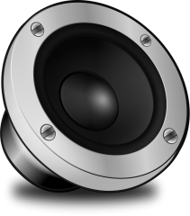 

**Fig.3.6.2.1 Speaker**

In this project we use Speaker which has in-built Amplifier, which Amplifies the

Analog signal received from the output of the Solar cell. It also helps to remove any phase

errors that may occurred during the Transmitting or Processing of the input signal. The main

Function of a speaker is to convert Electrical or Analog Signals in to the Audible form to reach the Receptor.

It converts the sound signal with the help of Electromagnets Present in the

# Speaker. Hence the Receptor Receive the input that has been transmitted from the Transmitter.

**3.6.3 TDA 2822N:**

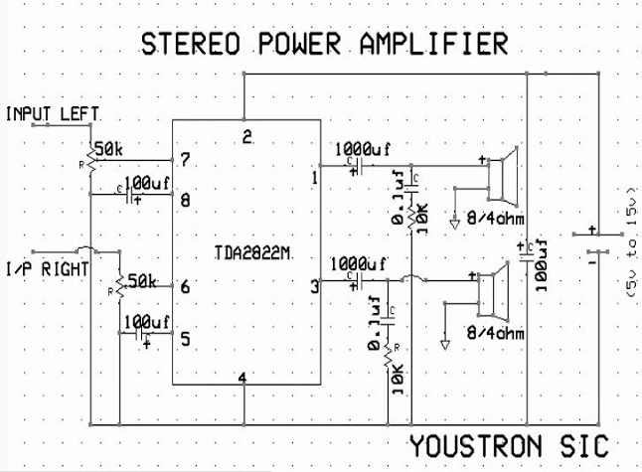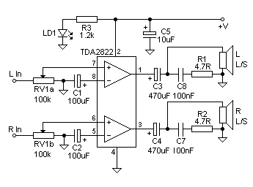

# The TDA2822M is a monolithic integrated circuit in 8 lead Minidip package. It is intended for use as dual audio power amplifier in portable cassette players and radios.

# **3.7 THE PCB LAYOUT**

# **3.7.1 PCB DESIGN**

# **-** Design of printed circuit board (PCB) can be considered as the last step in electronic circuit design as well as the first step in production. It plays important role in the performance and reliability of electronic circuits, the productivity of the PCB‟s its assembling, and its service ability depends on design. All these factors get reflected in a piece of electronic equipment. It is clear that task of PCB design is not very simple or always straight forward. The schematic is follower by layout generation. Layout design is the stage where engineering capacity combined with creativity is the governing inputs.

# **3.7.2 ELECTRONIC DESIGN AUTOMATION TOOLS**

# Most product testing is being done is done with the help of computer programs. The term Electronic Design Automation (EDA) is being used to describe the use of these tools. With the help of advanced powerful computing systems and interactive software tools and development of electronic circuits has undergone automation. Thus the software and hardware tools, which enables this automation includes PCB designing, IC design, circuit simulation etc. These tools help us in such a way that we can draw the circuit; test the functioning of the circuit in response to test inputs in simulation software. After successfully simulation we can get the PCB art work done by replacing the routing software. The design automation tool used here is ORCAD.

# **3.7.3 PCB DESIGN PROCEDURES**

# The PCB designing procedure consists of following steps:

# **3.7.3.1 DRAWING THE CIRCUIT SCHEMATIC** Drawing of circuit is done through ORCAD CAPTURE. It includes many libraries with thousands of component symbols. We can select the required symbol from the library and place it in the schematic page. After placing the component symbols, we can complete the interconnection using wire or bus control. 18 The next step is to assign part reference. Each component has to be assigned footprint or PCB pattern name. The footprint gives the actual size physical representation of components on the PCB artwork. The component symbol and foot symbol should correspond in all respects.

# **3.7.3.2 DESIGN RULE CHECK AND NET LIST CREATION**

# After the circuit schematic is completed with all required information such as part reference and footprints, the design rule check can be used for checking errors in the design. It will check for duplicate symbols, overlapped lines and dangling lines. After the schematic design file passes the DRC check, it is processed by a program called an electric rule checker (ERC) that checks for writing errors. The final operation to be done before starting PCB artwork is the net list creation. A net list creation of the components and interconnection along with other information such as foot prints, track width etc. A net list software or tool can take the circuit schematic as input and generate net list. The net list can be used as an information source for the remaining stages.

# **3.7.3.3 CREATING THE PCB ARTWORK**

# In automatic design, the net list obtained from the previous stage is used for getting the required foot print and interconnections. The software used for the PCB artwork design in the ORCAD LAYOUT.

# **3.7.3.7 SOLDERING** Soldering is the joining together of two metals to give physical bonding and good electrical conductivity. It is used primarily in electrical and electronic circuitry. Solder is a combination of metals, which are solid at normal room temperatures and become liquid between 180 and 200 degree Celsius. Solder bonds well to various metals, and extremely well to copper. Soldering is a necessary skill you need to learn to successfully build electronics circuits.

# To solder you need a soldering iron. A modern basic electrical soldering iron consists of a heating element, a soldering bit (often called a tip), a handle and a power cord.

# The heating element can be either a resistance wire wound around a ceramic tube, or a thick film resistance element printed on to a ceramic base.

# The element is then insulated and placed into a metal tube for strength and protection. This is then thermally insulated from the handle.

# The heating element of soldering iron usually reaches temperatures of around 370 to 400 degree Celsius (higher than need to melt the solder). The strength or power of a soldering iron is usually expressed in watts.

# Irons generally used in electronics are typically in the range of 12 to 25 watts.

# Higher powered iron will not run hotter. Most irons are available in a variety of voltages; 12V, 24V, 115V and 230V are most popular. Today most laboratories and repair shops use soldering irons, which operate at 24V.

# You should always use this low voltage where possible, as it is much safer. For advanced soldering work, you will need a soldering iron with temperature control.

# In this type of soldering irons, the temperature may be usually set between 200 and 450 degree Celsius. Many temperature control soldering iron designed for electronics have a power rating of around 40 to 50 watt.

# They will heat fast and give enough power for operation, but are mechanically small. You will occasionally see gas-powered soldering irons which use butane rather than the main electrical supply to operate. They have a catalytic element which once warmed up, continues to glow hot when gas passes over them. Gas powered soldering irons are designed for occasional „on the spot‟ used for quick repairs, rather than for main stream construction or for assembly work. Currently, the best commonly available, workable, and safe solder alloy is 63/37. That is, 63% lead, 37% tin. It is also known as eutectic solder. Its most desirable characteristic is that it solids („pasty‟) state, and its liquid state occur at the same temperature -361 degree 22 Fahrenheit. The combination of 63% lead and 37% tin melts at the lowest possible temperature. Nowadays there is tendency to move to use lead free solders, but it will take years until they catch on normal soldering work. Lead free solders are nowadays available, but they are generally more expensive or harder to work on than traditional solders that they have lead in them.

# The metals involved are not the only things to consider in a solder. Flux is vital to a good solder joint. Flux is an aggressive chemical that removes oxide and impurities from the parts to be soldered.

# The chemical reactions at the point(s) of connection must take place for the metal to fuse. RMA type flux (Rosin Mildly Active) is the least corrosive of the readily available materials, and provides an adequate oxide.

# In electronics, a 60/40 fixed core solder is used. This consists of 60% lead and 40% tin, with flux cores added to the length of solder. There are certain safety measures which you should keep in mind when soldering.

# The tin material used in soldering contains dangerous substances like lead (40-60% of typical soldering tins are lead and lead is poisonous). Also the various fumes from the soldering flux can be dangerous. While it is true that lead does not vaporize at the temperature at which soldering is typically done. When soldering, keep the room well ventilated and use a small fan or fume trap.

# A proper fume trap of a fan will keep the most pollution away from your face. Professional electronic workshops use expensive fume extraction systems to protect their workers. Those fume extraction devices have a special filter which filters out the dangerous fumes. If you can connect a duct to the output from the trap to the outside, that would be great. Always wash hands prior to smoking, eating, drinking or going to the bathroom. When you handle soldering tin, your hands will pick up lead, which needs to be washed out from it before it gets to your body. Do not eat, drink or smoke while working with soldering iron.

# ‘Do not place cups, glasses or a plate of food near your working area ‘

# 

# **Emitter Circuit :**

# 

# 

# 

# **CHAPTER 4**

# **Result:**

# **4.1 Emitter Circuit:**

# **4.1.1 on the Breadboard:**

# <Here the circuit tested first in the breadboard and some of the values of the circuit Components have been change.>

# 

# **4.1.2 First circuit Solder (test):**

# 

# **4.1.3 Second attempted Make the circuit fit in a light bulb:**

# 

# 

# **<I replace the 3 led with one 1 watt led >**

# 

# **4.2 Receiver Circuit:**

# **4.2.1 on the Breadboard:**

# 

# **4.2.2 Front view of the circuit:**

# 

# **4.2.3 Backward view of the circuit:**

# 

# **4.2.4 Signal in the Reception side Shown with the oscilloscope:**

# 

# 

# **Final Result:**

# 

# **https://www.youtube.com/watch?v=5GwjK__0OWA**

# **5.1 ADVANTAGES**

# *Li-Fi* technology is based on LEDs or other light source for the transfer of data. The transfer of the data can be with the help of all kinds of light, no matter the part of the spectrum that they belong. That is, the light can belong to the invisible, ultraviolet or the visible part of the spectrum. Also, the speed of the communication is more than sufficient for downloading movies, games, music and all in very less time. Also, *Li-Fi* removes the limitations that have been put on the user by the *Wi-Fi*.

# **5.1.1 CAPACITY** Light has 400 times wider bandwidth than radio waves. Also, light sources are already installed. So, *Li-Fi* has got better capacity and also the infrastructures are already available.

# **5.1.2 EFFICIENCY** Data transmission using *Li-Fi* is very cheap. LED lights consume less energy and are highly efficient and long lasting.

# **5.1.3 AVAILABILITY** Availability is not an issue as light sources are presents everywhere. There are billions of light bulbs worldwide, They just need to be replaced with LEDs for proper transmission of data.

# **5.1.4 SECURITY** Light waves do not penetrate through walls. So, they can„t be intercepted and misused.

# **5.1.5 NO LIMIT FOR CONNECTIVITY** The High speed capability of *Li-Fi* enables large number users can be connected, since speed will not be throttled or slowed down. 27

# **5.2 LIMITATIONS**

# The major Limitations of this technology are:

# **5.2.1 *Li-Fi* CANNOT PENETRATE THROUGH WALLS**

# The artificial light cannot penetrate into walls and other opaque materials which radio waves can do. So a *Li-Fi* enabled end device (through its inbuilt photo-receiver) will never be as fast and handy as a *Wi-Fi* enabled device if any obstacle is present between Transmitter and Reciever.

# **5.2.2 REQUIRES LoS.**

# To function *Li-Fi* with full efficiency, It Requires Line of Sight. That is the Transmitter Antenna and Receiver Antenna should be in a line (Face to Face). Still, *Li-Fi* could emerge as a boon to the rapidly depleting bandwidth of radio waves. And it will certainly be the first choice for accessing internet in a confined room at cheaper cost.

# **5.3 APPLICATIONS**

# There are numerous applications of this technology, from public internet access through street lamps to auto-piloted cars that communicate through their headlights. Applications of *Li-Fi* can extend in areas where the *Wi-Fi* technology lacks its presence like medical technology, power plants and various other areas. Since *Li-Fi* uses just the light, it can be used safely in aircrafts and hospitals where *Wi-Fi* is banned because they are prone to interfere with the radio waves. All the street lamps can be transferred to *Li-Fi* lamps to transfer data. As a result of it, it will be possible to access internet at any public place and street. Some of the future applications of *Li-Fi* are as follows

# **5.3.1 EDUCATION SYSTEMS**

# *Li-Fi* is the latest technology that can provide fastest speed internet access. So, it can replace *Wi-Fi* at educational institutions and at companies so that all the people can make use of *Li-Fi* with the same speed intended in a particular area. 28

# **5.3.2 MEDICAL APPLICATIONS**

# Operation theatres (OTs) do not allow *Wi-Fi* due to radiation concerns. Usage of *Wi-Fi* at hospitals interferes with the Mobile and PC which blocks the signals for monitoring equipments. So, it may be hazardous to the patient's health. To overcome this and to make OT tech savvy *Li- Fi* can be used to accessing internet and to control medical equipments. This can even be beneficial for robotic surgeries and other automated procedures.

# **5.3.3 CHEAPER INTERNET IN AIRCRAFTS**

# The passengers travelling in aircrafts get access to low speed internet at a very high rate. Also *Wi-Fi* is not used because it may interfere with the navigational systems of the pilots. In aircrafts *Li-Fi* can be used for data transmission. *Li-Fi* can easily provide high speed internet via every light source such as overhead reading bulb, etc. present inside the airplane.

# **5.3.4 UNDERWATER APPLICATIONS**

# Underwater ROVs (Remotely Operated Vehicles) operate from large cables that supply their power and allow them to receive signals from their pilots above. But the tether used in ROVs is not long enough to allow them to explore larger areas. If their wires were replaced with light say from a submerged, high-powered lamp then they would be much freer to explore. They could also use their headlamps to communicate with each other, processing data autonomously and sending their findings periodically back to the surface. *Li-Fi* can even work underwater where *Wi-Fi* fails completely, thereby throwing open endless opportunities for military operations**.**

# **5.3.5 DISASTER MANAGEMENT**

# *Li-Fi* can be used as a powerful means of communication in times of disaster such as earthquake or hurricanes. The average people may not know the protocols during such disasters. Subway stations and tunnels, common dead zones for most emergency communications, pose no obstruction for *Li-Fi*. Also, for normal periods, *Li-Fi* bulbs could provide cheap high-speed Web access to every street corner. 29

# **5.3.6 APPLICATIONS IN SENSITIVE AREAS**

# Power plants need fast, inter-connected data systems so that demand, grid integrity and core temperature (in case of nuclear power plants) can be monitored. *Wi-Fi* and many other radiation types are bad for sensitive areas surrounding the power plants. *Li-Fi* could offer safe, abundant connectivity for all areas of these sensitive locations. This can save money as compared to the currently implemented solutions. Also, the pressure on a power plant’s own reserves could be lessened. *Li-Fi* can also be used in petroleum or chemical plants where other transmission or frequencies could be hazardous.

# **5.3.7 TRAFFIC MANAGEMENT**

# In traffic signals *Li-Fi* can be used which will communicate with the LED lights of the cars which can help in managing the traffic in a better manner and the accident numbers can be decreased. Also, LED car lights can alert drivers when other vehicles are too close.

# **5.3.8 REPLACEMENT FOR OTHER TECHNOLOGIES**

# *Li-Fi* doesn’t work using radio waves. So, it can be easily used in the places where Bluetooth, infrared, *Wi-Fi*, etc. are banned.

# **CHAPTER 6 CONCLUSION**

# The possibilities are numerous and can be explored further. If his technology can be put into practical use, every bulb can be used something like a *Wi-Fi* hotspot to transmit wireless data and we will proceed toward the cleaner, greener, safer and brighter future. The concept of *Li-Fi* is currently attracting a great deal of interest, not least because it may offer a genuine and very efficient alternative to radio-based wireless. As a growing number of people and their many devices access wireless internet, the airwaves are becoming increasingly clogged, making it more and more difficult to get a reliable, high-speed signal. This may solve issues such as the shortage of radio-frequency bandwidth and also allow internet where traditional radio based wireless isn‟t allowed such as aircraft or hospitals. The main shortcoming however is that it only work in direct line of sight.

# **6.1 FUTURE SCOPE**

# By using *Li-Fi* we can have Energy saving Parallelism. With growing number of people and their many devices access wireless internet, on one way data transfer at high speed and at cheap cost. In future we can have LED array beside a motorway helping to light the road, displaying the latest traffic updates and transmitting internet information to wirelessly to passengers Laptops, Notebooks and Smart phones. This is the kind of extra ordinary, energy saving parallelism that is believed to deliver by this pioneering technology. 31