User manual: how to set an alarm

Step1: plug the wire
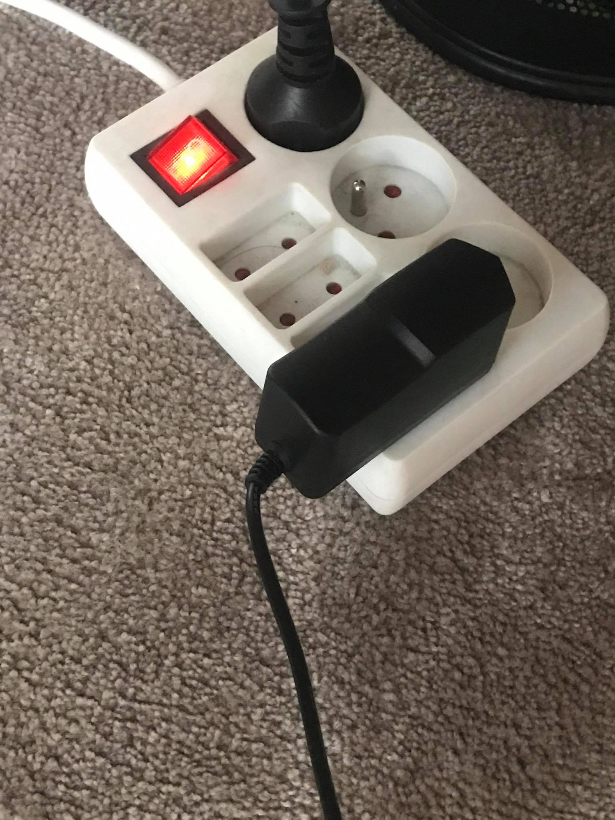
Step2: visit the url
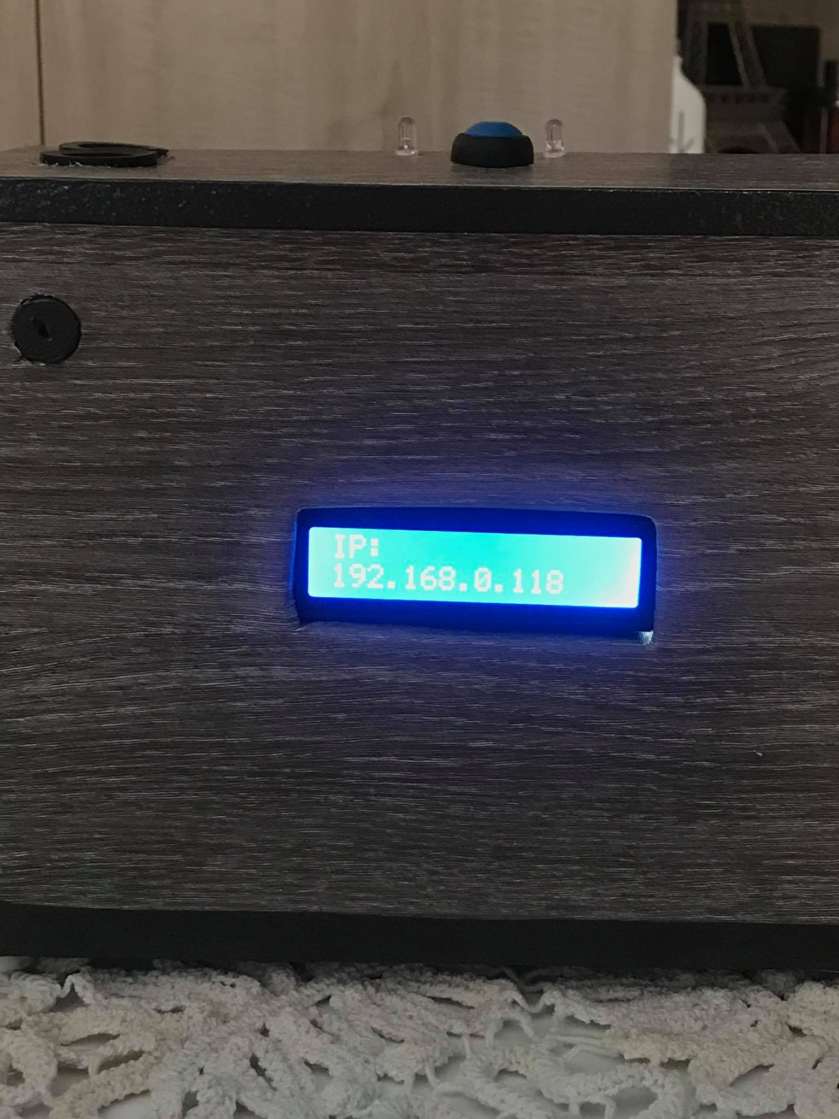
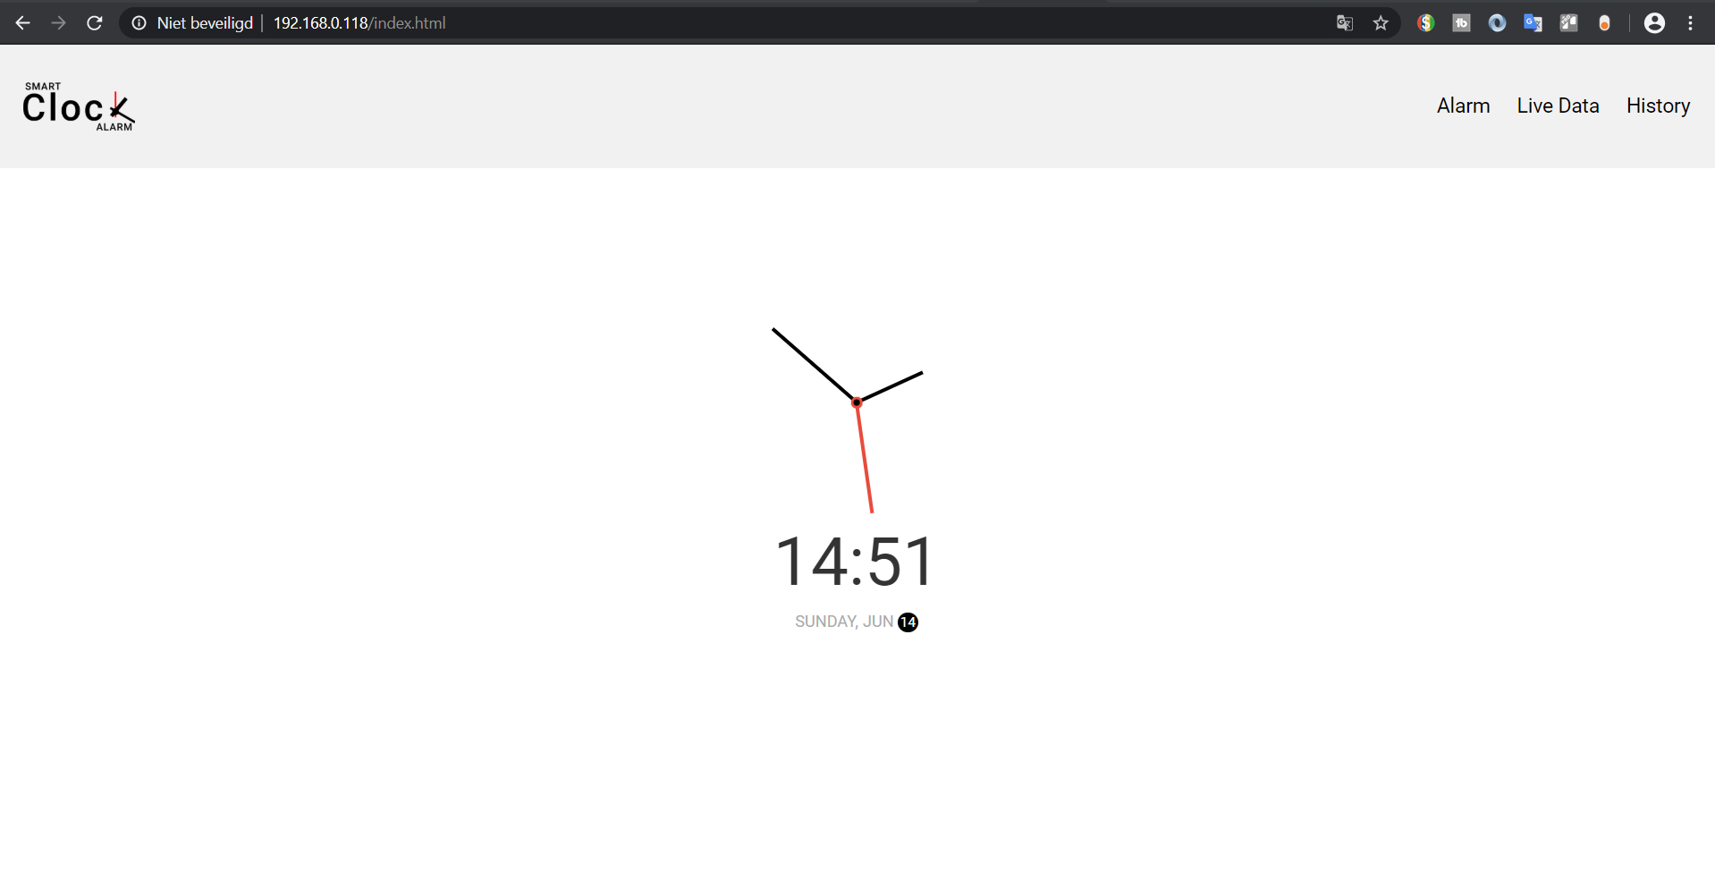
Step 3: go to alarm page and add an alarm
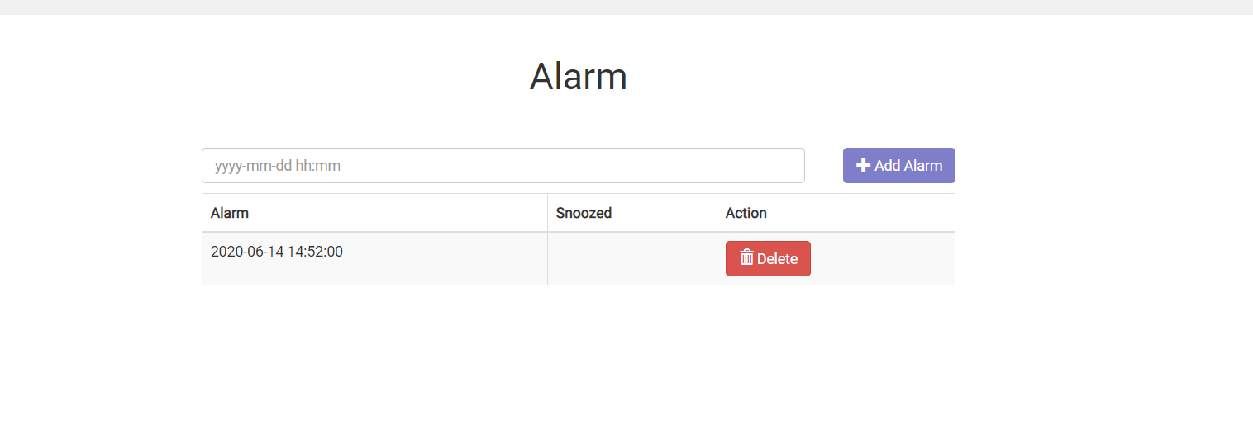

Step4: u can snooze the alarm by hold yr hand above the ultrasonic sensor

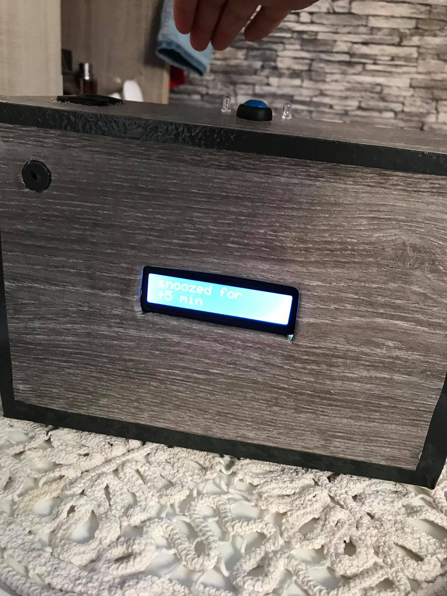

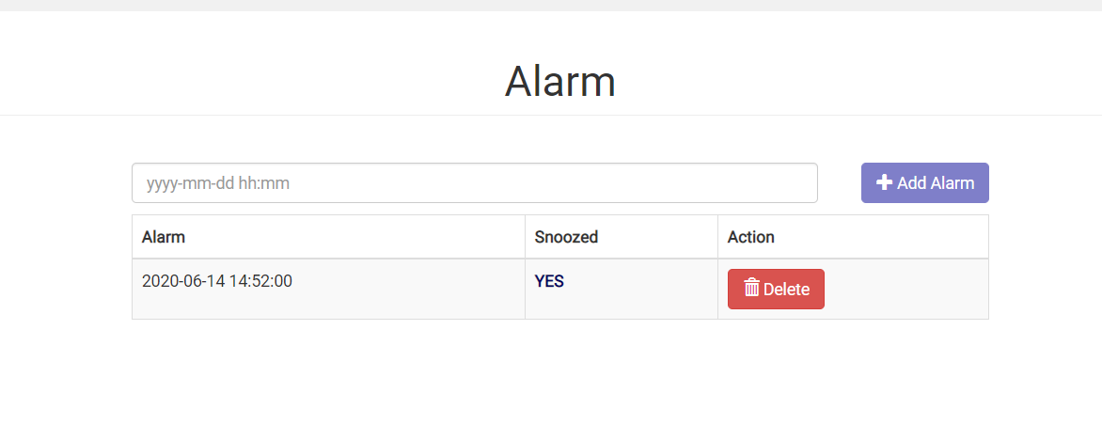

Stap5: u can also diable an alarm by pressing the button
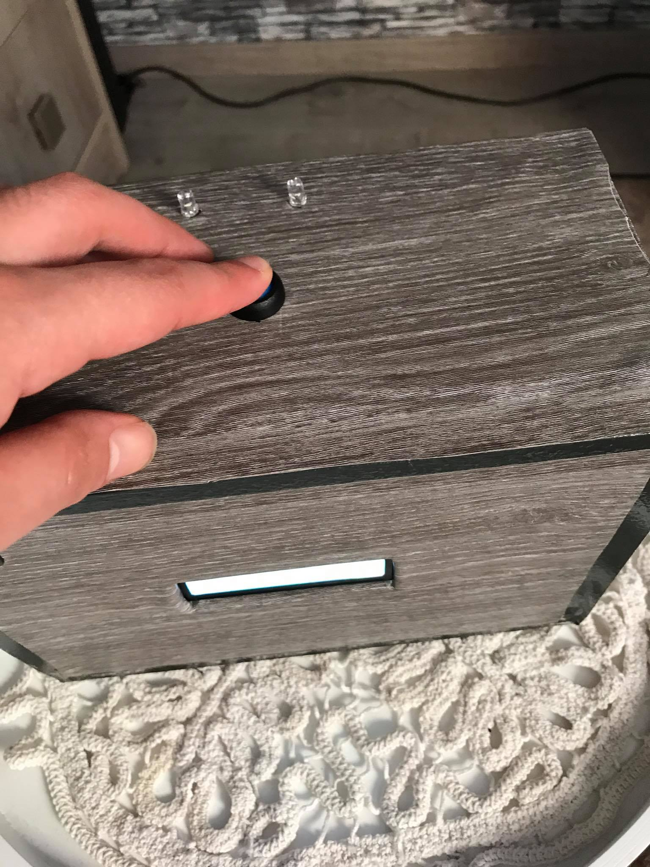essing the button

