Art Contest July 29, 2019
ROCCO
By Connie Gerock 7/28/2019

I haven’t painting in over 40 yrs and decided to attemp a painting of my brothers dog Rocco
I realized I need to practice a lot more and learn depth. I did have fun with this painting.
Hope you find the chaallenge and humor in my funky Rocco painting.

Supplies:

Acrylic paint, Blue, Lt blue, Blue green, Yellow, Off white, Black
A variety of brushes
Ruler the metal with cork backing works the best
Grid formula
Paste
Index cards use these cards helps to highlight the square you are working on
Pallet to mix paints
Water
Paper towel
Qtips
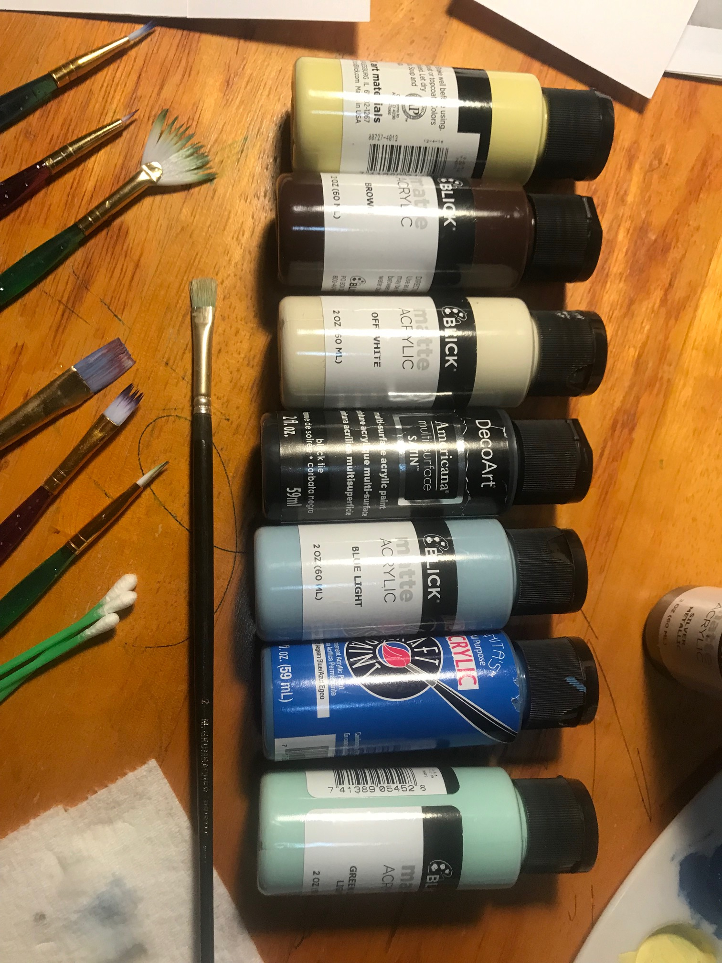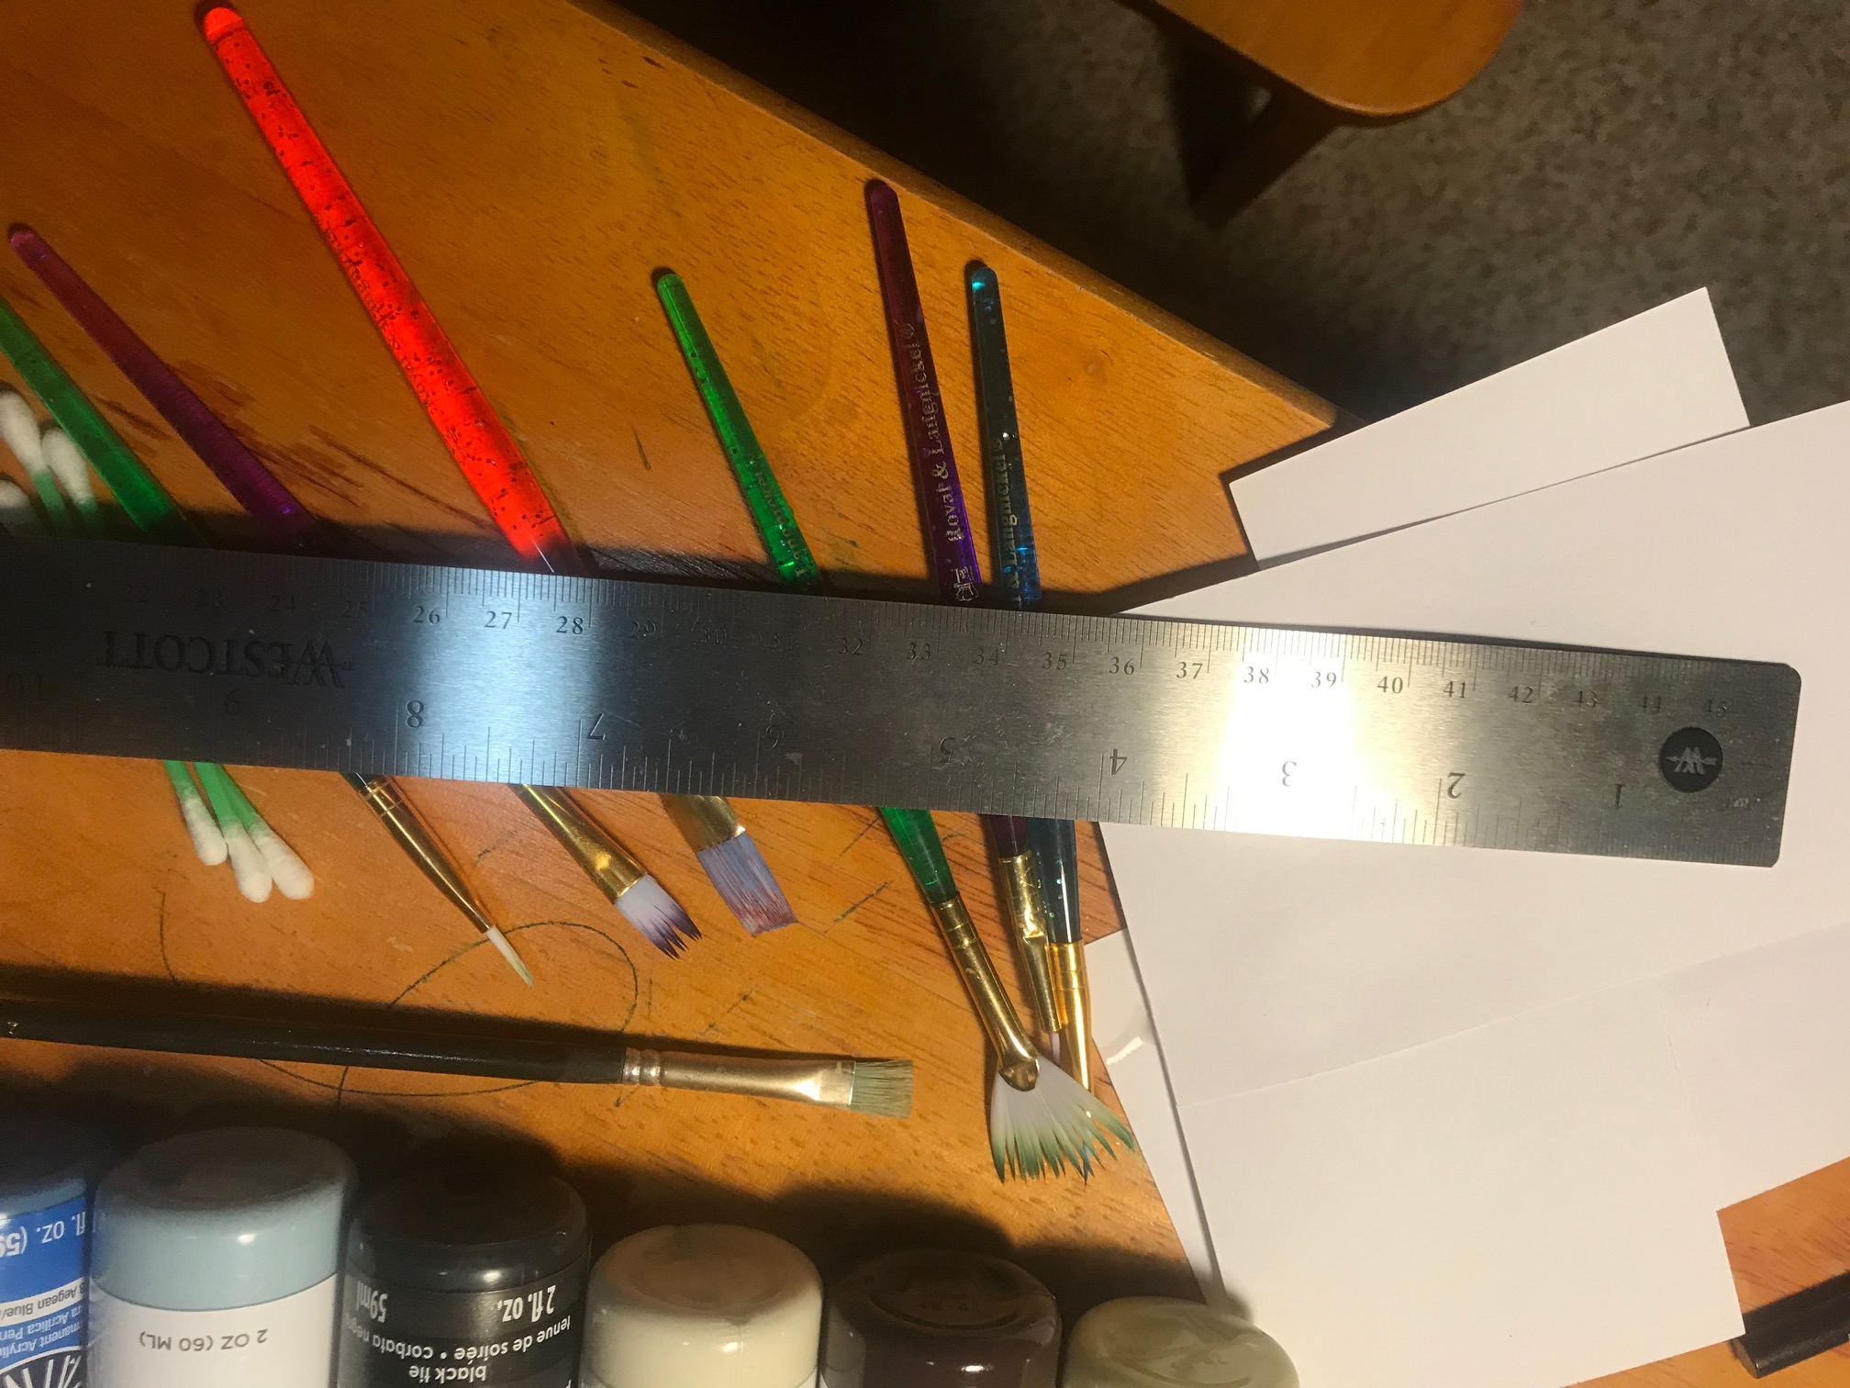

To make the grid:
Original photo is a 4 x 6 I enlarged to a ratio of 3:1
4x3=12
6x3=18
It’s important to have the same number of squares across and down on photo as you do on the canvas.

For this first photo I made the grid lnes on the canvas dark so you can see it. Normally I would make very light so they can be erased.

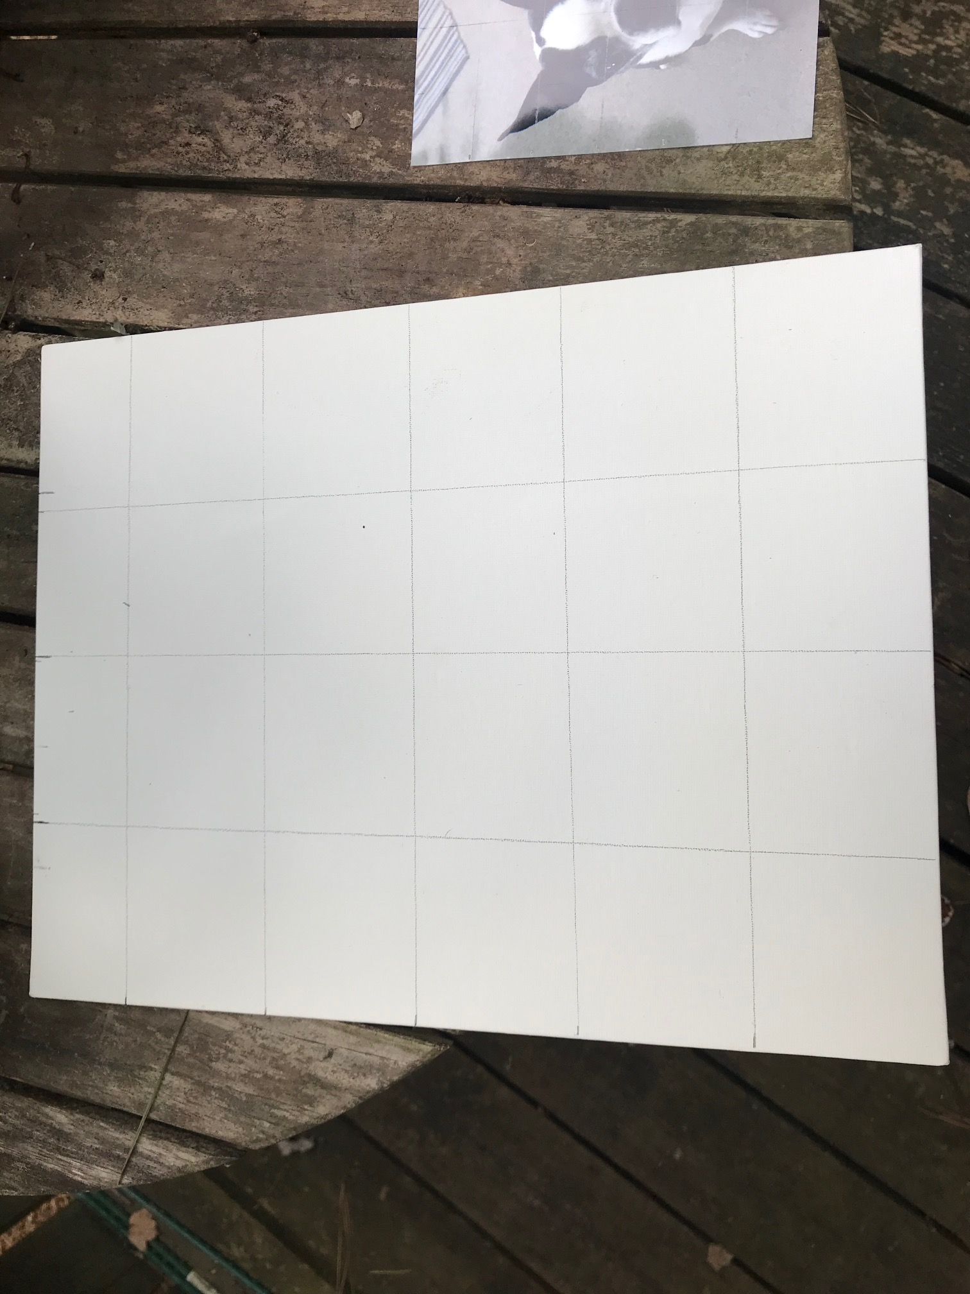

Rough draft of photo

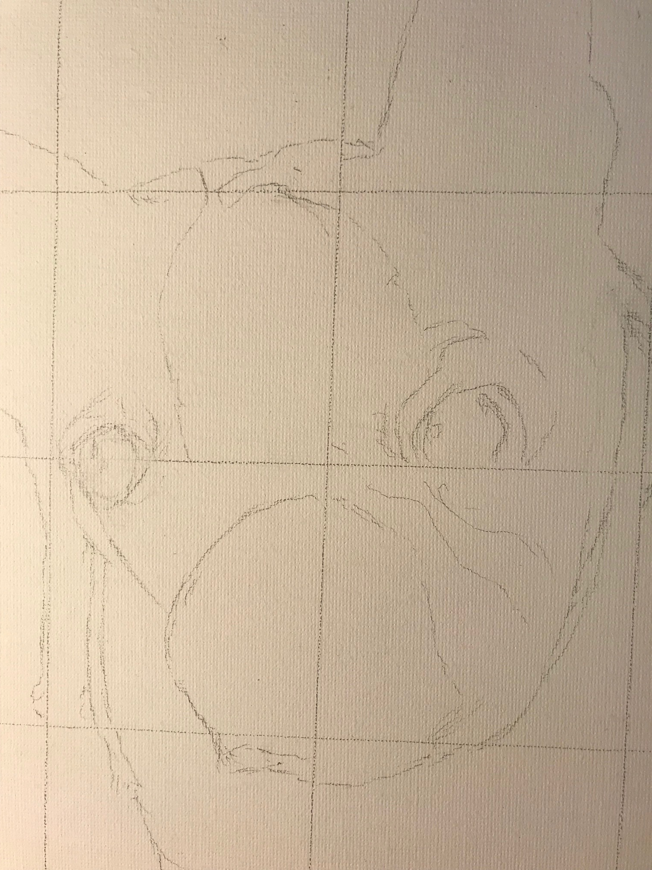
I mixed water with some of the paint, I mixed the light blue with the blue green for some of the shading.

