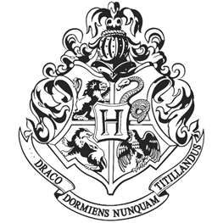

Uniform First-year students will require:

1. Three sets of plain work robes (black)
2. One plain pointed hat (black) for day wear
3. One pair of protective gloves (dragon hide or similar)
4. One winter cloak (black, silver fastenings)

Please note that all pupils' clothes should carry name tags

Set books

All students should have a copy of each of the following:

The Standard Books of Spells (Grade 1) by Miranda Goshawk

A History of Magic by Bathilda Bagshot

Magical Theory by Adalbert Waffling

A Beginners Guide to Transfiguration by Emeric Switch

One Thousand Magical Herbs and Fungi by Phyllida Spore

Magical Drafts and Potions by Arsenius Jigger

Fantastic Beasts and Where to Find Them by Newt Scamander

The Dark Forces: A Guide to Self-Protection by Quentin Trimble

Other equipment

1 wand

1 cauldron (pewter, standard size 2)

1 set glass or crystal phials

1 telescope

1 set brass scales

Students may also bring an owl OR a cat OR a toad

You may find all the books and equipment on Diagon Ally

## PARENTS ARE REMINDED THAT FIRST-YEARS ARE NOT ALLOWED THEIR OWN BROOMSTICKS

Hogwarts School

of Witchcraft and Wizardry

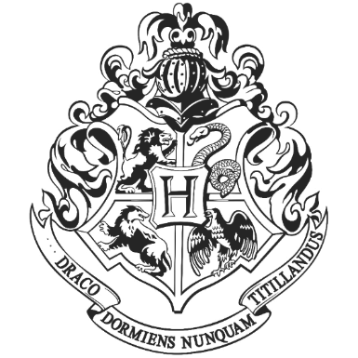

Hogwarts School

of Witchcraft and Wizardry

Headmaster: Albus Dumbledore (Order of Merlin, First Class, Grand Sorcerer, Chief Warlock, Supreme Mugwump, International Confederation of Wizards)

Mr. (Enter name here) (Enter location here) (enter wizard nickname here)

Dear (enter name here)

We are pleased to inform you that you have been accepted at the Hogwarts School of Witchcraft and Wizardry. Students will be required to report to the Chamber of Reception upon arrival. Please find an enclosed list of all necessary books and equipment. Term begins on September 1st. We await your owl by no later than July 31st. To avoid detection by Muggles, please use the entrance located at Kings Cross Station Downtown London, on platform 9¾. We look forward to having you at our school.

Yours Sincerely Minerva McGonagall Deputy Headmistress