How to make a Constellation lace up card using your Cricut

You will need:
- Cricut machine (either Maker or Explore)
- Standard Grip mat
- Black cardstock
- Fine point blade
- Cricut Gold 1.0 Marker pen
- Laptop/ tablet/ phone with access to the internet

- Open Cricut Design Space (design.cricut.com) and open a new canvas. Insert a square, the size depending on how big or small you would like your project to be. The square should be set to ‘cut’.
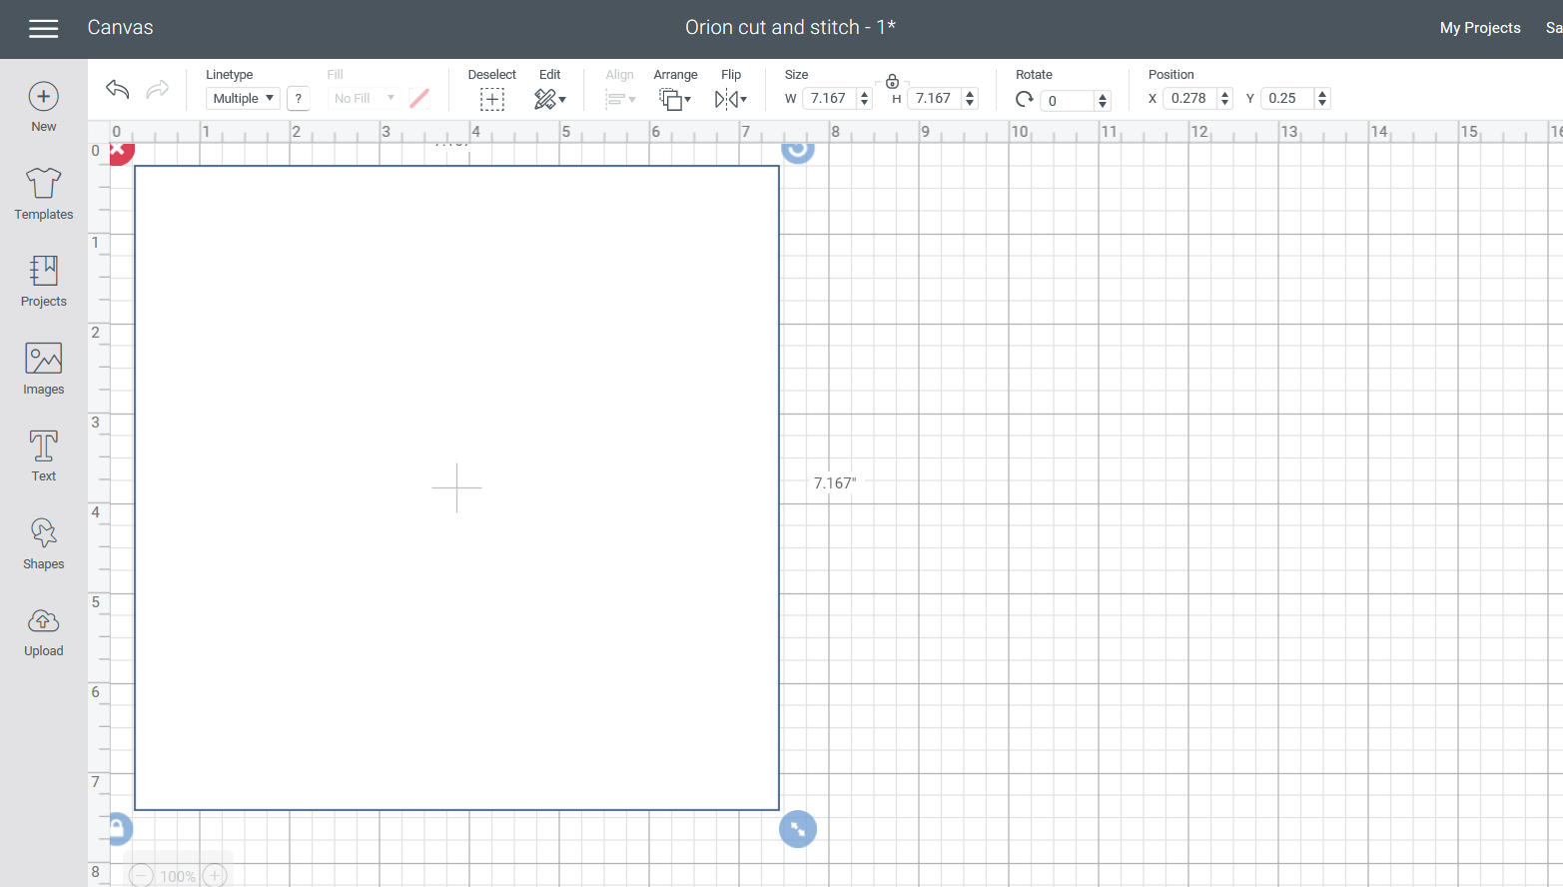

- Using a series of ‘draw’ lines, map out the shape of your constellation.
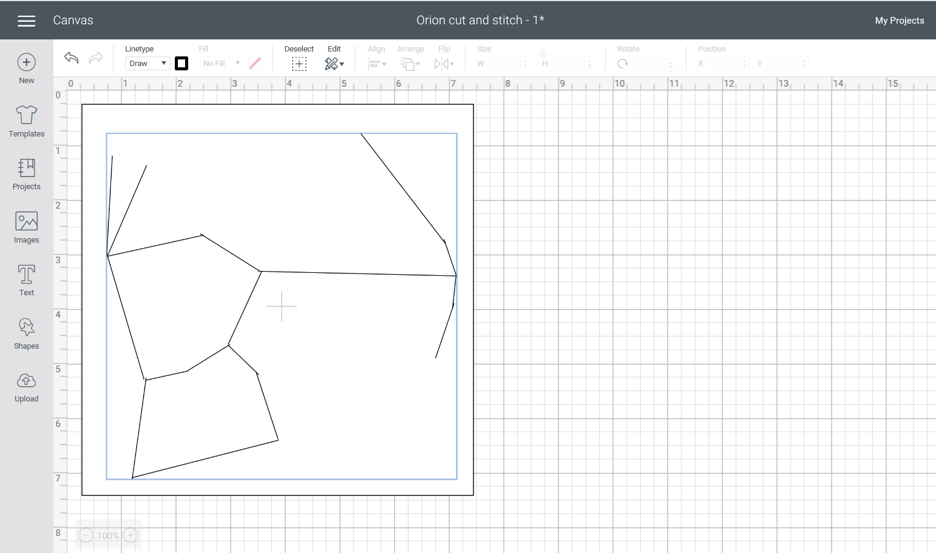

- Using ‘cut’ circles, create the stars at the points of the lines you have drawn. Copying and pasting one hole to make all of them will ensure they are a uniform size.
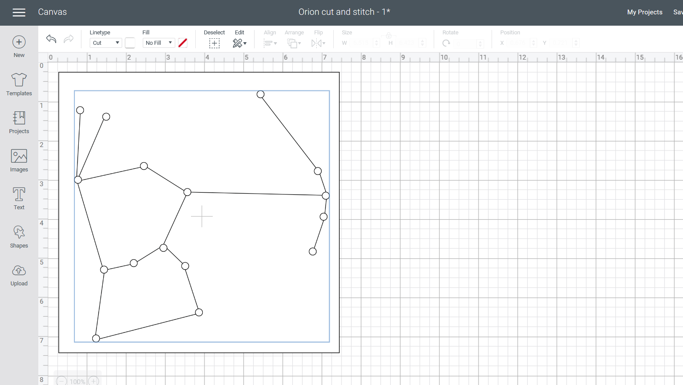

- Add the name of your constellation using the ‘draw’ function.
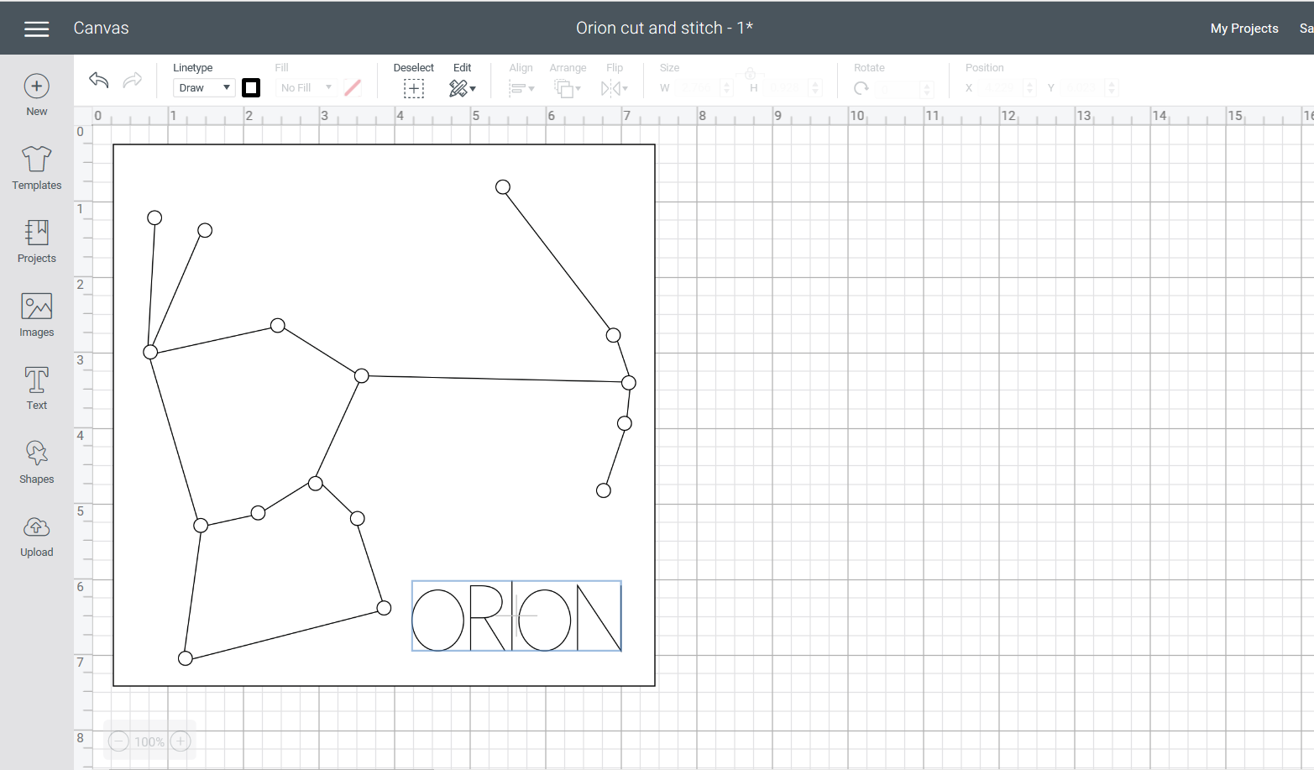

- Hide the drawn lines of your constellation by clicking the eye symbol to the right of your canvas (not pictured). This will give your kids a bit of a challenge as they have to figure out the shape of the constellation on their own!
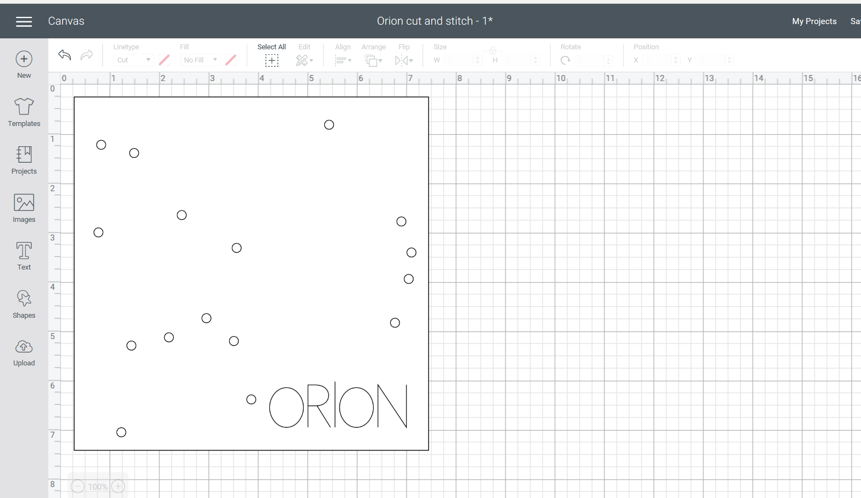

- Make your project by loading black cardstock onto a Standard Grip Cricut mat and following the ‘Make It’ directions on your screen.
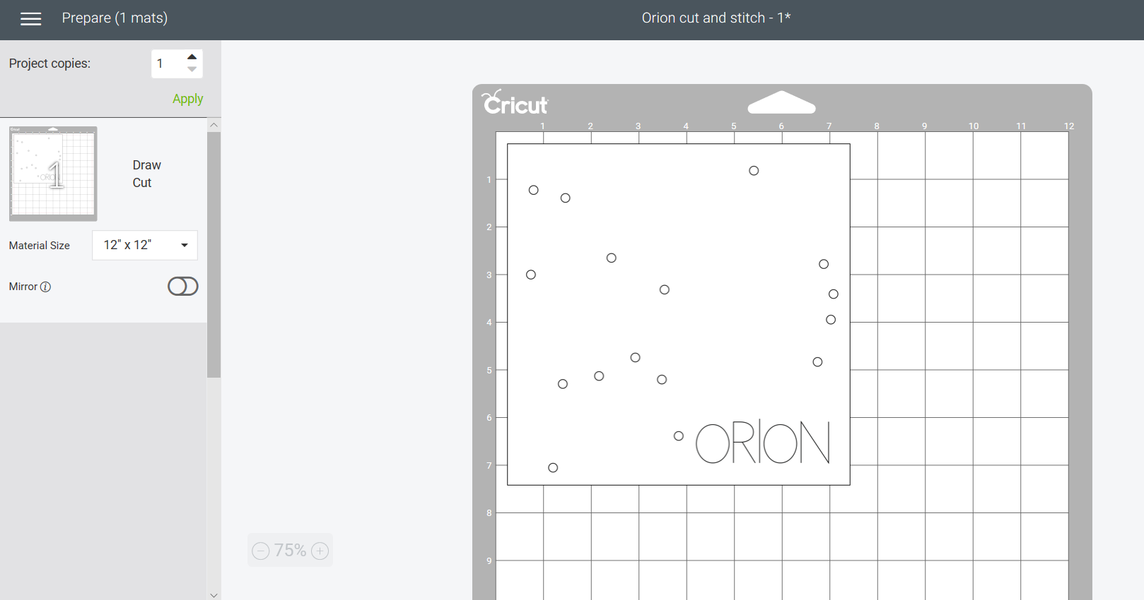

- Connect up your machine. If using a Cricut Maker, select Cardstock from your list of materials. If using a Cricut Explore, turn your dial to Cardstock. You are ready to make your project!

