Skateboard design steps
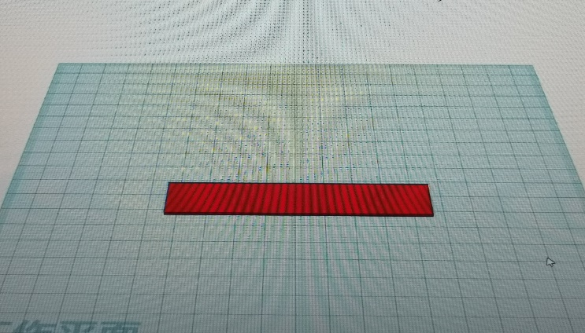
Drag the box to the work plane and set it to 90 lengths, 10 widths, and heights of 1.
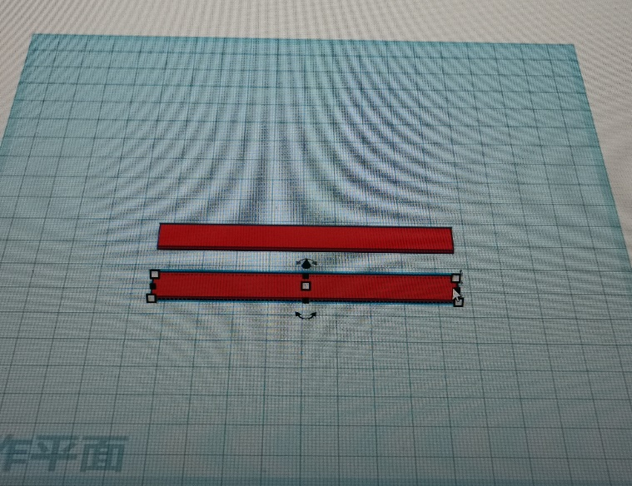
Drag the box to work, set it to 90 lengths, 10 wide, high 1, and copy and paste.
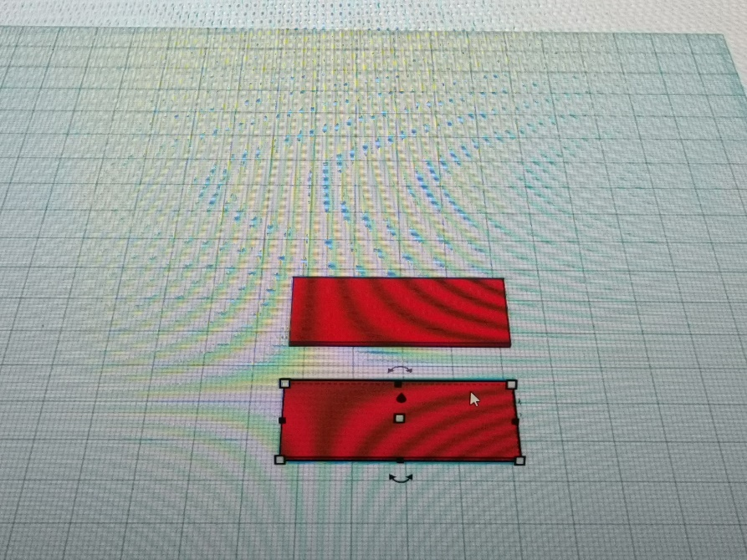
Drag the box to the work plane and set it to 45 lengths, 20 wide, high 1, copy and paste.
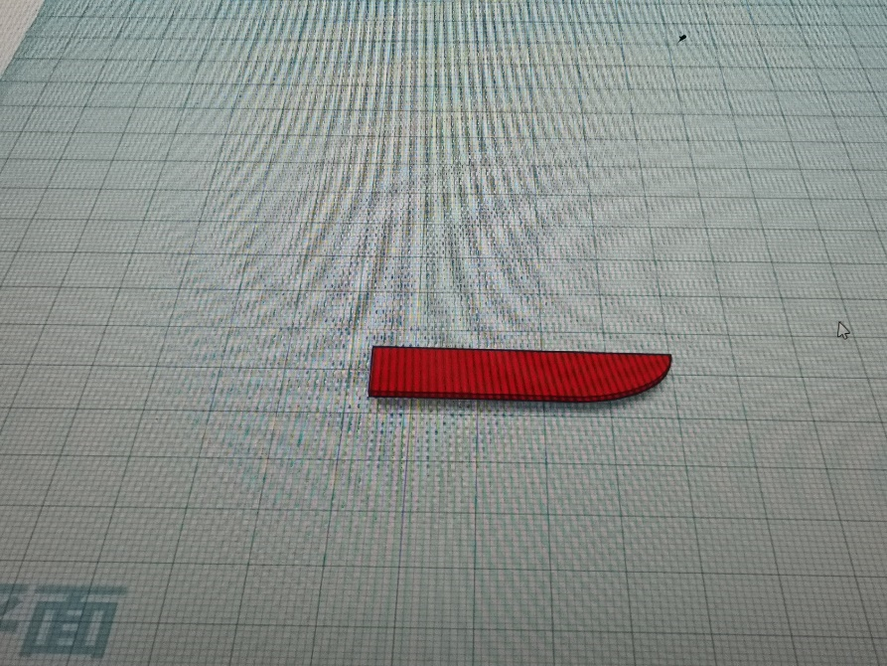
The square body is placed on the work plane, its length is 45, the width is 10, the height is 1. Then the meta-filled face, and set to the hole, adjust the size, the board and the element angle group, forming a 90-degree arc.
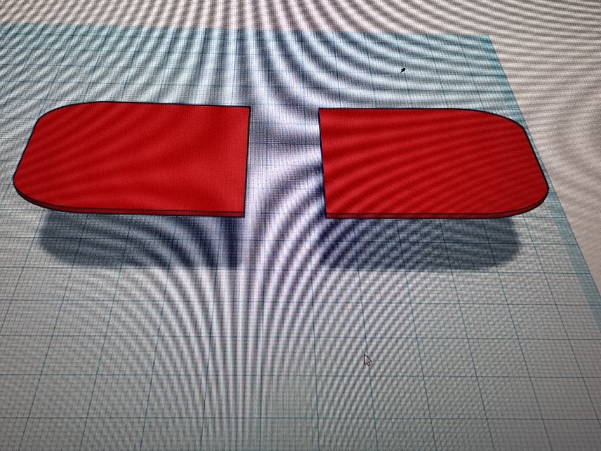
Copy the grouped boards into 4 pieces and group them with boards that are 40 long and 20 wide. Use the mirror after grouping.
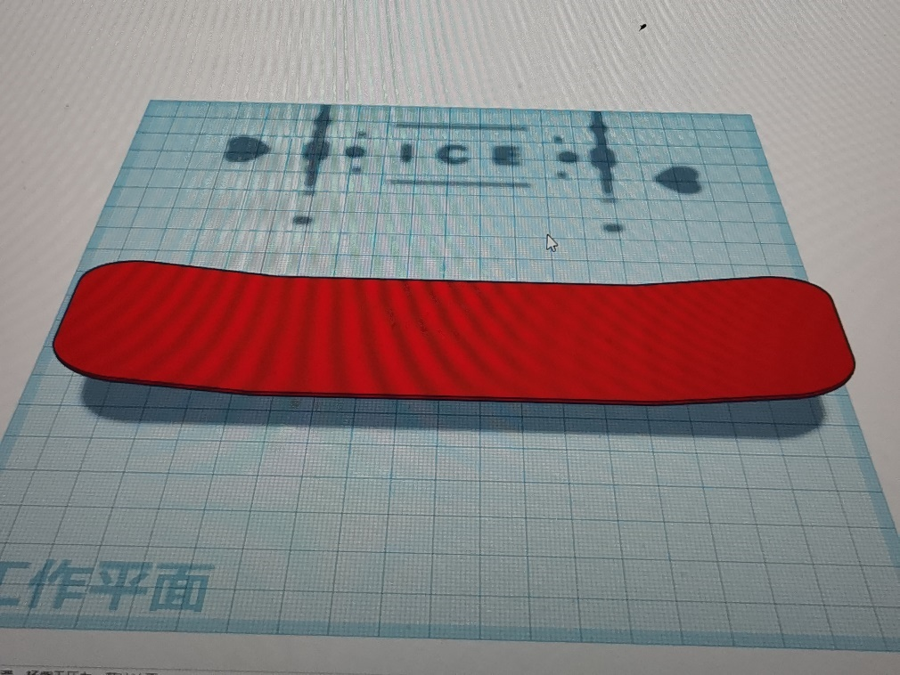
Align all the boards, rotate the rockers clockwise by 8 degrees, and set the mesh to 0.1 for easy stitching.
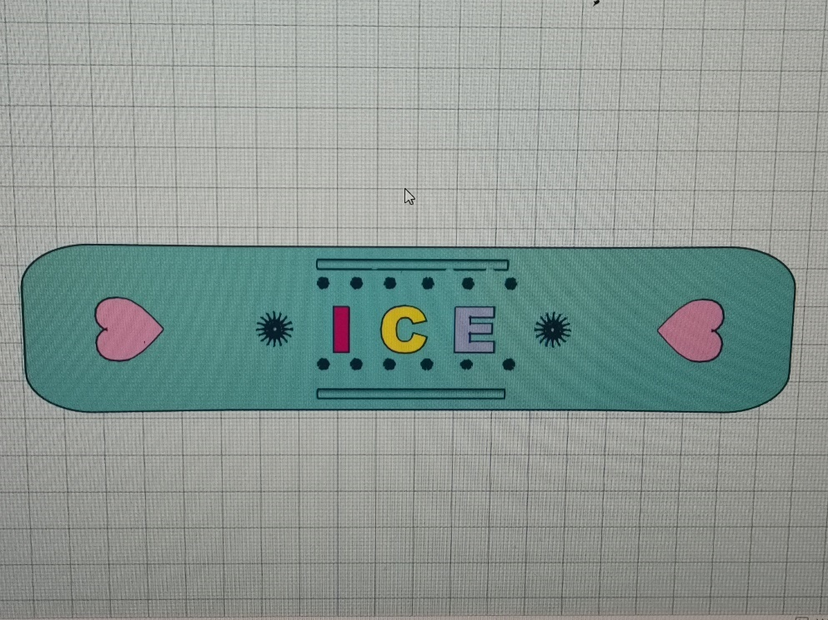
Snowflakes, sunflowers in the form of holes to decorate the skateboard, the board with love decoration appears more loving, long half-cylindrical and plate sides symmetrical. Finally, name the skateboard theme after ICE.
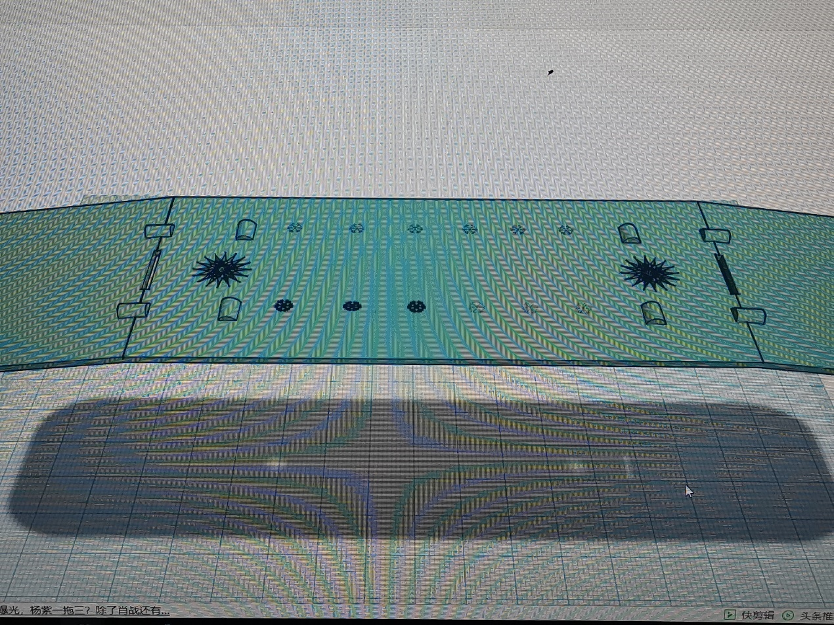
Stitch together using semi-cylindrical plates.

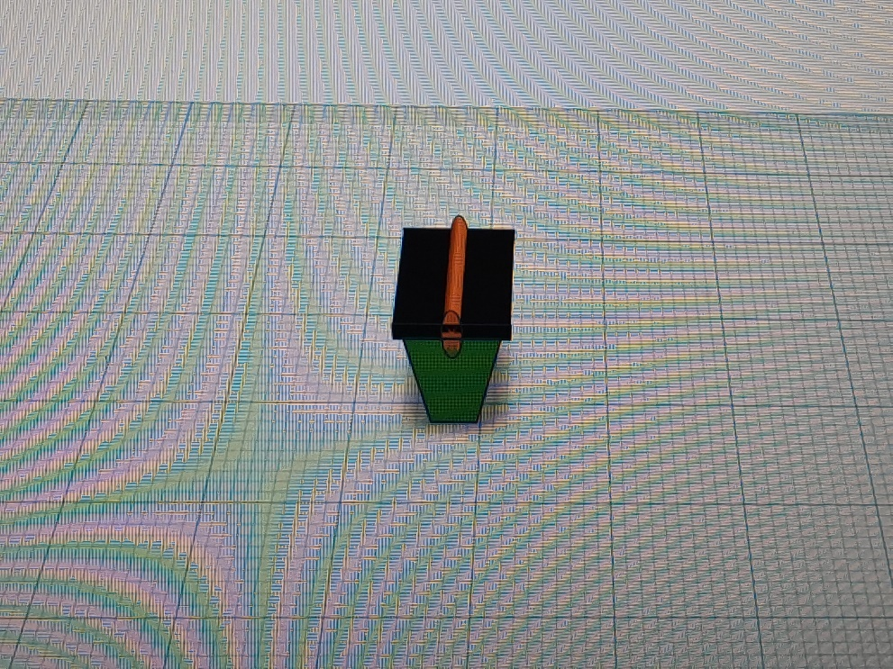
The box, cylindrical, and trapezoids are reasonably grouped to form connectors.
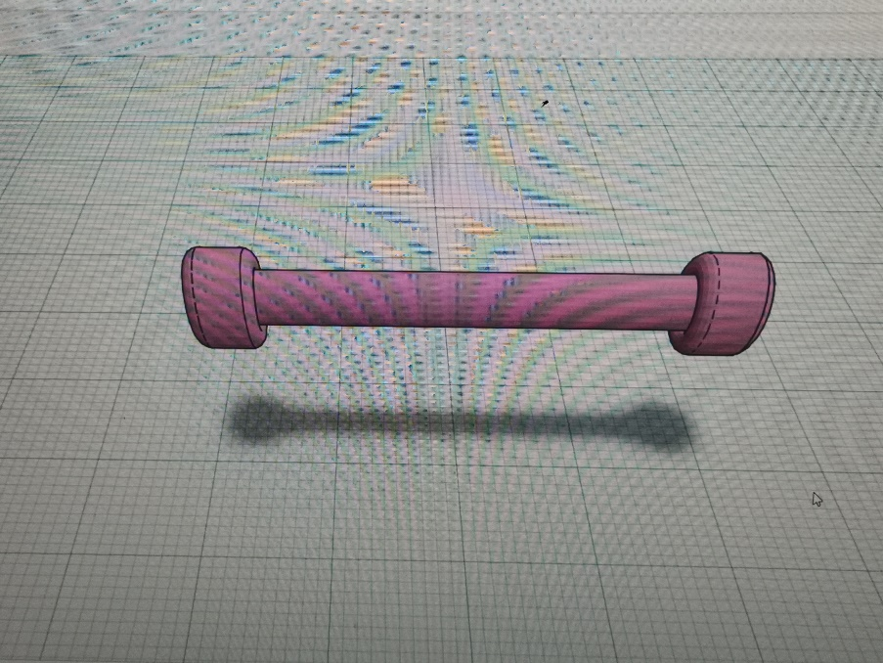
Group the cylinder and the tire into a pulley.
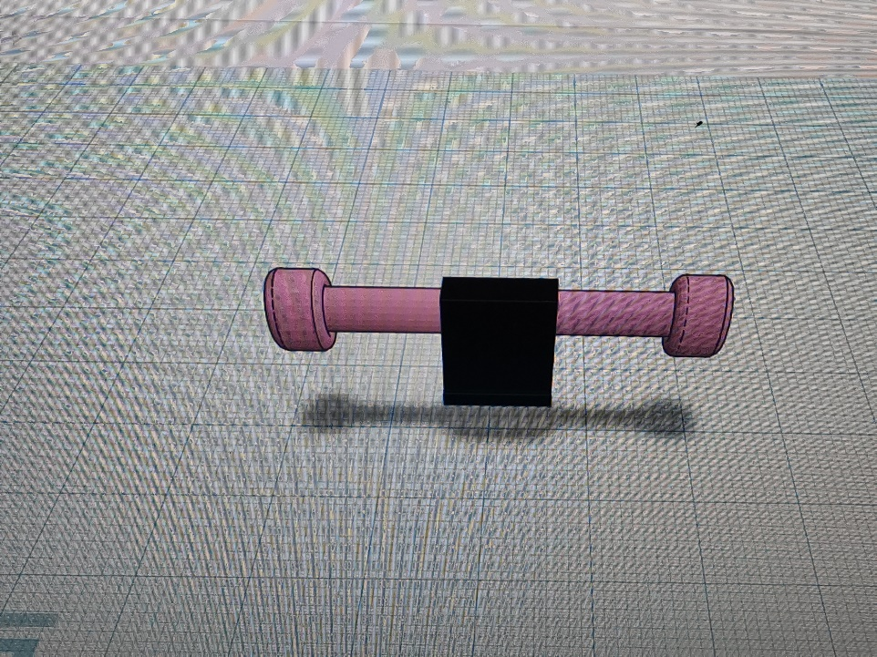
Connect the pulley into the connector and connect the plate to the sheave with the connector.
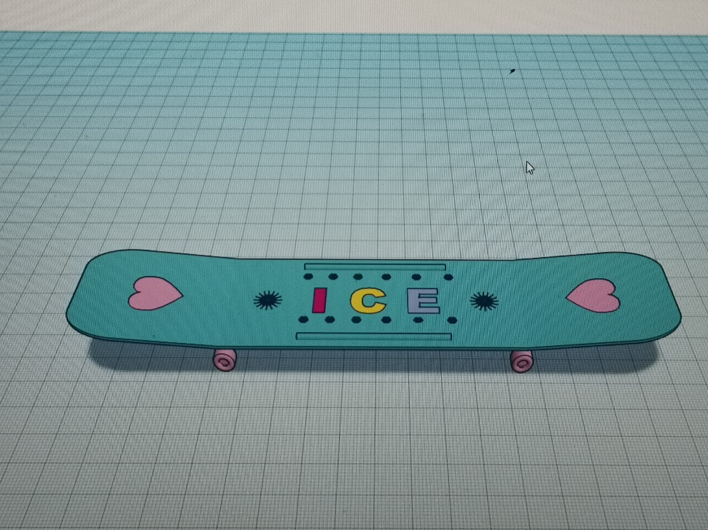
Set the color to color for a colorful and beautiful effect. The skateboard design is done.

