Plan of Procedures Flat Pack Clown Fish

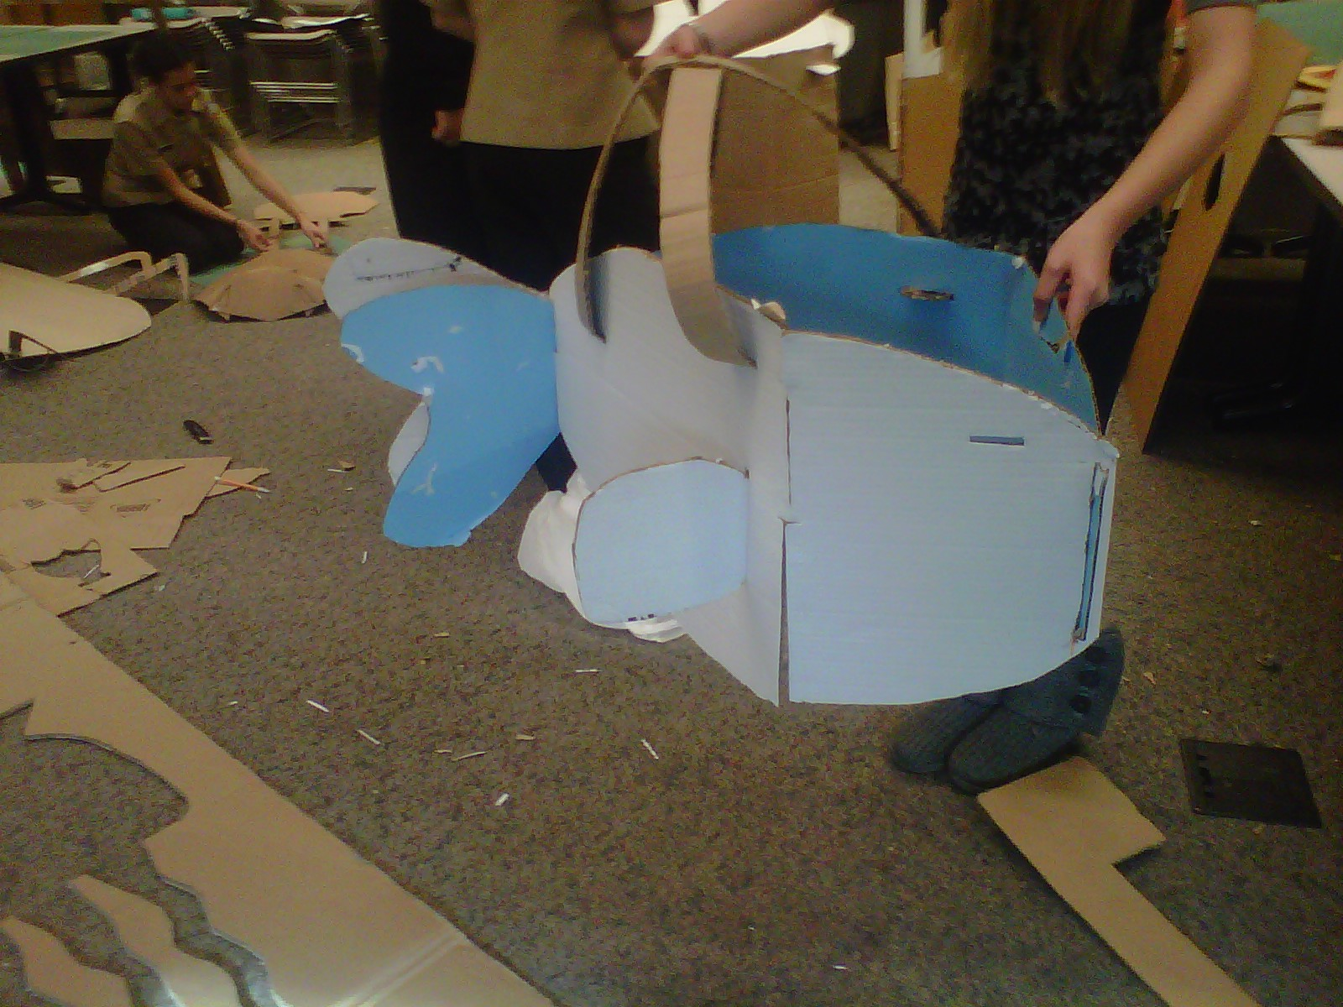
Supply list
ITEM | MATERIAL DESCRIPTION | QTY | SIZE | REMARKS - PART
S1 | CARDBOARD | 3 | 60” x 20”  30” x 10” | Used to make the body, fins, and straps

Tools and Equipment list
ITEM | TOOL | USE
TI | CUTTING MAT | To place under cardboard while cutting in order to prevent damage to surface underneath
T2 | UTILITY KNIFE | To cut the various pieces of cardboard
T3 | RULER | To measure the parts of the costume
T4 | PENCIIL | To outline/mark where cutting should take place.

Part P1:
1. Measure using ruler (T3) and score using pencil (T4) body piece 1.
2. Scribe using pencil (T4) a 1” line going left to right beginning at the left edge
3. Measure using ruler (T3) and score using pencil (T4) body piece 2
4. Draw using pencil (T4) and ruler (T3) a 6¼” x ¼” rectangle ¼” in from left edge of body piece 1

Part P2:
1. Measure using T3 and scribe using T4 (2) 24” x 2” rectangles using T4
2. Cut along the lines drawn using utility (T2) on mat.
3. Coil straps using hands

Part P3:
1. Measure using ruler (T3), and scribe (2) fins. 6” in length, left side 6 ½” in height and right side 5 ¼” in height
2. Score a 1” line using pencil (T4), starting from the top and bottom of the right side going right to left
3. Cut along lines made using utility knife (T2) on mat

PART LIST
ITEM | QTY | PART NAME
P1 | 1 | BODY PIECE 1
P2 | 1 | BODY PIECE 2
P3 | 2 | STRAPS
P4 | 2 | FINS

Assembly Steps:
1. Insert P1 into P2 at slot made on front end
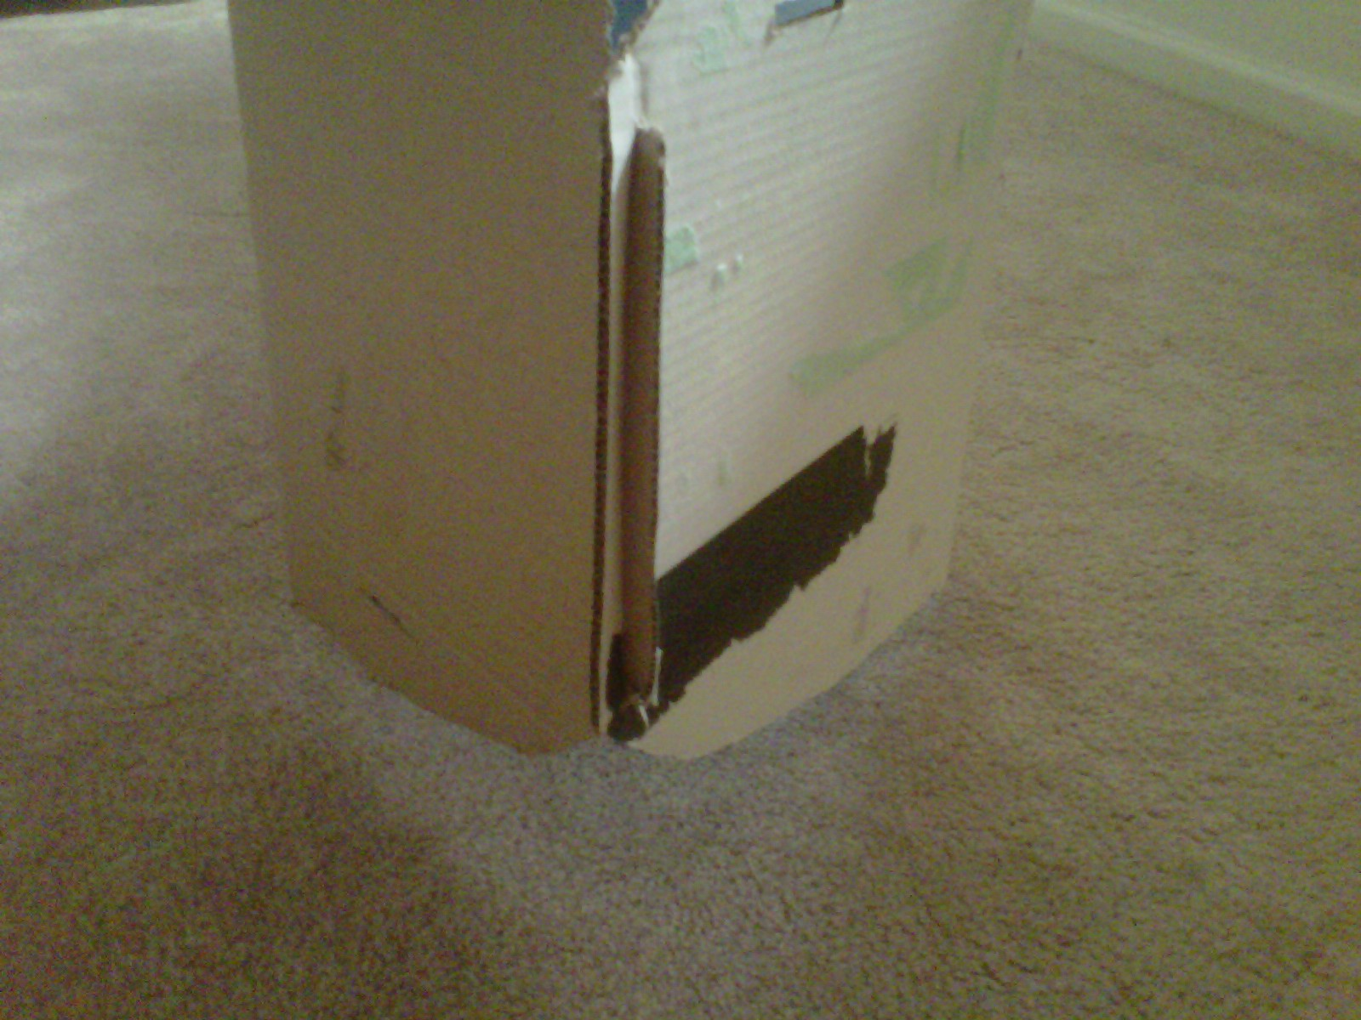

2. Slot tail end of P2 onto tail end of P1
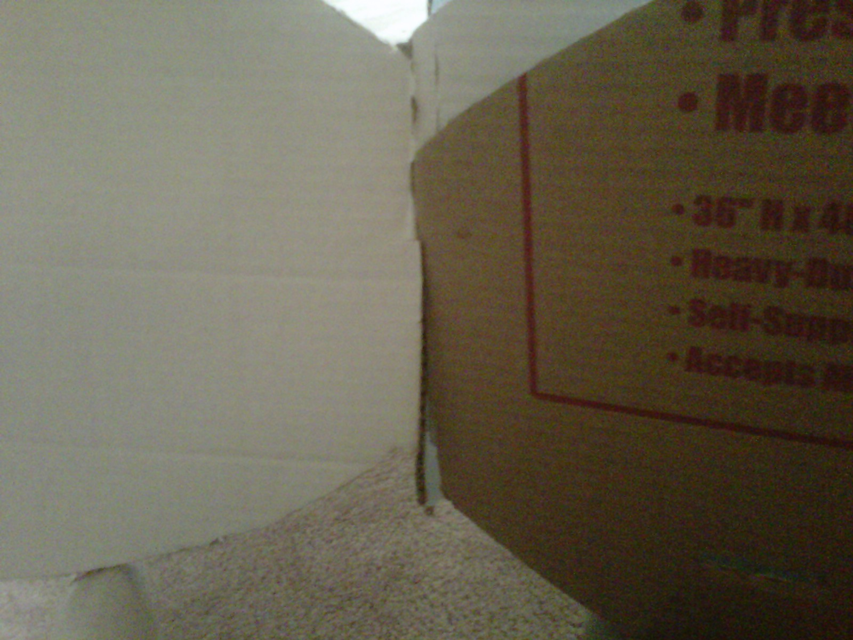

3. Slide P4 into the 5” on the side of P1 and P2
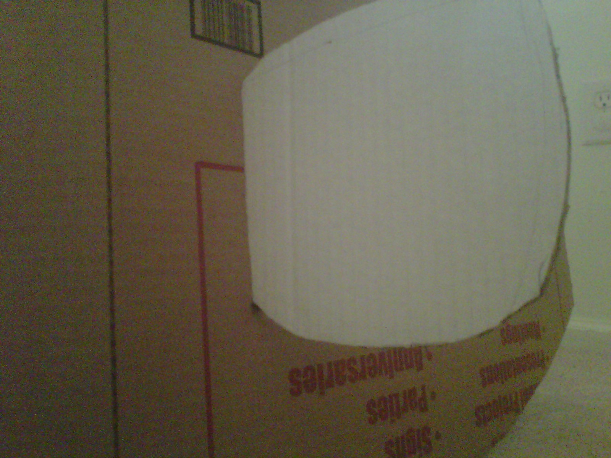

4. Place P3 into the four slots made in a criss-cross manner
