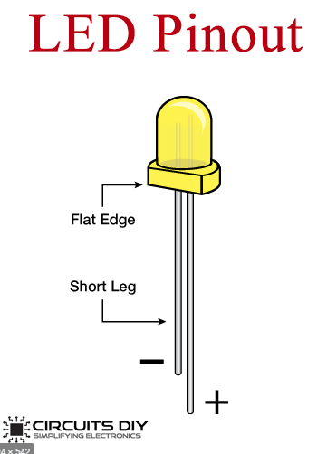
Wiring info

Leds are connected to the arduino in pairs so that two light up from each assigned pin. The order goes as such:

PIN 49: LED group 1
PIN 50: LED group 2
PIN 51: LED group 3
.
.
(this goes on until PIN 42)
.
.
PIN 43: LED group 7
PIN 42: LED group 8

The negative side (shorter wire) of the LEDs go to ground

The single RGB LED is wired as such:
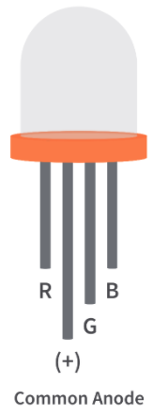
PIN 36: R
PIN 35: G
PIN 34: B

The longest pin of the RGB LED is connected to 5V on the Arduino.

The + end of the small speaker will be connected to PIN 18 of the Arduino, and the other end goes to ground.

The banana plug is connected to a 9V battery for power.
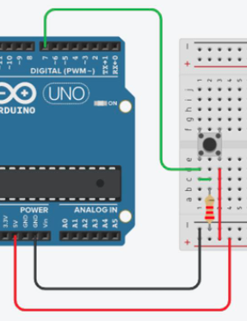

The pushbutton is connected to pin 25 of the arduino and ground
(reference for how it is set up to the right)

