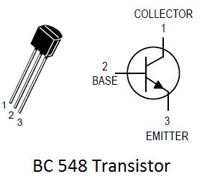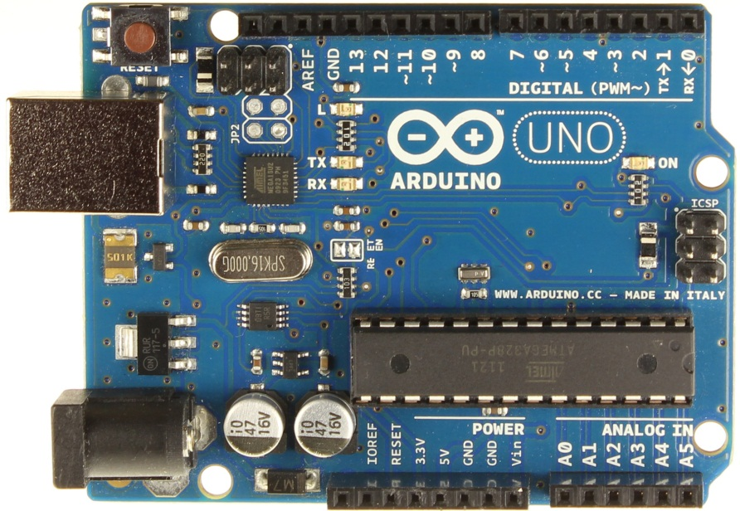

Relay

Vin

Pin 10

GND

Connection of buzzer’s positive wire

10K Resistor

E

B

C

IN4007

BC548