STEP-BY-STEP INSTRUCTIONS FOR MAKING CENSUS BOT 2020

The Census Bot 2020’s mission is to roam the neighborhood and make sure everyone is counted in the 2020 Census. You have everything you need to make Census Bot 2020 on a single page. Follow the assembly instructions below to make and customize your Census Bot. Please note that you should ONLY cut along solid lines and ONLY fold along dotted lines. If you would like to custom decorate your Census Bot 2020, I recommend cutting out all shapes listed below and drawing or pasting new decorations on a flat surface. Or you can stick with the Census logo decorations that come with this kit.

Other tips: You may substitute double-sided tape for glue if you prefer to put that on each tab. REMEMBER: Cut all slots for arms and wheels (noted as solid lines on the page) BEFORE you glue each shape together.

- SHAPE A: Cut out Shape A, which has five panels. Fold along the dotted lines, apply a light coat of glue to each of the tabs, and make a cube to complete the Census Bot head.
- SHAPE B: Cut out Shapes B1 and B2, the two body panels. Apply glue to the other tabs on both shapes to create a four-sided body. Line up the two top tabs (on the shortest sides) and insert them into the cuts you already made in the bottom of your cube head.
- SHAPE C: Cut out shapes C1 and C2, the arms. Before inserting the tabs into the two cuts you made on either side of the body, curl the arms around a pencil at least twice to give them a curved shape.
- SHAPE D: This is the bottom of your robot. Follow the cutting, folding and gluing technique you used for the other shapes and place at the bottom of the body. Make sure there are proper cuts made for wheels.
- Shape E: Cut out shapes E1 and E2, the wheels. Make small notches halfway up the wheels so that they lock in place when you insert them into the Shape D (bottom) slits.
- Get your Census Bot out there to get a complete and accurate count!

STEP-BY-STEP INSTRUCTIONS FOR MAKING CENSUS BOT 2020
WITH PHOTOS!

The Census Bot 2020’s mission is to roam the neighborhood and make sure everyone is counted in the 2020 Census. You have everything you need to make Census Bot 2020 on a single page. Follow the assembly instructions below to make and customize your Census Bot. Please note that you should ONLY cut along solid lines and ONLY fold along dotted lines. If you would like to custom decorate your Census Bot 2020, I recommend cutting out all shapes listed below and drawing or pasting new decorations on a flat surface. Or you can stick with the Census logo decorations that come with this kit.

Other tips: You may substitute double-sided tape for glue if you prefer to put that on each tab. REMEMBER: Cut all slots for arms and wheels (noted as solid lines on the page) BEFORE you glue each shape together.

- SHAPE A: Cut out Shape A, which has five panels. Fold along the dotted lines, apply a light coat of glue to each of the tabs, and make a cube to complete the Census Bot head.
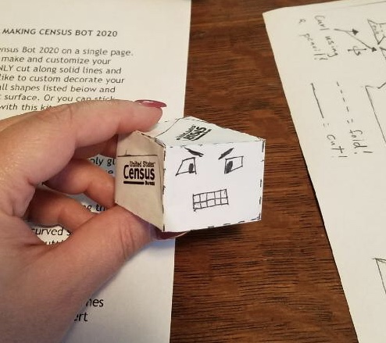

- SHAPE B: Cut out Shapes B1 and B2, the two body panels. Apply glue to the other tabs on both shapes to create a four-sided body. Line up the two top tabs (on the shortest sides) and insert them into the cuts you already made in the bottom of your cube head.
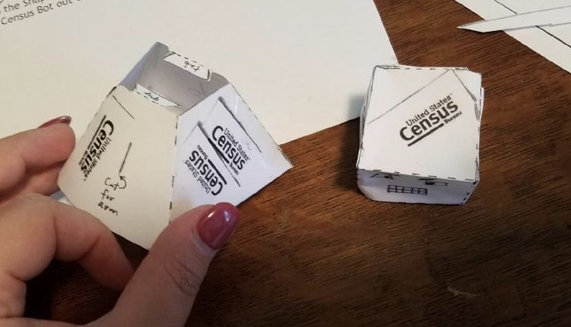
- SHAPE C: Cut out shapes C1 and C2, the arms. Before inserting the tabs into the two cuts you made on either side of the body, curl the arms around a pencil at least twice to give them a curved shape.
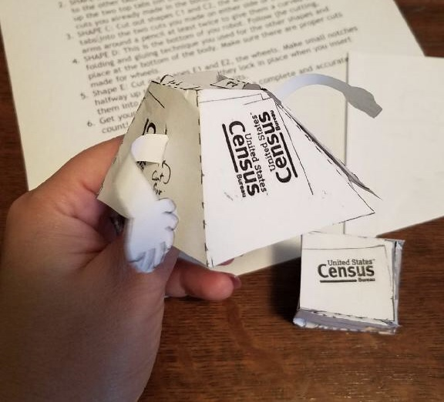
- SHAPE D: This is the bottom of your robot. Follow the cutting, folding and gluing technique you used for the other shapes and place at the bottom of the body. Make sure there are proper cuts made for wheels.
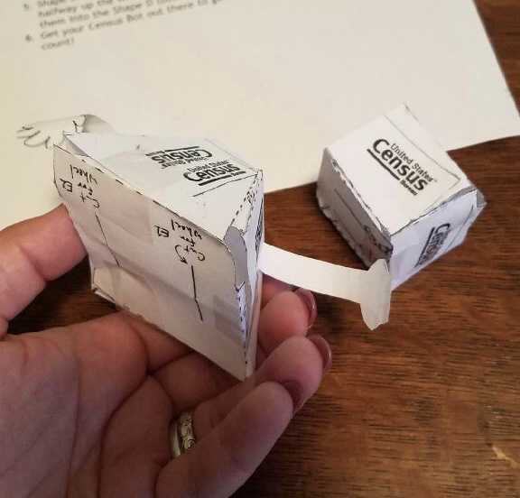
- Shape E: Cut out shapes E1 and E2, the wheels. Make small notches halfway up the wheels so that they lock in place when you insert them into the Shape D (bottom) slits.
- Get your Census Bot out there to get a complete and accurate count!
